CHEMICAL ENGINEERING TRANSACTIONS  VOL. 73, 2019 | A publication of
The Italian Association
of Chemical Engineering
Online at www.aidic.it/cet
Guest Editors: Andrea D’Anna, Paolo Ciambelli, Carmelo Sunseri
Copyright © 2019, AIDIC Servizi S.r.l.
ISBN 978-88-95608-70-9; ISSN 2283-9216

Fundamentals of Environmental Monitoring of Heavy Metals using Graphene
Ivan Shtepliuk*, Mikhail Vagin, Tihomir Iakimov, Rositsa Yakimova
Department of Physics, Chemistry and Biology, Linköping University, SE-58183 Linköping, Sweden
ivan.shtepliuk@liu.se
Predicting interaction between toxic heavy metals in neutral charge state with graphene and a holistic understanding the interaction mechanisms are still very important tasks due to a strong necessity to develop reliable and real-time sensing applications providing the environmental control of toxic pollutants, especially in industrial regions of developing countries. By means of electrochemical measurements and density functional theory (DFT) modelling, we investigated the adsorption behaviour of three most toxic heavy metals (namely, Cadmium, Mercury and Lead) onto graphene and revealed the relationship between stripping current density and adsorption energy. Electrochemical results indicate that graphene exhibits different stripping behaviour toward heavy metal species, enabling only detection of the Cd and Pb. Comprehensive theoretical calculations explain the enhanced sensitivity of graphene to Pb through performing extended charge decomposition analysis (ECDA), noncovalent interaction (NCI) analysis and topological analysis.
  - Introduction
The on-time discriminative identification of toxic pollutants in the environment is a global challenge, since hazardous substances and non-biodegradable contamination can cause abrupt and irreversible ecological changes and affect adversely human health (Sun, 2017). Such global threats have to be addressed in a holistic manner through developments of reliable and portable technologies for constant monitoring of dangerous pollutants and reaching complete understanding of the fundamental physical principles that underlay the real-time response of the detection/monitoring systems to pollutants' exposure. Among different hazardous chemicals, heavy metals (especially, Lead, Cadmium and Mercury) are believed to be one of the most dangerous categories of persistent toxins with high bioaccumulation ability (Wang, 2017). When exceeding maximal acceptable concentrations, heavy metals can result in human poisoning, brain dysfunctions, bone diseases, cancer tumours and, therefore a high lethality (Jaishankar, 2014). Thus, a strict environmental control of heavy metals is highly demanded. Trace heavy metals analysis is conventionally performed by analytical methods including atomic absorption spectroscopy, mass spectrometry, emission spectroscopy, gas chromatography, etc. Nevertheless, such methods are, in most cases, nonportable and have some drawbacks, which do not compete with real-time analysis. These factors suggest the need of novel detection concepts and easy-to-use devices that can monitor the presence of heavy metals and their concentration status in situ. In this regard, a combination of highly sensitive materials and state-of-the-art electrochemical methods (anodic stripping voltammetry, chronoamperometry, cyclic voltammetry) can be an alternative way to reach reliable environmental monitoring and assessment of heavy metals through the control of the metal-involved reduction-oxidation reactions, nucleation and adsorption events at the surface of the working electrode. Since each metal has a unique value of the redox potential, electrochemical methods enable not only precise determination of the specific metals, but also simultaneous detection of different metal species. Therefore, the choice of the sensitive materials for working electrodes, in which as many surface atoms as possible will be available for chemical reactions is a cornerstone for future realization of smart sensors. During last decade, SiC-supported graphene (also called epitaxial graphene) has been attracting considerable attention of the sensors community by its large surface area, which provides a lot of electroactive sites, high carrier mobility, high chemical stability and biocompatibility (Shtepliuk, 2016), wide potential window (Shtepliuk, 2018), and tuneable electrochemical activity (Vagin, 2017). Such characteristics are excellent prerequisites to use epitaxial graphene as working electrode favouring fast electrochemical electron-transfer reactions underlaying detection of heavy metals. In our previous studies, we investigated the response of the epitaxial graphene under exposure to Lead and deeply explored the redox, adsorption and nucleation behaviour of Pb (Shtepliuk, 2018). In this paper, we extend our study to three metals (namely Cd, Hg and Pb) and examine their plating/stripping behaviour by square-wave anodic stripping voltammetry (SWASV) technique. Since the correct interpretation of the experimental results is still challenging, theoretical background of heavy metals detection using graphene is required. The nature of the fundamental interaction between heavy metals and graphene as well as sensitivity/selectivity of the investigated material to heavy metals will be, for the first time, elucidated through performing extended charge decomposition analysis (ECDA), noncovalent interaction (NCI) analysis and topological analysis.
  - Experimental details and theoretical approach
    - Electrochemical measurements
Electrochemical measurements were performed by using computer-controlled potentiostat (Autolab, EcoChemie, Metrohm, Utrecht, The Netherlands). The custom-built electrochemical cell of o-ring type was assembled with three-electrode system: Gr/SiC, Ag/AgCl and platinum wire were used as the working electrode, reference electrode and counter electrode, respectively. For more information about the design of the electrochemical cell, see our previous work (Vagin, 2017). Aqueous solutions of Cd²⁺, Hg²⁺ and Pb²⁺ were prepared by dissolving the appropriate amounts of corresponding salts (CdCl₂, HgCl₂ and (Pb(NO₃)₂, respectively) in buffer solution (0.1 mol·L⁻¹ HClO₄ in Milli-Q-water) with pH=4.5. Stripping process was performed by square wave anodic stripping voltammetry (SWASV) at the following parameters: accumulation time of 2 min; frequency, 15 Hz; amplitude, 25 mV; increment potential, 5 mV. Since the stripping peak current is dependent on both the redox potential of the metal and concentration of the metal cations, the analysis of this peak enables quantification of the metals.
    - Density Functional Theory (DFT) calculations
The nature of the interaction between heavy metals (Cd, Hg and Pb) and graphene was examined based on hybrid gas-phase DFT calculations performed by using Gaussian 09 Rev. D.01 program package (Frisch, 2009). As a model of graphene, 4x5 supercell with edge hydrogen passivation has been chosen. All the calculations were carried out using M06-2X level of theory with consideration of split basis set. 6-31G basis set was used for carbon and hydrogen atoms, while basis set developed by the Stuttgart–Dresden–Bonn group (SDD) was utilized for the heavy metal species (Martin and Sundermann, 2001). All atoms are enabled to be fully relaxed during geometrical optimisation procedure. All calculations were carried out without symmetry restrictions. Since the van-der-Waals interaction is supposed to be prevailing factor in adsorption of elemental heavy metals, noncovalent interactions (NCI) analysis and topological analysis were performed using Multiwfn program to better understand the metal-carbon (M-C) bonding (Lu, 2012). The nature of M-C bonding and orbital interactions for all considered complexes were also explored by quantum theory of atoms in molecules (QTAIM) method (Bader, 1990) and extended charge transfer analysis (CDA) implemented in Multiwfn program.
  - Results and discussion
    - Square-wave anodic stripping voltammetry (SWASV) measurements
Before focusing on the fundamentals underlying the interaction between heavy metals and graphene, we investigated and compared the stripping responses of the graphene to exposure of Hg, Cd and Pb. The corresponding two-dimensional contour plots of anodic stripping current conveying both the current density and HMs concentrations are presented in Figure 1. It is clearly seen that no stripping response was observed in the case of Mercury. It can be explained by the very small intrinsic adsorption energy of Hg on the surface of the graphene electrode, which is not enough to accumulate metal species required for generating the stripping current. A close look at contour plots describing the response of the graphene to Cd and Pb confirms that SiC-supported monolayer graphene provides single, well-defined stripping peak currents at the certain potentials, which are proportional to the concentration of Cd²⁺ and Pb²⁺, respectively. Visual analysis of the maps suggests that the graphene is more sensitive to Pb than to Cd, which is evidenced by an earlier appearance of the signal during Pb-involved reduction-oxidation processes at the graphene surface. In other words, due to faster electrode reactions, the striping-peak current starts to appear at smaller Pb concentrations. To obtain quantitative information about sensitivity of graphene to different metals, the dependences of the stripping-peak current density on the concentrations of the Cd and Pb ions are investigated (see Fig 2a and b, respectively). It is obvious that both dependences exhibited a linear relationship. For the Cd ion (Figure 2(a)), the linear-regression equation is calibrated as I_{Cd}(mA·cm⁻²) =8.6 × 10⁴·[Cd(mol/L)] + 0.066, with a correlation coefficient of 0.9951 and a sensitivity of 8.6 × 10⁴ mA·cm⁻² ·mol⁻¹·L. While the correlation equation for Lead is I_{Pb}(mA·cm⁻²) =2.3 × 10⁶·[Pb(mol/L)] + 0.9 with a correlation coefficient of 0.9945 and sensitivity of 2.3 × 10⁶ mA·cm⁻² ·mol⁻¹·L (Figure 2(b)). The sensing mechanism in the case of the electrochemical detection is governed by the interaction between elemental (reduced) metal species and graphene (Figure 2c). In fact, divalent metal ions (M²⁺) are initially reduced to neutral metal species (M⁰) at a specific potential. Immediately after, anodic stripping current related to their re-oxidation identifies the amount of metal species adsorbed onto the electrode surface. The stronger adsorption ability of metal, the more intensive current peak. The enhanced sensitivity of graphene to Pb species and observed limit of detection correspond well to modern WHO requirements for critical concentrations of Pb in potable water. Despite the existing HMs sensors demonstrate even more superior sensitivity, in most cases a synthesis of sensitive materials is multistage technological process, which demands functionalization and/or immobilization steps. In this regard, epitaxial graphene itself exhibits strong ability to Pb binding, thereby offering obvious advantages over other sensing platforms.
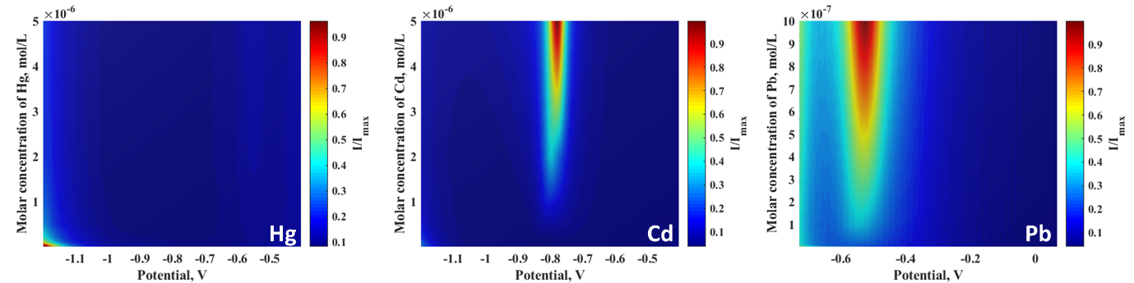
Figure 1: Two-dimensional contour plots showing the current density as a function of potential and metal concentrations for epitaxial graphene (EG on Si-face 4H-SiC) electrode after exposure to different heavy metals: Hg²⁺, Cd²⁺ and Pb²⁺ (see from the left to the right). The current maps were constructed based SWASV measurements. Brighter regions correspond to a higher current density. The values of anodic stripping current density are normalized to the maximum value of current density for each case considered.
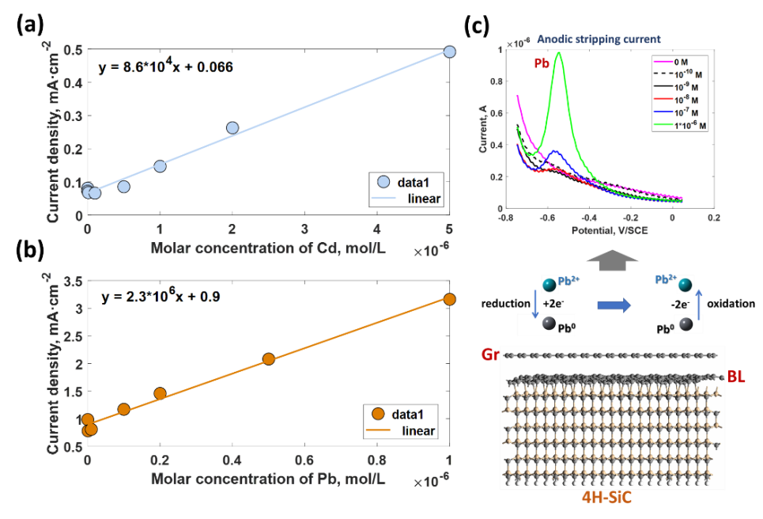
Figure 2: Calibration curves for (a) Cd²⁺ and (b) Pb²⁺ and (c) schematic of the sensing mechanism for the detection of Pb²⁺ ions
  - DFT analysis
To shed more light on the interaction between studied metals and graphene, we mimic the adsorption of individual metal atoms (Cd, Hg and Pb) in the neutral charge state by performing DFT calculations at M06-2X/6-31g/SDD level of theory. Figure 3(a-c) shows the optimized structures of three metal adsorption configurations on graphene nanofragment. As can be seen, Cd and Hg adatoms prefer to adsorb onto hollow site of the sp²-bonded network (central of the hexagonal ring), while Pb adsorbs on graphene surface by interacting with two adjacent carbon atoms (so-called bridge site). Among the three metals, the Pb on graphene is the most stable adsorption configuration. Counterpoise-corrected adsorption energy of Pb is 0.688 eV, which is significantly larger than the adsorption energy of Cd and Hg on graphene surface (0.138 eV and 0.114 eV, respectively). The substantial energy difference indicates that Cd and Hg adatoms are always physiosorbed on the hollow sites, while the interaction between the Pb adatom and the sp² plane belongs rather to a weak chemisorption. All three metals behave as electron-donating dopants. According to the extended charge decomposition analysis, the number of electrons transferred from the metal adsorbates to a graphene fragment is 0.09, 0.12 and 0.62 for Cd, Hg and Pb, respectively. The enhanced charge transfer from Pb to graphene can be explained by lower ionization energy of Pb compared to Cd and Hg. Thus, it is easier to extract an electron from a Pb adatom. The electron localization function (ELF) analysis gives more evidences on charge redistribution in the interacting systems (see Figure 3 (d-e)). From the ELF images, it is clearly seen that there is no electron localization overlap between Cd (Hg) and graphene, while the electrons are shared between Pb and carbon atoms pointing out a larger interaction strength.
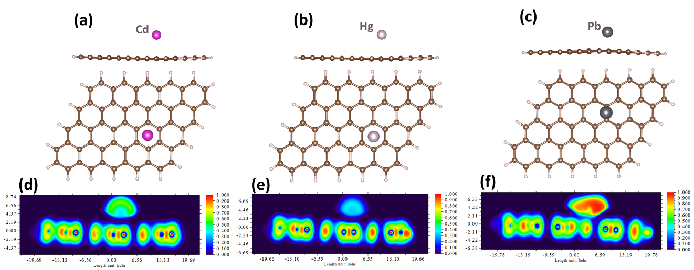
Figure 3: Side view and top view of the relaxed adsorption configurations of Cd (a), Hg (b) and Pb (c) on graphene surface. Contour plots of the electron localization function (ELF) for the heavy metals adsorbed onto graphene: Cd on Gr (d), Hg on Gr (e) and Pb on Gr (f).
Indeed, charge decomposition analysis (CDA) presented in Figure 4 revealed strong orbital interactions between the three lowest orbitals of Pb (6s and 6p) and the molecular orbitals of graphene nanofragment (Figure 4c). The formation of frontier orbitals in Pb@graphene complex (Figure 4c) is due to the mixture of unoccupied orbitals labelled 3 and 4 in Pb and frontier orbitals 184 and 185 in graphene. Unlike the Pb case, no orbital interaction between Cd (Hg) and graphene is observed as shown in Figure 4 (a, b). In other words, molecular orbitals in graphene after adsorption of Cd and Hg species remain unperturbed. This funding suggests that the physisorption of Cd and Hg is predominantly governed by van-der-Waals dispersion forces. To validate this assumption, we performed non-covalent interaction (NCI) analysis for all considered complexes. The results are illustrated in Figure 5. For graphene interacting with Cd and Hg, three well-pronounced sharp spikes (Figure 5a and b), which tend to approach zero values of reduced density gradient (RDG), are observed. The presence of two peaks within the sign(λ₂)ρ region extending from -0.01 to 0.01 a.u. suggests evident attractive intermolecular interaction between metal and graphene, which is dominated by dispersion. According to the NCI iso-surfaces at constant RDG=0.5, this non-bonding interaction region is located at the centre of the hexagonal ring (green-coloured area). It can be attributed to the presence of a ring critical points (RCPs) with vanishing density gradient. For both cases, a spike at the positive side at sign(λ₂)ρ ≈0.02, which is related to steric repulsion region, is also observed. It is important to note that this spike remains almost constant for all adsorption configurations, indicating its independency of the metal type. More complicated nature of the interaction occurs in the case of Lead adsorption (Figure 5 c and f). In particular, there is a competitive contribution of different components (steric repulsion, strong chemical bonding and weak van-der-Waals interaction) to the total interaction energy, which is confirmed by the presence of the corresponding peaks in the NCI diagram (Figure 5c) and the overlap of differently-coloured regions of the iso-surface (Figure 5f). For Pb, the weak nonbonding peak associated with van-der-Waals interaction region is observed only at the positive side, implying the smaller energy contribution of the dispersion forces compared to the Cd and Hg adsorption. Considering the results of the charge decomposition analysis, it is reasonable to assume that the nature of the chemical bonding is mainly originating from the orbital interaction.
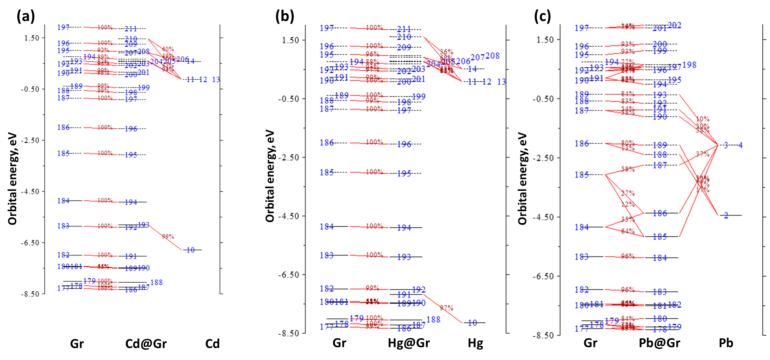
Figure 4: Orbital interaction diagrams determined using CDA analysis for three considered cases: Cd on Graphene (a), Hg on Graphene (b) and Pb on graphene (c). Occupied and empty molecular orbitals are represented as solid and dashed lines, respectively.
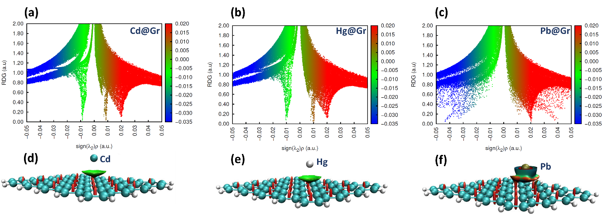
Figure 5: Non-covalent interaction (NCI) analysis of graphene interacted with Cd (a), Hg (b) and Pb (c). Red indicates steric repulsion region; green (light brown) indicates vdW interaction region and blue implies the strong attractive interaction. (d-f) Corresponding plots of the NCI iso-surfaces (RDG=0.5) for Cd (d), Hg (e) and Pb (f) adsorbed onto graphene are depicted below. The iso-surfaces are coloured according to sign(λ₂)ρ over the range -0.035 to 0.02 a.u.
To get deeper insights into the nature of the interaction between elemental heavy metals, topological properties of critical points were calculated. Topological parameters of bond critical points (BCPs) are summarized in Table 1. Analysis of the data in Table 1 suggests that the electron density ρ at BCPs are the highest in the Pb-C bonds. Laplacians of the electron densities are positive only for Cd and Hg, indicating non-covalent nature of the interactions. While the negative value of $∇^{2}$ρ at BCP in the Pb@graphene complex may imply the weak covalency of the Pb-C bond. The relationship between potential energy density, V(r), and Lagrangian kinetic energy density, G(r), is regarded as an additional descriptor of the bond type. Data collected in Table 1 show that the -V(r)/G(r) ratio is slightly smaller than 1 for Cd-C and Hg-C bonds, whereas this ratio reaches much higher value (3.12) for Pb-C. This means that there is no covalency in interaction between Cd (Hg) with graphene, but Pb-C demonstrates classical covalent character. It is also evidenced by the negative value of energy density, H(r), and higher values of ELF and LOL. Thus, topological analysis also indicates that the Cd(Hg)-C bonds in considered interacting complexes are predominantly regulated by van-der-Waals forces, while Pb-C bonds are mostly covalent in nature.
Table 1: Topological parameters for bond critical points (BCPs) existing between HM species and graphene surface. Two different BCPs are regarded for each case.
Topological parameter | Cd-C | Hg-C | Pb-C
Electron density, ρ(r) | 0.0087(0.0093) | 0.0106(0.0105) | 0.0307(0.0310)
Laplacian of electron density, $∇^{2}$ρ | 0.020(0.0212) | 0.0281(0.0290) | -0.0433(-0.0268)
Hamiltonian kinetic energy density, K(r) | -0.000056(0.000025) | -0.000097(-0.00019) | 0.0204(0.0183)
Lagrangian kinetic energy density, G(r) | 0.0051(0.0053) | 0.00695(0.00707) | 0.00961(0.0116)
Electron Localization Function, ELF | 0.041(0.0469) | 0.0434(0.0402) | 0.446(0.365)
Localized orbital locator, LOL | 0.172(0.181) | 0.175(0.170) | 0.473(0.431)
Potential energy density, V(r) | -0.00508(-0.00535) | -0.00685(-0.00688) | -0.0300(-0.0299)
Energy density, H(r) | 0.000056(-0.000025) | 0.000097(0.00019) | -0.0204(-0.0183)
-V(r)/G(r) | 0.9961(1.0094) | 0.9689(0.9899) | 3.1217(2.5776)
G(r)/ρ(r) | 0.5862(0.5699) | 0.6557(0.6733) | 0.3130(0.3742)
- Conclusions
In summary, the adsorption behaviour of heavy metal species on graphene supported by Si-terminated 4H-SiC has been evaluated. By using anodic stripping voltammetry measurements, we investigated the response of the graphene under exposure to Cd, Hg and Pb. Our results indicated that graphene is very sensitive to Pb, less sensitive to Cd and insensitive to Hg, which is in good agreement with theoretically-determined adsorption order of considered heavy metals (Pb>Cd>Hg). The considered elemental heavy metals always act as electron-donating dopants preferring to be adsorbed onto bridge site (Pb) and hollow site (Cd, Hg). As revealed by the DFT computations, the adsorption energies of Cd and Hg are mainly governed by dispersion forces, while the adsorption energy of Pb is mainly determined by orbital interaction with less contribution from van-der-Waals interaction. The obtained results are expected to be good prerequisites of designing highly sensitive portable devices for in situ monitoring of environmental pollutants.
Acknowledgments
The authors would like to thank financial support via VR grants (VR 621-2014-5805 and VR 2016-05362) and SSF grants (SSF GMT14-0077, SSF RMA15-0024). I.S. acknowledges the support from Ångpanneföreningens Forskningsstiftelse (Grant 16-541). We acknowledge support from the Swedish Government Strategic Research
Area in Materials Science on Functional Materials at LiU (Faculty Grant SFO-Mat-LiU #2009-00971).
References
Bader R.W.B., 1990, Atoms in Molecules: A Quantum Theory, Oxford University Press, Oxford, U.K.
Frisch M.J., Trucks G.W., Schlegel H.B., Scuseria G.E., Robb M.A., Cheeseman J.R., Scalmani G., Barone V., Petersson G.A., Nakatsuji H., et al., 2009, Gaussian 09, Revision D. 01; Gaussian Inc.: Wallingford, CT, USA.
Jaishankar M., Tseten T., Anbalagan N., Mathew B.B., Beeregowda K. N., 2014, Toxicity, mechanism and health effects of some heavy metals, Interdisciplinary Toxicology, 7(2), 60–72.
Lu T., Chen F.W., 2012, Multiwfn: a multifunctional wavefunction analyzer, Journal of Computational Chemistry, 33, 580–592.
Martin J.M.L., Sundermann A., 2001, Correlation consistent valence basis sets for use with the Stuttgart–Dresden-Bonn relativistic effective core potentials: The atoms Ga–Kr and In–Xe, Journal of Computational Chemistry, 114, 3408–3420.
Shtepliuk I., Vagin M., Ivanov I.G., Iakimov T., Reza Yazdi G., Yakimova R., Lead (Pb) interfacing with epitaxial graphene, 2018, Physical Chemistry Chemical Physics, 20, 17105–17116.
Shtepliuk I., Khranovskyy V., Yakimova R., 2016, Combining graphene with silicon carbide: Synthesis and properties—A review. Semiconductor Science and Technology, 31, 113004.
Sun Z., 2017, Study on Environmental Chemical Behavior and Dust Control of Lead and Cadmium in Atmosphere, Chemical Engineering Transactions, 59, 931-936.
Vagin M.Y., Sekretaryova A.N., Ivanov I.G., Håkansson A., Iakimov T., Syväjärvi M., Yakimova R., Lundström I., Eriksson M, 2017, Monitoring of epitaxial graphene anodization, Electrochimica Acta, 238, 91-98.
Wang X., Yang F., Chen X., and Yang S., 2017, Environmental Chemistry of Toxic Heavy Metals Hg-As in the Jialing River, Chemical Engineering Transactions, 59, 883-888.

