|  |  |
| --- | --- |
| cetlogo ***CHEMICAL ENGINEERING TRANSACTIONS***  ***VOL. , 2023*** | A publication of  aidiclogo_grande |
| The Italian Association  of Chemical Engineering  Online at www.cetjournal.it |
| Guest Editors: Paolo Ciambelli, Luca Di Palma  Copyright © 2023, AIDIC Servizi S.r.l. **ISBN** 979-12-81206-00-7; **ISSN** 2283-9216 | |

Computer Simulation of Attractive Swarming with A Moving Attractor

Zhomart Zhaksylykb, Leila Musabekovaa,b,\*, Arnold Brenerb, Altynay Yunussovaс, Aydin Berdaliyevaa, Nurlybek Zhumatayevb

aSouth Kazakhstan Medical Academy, Al-Farabi square, 1, Shymkent, Kazakhstan

bAuezov University of South Kazakhstan, Tauke Khan, 5, Shymkent, Kazakhstan

сMiras University, Sapak Datka street, 2, Shymkent, Kazakhstan

mleyla@bk.ru

This work continues researches in developing models of swarming and aggregation in flows with dispersed systems. In the submitted work the new approach based on the method of random walk on stochastic lattices to computer simulation of attractive swarming, accompanied by particle aggregation, for the case of a moving region of attraction has been applied. Attractors of this type can arise, for example, in flows of charged particles or in biological systems. The competition of various control parameters has been considered. They are: the rate of entrainment of dispersion particles and attractive region by a continuum media flow in the apparatus; random drift of particles, which simulates the influence of Brownian motion and turbulent pulsations; diffusion limited kinetics of particle aggregation with the formation of clusters with account of the influence of moving attractor. The principal novelty of the modified algorithm is that the influence of the moving attractor on the drift of particles is described by the prevalence of the transition probability from a given cell to that lattice cell adjacent to it, which is located closer to the attractor. A justification for the developed algorithm, the results of numerical experiments, and their interpretation have been described. The results of the work can be useful in the design of technological apparatuses for the fine chemical and pharmaceutic technology or energetics.

* 1. Introduction

Recently, researchers and engineers have been confronted with numerous problems in the development and management of processes in ever-growing distributed systems (Carranza and Coates, 2020), which, in turn, consist of many interconnected components and clusters (Rocha-Gregg and Huttenlogher, 2021). Problems of this type can have a very different nature (Rütschlin and Böttcher, 2020). These are electronic systems, transport networks (Aibara et al., 2020), life sciences (Carrillo, 2010), biological systems (Jose and Singh, 2020) in which complex processes (Bouffanais, 2016) and transformations take place (Tadmor and Tan, 2014), as well as self-organization phenomena (Monaco et al., 2020). Such processes and phenomena are also characteristic of finely dispersed and nanodispersed systems in fine technological processes (Su et al, 2018), pharmacy and energy (Sun et al., 2021). All these systems have, as a rule, a high level of complexity (Villa et al., 2020) and are dynamic systems with signs of non-locality (Mogilner and Edelstein-Keshet, 1999), since contain many constantly interacting subsystems of various levels of dispersion (Carranza and Coates, 2000).

Previously, in the paper of Brener et al. (Brener et al., 2021), a classification of various mechanisms of swarming processes accompanied by particle aggregation was proposed. Swarming in technological processes is often accompanied by particle aggregation with the formation of larger clusters (Be’er and Ariel, 2019). In any case, there are numerous examples of just such implementation of processes, which is especially true for processes in fairly dense systems (Rimer and Ariel, 2017). Currently, it is hard to find works in which the criteria for the implementation of such a phenomenon of the joint occurrence of swarming (Brückner et al, 2019) and aggregation processes would be unambiguously described and identified (Dong et al., 2021). In this paper, the classification that was submitted in work (Brener et al.) has been used. The attempt to create a model for swarming accompanied by aggregation (Ha et al., 2019) in the presence of an moving attractor in a dispersed medium has been done. In contrast to the work (Musabekova et al.), the case of a mobile attractor in the form of a separate particle, which participates in the aggregation process, along with other particles of the dispersed medium, is considered. Such a statement of the problem has a certain proximity to the problems of describing swarming with the leader of the swarm (Mishra et al., 2018).

In this case, the same technique is used that was used to create an attractive swarming model for a fixed attractor on the reactor wall (Musabekova et al., 2022). Namely, the force interaction of a particle flow with an attractor is described using a random walk model by creating a non-uniform field of transition probabilities on a stochastic lattice. This approach is the scientific contribution of the authors' work on modeling swarming with aggregation and, probably, can also be useful for describing the processes of the structure transformation in dispersed flows of fine and nanoparticles. In this paper the case of a constant speed of the attractor has been only considered. Besides, the problem has been solved with a simplifying assumption about the absence of mutual influence of the speed of the carrier flow and the speed of the attractor.

* 1. Problem statement and algorithm

If the attractor moves at a constant speed , then at the time step  of calculation the attractor will be in the cell . That is, on the time step of calculation the attractor will be at the column , and the row  in which it is located for the horizontal direction of its movement remains constant for the attractor all the time. Thus, on the time step , the particle with coordinates  is the attractor.

For this particle, the random drift is not calculated, the row is constant, and the column grows at each time step (Figure 1).

m

n

r

s

moving attractor

w

UA

+

-

+

-

up OR down: Abs(n-m) •sign(m-n) times

left OR right: Abs(r-s) •sign(s-r) *times*

*Figure 1: Explanatory diagram for the description of the algorithm*

The main steps of the computer simulation algorithm are briefly described below.

**1**. Let at a certain moment the particle is in the cell (*n, r*), and the attractor is in the cell (*m, s*).

Then it is necessary to choose the drift of the particle in the horizontal and vertical directions (i.e., along the columns and rows), taking into accounting influence of the attractor. If the particle is below the attractor (*n>m*), then it will be attracted upwards, and if it is above the attractor (*n<m*), then downwards. If it is located to the left of the attractor (*r<s*), then it will be attracted to the right; if it is located to the right of the attractor (*r>s*), then it will be attracted to the left.

**2**. It is supposed that at each time step, the particles can drift only one step up or down, and one step to the right or left plus horizontal transfer with medium flow on *w* columns (Musabekova et al., 2022). Let's introduce the notations: 1 - drift up, 2 - drift down, 3 - drift to the right, 4 - drift to the left.

**3**. If *n>m*, that the sequence of integers 1 and 2 will be formed. In this sequence, integer 1 will be repeated (*M-n+1*) times, and integer 2 will be repeated  times. Hereis the control parameter which regulates the intensity of the attractor influence (Brener et al., 2021). In this sequence, the position is randomly chosen, and the position determines the drift direction. As integer 1 occurs the more often, the closer the particle is to the attractor, then the attraction in the vertical upward direction is modeled in this way.

**4**. If *n<=m*, a sequence of integers 1 and 2 is also formed. In this sequence, on the contrary, integer 2 should be repeated *n* times, and let 1 is repeatedtimes. Further the random choice of symbol position is done again. As integer 2 occurs more often, the closer the particle is to the attractor, the attraction in the vertical downward direction is modeled in this way.

**5**. The algorithm of choosing drifts to the right or to the left is done analogously. If *r<s*, that a sequence of numbers 3 and 4 is formed. In this sequence, integer 3 should be repeated *r* times, and integer 4 -  times.

**6**. If *r>=s*, that a sequence of integers 3 and 4 is formed. In this sequence, integer 4 should be repeated (*L-r+1*) times, and let 3 -times. As 4 occurs the more often, the closer the particle is to the attractor, then the attraction in the horizontal direction to the left is modeled in this way.

**7**. As soon as the particle hits the attractor, it sticks to it (according to DLA (diffusion-limited aggregation) mechanism (Brener et al., 2021)) and then moves along with it as one cluster. In this case, the order of the attractor increases all the time. Particles falling into one cell also aggregate according to DLA mechanism (Pirani et al., 2013). For processing and visualization of the results of a computer simulation, the coarse block matrices are formed according to the algorithm developed and described in the article (Brener et al., 2021).

* 1. Results and discussion

As in the previous works of the authors (Brener et al., 2021, Musabekova et al., 2022), a calculation matrix with 20 rows and 200 columns was chosen, the dimensions of any block of the coarse matrix are 4x40. Figures 2- 8 depict some results of computer simulation. All values of the control parameters in the computer experiment are given in the captions to the figures, as well as the identifiers of the observed results of the experiment.

a) 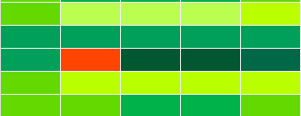 b) 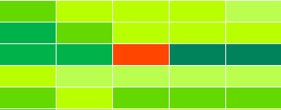

c) 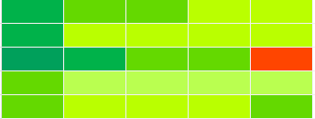

Figure 2: Matrix size 200 x 20, conditional flow rate w = 2, Ua = 8, initial number of clusters in each cell is equal to one. Time step: a) dt = 6, b) dt = 12, c) dt = 25. The number of clusters into the block (the same colours in all Figures): 0 - 20  20 - 40  40 - 60 60 - 80  80 - 100 100 - 120 120 - 140140 - 160 160 - 180 180 - 200 attractor 

a) 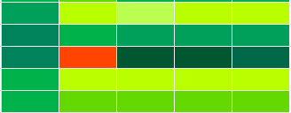 b)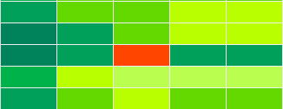

c) 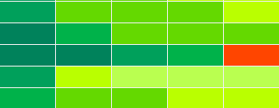

Figure 3: The number of clusters in blocks. Conditional flow rate w = 8, Ua = 8. Time step: a) dt = 6, b) dt = 12, c) dt = 25.

a)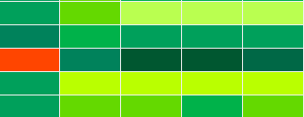 b)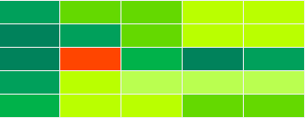

c)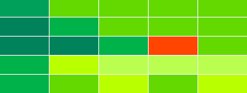

Figure 4: The number of clusters in blocks. Conditional flow rate w = 8, Ua = 6. Time step: a) dt = 6, b) dt = 12, c) dt = 25.

a) 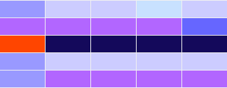 b)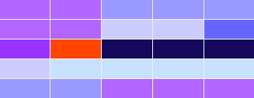

c) 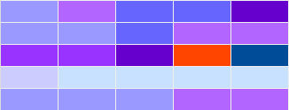

Figure 5: Matrix size 200 x 20, conditional flow rate w = 2, Ua = 6; initial number of clusters in each cell is equal to one. Time step: a) dt = 6, b) dt = 12, c) dt = 25. The sum of clusters orders into the block (the same colours in all Figures): 0 - 40  40 - 80  80 - 120  120 - 160  160 - 200 200 - 240  240 - 280 280 - 320  320 - 360  360 - 400 400 - 440 440 - 480  480 - 520  520 - 560  > 560 

a) 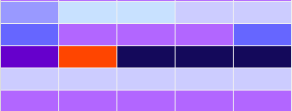 b) 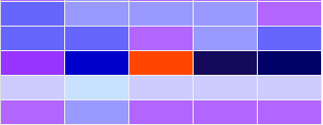

c) 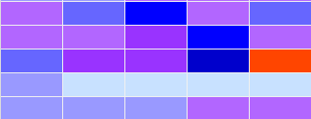

Figure 6: Conditional flow rate w = 2, Ua = 8. Time step: a) dt = 6, b) dt = 12, c) dt = 25.

a) 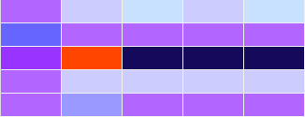 b) 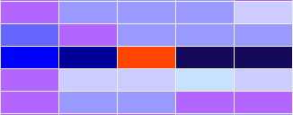

c) 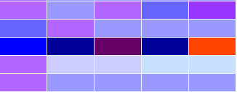

Figure 7: Conditional flow rate w = 8, Ua = 8. Time step: a) dt = 6, b) dt = 12, c) dt = 25.

a) 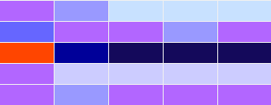 b)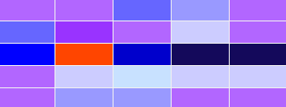

c) 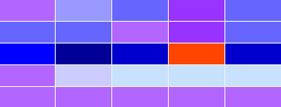

Figure 8: Conditional flow rate w = 8, Ua = 6. Time step: a) dt = 6, b) dt = 12, c) dt = 25.

The results of the numerical experiment quite clearly show the formation of the particles swarms along the trajectory of the attractor. These swarms can form both behind and in front of a moving attractor.

Comparison of the results of swarming in terms of the total number of clusters without taking into account their orders and the results of the assessment based on the summation of the cluster orders convincingly shows an increase in the intensity of aggregation in the zone of swarm formation. When the attractor moves at a velocity exceeding the average flow velocity, i.e., when the flow around the attractor occurs towards the carrier flow, the main swarm is formed in front of the attractor.

The concentration of particles in the swarm in the experiment for this case was 3-4 times higher than that behind the attractor. In the case of the attractor velocity lower than the velocity of the carrier flow, at the initial stage of the process, the concentration of particles behind the attractor exceeds their concentration in front of the attractor by 2 – 3 times due to the absence of the influence of the attractor on the aggregation process in this zone. However, as the attractor approaches the output part of the matrix, the situation changes to the opposite, because behind the slowly moving attractor, particles of the discrete phase are more intensely attached to the attractor.

* 1. Conclusions

The results confirm the efficiency of the stochastic lattice method for describing attractive swarming while the moving attractor. In the course of computer simulation, some features that characterize the formation of a swarm of particles both behind and in front of a moving attractor have been established.

The mutual influence of the carrier flow and the attractor should be investigated more detail in future. The results of the work can be useful in the design of technological apparatuses for the fine chemical and pharmaceutic technology or energetics.

Nomenclature

M – number of rows in calculation matrix Ua  – the attractor velocity, 1/s

L – number of columns in calculation matrix w – flow rate, 1/s

m – row number

n – column number

dt – time step, s

References

Aibara I., Huang Ch.-H., Kudo T., Bresolí-Obach R., Hofkens J., Furube A., Masuhara H., 2020, Dynamic Coupling of Optically Evolved Assembling and Swarming of Gold Nanoparticles with Photothermal Local Phase Separation of Polymer Solution, [The Journal of Physical Chemistry](https://pubs.acs.org/journal/jpcafh), 124, 16604-16615.

Be’er A., Ariel G., 2019, A Statistical Physics View of Swarming Bacteria, Movement Ecology, 7(1), 1-17.

Bouffanais R., 2016, Design and Control of Swarm Dynamics, Springer-Verlag, Singapore.

Brener A., Musabekova L.M., Dausheyeva N., 2021, On Modelling the Swarming in Dispersed Systems, Chemical Engineering Transactions, 84, 217-222.

Brückner, D. B., Fink, A., Schreiber, C., Röttgermann, P. J. F., Rädler, J. O., Broedersz, C. P., 2019, Stochastic nonlinear dynamics of confined cell migration in two-state systems. Nature Physics, 15(6), 595-601.

Carranza, P.M., Coates, P.S., 2000, Swarm modelling, Proceedings of the 3rd Generative Art Conference (GA2000), Milan: Generative Design Lab Milan, Polytechnic University, Italy.

Carrillo J.A., Fornasier M., Toscani G., Vecil F., 2010, Particle, Kinetic and Hydrodynamic Models of Swarming. In: Mathematical Modeling of Collective Behavior in Socio-Economic and Life Sciences, 297-336.

Dong Y., Wang L., Yuan K., Ji F., Gao J., Zhang Z., Du X., Tian Y., Wang Q., Zhang L., 2021, Magnetic Microswarm Composed of Porous Nanocatalysts for Targeted Elimination of Biofilm Occlusion, American Chemical Society Nano, 15(3), 5056-5057.

Ha S.-Y., Kim D., Lee J., Noh S.E., 2019, Particle and Kinetic Models for Swarming Particles on a Sphere and Stability Properties, Journal of Statistical Physics, 174, 622-655.

Jose R., Singh V., 2020, Swarming in Bacteria, J. Indian Inst. Sci., A Multidisciplinary Reviews Journal, 100(3), 515-524.

Mishra K.K., Bisht H., Singh T., Chang V., 2018, A direction aware particle swarm optimization with sensitive swarm leader, Big data research, *14*, 57-67.

Mogilner A., Edelstein-Keshet L., 1999, A non-local model for a swarm, Journal of Mathematical Biology, 38, 534-570.

Monaco J.D., Hwang G.M., Schultz K.M., Zhang K., 2020, Cognitive Swarming in Complex Environments with Attractor Dynamics and Oscillatory Computing, Biological Cybernetics, 114(2), 269-284.

Musabekova L., Arystanbayev K., Jamankarayeva M., Amandikov M., 2022, Computer Simulation of Attractive Swarming Accompanied by Particles Aggregation in Dispersed Systems, Chemical Engineering Transactions, 94, 1021-1026.

Pirani M., Bazirat T.H., Farshad A., 2013, Study of Swarm Behavior in Modeling and Simulation of Cluster Formation in Nanofluids, Hindawi Publishing Corporation, Modelling and Simulation in Engineering, ID 142165.

Rimer O., Ariel G., 2017, Kinetic Order-Disorder Transitions in a Pause-and-Go Swarming Model with Memory, Journal of Theoretical Biology, 419, 90-99.

Rocha-Gregg B.L., Huttenlogher A., 2021, Swarming Motility in Host Defense, Science, 372(6548), 1262-1263.

Rütschlin S., Böttcher T., 2020, Inhibitors of Bacterial Swarming Behavior, [Chemistry - A European Journal](https://www.scimagojr.com/journalsearch.php?q=23392&tip=sid&clean=0), 26, 964-979.

Su G., Lu G., Yan P., 2018, Improved particle swarm optimization for fast block matching with application to motion estimation in micro/nano systems, 14th IEEE/ASME International Conference on Mechatronic and Embedded Systems and Applications (MESA), Oulu, 1-6.

Sun M., Fan X., Tian C., Yang M., Sun L., Xie H., 2021, [Swarming microdroplets to a dexterous micromanipulator](https://onlinelibrary.wiley.com/doi/abs/10.1002/adfm.202011193), Advanced Functional Materials, 2011193, 31(19), 1-11.

Tadmor E., Tan C., 2014, Critical Thresholds in Flocking Hydrodynamics with Non-Local Alignment, Philosophical Transactions of the Royal Society A 372, 20130401, 1-22.

Villa K., Děkanovský L., Plutnar J., Kosina J., Pumera M., 2020, Swarming of Perovskite-Like Bi2WO6 Microrobots Destroy Textile Fibers under Visible Light, Advances Functional Materials, 2007073, 1-10.