CHEMICAL ENGINEERING TRANSACTIONS  VOL. , 2023 | A publication of
The Italian Association
of Chemical Engineering
Online at www.cetjournal.it
Guest Editors: Paolo Ciambelli, Luca Di Palma
Copyright © 2023, AIDIC Servizi S.r.l.
ISBN 979-12-81206-00-7; ISSN 2283-9216

Adsorption of Methylene Blue (MB), Rhodamine B (RB) and Methyl Orange (MO) from wastewater on Aloe Vera waste rind.
Leone Mazzeo^{a,*}, Alice Bertinoª, Vincenzo Piemonteª and Luca Di Palma^{b}
ªFaculty of Science and technology for sustainable Development and One Helt, Unit of Chemical-physics Fundamentals in Chemical Engineering, University Campus Bio-medico of Rome, Via Alvaro del Portillo, 21, 00128 Rome, Italy
^{b}Department of Chemical Engineering Materials & Environment, Sapienza University of Rome, Via Eudossiana, 18, 00184 Rome, Italy;
l.mazzeo@unicampus.it

A cosmetic production factory's waste of Aloe Vera (Aloe barbadensis miller) was utilized as a bio-adsorbent to remove three different dyes: Methylene Blue (MB), Rhodamine B (RB), and Methyl Orange (MO). The material was preliminary washed with water at room temperature, and batch tests were performed at 25°C. The experimental data were fitted using the pseudo-second-order kinetic model, which revealed that the adsorption rate of the tested dyes was in the order of MO > MB > RB. The findings indicate that Aloe Vera waste can be effectively used to remove cationic dyes in aqueous solution. When the starting concentration of each dye was set to 210 mg/L, and the bio-adsorbent dosage was set to 20g/L, separate tests showed a 94% removal of MB, a 71% removal of RB, and a 13% removal of MO. Moreover, preliminary continuous adsorption test were conducted for the removal of MB alone showing promising results on the application of such material in industrial apparatus.
  - Introduction
The removal of pollutants from wastewater is one of the most significant environmental challenge of the century. Lack of available water sources and tightening of regulatory standards of permissible component level make wastewater treatment essential and mandatory. Pollutants are characterized by a very wide range of toxicological profiles and physio-chemical properties. Out of all the potential impurities, dyes are the most easily identified due to their high visibility even in very small amounts (< 1ppm). Studies have shown that over 100,000 different types of commercial dyes are used in industrial processes, resulting in an annual production of approximately 7∙10⁵ ÷ 1∙10⁶ tons (Gupta and Suhas, 2009; Husain, 2006; Malik and Grohmann, 2012), with a 10% ÷ 15% loss of dye during the dyeing process (Hai et al., 2007; Piaskowski et al., 2018) . The textile industry, which comprises 2/3rds of the dyestuff market (Malik and Grohmann, 2012), produces 120 m³ of wastewater for each ton of fibre manufactured (Anjaneyulu et al., 2005). Dyes can perturb the biological activities of algae and plants by hindering light penetration in water. Moreover, they can develop allergies, dermatitis, and even cancers, through contact with the gastrointestinal tract, skin, and lungs (Sardar et al., 2021). Most of the wastewater treatment technologies have high operational and maintenance costs, i.e. replacement costs, generation of toxic sludge and difficulty of its disposal, complexity of the process involved (Schwarzenbach et al., 2010). Adsorption is instead a valid alternative because of ease of operation, and simplicity of design. Although activated carbons are worldwide recognized as the most performant adsorbents (Sulyman et al., 2017), their high activation cost led to search for new low-cost environmental friendly adsorbents. In particular, agro-industrial wastes seems to be a promising alternative (Mazzeo et al., 2023, 2022b, 2020). Aloe Vera (Aloe Barbadensis Miller) is a perennial, drought-resistant succulent herb, called the healing plant or the silent healer because of its wound and burn healing properties. The healthcare and cosmetics sectors are currently the two biggest drivers of Aloe Vera consumption. Thailand is the bigger producer (one-third of global production), followed by Mexico, Dominican Republic, United States and Costa Rica. The global Aloe Vera market size was US$602 Million in 2019 (IMARC Group, n.d.), thus a large number of wastes are available to be recycled before disposal. Some studies used Aloe Vera wastes for adsorption of dyes from wastewater in form of non-treated materials, air-dried bio-sorbent, thermally dried biomass, carbonized and functionalized materials, chemically treated dried powder (Giannakoudakis et al., 2018). Untreated Aloe Vera waste was investigated to remove Methylene Blue (MB) from aqueous solutions under batch experiments (Hanafiah et al., 2018): MB adsorption was favored at pH> 3 and room temperature; data were fitted by Langmuir isotherm and maximum adsorbent capacity was 365 mg/g. Aloe Vera leaves were also used in the form of air-dried and thermally treated at 300-500°C (El-Azazy et al., 2019) to remove Titan yellow: results showed that air-dried had a better performance than thermally treated Aloe Vera, reaching maximum adsorption capacity of 52 mg/g. Aloe Vera waste was also investigated for the removal of Methylene Blue after activation at 1000°C (Abuthahir et al., 2017): removal percentage was 90% at 30°C by using an adsorbent dosage of 0.5 g/L and MB concentration of 50 mg/L. Aloe Vera leaves were sulfuric acid modified activated carbon in (Khaniabadi et al., 2016) for the removal of aniline and methyl orange, resulting in 185.18 and 196.07 mg/g maximum adsorption respectively. Moreover, a recent study investigated how the adsorption properties of Aloe Vera toward the uptake of Methylene Blue changed according to an extraction (water-ethanol mixture were used as solvent) step used as pre-treatment (Mazzeo et al., 2022a).
The present work investigated the potential of air-dried Aloe Vera as bio-adsorbent of Methylene Blue (MB), Methyl Orange (MO) and Rhodamine B (RB) as target dyes. Kinetics behaviors were fitted by the pseudo-second order model and a preliminary column test was performed.

  - Materials and Methods
    - Bio-adsorbent preparation

The outer layer of Aloe Vera (Aloe Barbadensis Miller) leaf was obtained from residues of a cosmetic industry located in Lazio region, Italy. The solid was washed three times in distilled water at room temperature with a concentration of 50 mg/L for 2 h, then dried at 60 °C for 24 h. The bio-adsorbent was then grinded in order to obtain a size less than 5 mm.

    - Chemicals

Methylene blue (C₁₆H₁₈CIN₃S; MB), Rhodamine B (C₂₈H₃₁ClN₂O₃; RB) and Methyl Orange (C₁₄H₁₄N₃NaO₃S; MO) were purchased from Sigma Aldrich (United States). All chemicals were of analytical reagent grade and used without any further purification. The solutions used in the experimental tests were prepared by providing a dilution in ultra-pure water.

    - Batch tests

Batch tests were conducted at 25 °C, neutral pH and a solid to liquid ratio of 20 g/L. Each dye was tested alone in every experiment. Kinetic tests were performed on 15 mL solution of MB, RB, and MO at an initial concentration of 9 mg/L, 8 mg/L and 14 mg/l, respectively. Equilibrium tests were performed at an initial concentration of 210 mg/L for all the dyes. The equilibrium test lasted 2 h. The concentration of MB, RB and MO was measured by spectrophotometric analysis using a PG Instruments (United States) T80+ UV/Vis spectrophotometer (with glass cells of 1 cm path length) at λ = 664 nm, λ = 554 nm and λ = 464 nm respectively. The percentage of the dye $i$ removed at equilibrium (R_{i}%) was calculated with the following equation:
$$R_{i}\%=\frac{C_{0}-C(t=2h)}{C_{0}}$$ | (1)
where $C_{0}$ (mg/L) is the concentration of MB at the beginning of the test and C(t=2h) (mg/L) is the concentration of MB calculated after 2 h.

    - Column test
A preliminary fixed-bed adsorption test was performed for the removal of MB alone. The experimental apparatus was already described in the work of Mazzeo et al.(Mazzeo et al., 2023). Briefly, it was adopted a glass column having a 1 cm internal diameter and a porous glass septum at the bottom in order to support the adsorbent material. The amount of solid used for the tests was 0.9 g reaching a bed height of 5 cm. An up-flow liquid solution of 10 mg/L of MB was continuously provided to the system at 12 ml/min by means of a peristaltic pump. Moreover, the column was equipped with a thermostat jacket in order to keep the temperature constant at 25 ± 0.1 °C.
  - Results and discussion

The kinetics bath tests were performed to detect significant differences in the adsorption rate between the three dyes under analysis. In Figure 1 is reported the ratio between the concentration measured at a certain time respect to the initial concentration of the dye versus time. In order to quantify the adsorption rate, the data were fitted with the second order kinetic model which is expressed as follows:

$$R_{i}\%=\frac{C_{0}-C(t=2h)}{C_{0}}$$ | (2)
$$\frac{C\left(t\right)}{C_{0}}=1-q\left(t\right)\frac{C_{s}}{C_{0}}$$ | (3)

where q(t) (mg/g) is the amount of dye adsorbed respect to the grams of bio-adsorbent used, q_{e} (mg/g) is the amount of dye adsorbed respect to the grams of bio-adsorbent used at equilibrium, C_{s} (g/L) is the solid concentration and k (mg/g s) is the pseudo second order kinetic constant.
A non-linear regression was performed to fit the experimental data with Eq. (2) and (3) using as objective function the minimization of the mean square error

$$∅=min\left[\frac{1}{N}\sum_{i=1}^{N}{ε_{i}^{2}}\right]$$ | (4)

where N is the number of experimental points and $ε_{i}^{}$ is the error calculated by the difference of the experimental data and the values predicted by the model.
Figure 1 shows that the pseudo second order perfectly fitted the experimental data and the values of k and q_{e} resulting from fitting are reported in Table 1
Table 1: Values of k and q_{e} derived from fitting.
 | k (mg g⁻¹ min⁻¹) | q_{e} (mg g⁻¹)
MB | 0.17 | 0.38
RB | 0.13 | 0.31
MO | 0.78 | 0.10

In Table 1 it is possible to observe, that the rate of adsorption follows the order MO>MB>RB. According to the molecular weights of the three dyes (which influences the sizes of the dyes and therefore their adsorption rate) this order should have been MB>MO>RB. A possible explanation of such phenomena was provided by Ocholi et al. (O.J et al., 2016) which attributed the faster adsorption of MO to its linear and flexible molecular structure compared to the one of MB.

On the other hand, the values of q_{e} obtained suggest that Aloe Vera affinity towards the adsorption of the analyzed dyes follows the order MB>RB>MO. Such observation is confirmed by Figure 2 in which are reported the removal percentage of dye after 2h batch test when the starting concentration was set to 210 mg/L for all the dyes. Since both MB and RB are cationic dyes while MO is an anionic dye, it was observed a higher adsorption affinity of Aloe with respect to cationic dyes.

The results of the column tests were provided in Figure 3 from which is immediately noticeable that (in the operating conditions adopted) Aloe Vera waste rind was able to treat 3 L of MB solution abating more than 80% of the initial amount of MB.

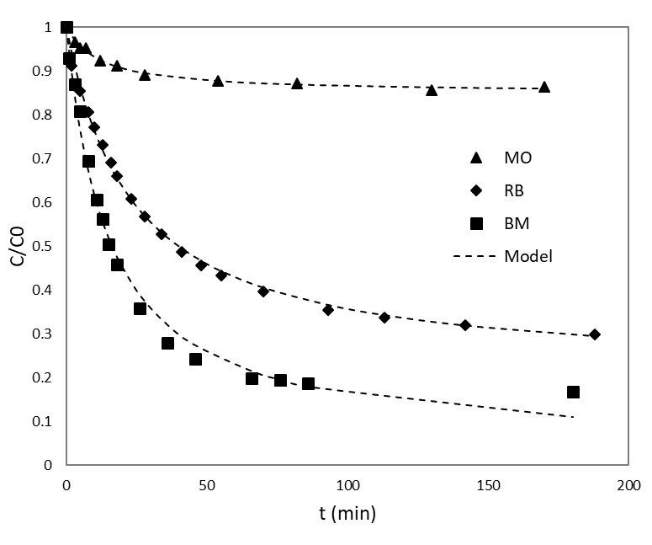
Figure 1: Kinetics batch tests performed with a solid dosage of 20 g/L at 25°C together with pseudo second order model fitting. Initial concentrations are 9 mg/L, 8 mg/L and 14 mg/l for MB, RB, and MO respectively.

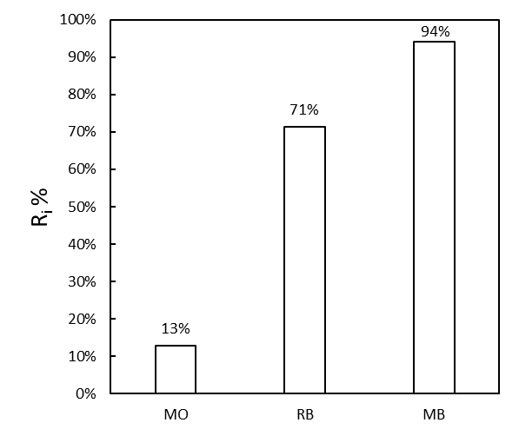
Figure 2: Dye removal percentage after 2h batch test at 25°C with a solid dosage of 20 g/L and an initial dye concentration of 210 mg/L (for all the different dyes).
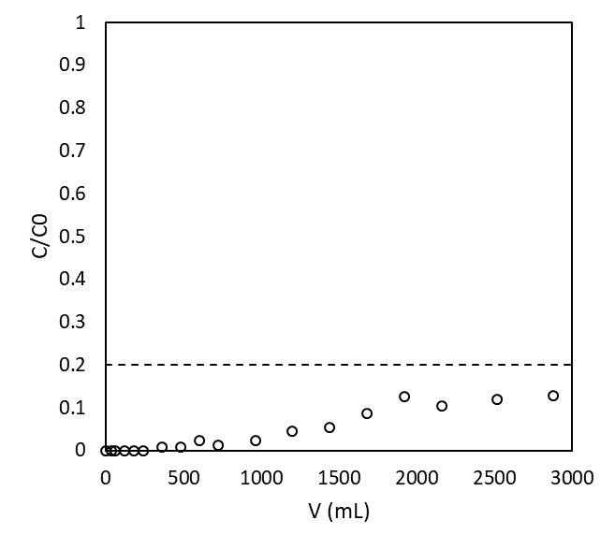
Figure 3: Methylene Blue experimental breakthrough curve on Aloe Vera waste rind at 25 °C and at a flow rate of 12 mL/min.

  - Conclusions

This work investigated the potential of air-dried Aloe Vera waste rind to adsorb Methylene Blue (MB), Rhodamine B (RB) and Methyl Orange (MO). The proposed bio-adsorbent proved to be more efficient in the removal of the two cationic dyes MB and RB while it was less performant for the uptake of the anionic dye MO. However, by means of the pseudo-second order fitting, it was observed a higher adsorption rate for MO uptake. This result was attributed to the molecular flexibility of MO which can diffuse more rapidly respect to MB and RB towards the adsorption sites. Moreover, from a preliminary column test on continuous MB adsorption Aloe Vera waste rind showed promising results abating more than 80% of the MB concentration of the inlet liquid stream.

References
Abuthahir, K.A.S., Pragathiswaran, C., Govindhan, P., Abbubakkar, B.M., Sridevi, V.S., 2017. Adsorption of Methylene blue Dye using Activated Carbon from the Natural Plant Stem. Int. J. Res. Pharm. Chem. 7, 120–125.
Anjaneyulu, Y., Sreedhara Chary, N., Samuel Suman Raj, D., 2005. Decolourization of industrial effluents - Available methods and emerging technologies - A review. Rev. Environ. Sci. Biotechnol. 4, 245–273. https://doi.org/10.1007/s11157-005-1246-z
El-Azazy, M., Dimassi, S.N., El-Shafie, A.S., Issa, A.A., 2019. Bio-Waste Aloe vera Leaves as an efficient adsorbent for Titan Yellow from Wastewater: Structuring of a novel adsorbent using Plackett-Burman factorial design. Appl. Sci. 9, 1–20. https://doi.org/10.3390/app9224856
Giannakoudakis, D.A., Hosseini-Bandegharaei, A., Tsafrakidou, P., Triantafyllidis, K.S., Kornaros, M., Anastopoulos, I., 2018. Aloe vera waste biomass-based adsorbents for the removal of aquatic pollutants: A review. J. Environ. Manage. 227, 354–364. https://doi.org/10.1016/j.jenvman.2018.08.064
Gupta, V.K., Suhas, 2009. Application of low-cost adsorbents for dye removal - A review. J. Environ. Manage. 90, 2313–2342. https://doi.org/10.1016/j.jenvman.2008.11.017
Hai, F.I., Yamamoto, K., Fukushi, K., 2007. Hybrid treatment systems for dye wastewater. Crit. Rev. Environ. Sci. Technol. 37, 315–377. https://doi.org/10.1080/10643380601174723
Hanafiah, M.A.K.M., Mohd Jamaludin, S.Z., Khalid, K., Ibrahim, S., 2018. Methylene blue adsorption on aloe vera rind powder: Kinetics, isotherm and mechanisms. Nat. Environ. Pollut. Technol. 17, 1055–1064.
Husain, Q., 2006. Potential applications of the oxidoreductive enzymes in the decolorization and detoxification of textile and other synthetic dyes from polluted water: A review. Crit. Rev. Biotechnol. 26, 201–221. https://doi.org/10.1080/07388550600969936
IMARC Group, n.d. Aloe Vera Market: Global Industry Trends, Share, Size, Growth, Opportunity and Forecast 2020-2025 [WWW Document].
Khaniabadi, Y.O., Heydari, R., Nourmoradi, H., Basiri, Hesam, Basiri, Hassan, 2016. Low-cost sorbent for the removal of aniline and methyl orange from liquid-phase: Aloe Vera leaves wastes. J. Taiwan Inst. Chem. Eng. 68, 90–98. https://doi.org/10.1016/j.jtice.2016.09.025
Malik, A., Grohmann, E., 2012. Environmental protection strategies for sustainable development, Environmental Protection Strategies for Sustainable Development. https://doi.org/10.1007/978-94-007-1591-2
Mazzeo, L., Bavasso, I., Bracciale, M.P., Cocchi, M., Palma, L. Di, Piemonte, V., 2020. Yerba Mate (Ilex paraguarensis) as Bio-Adsorbent for the Removal of Methylene Blue , Remazol Brilliant Blue and Chromium Hexavalent : Thermodynamic and Kinetic Studies.
Mazzeo, L., Bavasso, I., Spallieri, M., Bracciale, M.P., Piemonte, V., Di Palma, L., 2022a. Effect of Water–Ethanol Extraction as Pre-Treatment on the Adsorption Properties of Aloe vera Waste. Materials (Basel). 15, 1–18. https://doi.org/10.3390/ma15165566
Mazzeo, L., Marzi, D., Bavasso, I., Piemonte, V., Palma, L. Di, 2023. Removal of Methylene Blue from Wastewater by Waste Roots from the Arsenic-Hyperaccumulator Pteris vittata : Fixed Bed Adsorption Kinetics. Materials (Basel). 16, 1450. https://doi.org/10.3390/ma16041450
Mazzeo, L., Marzi, D., Irene, B., Bracciale, M.P., Piemonte, V., Di Palma, L., 2022b. Characterization of waste roots from the As hyperaccumulator Pteris vittata as low-cost adsorbent for Methylene Blue removal. Chem. Eng. Res. Des. https://doi.org/10.1016/j.cherd.2022.07.025
O.J, O., C.E, G., G.I, N., M, T., S.E, A., P.R.O, E., 2016. Effect of Time on the Adsorption of Methylene Blue, Methyl Orange and Indigo Carmine onto Activated Carbon. IOSR J. Appl. Chem. 09, 55–62. https://doi.org/10.9790/5736-0909015562
Piaskowski, K., Świderska-Dąbrowska, R., Zarzycki, P.K., 2018. Dye removal from water and wastewater using various physical, chemical, and biological processes. J. AOAC Int. 101, 1371–1384. https://doi.org/10.5740/jaoacint.18-0051
Sardar, M., Manna, M., Maharana, M., Sen, S., 2021. Remediation of Dyes from Industrial Wastewater Using Low-Cost Adsorbents, in: Green Adsorbents to Remove Metals, Dyes and Boron from Polluted Water, Environmental Chemistry for a Sustainable World 49. pp. 377–403. https://doi.org/10.1007/978-3-030-47400-3_15
Schwarzenbach, R.P., Egli, T., Hofstetter, T.B., Von Gunten, U., Wehrli, B., 2010. Global water pollution and human health. Annu. Rev. Environ. Resour. 35, 109–136. https://doi.org/10.1146/annurev-environ-100809-125342
Sulyman, M., Namiesnik, J., Gierak, A., 2017. Low-cost adsorbents derived from agricultural by-products/wastes for enhancing contaminant uptakes from wastewater: A review. Polish J. Environ. Stud. 26, 479–510. https://doi.org/10.15244/pjoes/66769

