CHEMICAL ENGINEERING TRANSACTIONS  VOL. , 2023 | A publication of
The Italian Association
of Chemical Engineering
Online at www.cetjournal.it
Guest Editors: Paolo Ciambelli, Luca Di Palma
Copyright © 2023, AIDIC Servizi S.r.l.
ISBN 979-12-81206-00-7; ISSN 2283-9216

Characterization of albumin-functionalized silica particles as novel solid adsorbent of bilirubin from albumin-containing solution.
Leone Mazzeo^{a,*}, Tamara Boscarino^{b}, Alice Bertinoª, Maria Beatrice Falasconiª, Franca Abruzzese^{c} and Vincenzo Pimeonteª
ªFaculty of Science and technology for sustainable Development and One Helt, Unit of Chemical-physics Fundamentals in Chemical Engineering, University Campus Bio-medico of Rome, Via Alvaro del Portillo, 21, 00128 Rome, Italy
^{b}Department of Engineering, Unit of Intelligent Health Technologies, Sustainable Design Management and Assessment, University Campus Biomedico of Rome, Via Alvaro del Portillo, 21, 00128 Rome, Italy;
^{c}Department of Engineering, Unit of Tissue Engineering and Chemistry for Engineering, University Campus Biomedico of Rome, Via Alvaro del Portillo, 21, 00128 Rome, Italy;
l.mazzeo@unicampus.it

The liver is a fundamental organ that performs a wide range of life-important functions such as blood detoxification from endogenous substances. In particular, Albumin-bound toxins such as bilirubin are involved in the aetiology of many liver failure associated pathologies. For this reason, albumin based dialysis devices are crucial to provide a temporary solution for patients affected by liver diseases. Adsorption units play a key role in such apparatus for the dialysate regeneration. In this work was 3-Aminopropyl-functionalized silica gel (40-63µ𝑚) micro-particles bounded with albumin were tested as a novel adsorbent material for the removal of bilirubin from an albumin-containing solution. Frist of all, the adsorption equilibrium of albumin on silica gel surface was experimentally investigated and a maximum adsorption capacity of 290.6 mg/g was estimated using Langmuir isotherm. Then, batch tests were performed to evaluate the equilibrium conditions for the uptake of bilirubin by the albumin functionalized silica particles. In this case the behaviour of the system was best represented by a linear isotherm with an angular coefficient of 1.91 µmol/g.

  - Introduction
Ensuring that the levels of toxins in the blood are properly managed is a vital concern when caring for patients with liver failure. When the liver loses its ability to detoxify, harmful substances can accumulate in the bloodstream, potentially leading to a fatal outcome if prompt action is not taken. Currently, the treatment for acute and acute-on-chronic liver failure involves using extra-corporeal devices to safely bring patients out of the acute phase or serve as a bridge to organ transplantation (Jalan et al., 2004; Rozga, 2006; Stegmayr, 2005). The most adopted clinical option for blood detoxification involves a membrane separation process that takes the name of dialysis. Differently from the removal of small hydrophilic toxins such as urea, conventional dialysis is not enough to remove harmful substances that are tightly bound to blood proteins (e.g. albumin). Among these class of toxins there is bilirubin. The latter is one of the main components of bile and it is often used as a marker of the clinical state of liver-failure patients. Recognized that bilirubin plays a key role in the development of various liver-failure related conditions, distinct methods have been created to eliminate it together with all the other albumin-bound toxins.
The best-known device that deals with liver failure patients is MARS (Molecular Adsorbents Recirculating System; Teraklin AG, Rostok, Germany, now Gambro AB, Lund, Sweden) (Novelli et al., 2009a, 2009b). This process consists of an albumin dialysis (Stange et al., 1993a, 1993b) coupled with an adsorption unit. More precisely, blood detoxification occurs in a special dialysis module provided with an albumin-impregnated membrane and a concentrated albumin solution as dialysate. The latter passes through two adsorption columns to eliminate all albumin bound toxins. The first one is filled with Activated Carbons (AC) while the second one contains a cholestyramine anionic-exchange resin which is responsible for the uptake of negatively charged substances such as bilirubin. The adsorption performances of solid adsorbents toward bilirubin removal were firstly investigated in clinical articles which lacked of a quantitative analysis that could induce to rational design criteria of the adsorption units. With this approach, the ability of Active carbons (AC) were evaluated for the removal of bilirubin from chloroform–bilirubin (albumin-free) solutions (Dunlop et al., 1978), human serum albumin–bilirubin solutions (Ash et al., 2006; Nikolaev et al., 1991; Sarnatskaya et al., 2002), bovine serum albumin–bilirubin solutions (Fesenko et al., 1999). For this reason, in the works of Annesini et al. (Annesini et al., 2008) (Annesini et al., 2005) a mathematical model was developed for the description of the adsorption equilibrium referred to the total bilirubin concentration for the adsorption on non-ionic polymeric resin and activated carbons. Moreover, in further studies also the adsorption dynamics on AC in column system was investigated (Piemonte et al., 2010).
In this work, the same modeling approach was used to evaluate the adsorption properties of a novel solid adsorbent made of silica particles whose surface was functionalized with albumin molecules. This strategy was adopted in order to maximize both the selectivity and the adsorption capacity toward the uptake of albumin-bound compounds and in particular of bilirubin.

  - Materials and Methods
    - Materials
All the materials and chemicals were purchased from Sigma Aldrich and all chemicals used were reagent grade
Bovine serum albumin (fraction V defatted) and bilirubin (mixed isomers) were used without further purification.
The solid support selected to host albumin for the adsorption of bilirubin was 3-Aminopropyl-functionalized silica gel (40-63$µm$), a white powder of silica microparticles with pore diameter of 60 $\dot{A}$. In order to facilitate the functionalization of the silica particles with albumin chemicals, promoters such as MES hemisodium salt, N-(3dimethylaminopropyl)-N’-etilcarbodiimmide (EDC) and N-Hydroxysuccinimide (NHS), were employed.
    - Methods
Functionalization of silica particles
The term “functionalization” was used to indicate the creation of chemical bonds between albumin and the surface of the silica particle. From a thermodynamic point of view, this process is nothing else than a phenomenon of chemisorption. First of all, 100 mg of silica micro-particles were dispersed in 2 mL of MES buffer solution (pH 6.1) provided of 0.4 M and 0.1 M of EDC and NHS respectively. Secondly, different solutions with an albumin concertation ranging between 2-50 g/L were prepared dissolving various amount of albumin in 2 mL of phosphate buffer saline (PBS) 0.15 M at pH 7.4.
Adsorption tests at equilibrium were then performed at 25°C in a magnetically stirred flask mixing together the above-mentioned solutions in order to keep a fixed solid dosage of 25 g/L for different albumin starting concentration (1.2-25 g/L). Equilibrium tests lasted 24 h that was evaluated from preliminary runs (data not shown) to be enough time for reaching equilibrium conditions. Moreover, for each test three repetitions were conducted and the final concentration of albumin in the liquid solution was measured analysing the supernatant with the Infinite M200 PRO Tecan microplate spectrophotometer (Tecan Trading AG, Switzerland) at 595 nm.
Finally, the amount of albumin adsorbed on the silica particles was evaluated by the mass balance reported in Eq. (1) and already adopted in several works (Mazzeo et al., 2022a, 2022b, 2020)

$$n_{a}=\frac{V}{M_{S}}(C_{in}-C_{a})$$ | (1)

where $V$ (mL) is the liquid volume of the solution, $M_{S}$ (g) is the mass of the solid adsorbent, $C_{in}$ (mg/L) is the albumin concentration at the beginning of the test and $C_{a}$ (mg/L) is the concentration of albumin at equilibrium.
Bilirubin adsorption: isotherm tests
The solubility of bilirubin in water is very small. For this reason, albumin–bilirubin solutions were prepared dissolving firstly bilirubin in aqueous NaOH 20 mM and then adding the albumin solution prepared in the phosphate buffer (PBS) 0.15 M at pH 7.4. Several solutions with a different initial bilirubin concentration ranging from 15.8-58.1 mg/L were prepared. The latter were used to conduct the adsorption equilibrium tests at a fixed dosage adsorbent silica particles of 50 g/L The solution was magnetically stirred for at least 16 h (time enough to reach equilibrium) at pH 7.4. The samples were placed inside an incubator which kept constant the temperature at 37°C with 95% humidity and 5% CO₂. The residual concentration of bilirubin was evaluated by means of a spectrophotometric analysis at the wavelength of 458 nm. Each experiment was reproduced at least three times.
  - Results and discussion
    - Functionalization of silica particles
The amount of albumin adsorbed on the surface of silica particles respect to the residual albumin concentration in the liquid phase at equilibrium is provided in Figure 1. Since it was performed a chemical adsorption (peptide bonds connect albumin to silica) the experimental data were fitted using the Langmuir isotherm reported in Eq. (2):

$$n_{a}= \frac{ n_{a}^{max} C_{a} }{K_{a}+C_{a}}$$ | (2)

where $n_{a}$ (mg/g) is the amount of albumin adsorbed for unit adsorbent mass, $C_{a}$ (g/L) is the albumin concentration in the liquid phase at equilibrium, $n_{a}^{max}$ (mg/g) is the maximum amount of albumin adsorbed for unit of adsorbent mass and $K_{a}$ (g/L) is the reciprocal of the Langmuir constant. The experimental data were fitted using a non-linear regression using the mean least square method for the minimization of the objective function as reported in Eq. (3)

$$∅=min\left[\frac{1}{N}\sum_{i=1}^{N}{ε_{i}^{2}}\right]$$ | (3)

where $N$ is the number of experimental points and $ε_{i}$ is the error calculated by the difference of the experimental data and the values predicted by the model. The results outcoming from fitting were: $n_{a}^{max}$=$290.6$ mg/g and $K_{a}$=$5.558$ g/L. In Figure 2 is provided a TEM micrograph in which the presence of albumin on the micro particles surface was confirmed.

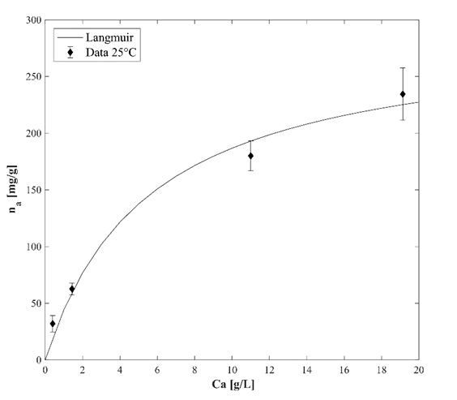
Figure 1: Albumin adsorption isotherm at 25°C and pH 7.4 using silica particles.

c)
b)
a)
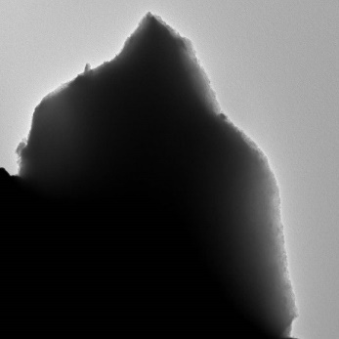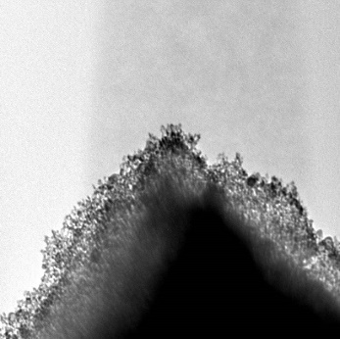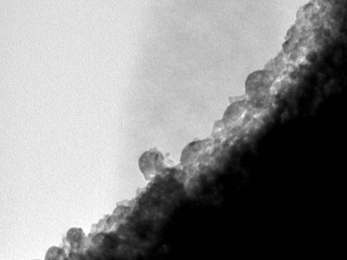
Figure 2: TEM micrography of silica particles loaded with albumin with different magnifications: a)x1000; b)x10000; c)x100000
    - Bilirubin equilibrium
The bilirubin adsorption isotherm at 37°C on silica micro particles functionalized with albumin is depicted in Figure 3. In this case the equilibrium concentration of bilirubin considered is referred to both the free bilirubin and the bilirubin linked with albumin in the liquid phase. For this reason, the Langmuir expression for the adsorption isotherm presents the following form:

$$n_{B}= \frac{ n_{max}^{B} {f_{B }C}_{B} }{K_{B}+{f_{B}C}_{B}}$$ | (4)

where $n_{B}$ (µmol/g) is the amount of bilirubin adsorbed for unit of solid adsorbent mass, $C_{B}$ (µmol//L) is the total concentration of bilirubin in the liquid phase at equilibrium, $n_{max}^{B}$ (µmol/g) is the maximum amount of bilirubin adsorbed for unit of adsorbent mass, $K_{B}$ (µmol//L) is the reciprocal of the Langmuir constant and $f_{B }$ (-) is the fraction of free bilirubin in the liquid phase. The latter depends strictly on the binding constant which regulates the formation of the complex albumin-bilirubin in the liquid phase. For the system under examination, it was verified in previous studies that (Annesini et al., 2016):

$$f_{B}= \frac{ 1 }{K_{i}C_{A}}$$ | (5)
$$n_{B}= \frac{ n_{max}^{B} C_{B} }{{K_{i}K}_{B}C_{A}+C_{B}}$$ | (6)

where $K_{i}$ (L/mol) is the binding constant and $C_{A}$ (mol/L) is the concentration of albumin in the liquid phase. As it is possible to observe in Figure 3, the experimental data do not follow a Langmuir type behavior but instead a linear one. This result is perfectly in accordance with Eq. (6) since $K_{i}$ =10⁸ M⁻¹ (Annesini et al., 2016) ,$C_{A}$=5.7·10⁻⁵ M which make possible that in the range of concentrations considered for $C_{B}$ that Eq. (6) can be simplified in:

$$n_{B}≅ \frac{ n_{max}^{B} }{{K_{i}K}_{B}C_{A}}C_{B}=\frac{m}{C_{A}}C_{B}$$ | (7)

which has a linear trend with respect to $C_{B}$ and $m$ (µmol/g) can be considered as an adjustable parameter. In this case the experimental data were fitted by means of a linear regression. It resulted that $m$=1.91 µmol/g and the regression showed an R²=0.9426 that confirmed the goodness of fitting. As described in the work of Mazzeo et al. (Mazzeo et al., 2023), equilibrium information are crucial to proceed toward the design of a continuous apparatus.
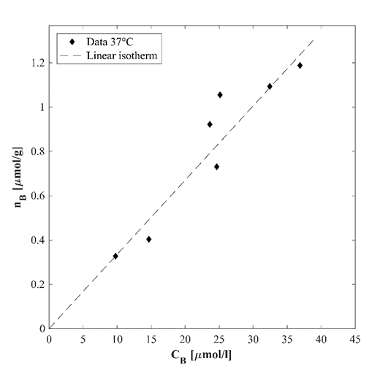
Figure 3: Bilirubin isotherm at 37°C using silica particles functionalized with albumin.

  - Conclusions
In this work a novel approach for the adsorption of bilirubin from an albumin-containing solution was proposed. In particular, silica micro-particles were functionalized with albumin in order to promote the removal of bilirubin from the liquid solution. It was found out that the chemical functionalization of the particle surface can be described by the Langmuir isotherm model. Moreover, a maximum adsorption capacity and the reciprocal of the Langmuir constant were estimated to be 290.6 mg/g and 5.558 g/L respectively. Once verified the successful linkage between albumin and the silica particles by means of a TEM analysis, the adsorption of bilirubin was performed on the functionalized particles. The latter phenomenon showed a linear behavior at equilibrium and the angular coefficient of the isotherm was evaluated to be $m$=1.91 µmol/g. This article sets the basis for the application of novel material for the regeneration of the dialysate in blood detoxification application. Further studies should regard the comparison with other adsorbent materials of the same field of application and experimental analysis in a continuous operation mode.
References
Annesini, M.C., Di Carlo, C., Piemonte, V., Turchetti, L., 2008. Bilirubin and tryptophan adsorption in albumin-containing solutions. I. Equilibrium isotherms on activated carbon. Biochem. Eng. J. 40, 205–210. https://doi.org/10.1016/j.bej.2007.12.010
Annesini, M.C., Di Paola, L., Marrelli, L., Piemonte, V., Turchetti, L., 2005. Bilirubin removal from albumin-containing solution by adsorption on polymer resin. Int. J. Artif. Organs 28, 686–693. https://doi.org/10.1177/039139880502800707
Annesini, M.C., Marrelli, L., Piemonte, V., Turchetti, L., 2016. Artificial Organ Engineering. https://doi.org/10.1007/978-1-4471-6443-2
Ash, S.R., Sullivan, T.A., Carr, D.J., 2006. Sorbent suspensions vs. sorbent columns for extracorporeal detoxification in hepatic failure. Ther. Apher. Dial. 10, 145–153. https://doi.org/10.1111/j.1744-9987.2006.00356.x
Dunlop, E.H., Hughes, R.D., Williams, R., 1978. Physico-chemical aspects of the removal of protein-bound substances by charcoal and other adsorbents of potential value in systems of artificial liver support: Part 1-Equilibrium properties. Med. Biol. Eng. Comput. 16, 343–349. https://doi.org/10.1007/BF02442650
Fesenko, E.A., Gaylor, J.D.S., Smith, E.M., Kozynchenko, O.P., Courtney, J.M., Mikhalovsky, S. V., 1999. Bilirubin adsorption and catalytic oxidation on activated carbons. Carbon-1999 332–333.
Jalan, R., Sen, S., Williams, R., 2004. Prospects for extracorporeal liver support. Gut 53, 890–898. https://doi.org/10.1136/gut.2003.024919
Mazzeo, L., Bavasso, I., Bracciale, M.P., Cocchi, M., Palma, L. Di, Piemonte, V., 2020. Yerba Mate (Ilex paraguarensis) as Bio-Adsorbent for the Removal of Methylene Blue , Remazol Brilliant Blue and Chromium Hexavalent : Thermodynamic and Kinetic Studies.
Mazzeo, L., Bavasso, I., Spallieri, M., Bracciale, M.P., Piemonte, V., Di Palma, L., 2022a. Effect of Water–Ethanol Extraction as Pre-Treatment on the Adsorption Properties of Aloe vera Waste. Materials (Basel). 15, 1–18. https://doi.org/10.3390/ma15165566
Mazzeo, L., Marzi, D., Bavasso, I., Piemonte, V., Palma, L. Di, 2023. Removal of Methylene Blue from Wastewater by Waste Roots from the Arsenic-Hyperaccumulator Pteris vittata : Fixed Bed Adsorption Kinetics. Materials (Basel). 16, 1450. https://doi.org/10.3390/ma16041450
Mazzeo, L., Marzi, D., Irene, B., Bracciale, M.P., Piemonte, V., Di Palma, L., 2022b. Characterization of waste roots from the As hyperaccumulator Pteris vittata as low-cost adsorbent for Methylene Blue removal. Chem. Eng. Res. Des. https://doi.org/10.1016/j.cherd.2022.07.025
Nikolaev, V.G., Sarnatskaya, V. V., Sigal, V.L., Klevtsov, V.N., Makhorin, K.E., Yushko, L.A., 1991. High-porosity activated carbons for bilirubin removal. Int. J. Artif. Organs 14, 179–185. https://doi.org/10.1177/039139889101400311
Novelli, G., Annesini, M.C., Morabito, V., Cinti, P., Pugliese, F., Novelli, S., Piemonte, V., Turchetti, L., Rossi, M., Berloco, P.B., 2009a. Cytokine Level Modifications: Molecular Adsorbent Recirculating System Versus Standard Medical Therapy. Transplant. Proc. 41, 1243–1248. https://doi.org/10.1016/j.transproceed.2009.03.035
Novelli, G., Rossi, M., Ferretti, G., Pugliese, F., Ruberto, F., Lai, Q., Novelli, S., Piemonte, V., Turchetti, L., Morabito, V., Annesini, M.C., Berloco, P.B., 2009b. Predictive criteria for the outcome of patients with acute liver failure treated with the albumin dialysis molecular adsorbent recirculating system. Ther. Apher. Dial. 13, 404–412. https://doi.org/10.1111/j.1744-9987.2009.00759.x
Piemonte, V., Trchetti, L., Annesini, M.C., 2010. Bilirubin removal from albumin-containing solutions: dynamic adsorption on anionic resin. Asia-pacific J. Chem. Eng. 5, 708–713. https://doi.org/10.1002/apj
Rozga, J., 2006. Liver support technology - An update. Xenotransplantation 13, 380–389. https://doi.org/10.1111/j.1399-3089.2006.00323.x
Sarnatskaya, V. V., Lindup, W.E., Walther, P., Maslenny, V.N., Yushko, L.A., Sidorenko, A.S., Nikolaev, A. V., Nikolaev, V.G., 2002. Albumin, bilirubin, and activated carbon: New edges of an old triangle. Artif. Cells. Blood Substit. Immobil. Biotechnol. 30, 113–126. https://doi.org/10.1081/BIO-120003192
Stange, J., Mitzner, S., Ramlow, W., Gliesche, T., Hickstein, H., Schmidt, R., 1993a. A new procedure for the removal of protein bound drugs and toxins. ASAIO J. 39, M621–M625.
Stange, J., Ramlow, W., Mitzner, S., Schmidt, R., Klinkmann, H., 1993b. Dialysis against a Recycled Albumin Solution Enables the Removal of Albumin‐Bound Toxins. Artif. Organs 17, 809–813. https://doi.org/10.1111/j.1525-1594.1993.tb00635.x
Stegmayr, B.G., 2005. A survey of blood purification techniques. Transfus. Apher. Sci. 32, 209–220. https://doi.org/10.1016/j.transci.2004.10.023

