CHEMICAL ENGINEERING TRANSACTIONS  VOL. , 2023 | A publication of
The Italian Association
of Chemical Engineering
Online at www.cetjournal.it
Guest Editors: Paolo Ciambelli, Luca Di Palma
Copyright © 2023, AIDIC Servizi S.r.l.
ISBN 979-12-81206-00-7; ISSN 2283-9216

Adsorption of Rhodamine B from wastewater on the Arsenic-hyperaccumulator Pteris vittata waste roots.
Leone Mazzeo^{a,*}, Maria Beatrice Falasconiª, Alice Bertinoª, Davide Marzi^{b}, Irene Bavasso^{c}, Vincenzo Pimeonteª and Luca Di Palma^{c}
ªFaculty of Science and technology for sustainable Development and One Helt, Unit of Chemical-physics Fundamentals in Chemical Engineering, University Campus Bio-medico of Rome, Via Alvaro del Portillo, 21, 00128 Rome, Italy
^{b}Department of Biology and Biotechnology “Charles Darwin”, Sapienza University of Rome, Piazzale Aldo Moro 5, 00185 Rome, Italy
^{c}Department of Chemical Engineering Materials & Environment, Sapienza University of Rome, Via Eudossiana, 18, 00184 Rome, Italy;
l.mazzeo@unicampus.it

The Pteris vittata fern, which is a perennial plant known for hyper-accumulating Arsenic, can be grown in hydroponic cultures and is often used for phytoremediation of contaminated water. To reduce the cost of disposing As-contaminated biomass, this study examined the potential of using waste roots from Pteris vittata as a new and inexpensive bio-adsorbent for removing Rhodamine B (RB) dye, which is commonly used in industrial applications. Batch tests were performed at 25°C in order to observe both the rate and the equilibrium conditions of the system. The isotherm showed a typical Langmuir behavior exhibiting a maximum adsorption capacity of 42.7 mg/g. Kinetics tests were conducted at different solid-liquid ratios and fitted by a mathematical model. The maximum likelihood method was employed to estimate the effective diffusivity of RB in the solid which resulted 4.48·10⁻⁹ cm²/min. This study lays the groundwork for future investigations into the use of this material in continuous systems to determine its feasibility for application in industrial apparatus.
  - Introduction
Water is a vital resource for both natural and social environments due to its significant impact on human health, agriculture, and energy production. However, it is projected that climate change and population growth will result in a decrease in freshwater availability for two-thirds of the world's population by 2025 (UNESCO, 2015). To achieve sustainable water management, wastewater treatment and reuse are critical, as emphasized in the United Nations' 2030 Agenda for Sustainable Development (Capocelli et al., 2019). The majority of wastewater treatment methods have severe drawbacks, such as toxic sludge generation and complex treatment processes (Schwarzenbach et al., 2010), adsorption results an attractive alternative due to its simplicity and ease of operation. To reduce costs associated with commercial adsorbent synthesis, agro-industrial waste is frequently employed as a low-cost and eco-friendly adsorbent (Mazzeo et al., 2020) (Mazzeo et al., 2022a). Heavy metals are a type of pollutant that has a significant impact on the water bodies' geological condition (European Environmental Agency, 2018), posing a severe threat to biological species' health even at low concentrations (Taşar et al., 2014). Hyperaccumulator plants have been shown to effectively remove heavy metals from soil and water in phytoremediation approaches. The fern Pteris vittata is particularly effective at removing large quantities of arsenic from soil and water, and it can be grown in hydroponic culture systems (Fayiga et al., 2005; Huang et al., 2016). Additionally, it can be reused in multiple phytofiltration cycles without releasing previously accumulated arsenic (Marzi et al., 2021), making it a sustainable approach. However, the disposal of As-rich biomass constitutes a significant cost and a critical issue for phytoremediation technology's development. To address this problem, a novel approach was proposed in which PV waste roots are used as low-cost bio-adsorbents for wastewater treatment. As a matter of fact, PV roots were already tested for the removal of the dye Methylene blue both in batch (Mazzeo et al., 2022b) and in continuous mode (Mazzeo et al., 2023). For this reason, this study aims to characterize the thermodynamics and the kinetic of PV roots for the removal of another dye: Rhodamine B (RB).
  - Materials and Methods
    - Bio-adsorbent preparation
Hydroponic culture systems according to Marzi et al. (Marzi et al., 2021) were prepared to cultivate Pteris vittata (PV) plants using tap water. Waste roots were collected and washed before their application in adsorption tests. Such pre-treatment step was conducted at room temperature in a 500 ml beaker filled with 250 ml of demineralized water and 2 g of PV roots. Then, the roots were dried at 50°C for 24h and cut in order to obtain an average length of the roots in the range of 1 – 2 cm.
    - Chemicals
Rhodamine B (C₂₈H₃₁ClN₂O₃; RB) was purchased from Sigma Aldrich (United States) and used without any further purification.
    - Batch tests
Batch tests were conducted to evaluate the PV roots affinity toward the uptake of RB. In all the experimental tests, the concertation of RB in the liquid solution was measured PG Instruments (United States) T80+ UV/Vis spectrophotometer (with glass cells of 1 cm path length) at the wavelength of 554 nm.

Equilibrium tests were performed in beakers of 100 mL filled with 50 mL of RB solution stirred at 320 rpm. The beakers were placed in a thermostatic bath in order to maintain the temperature constant at 25 ± 0.2 °C. The solid dosage was fixed at 0.2 g/L while the initial dye concentration varied between 2.5 mg/L – 350 mg/L. From preliminary test it was evaluated that 24 h were more than enough for the system to reach equilibrium conditions. For this reason, each run lasted 24 h. The surface concentration was calculated as follows:
$$q_{e}=\frac{V}{M_{S}}(C_{in}-C_{e})$$ | (1)
where $V$ (mL) is the liquid volume of the solution, $M_{S}$ (g) is the mass of the solid adsorbent, $C_{in}$ (mg/L) is the concentration of RB at the beginning of the test and $C_{e}$ (mg/L) is the concentration of RB at equilibrium. Each test was reproduced at least in triplicate.

Kinetic tests were carried out at 25 ± 0.2 °C and solid dosages of 0.187 g/L, 1.25 g/L, and 2.5 g/L. For all the tests the initial concentration of RB was fixed to 5.5 mg/L and were conducted for a duration of 110 minutes, during which the concentration of RB was measured non-destructively, ensuring that the solution's volume remained constant. The stirring speed was kept constant at 320 rpm. Each test was repeated at least twice, and the experimental data were fitted using a mathematical model. The process simulator gProms (Process System Enterprises, London, UK) was used to estimate the model parameters and identify the system's controlling resistance. More information about the mathematical model can be found in the following section.
  - Results and discussion
    - Equilibrium
The isotherm at 25 °C for the adsorption of RB on PV waste roots was reported in Figure 1. The experimental data were fitted using the least square non-linear regression method my means of the Langmuir (Eq. (2)) and Freundlich (Eq. (3)) isotherm expressions reported below:

$$q_{e}=q_{max}\frac{bC_{e}}{{1+bC}_{e}}$$ | (2)
$$q_{e}=K_{f}C_{e}^{1/n}$$ | (3)

where $b$ (L/mg) is the equilibrium constant of the Langmuir model related to the affinity between RB and the active sites, $q_{max}$ (mg/g) is the maximum adsorption capacity, $K_{f}$ is the distribution coefficient and 𝑛 is a correction factor. The estimated Langmuir and Freundlich model constants were evaluated and reported in Table 1 together with their corresponding value of the Root Mean Square Error (RMSE). From such results it is possible to observe that the Langmuir model is the best one to represent the equilibrium of the system in agreement with the shape of the curve that shows a saturation trend. The Langmuir isotherm was also applied in the kinetic model as reported later in this section.
Table 1: Langmuir and Freundlich isotherm parameters at 25°C derived from fitting of experimental data.
 | $b$ (L/mg) | $q_{max}$ (mg/g) | $K_{f}$(mg/g) (L/mg)^{1/n} | 𝑛 | RMSE (mg/g)
Langmuir | 0.044 | 42.89 | - | - | 1.28
Freundlich | - | - | 5.31 | 2.65 | 3.08

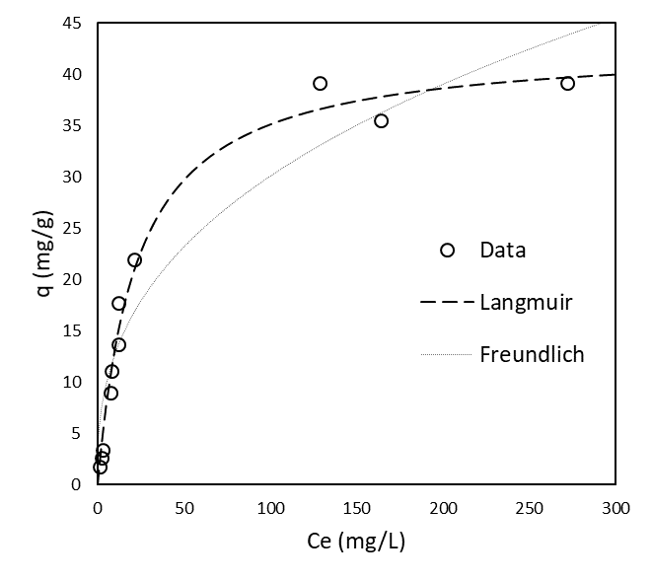
Figure 1: Isotherm data of Pteris vittata (PV) for the adsorption of Rhodamine B at 25°C fitted with the Langmuir and Freundlich models.

Table 2 presents a comparison between various agro-waste materials and PV roots. It is possible to observe that there are other bio-adsorbents such as Raphia hookerie fruit epicarp, Artocarpus odoratissimus peel, Aleurites Moluccana waste seeds and Paspalum notatum grass waste that show a higher maximum adsorption capacity than the one of PV. However, for the selection of the best adsorbent material a simple comparison between the maximum adsorption capacities is not enough. As a matter of fact, a key role is played by the operating conditions at which the adsorption properties are evaluated. For example, the outstanding performance of Raphia hookerie fruit epicarp were observed for a very severe pH condition (pH=3). Moreover, also the value of the Langmuir constant $b$ must be considered. In Table 2 was reported the product $q_{max} b$ which is representative of the angular coefficient of the linear region of the isotherm for low concentrations. The data indicates that PV has the second-highest $q_{max} b$ value, following only Exhausted coffee ground. Although selecting the most effective adsorbent depends on the initial concentration of RB in the solution, these results suggest that PV is a promising candidate for efficient RB uptake.
Table 2: Operation conditions and Langmuir parameters for various agro-waste adsorbents.
 | T (°C) | pH | $q_{max}$ (mg/g) | $b$ (L/mg) | $$q_{max} b$$ | Reference
Raphia hookerie fruit epicarp | 26 | 3 | 666.6 | 0.01 | 6.66 | (Inyinbor et al., 2016)
Artocarpus odoratissimus peel | 25 | 7 | 130.62 | 4.17·10⁻⁵ | 0.0054 | (Lim et al., 2017)
Aleurites Moluccana waste seeds | 25 | 6 | 81 | 0.0041 | 0.33 | (Postai et al., 2016)
Paspalum notatum grass waste | 30 | 6.6 | 54 | 2.4·10⁻⁵ | 0.0012 | (Zahir et al., 2020)
Pteris vittata waste roots | 25 | 7 | 42.89 | 0.044 | 1.88 | (This study)
Exhausted coffee ground | 19 | 7 | 2.51 | 9.11 | 22.86 | (Shen and Gondal, 2017)

The mathematical model adopted to represent the kinetic behavior of the system was based on both pore and surface diffusion mechanisms within the solid. However, since the initial concertation of 5.5 mg/L was small enough to consider the isotherm in its linear region, a modified effective diffusion could be introduced to describe the overall diffusion phenomena. In this case the complete set of integral-differential equations assume the mathematical (but not conceptual) form of the “Homogeneous Solid Diffusion Model” (HSDM) developed by McKay (McKay, 1998, 1984). Moreover, the following hypothesis were introduced:
- the system isothermal;
- perfect mixing of the liquid phase;
- cylindrical solid particles of constant radius;
- the radius of the roots was much smaller than their length (L>>R);
- adsorption occurs instantaneously.

The kinetic model was reported below starting from the mass balance the liquid phase (Eq. 4):
$$\frac{dC^{L}}{dt}={-k}_{L}a\left(C^{L}-C^{L,i}\right)$$ | (4)
Here $C^{L}$ (mg/L) is the concentration of RB in the liquid solution,$C^{L,i}$ (mg/L) is the liquid concentration of RB at the solid-liquid interface, $k_{L}$ (cm/s) is the liquid mass transfer coefficient and $a$ (cm²/mL) is the specific surface area of the solid particles per volume of liquid. The microscopic material balance for the sold phase within the material was expressed as
$$\frac{∂q}{∂t}=D_{eff,RB}\left[\frac{1}{r}\frac{∂q}{∂r}+\frac{∂^{2}q}{{∂r}^{2}}\right]$$ | (5)

where $q$ (mg/g) is the concentration of RB adsorbed per amount of solid and $D_{eff,RB}$ (cm²/s) is the modified effective diffusion coefficient of RB. The microscopic balances described above were coupled to the following a macroscopic balance:
$$\frac{V_{L}}{M_{S}}\left(C_{in}-C^{L}\right)=\frac{1}{πR^{2}}\int_{0}^{R}{q\left(r\right)2πrdr}$$ | (6)
where $R$ (cm) is the radius of the solid cylinder and $C_{in}$ is the concentration of RB at the beginning of the test . The initial and boundary condition of the system were:

$$IC: t=0 ∀r q=0; C^{L}=C_{in}$$ | (7)
$$BC: t>0 r=0 \frac{∂q}{∂r}=0; r=R q=q_{max}\frac{bC^{L,i}}{1+bC^{L,i}}≅q_{max} bC^{L,i}$$ | (8)

The values of $k_{L}a$ a and $D_{eff,RB}$ were used as adjustable parameters in order to fit the kinetic experimental data by means of the maximum likelihood method. The latter was implemented considering a constant error variance. Furthermore, for the simulations the value of the roots diameter was set at 216 µm according to previous works (Mazzeo et al., 2022b).
The results of the kinetic fitting are given in Figure 2. In particular, Figure 2 a) depicts the kinetic of RB uptake for different solid dosages in terms of the ratio between the concentration of RB in the liquid solution at a certain time and the initial one. On the other hand, Figure 2 b) reports the values estimated values of $k_{L}a$ versus the corresponding solid dosage
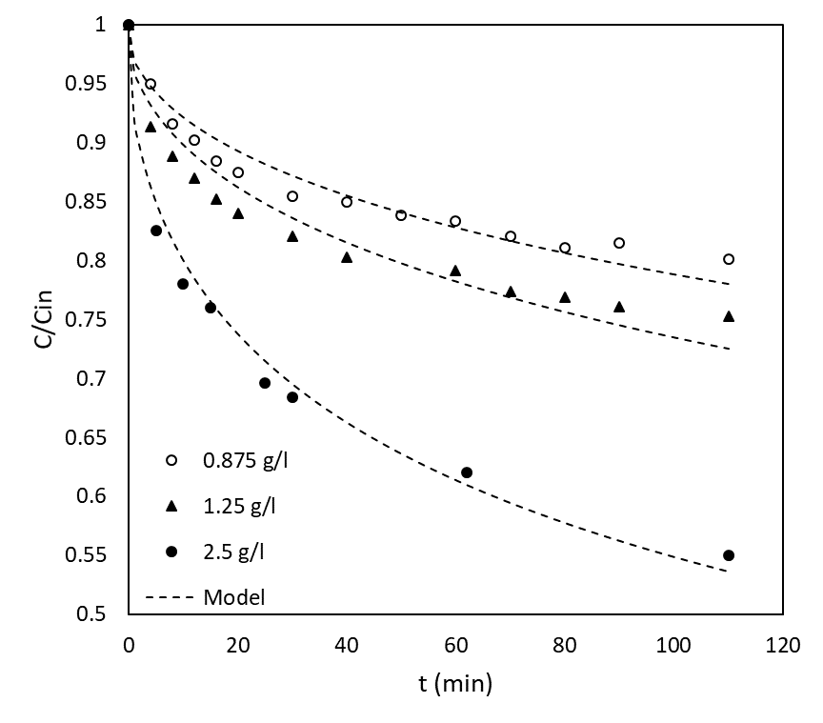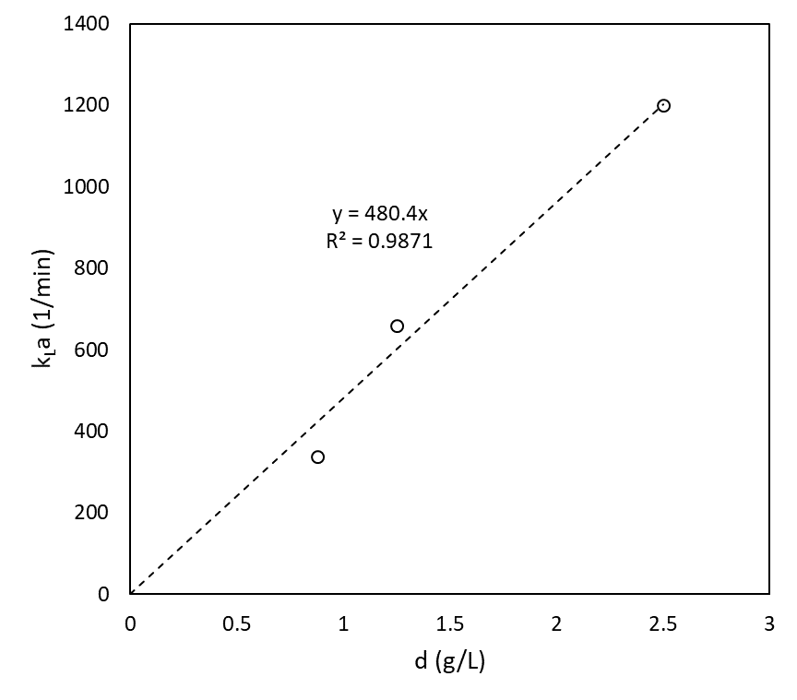
Figure 2: Kinetic data of the RB uptake (initial concentration 5.5 mg/L) at 25°C for different solid dosages (a); $k_{L}a$ versus the solid dosage together with the linear expression obtained by linear fitting and its corresponding R².

According to Figure 2 a), it is noticeable that the kinetic model well represents the dynamic behaviour of the system. In Figure 2 b), a linear dependence of $k_{L}a$ versus the solid dosage was observed. The latter result was expected considering that
$$k_{L}a =k_{L}\frac{2}{ρ_{s}R}d$$ | (9)
where $d$ (g/L) is the solid dosage and $ρ_{s}$ is the apparent density of the solid. The value of $k_{L}\frac{2}{ρ_{s}R}$ was estimated to be 480.4 (L g⁻¹ min⁻¹) by means of a linear regression (see Figure 2 a)). The modified effective diffusion coefficients of RB obtained from fitting were provided in Table 3 together with their average value of 4.48·10⁻⁹ cm²/min. The modified effective diffusivity's magnitude, which is approximately 10⁻⁸ cm2/min, indicates that solid surface diffusion is the primary mechanism for intra-particle mass transfer (Tien, 2019). Moreover, the value of $D_{eff,RB}$ estimated in this work resulted almost one order of magnitude lower than the one of Methylene Blue calculated at 20°C in the paper of Mazzeo et al. (Mazzeo et al., 2022b). This result could be related to the higher molecular weight of RB with respect to MB that directly affects the sizes of the dyes and therfore their mobility.
Table 3: Estimated values of the modified effective diffusion coefficients of RB at 25°C.
Solid dosage (g/L) | $D_{eff,RB}$, 25°C (cm²/min) | Bi
0.187 | 4.71·10⁻⁹ | 7.13·10⁵
1.25 | 4.02·10⁻⁹ | 1.09·10⁷
2.5 | 4.72·10⁻⁹ | 3.37·10⁷
Average value ± SD | 4.48·10⁻⁹ ± 4.01·10⁻¹⁰ | -

The controlling resistance of the adsorption kinetics was assessed by the calculation of the Biot dimensionless number. The latter is defined as the ratio between the characteristic time of solid diffusion ($τ_{D}$) and the characteristic time of mass transfer through the liquid film surrounding the solid particles ($τ_{t}$). Further information regarding its mathematical derivation can be found in the work of Yao and Zhu (Yao and Zhu, 2020). In Table 3 were collected the values of the Biot number ($Bi$). For all the solid dosages adopted $Bi≫1$ and hence ${τ_{D}>>τ}_{t}$ which means that the intra-particle mass transfer is the controlling resistance of the adsorption kinetics. It is important to bear in mind that altering the root diameter is impossible, and as a result, it is not feasible to decrease the intra-particle resistance which governs the rate of mass transfer. For this reason, also in continuous applications the intra-particle resistance will play a key role.
  - Conclusions
In this work PV waste roots were tested for the removal of Rhodamine B from water. Once pre-treated (wased) with distilled water, batch adsorption tests were run to investigate both the dynamics and the equilibrium conditions of the system. The Langmuir isotherm successfully fitted the equilibrium data and a maximum adsorption capacity of 42.89 mg/g was estimated. Depending on the initial concentration of the dye, PV roots showed competitive removal performances compared to other bio-adsorbents. A mathematical model was then developed to analyze the RB uptake kinetics estimating a modified effective diffusivity of 4.48·10⁻⁹ cm²/min. Moreover, the controlling resistance was attributed to the intra-particle one by means of the $Bi$ number. The latter is a crucial result since it suggests that the solid internal resistance will play a key role for the design of continuous apparatus systems. However, further investigation on the dynamic adsorption of RB on PV roots in a fixed-bed apparatus should be conducted.
References
Capocelli, M., Prisciandaro, M., Piemonte, V., Barba, D., 2019. A technical-economical approach to promote the water treatment & reuse processes. J. Clean. Prod. 207, 85–96. https://doi.org/10.1016/j.jclepro.2018.09.135
European Environmental Agency, 2018. European waters Assessment of status and pressures 2018, Parents and Children Communicating with Society: Managing Relationships Outside of Home. Luxembourg. https://doi.org/10.2800/303664
Fayiga, A.O., Ma, L.Q., Santos, J., Rathinasabapathi, B., Stamps, B., Littell, R.C., 2005. Effects of arsenic species and concentrations on arsenic accumulation by different fern species in a hydroponic system. Int. J. Phytoremediation 7, 231–240. https://doi.org/10.1080/16226510500215720
Huang, Y., Miyauchi, K., Inoze, C., Endo, G., 2016. Development of suitable hydroponics system for phytoremediation of arseniccontaminated water using an arsenic hyperaccumulator plant Pteris vittata. Biosci. Biotechnol. Biochem. 80, 614–618. https://doi.org/10.1080/09168451.2015.1107461
Inyinbor, A.A., Adekola, F.A., Olatunji, G.A., 2016. Kinetics, isotherms and thermodynamic modeling of liquid phase adsorption of Rhodamine B dye onto Raphia hookerie fruit epicarp. Water Resour. Ind. 15, 14–27. https://doi.org/10.1016/j.wri.2016.06.001
Lim, L.B.L., Priyantha, N., Fang, X.Y., Mohamad Zaidi, N.A.H., 2017. Artocarpusodoratissimus peel as a potential adsorbent in environmental remediation to remove toxic Rhodamine B dye. J. Mater. Environ. Sci. 8, 494–502.
Marzi, D., Antenozio, M.L., Vernazzaro, S., Sette, C., Veschetti, E., Lucentini, L., Daniele, G., Brunetti, P., Cardarelli, M., 2021. Advanced drinking groundwater as phytofiltration by the hyperaccumulating fern pteris vittata. Water (Switzerland) 13, 1–10. https://doi.org/10.3390/w13162187
Mazzeo, L., Bavasso, I., Bracciale, M.P., Cocchi, M., Palma, L. Di, Piemonte, V., 2020. Yerba Mate (Ilex paraguarensis) as Bio-Adsorbent for the Removal of Methylene Blue , Remazol Brilliant Blue and Chromium Hexavalent : Thermodynamic and Kinetic Studies.
Mazzeo, L., Bavasso, I., Spallieri, M., Bracciale, M.P., Piemonte, V., Di Palma, L., 2022a. Effect of Water–Ethanol Extraction as Pre-Treatment on the Adsorption Properties of Aloe vera Waste. Materials (Basel). 15, 1–18. https://doi.org/10.3390/ma15165566
Mazzeo, L., Marzi, D., Bavasso, I., Piemonte, V., Palma, L. Di, 2023. Removal of Methylene Blue from Wastewater by Waste Roots from the Arsenic-Hyperaccumulator Pteris vittata : Fixed Bed Adsorption Kinetics. Materials (Basel). 16, 1450. https://doi.org/10.3390/ma16041450
Mazzeo, L., Marzi, D., Irene, B., Bracciale, M.P., Piemonte, V., Di Palma, L., 2022b. Characterization of waste roots from the As hyperaccumulator Pteris vittata as low-cost adsorbent for Methylene Blue removal. Chem. Eng. Res. Des. https://doi.org/10.1016/j.cherd.2022.07.025
McKay, G., 1998. Application of Surface Diffusion Model to the Adsorption of Dyes on Bagasse Pith. Adsorption 4, 361–372. https://doi.org/10.1023/a:1008854304933
McKay, G., 1984. Two-Resistance Mass Transfer Models for the Adsorption of Dyestuffs From Aqueous Solutions Using Activated Carbon. J. Chem. Technol. Biotechnol. Chem. Technol. 34 A, 294–310. https://doi.org/10.1002/jctb.5040340604
Postai, D.L., Demarchi, C.A., Zanatta, F., Melo, D.C.C., Rodrigues, C.A., 2016. Adsorption of rhodamine B and methylene blue dyes using waste of seeds of Aleurites Moluccana, a low cost adsorbent. Alexandria Eng. J. 55, 1713–1723. https://doi.org/10.1016/j.aej.2016.03.017
Schwarzenbach, R.P., Egli, T., Hofstetter, T.B., Von Gunten, U., Wehrli, B., 2010. Global water pollution and human health. Annu. Rev. Environ. Resour. 35, 109–136. https://doi.org/10.1146/annurev-environ-100809-125342
Shen, K., Gondal, M.A., 2017. Removal of hazardous Rhodamine dye from water by adsorption onto exhausted coffee ground. J. Saudi Chem. Soc. 21, S120–S127. https://doi.org/10.1016/j.jscs.2013.11.005
Taşar, Ş., Kaya, F., Özer, A., 2014. Biosorption of lead(II) ions from aqueous solution by peanut shells: Equilibrium, thermodynamic and kinetic studies. J. Environ. Chem. Eng. 2, 1018–1026. https://doi.org/10.1016/j.jece.2014.03.015
Tien, C., 2019. Introduction to Adsorption. https://doi.org/10.1016/b978-0-12-816446-4.09991-7
UNESCO, 2015. Water reuse: Potential for expanding the Nation’s Water Supply through Reuse of Municipal Wastewater. The National Academies Press, Washington DC, USA.
Yao, C., Zhu, C., 2020. A new method of characterizing mass transfer controlling mechanism in pollutant adsorption from aqueous solutions. J. Mol. Liq. 301, 112455. https://doi.org/10.1016/j.molliq.2020.112455
Zahir, A., Aslam, Z., Aslam, U., Abdullah, A., Ali, R., Bello, M.M., 2020. Paspalum notatum grass-waste-based adsorbent for rhodamine B removal from polluted water. Chem. Biochem. Eng. Q. 34, 93–104. https://doi.org/10.15255/CABEQ.2020.1830

