CHEMICAL ENGINEERING TRANSACTIONS  VOL. , 2023 | A publication of
The Italian Association
of Chemical Engineering
Online at www.cetjournal.it

Guest Editors: Selena Sironi, Laura Capelli
Copyright © 2023, AIDIC Servizi S.r.l.
ISBN 978-88-95608-94-5; ISSN 2283-9216

Emission of nanoparticles in the nanotextile industry
Marek Nechvátal^{a,b,}*, Karel Klouda^{a,b}, Hana Kubátová^{c}, Petra Roupcová^{a,b}, Kateřina Bátrlová^{b}
ªVSB- Technical University of Ostrava, Lumirova 630/17, Ostrava, Czech republic, EU
^{b}Occupational Safety Research Institute, Prague, Czech Republic, EU
^{c}State Office for Nuclear Safety, Senovazne namesti 9, Prague, Czech Republic, EU
nechvatal@vubp-praha.cz
We consider nanostructures, i.e. particles and structures with dimensions between 1 nm and 100 nm, to be the basic building blocks of nanomaterials. Nanoparticles are a common part of the environment (erosion, forest fire emissions, decomposition of substances, volcanic gases, etc.). However, human activity can significantly contribute to the amount of nanoparticles created. Nanoparticles are purposefully produced by new technologies (nanotechnology), but at the same time they are unintentionally created in industry (steel mills, ironworks, mining of raw materials, ceramic industry, etc.) and transport.
In operations where nanoparticles are produced, employees are primarily at risk of inhaling them. Inhaled air containing particles is filtered in the respiratory system. Absorption of nanoparticles depends on their physicochemical properties. Compared to other materials that enter the body, nanomaterials have an exceptional ability to migrate in the living body, which increases their impact on human health.
Measurements for a given type of textile production are published on this topic. The procedure for our measurement of the concentration of nanoparticles (10-700 nm) and their mean diameters can be called a "field". The aim of these measurements in real situations was to prove the quality of applied technologies in the production of non-woven textiles.
Keywords: Nanosafety, Air pollution, Occupational health and safety.
  - Introduction
Nanotechnology is being incorporated into the textile fiber industry for its unique and valuable properties (Shah et al., 2022). The new properties have significantly improved the functionality and performance characteristics of textile and fiber materials (Karst and Yang, 2006). Based on its numerous advantages, nanotextile technology is increasingly used in various interrelated fields, including medical garments, geotextiles, or fire and water resistant textiles (Brown and Stevens, 2007).
Exposure to engineered nanomaterials has been linked to several health effects including carcinogenicity and genotoxicity (Johnston et al., 2020). Nanoparticles are the smallest and most easily penetrate into the inner human environment. This is why nanosafety is so important in the textile industry. Obtaining data on emissions and concentrations of nanomaterials of nanotextiles is extremely important (Saleem and Zaidi, 2020).
Current emission regulations do not take into account the number of nanoparticles or the type produced by the technology in the nanotextile industry. Due to the potential health effects of nanoparticles on human health, exposure to this source of air pollution should be minimal.
  - Material and methods
The Testo DiSC mini 133 device was used for all measurements - measuring range 10-700 nm. The diffusion size classifier (DiSCmini) is a relatively simple and robust instrument that can measure with a high time resolution of 1s. The device is based on charging and current detection, there is no working fluid as in CPC.
The measurement of nanoparticle emissions in the indoor environment in the nanotextile industry was carried out at several workplaces in the Czech Republic (Fig. 1, 2, 3). The main source of nanoparticles was identified from the measured results of nanoparticle concentrations (ISO/TR 27 628, 2007).
The evaluation of risks associated with the action of nanoparticles was performed according to a certified methodology for the provision of personal protective equipment in an environment with a risk of nanoparticles (Senčík et al., 2016).
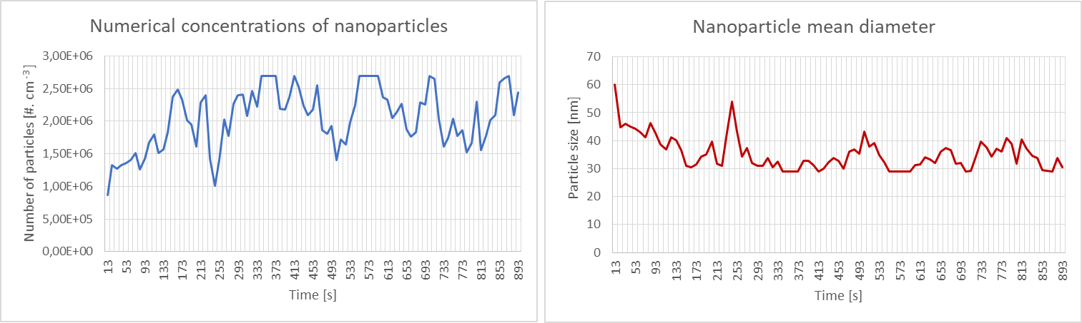
Figure 1: Nanoparticle emission measurement in Ecotextil factory, 30 January 2023.
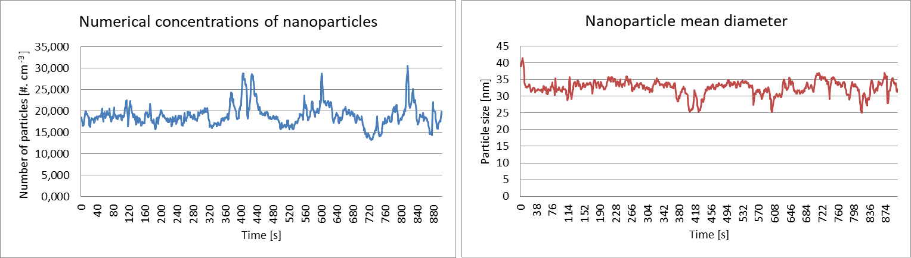
Figure 2: Nanoparticle emission measurement in Pardam factory, 7 September 2020.
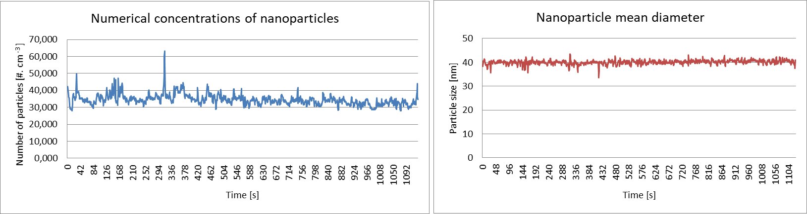
Figure 3: Nanoparticle emission measurement in SPUR factory, 8 October 2020.
  - Results
The expected exposure time when working in this environment (interior - factory hall) is over 6 hour / day, resp. over 30 hours per week (category 4). As these are man-made nanoparticles, their emissions are classified as the second worst hazard group (IV).
Based on the determination of the exposure time and classification into hazard groups, we evaluated the risks associated with the action of nanoparticles. The risk has a value of 3. This means that a negative impact on human health by nanoparticles can be expected. The risk of potential negative health effects associated with the action of nanoparticles can be perceived as unacceptable, Table 1. It is always recommended to use respiratory protection at work.
The expected exposure time when working in this environment (interior - laboratory room) is from 1 to 3 hours per day, or from 5 to 15 hours per week (category 2). As these are man-made nanoparticles, their emissions are classified in the second worst danger group (IV).
Based on the determination of the exposure time and classification into hazard groups, we evaluated the risks associated with the action of nanoparticles. The risk has a value of 2. This means that a negative impact on the employee's health due to exposure to nanoparticles cannot be ruled out. The risk of potential negative health effects associated with exposure to nanoparticles on employees can be perceived as conditionally acceptable, Table 1. It is recommended to use respiratory protection at work.
Table 1: Nanoparticle emission measurement in the indoor environment - assessment of risks (AVG – average, CP – closed technology, GV – general ventilation, LE – laboratory equipment, LEV – local exhaust ventilation, MP – mass production, OP – open technology, PA 6 – extruded polyamide (nylon), PL – product lines for industrial use, PP – polypropylene, PU – polyurethane, PVB – polyvinyl butyral, PVDF –polyvinylidene fluoride, SSP – small scale production, TM – trade mark)
Name and type | Technology, principle of production | Processed plastic | Place | Production size, ventilation | Exposure time category | Danger group | Assessment risks associated with the action of nanoparticles | Number of particles [#. cm⁻³] (AVG) | Particle size [nm] (AVG)
Ecotextil, factory | OP, meltblown | PP | Horňátky (CZ), Hall A | MP, PL, GV | 4 | IV | 3 | 2.043,062 | 35
Pardam, factory | OP, electrospinning | PA 6 | Roudnice nad Labem (CZ), Hall | MP, PL, GV | 4 | IV | 3 | 18,915 | 33
Spur, factory | OP, electrospinning | PVDF | Zlín (CZ), Main hall | MP, PL, GV | 4 | IV | 3 | 34,491 | 40
Nanomedical, factory | OP. elektrospinning, NanospiderTM | PVDF | Prague (CZ), Hall | MP, PL, GV | 4 | IV | 3 | 5,700 | 50
Institute of Hydrodynamics  The Czech Academy of Sciences, experimental laboratory | CP, electrospinning | PVB | Prague (CZ), Room | SSP, LE, LEV | 2 | IV | 2 | 6,399 | 46
Technical University of Liberec, experimental laboratory | CP, electrospinning | PA 6 | Liberec (CZ), Room | SSP, LE, LEV | 2 | IV | 2 | 3,102 | 59
Faculty of Science Charles University, experimental laboratory | CP, electrospraying | PU | Prague (CZ), Room | SSP, LE, LEV | 2 | IV | 2 | 12,428 | 28

The expected exposure time when working in this environment (interior - factory hall A) is over 6 hour / day, resp. over 30 hours per week (category 4). As these are man-made nanoparticles, their emissions are classified as the second worst hazard group (IV).
Based on the determination of the exposure time and classification into hazard groups, we evaluated the risks associated with the action of nanoparticles. The risk has a value of 3. This means that a negative impact on human health by nanoparticles can be expected. The risk of potential negative health effects associated with the action of nanoparticles can be perceived as unacceptable, Table 2. It is always recommended to use respiratory protection at work.
The expected exposure time when working in this environment (interior - factory hall B, C, D) is from 1 to 3 hours per day, or from 5 to 15 hours per week (category 2). As these are man-made nanoparticles, their emissions are classified in the second worst danger group (IV).
Based on the determination of the exposure time and classification into hazard groups, we evaluated the risks associated with the action of nanoparticles. The risk has a value of 2. This means that a negative impact on the employee's health due to exposure to nanoparticles cannot be ruled out. The risk of potential negative health effects associated with exposure to nanoparticles on employees can be perceived as conditionally acceptable, Table 2. It is recommended to use respiratory protection at work.
Table 2: Nanoparticle emission measurement in the indoor environment - assessment of risks (AVG – average, GV – general ventilation, MP – mass production, OP – open technology, PL – product lines for industrial use, PP – polypropylene)
Name and type | Technology, principle of production | Processed plastic | Place, number of employees | Production size, ventilation | Exposure time category | Danger group | Assessment risks associated with the action of nanoparticles | Number of particles [#. cm⁻³] (AVG) | Particle size [nm] (AVG)
Ecotextil, factory | OP, meltblown | PP | Hall A - pigment dispenser, 1 | MP, PL, GV | 4 | IV | 3 | 1.130,027 | 50
Ecotextil, factory | OP, meltblown | PP | Hall A – extruder, 1 | MP, PL, GV | 4 | IV | 3 | 1.100,627 | 52
Ecotextil, factory | OP, meltblown | PP | Hall A - Discharge head, 1 | MP, PL, GV | 4 | IV | 3 | 2.043,062 | 35
Ecotextil, factory | OP, meltblown | PP | Hall A - movement across the entire area, 5 | MP, PL, GV | 4 | IV | 3 | 347,863 | 56
Ecotextil, factory | OP, meltblown | PP | Hall B - empty hall, no production, PL dismantled, 4 | -, -, - | 2 | IV | 2 | 13,039 | 41
Ecotextil, factory | OP, meltblown | PP | Hall C, 5 | MP, PL, GV | 2 | IV | 2 | 37,998 | 62
Ecotextil, factory | OP, meltblown | PP | Hall D, 4 | MP, PL, GV | 2 | IV | 2 | 28,237 | 37

The expected exposure time when working in this environment (interior - laboratory room A) is from 1 to 3 hours per day, or from 5 to 15 hours per week (category 2). As these are man-made nanoparticles, their emissions are classified in the second worst danger group (IV).
Based on the determination of the exposure time and classification into hazard groups, we evaluated the risks associated with the action of nanoparticles. The risk has a value of 2. This means that a negative impact on the employee's health due to exposure to nanoparticles cannot be ruled out. The risk of potential negative health effects associated with exposure to nanoparticles on employees can be perceived as conditionally acceptable, Table 3. It is recommended to use respiratory protection at work.
The expected exposure time when working in this environment (interior - laboratory room B) is up to 1 hour / day, resp. up to 5 hours per week (category 1). As these are man-made nanoparticles, their emissions are classified in the second worst danger group (IV).
Based on the determination of the exposure time and classification into hazard groups, we evaluated the risks associated with the action of nanoparticles. The risk has a value of 2. This means that a negative impact on the employee's health due to exposure to nanoparticles cannot be ruled out. The risk of potential negative health effects associated with exposure to nanoparticles on employees can be perceived as conditionally acceptable, Table 3. It is recommended to use respiratory protection at work.
Table 3: Nanoparticle emission measurement in the indoor environment - assessment of risks (AVG – average, CP – closed technology, LE – laboratory equipment, LEV – local exhaust ventilation, PA 6 – extruded polyamide (nylon), SSP – small scale production)
Name and type | Technology, principle of production | Processed plastic | Place, number of employees | Production size, ventilation | Exposure time category | Danger group | Assessment risks associated with the action of nanoparticles | Number of particles [#. cm⁻³] (AVG) | Particle size [nm] (AVG)
Technical University of Liberec, experimental laboratory | CP, electrospinning | PA 6 | Room A - movement across the entire area, 1 | SSP, LE, LEV | 2 | IV | 2 | 2,829 | 67
Technical University of Liberec, experimental laboratory | CP, electrospinning | PA 6 | Room A - device operation, 1 | SSP, LE, LEV | 2 | IV | 2 | 2,600 | 66
Technical University of Liberec, experimental laboratory | CP, electrospinning | PA 6 | Room A - desk, 1 | SSP, LE, LEV | 2 | IV | 2 | 3,391 | 57
Technical University of Liberec, experimental laboratory | CP, electrospinning | PA 6 | Room A - corridor, 1 | SSP, LE, LEV | 2 | IV | 2 | 3,102 | 59
Technical University of Liberec, experimental laboratory | CP, electrospinning | PA 6 | Room B - hood, 1 | SSP, LE, LEV | 1 | IV | 2 | 698 | 42
Technical University of Liberec, experimental laboratory | CP, electrospinning | PA 6 | Room B - movement across the entire area, 8 | SSP, LE, LEV | 1 | IV | 2 | 1,033 | 54
  - Discussion
We focused on nanotextile producers - factories and laboratories. The source of nanoparticles is processed plastics (Table 1). It would be ideal to measure the emission of nanoparticles in several tens to hundreds of nanotextile enterprises, but there are not that many in the Czech Republic.
The priority is to eliminate or reduce exposure to nanoparticles in workplaces, using engineering control systems such as: containment, local exhaust ventilation and general ventilation (Aitken et al., 2004). The best way to protect yourself is to seal off the sources of the nanoparticles. If this is not possible, a local exhaust ventilation with different types of hoods depending on the process requirements can be used. Local ventilation must be supported by general ventilation systems. The effective performance of ventilation systems depends to a large extent on their appropriate use and maintenance. The measurements prove that the situation in the laboratory environment and in the factory is different. Laboratories have closed technologies and powerful hoods, while nanotextile factories have open technologies and general ventilation. The performance parameters of the ventilation and its maintenance were not evaluated.
Employees in the nanotechnology industry did not have any individual respiratory protection at work. This is precisely why protecting the health of employees when working in the nanotextile industry is very important, as exposure to engineered nanomaterials from textile materials could happen by means of several pathways: inhalation, skin absorption and ingestion (Alanezi, 2018). The easiest way to receive artificial nanoparticles is the respiratory tract. Since engineered nanoparticles are smaller than 100 nm (Table 1, 2, 3), these materials can smoothly penetrate cells (Aryal et al., 2019), the smaller the nanoparticle, the higher the potential health risk (ISO TR 27628, 2007). Thus, the main problem for employees in the nanotextile industry during exposure to nanoparticles from textiles is their inhalation.
If the risk is 2 or 3, measures should be taken to minimize the negative impact of nanoparticles on human health. This can be achieved through technical and organizational measures. Alternatively, with the help of individual measures, or with the help of personal protective equipment, here respiratory protection equipment.
Risk minimization should always be considered in the case of the danger of nanoparticles, which are listed in the certified methodology for providing personal protective work equipment in environments with a risk of nanoparticles (Senčík et al., 2016). In these cases, it is always recommended to use protective respiratory equipment. In the case of extreme exposure to nanoparticles, it is recommended to prioritize the protection of employees by technical means, or using collective protection.
In the event that the risk is marked 3 or 2 and is associated with the action of nanoparticles, it is advisable to address other possibilities of penetration of nanoparticles into the body and to consider, for example, suitable eye and skin protection (Senčík et al., 2016).
  - Conclusions
The concentration of nanoparticles in nanotextile operations is relatively high, as the risk assessment reaches medium and high values.
To minimize risks, it is best to implement technical and organizational measures. Alternatively, mitigate them with individual measures.
Acknowledgments
This result was financially supported by the institutional support for the long-term conceptual development of the research organization for the years 2018-2022 and is part of the research task Measurement and evaluation of the working atmosphere in the nanotechnology industry, solved by the Occupational Safety Research Institute in 2022.
References
2008
2008
2008
2008
Aitken, R.J., Creely, K.S., Tran, C.L., 2004, Nanoparticles: an occupational hygiene review, Health and Safety Executive Research Report, 274.
Alanezi, A.M., 2018, Impact of pollution generated by the textile industry on health and environment, J. Univ. Stud. Incl. Res, 2, 160-176.
Aryal, S., Park, H., Leary, J.F., Key, J., 2019, Top-down fabrication-based nano/microparticles for molecular imaging and drug delivery, International journal of nanomedicine, 6631-6644.
Brown P., Stevens, K., 2007. Nanofibers and nanotechnology in textiles. Woodhead Publishing Limited, Cambridge.
Inhalation exposure characterization and assessment, 2007, accessed on 13 November
Inhalation exposure characterization and assessment, 2007, accessed on 13 November
Inhalation exposure characterization and assessment, 2007, accessed on 13 November
Inhalation exposure characterization and assessment, 2007, accessed on 13 November
ISO TR 27628, 2007. Nanotechnologies — Workplace atmosphere-ultrafine, nanoparticle and nano-structured aerosols-inhalation exposure characterization and assessment, ISO, Geneva.
ISO/TR 27628: Workplace atmospheres. Ultrafine, nanoparticle and nano-structured aerosols.
ISO/TR 27628: Workplace atmospheres. Ultrafine, nanoparticle and nano-structured aerosols.
ISO/TR 27628: Workplace atmospheres. Ultrafine, nanoparticle and nano-structured aerosols.
ISO/TR 27628: Workplace atmospheres. Ultrafine, nanoparticle and nano-structured aerosols.
Johnston L.J., Gonzalez-Rojano N., Wilkinson K.J., Xing B., 2020. Key challenges for evaluation of the safety of engineered nanomaterials, NanoImpact, 18, 100219.
Karst D., Yang Y., 2006. Potential Advantages and Risks of Nanotechnology for Textiles. AATCC review, 6,3, 44-48.
Saleem H., Zaidi, S.J., 2020. Sustainable use of nanomaterials in textiles and their environmental impact, Materials, 13,22, 5134.
Senčík J., Nechvátal M., Klouda K., Škréta K., Böswartová J., Frišhansová L., 2016, Certified methodology for providing personal protective equipment in an environment with a risk of nanoparticles, Occupational Safety Research Institute, Prague, CZ. (in Czech)
Shah M.A., Pirzada B.M., Price G., Shibiru A.L., Qurashi A., 2022, Applications of nanotechnology in smart textile industry: A critical review, Journal of Advanced Research, 38, 55-75.

