CHEMICAL ENGINEERING TRANSACTIONS  VOL. , 2023 | A publication of
The Italian Association
of Chemical Engineering
Online at www.cetjournal.it

Guest Editors: Paolo Ciambelli, Luca Di Palma
Copyright © 2023, AIDIC Servizi S.r.l.
ISBN 979-12-81206-00-7; ISSN 2283-9216

Toxicity of Nanotextiles as Respirators Waste to Daphnia Magna
Jan Slany^{a*}, Petra Roupcovaª, Jiri Pavlovsky^{b}, Karel Kloudaª
ªDepartment of Occupational and Process Safety, Faculty of Safety Engineering, VSB-Technical University of Ostrava, Lumirova 13, 700 30 Ostrava-Vyskovice, Czech Republic
^{b}Department of Chemistry and Physico-Chemical Processes, Faculty of Materials Science and Technology, VSB-Technical University of Ostrava, 17. listopadu 2172/15, 708 00 Ostrava-Poruba, Czech Republic

jan.slany@vsb.cz

In recent years, the occurrence of nanotextiles has increased due to the Covid-19 situation all around the world. Nanotextiles are being used in form of face masks and respirators, which are the source of environmental pollution with nanoparticles. The goal of this contribution is to perform ecotoxicological tests according to European standards and Czech legislation. Firstly, nonwovens are briefly described, and a small planktonic crustacean (Daphnia magna S.) is introduced. The second part is focused on the experiments themselves and their results. In all cases, the tested nanotextiles had a non-toxic effect on the organisms, but a reaction could be seen. Further tests will be performed to explain and specify the effects.
  - Introduction
The presence of nanoparticles and microparticles in waters across the world is an indisputable fact that has recently been increasingly demonstrated through various research and studies (Klaine et al., 2008; Farre et al., 2009; Bhatt and Tripathi, 2011; Sovova and Koci, 2012; Novotna et al., 2019; Gerritse et al., 2020; Kögel et al., 2020; Pirsaher et al., 2020; Pivokonsky et al., 2020; Brewer et al, 2021; Martínez et al., 2021; Waymana and Niemann, 2021). The transfer of these particles to aquatic environments is usually caused by pollution from various plastic wastes. One example is the release of nanoparticles and microparticles from face masks or respirators, the use of which has increased exponentially in the last two years. These respiratory protective devices consist of non-woven fabrics made up of fibres, which are nanometre-sized. Of course, water pollution also affects the organisms that live in the environment. Studies have so far focused mainly on carrying out ecotoxicity tests that are proven and internationally recognised, but at the same time the emphasis is on simple and inexpensive implementation. These types of ecotoxicity tests include mainly international standards and legislatively recognised tests in individual countries. For the purpose of this study, the crustacean Daphnia magna S. was selected.
The use of daphnia’s in ecotoxicity tests is mainly based on the fact that they are very sensitive to environmental influences and at the same time relatively easy to breed. During breeding, it is necessary to monitor the daphnia’s by monitoring the total number of individuals, their age, the composition of the population (here the focus is on the number of new births), the activity of the colony (whether the individuals show mobility and in what way) and its appearance (the more transparent the body of the daphnia’s, the worse condition it is in (CSN EN ISO 6341, 1997; OECD 202, 2004). The advantages are certainly the ease of handling, there are a large number of daphnia’s in a colony, so it is not a problem to select suitable individuals for testing in large numbers, and at the same time it is easy to tell from the colouration and transparency of the daphnia’s what condition they are in. Another indisputable advantage is that this organism is capable of very rapid reproduction (CSN EN ISO 6341, 1997; OECD 202, 2004).

    - Nonwovens
Nonwovens are still among the materials whose properties have not been thoroughly investigated. Although there is no denying that efforts are being made to prevent the release of microparticles and nanoparticles into the environment, release does occur and at four stages of preparation, i) during the production of the materials, ii) during their processing, iii) during use or iiii) during the disposal of used textiles. The release technically occurs throughout the life cycle of the face mask/respirator (Roupcova et al., 2021). The toxicity of such released particles has already been addressed in several studies, whereby the toxic effect of polystyrene and polyethylene has been tested, using invertebrates, specifically bivalves and crustaceans, as test organisms. Exposure of the nematode Caenorhabditis elegans to five different sizes of spherical polystyrene (PS) microplastics, (0.1 to 5 μm) with a concentration in the medium (1 mg/L) resulted in ecotoxicity on locomotion/motor behaviour, reduced survival rates and decreased life expectancy, particularly after exposure to 1.0 μm polystyrene particles. Furthermore, the expression of various neuronal genes was affected, which coincided with impaired cholinergic and GABAergic neurons and oxidative stress (Lei et al., 2018; Sullivan et al., 2021). Three specific types of materials have been selected for use in the tests, all of which are personal protective equipment that was widely used during the Covid-19 pandemic.
  - Experimental part
The experimental part first deals with a detailed description of the tested materials and their specifications. The last and most extensive section focuses on a detailed description of the Daphnia magna test organisms, a description of the experiments performed, their results and subsequent discussion.
    - Specification of non-woven textiles
As mentioned above, only personal protective equipment used to protect the respiratory tract was tested, namely unlaminated PP-PVDF (polyvinyldenfluoride laminated on one side with polypropylene), PP-PVDF-PP (it is a similar material to the first mentioned, only with the difference that this time it is laminated on both sides). Both materials are used for the production of respirators. The last material tested is Nanovia, which was commonly used during the Covid-19 pandemic.
    - Selected ecotoxicological method – Acute immobilisation test for Daphnia magna S.
When keeping daphnia’s for laboratory testing, it is necessary to observe precisely defined conditions, i.e. the temperature should not exceed 26 °C and ideally, they should be kept in cooler rooms. A further condition is that the daphnia’s are reared in the medium of choice, which can be either natural, in which case it would be water from the tank from which the daphnia’s were fished, or laboratory prepared. In both cases, they must be treated with slight differences in order to ensure their maximum chance of survival. If natural media containing green algae is used, it is only necessary to filter the water and then remove a portion several times a week and add new media. When using laboratory prepared media, it is very important to provide food for the daphnia’s or they will die. Green algae can be used as a suitable food and can be cultivated in parallel with the daphnia’s. At the same time, it is advisable to set the light regime for the daphnia’s to a conventional day regime so that they have 16 hours of light and 8 hours of darkness. They can be kept in any type of glass container (Figure 1), but the size of the container should be appropriate to the number of individuals it contains (CSN EN ISO 6341, 1997; OECD 202, 2004).

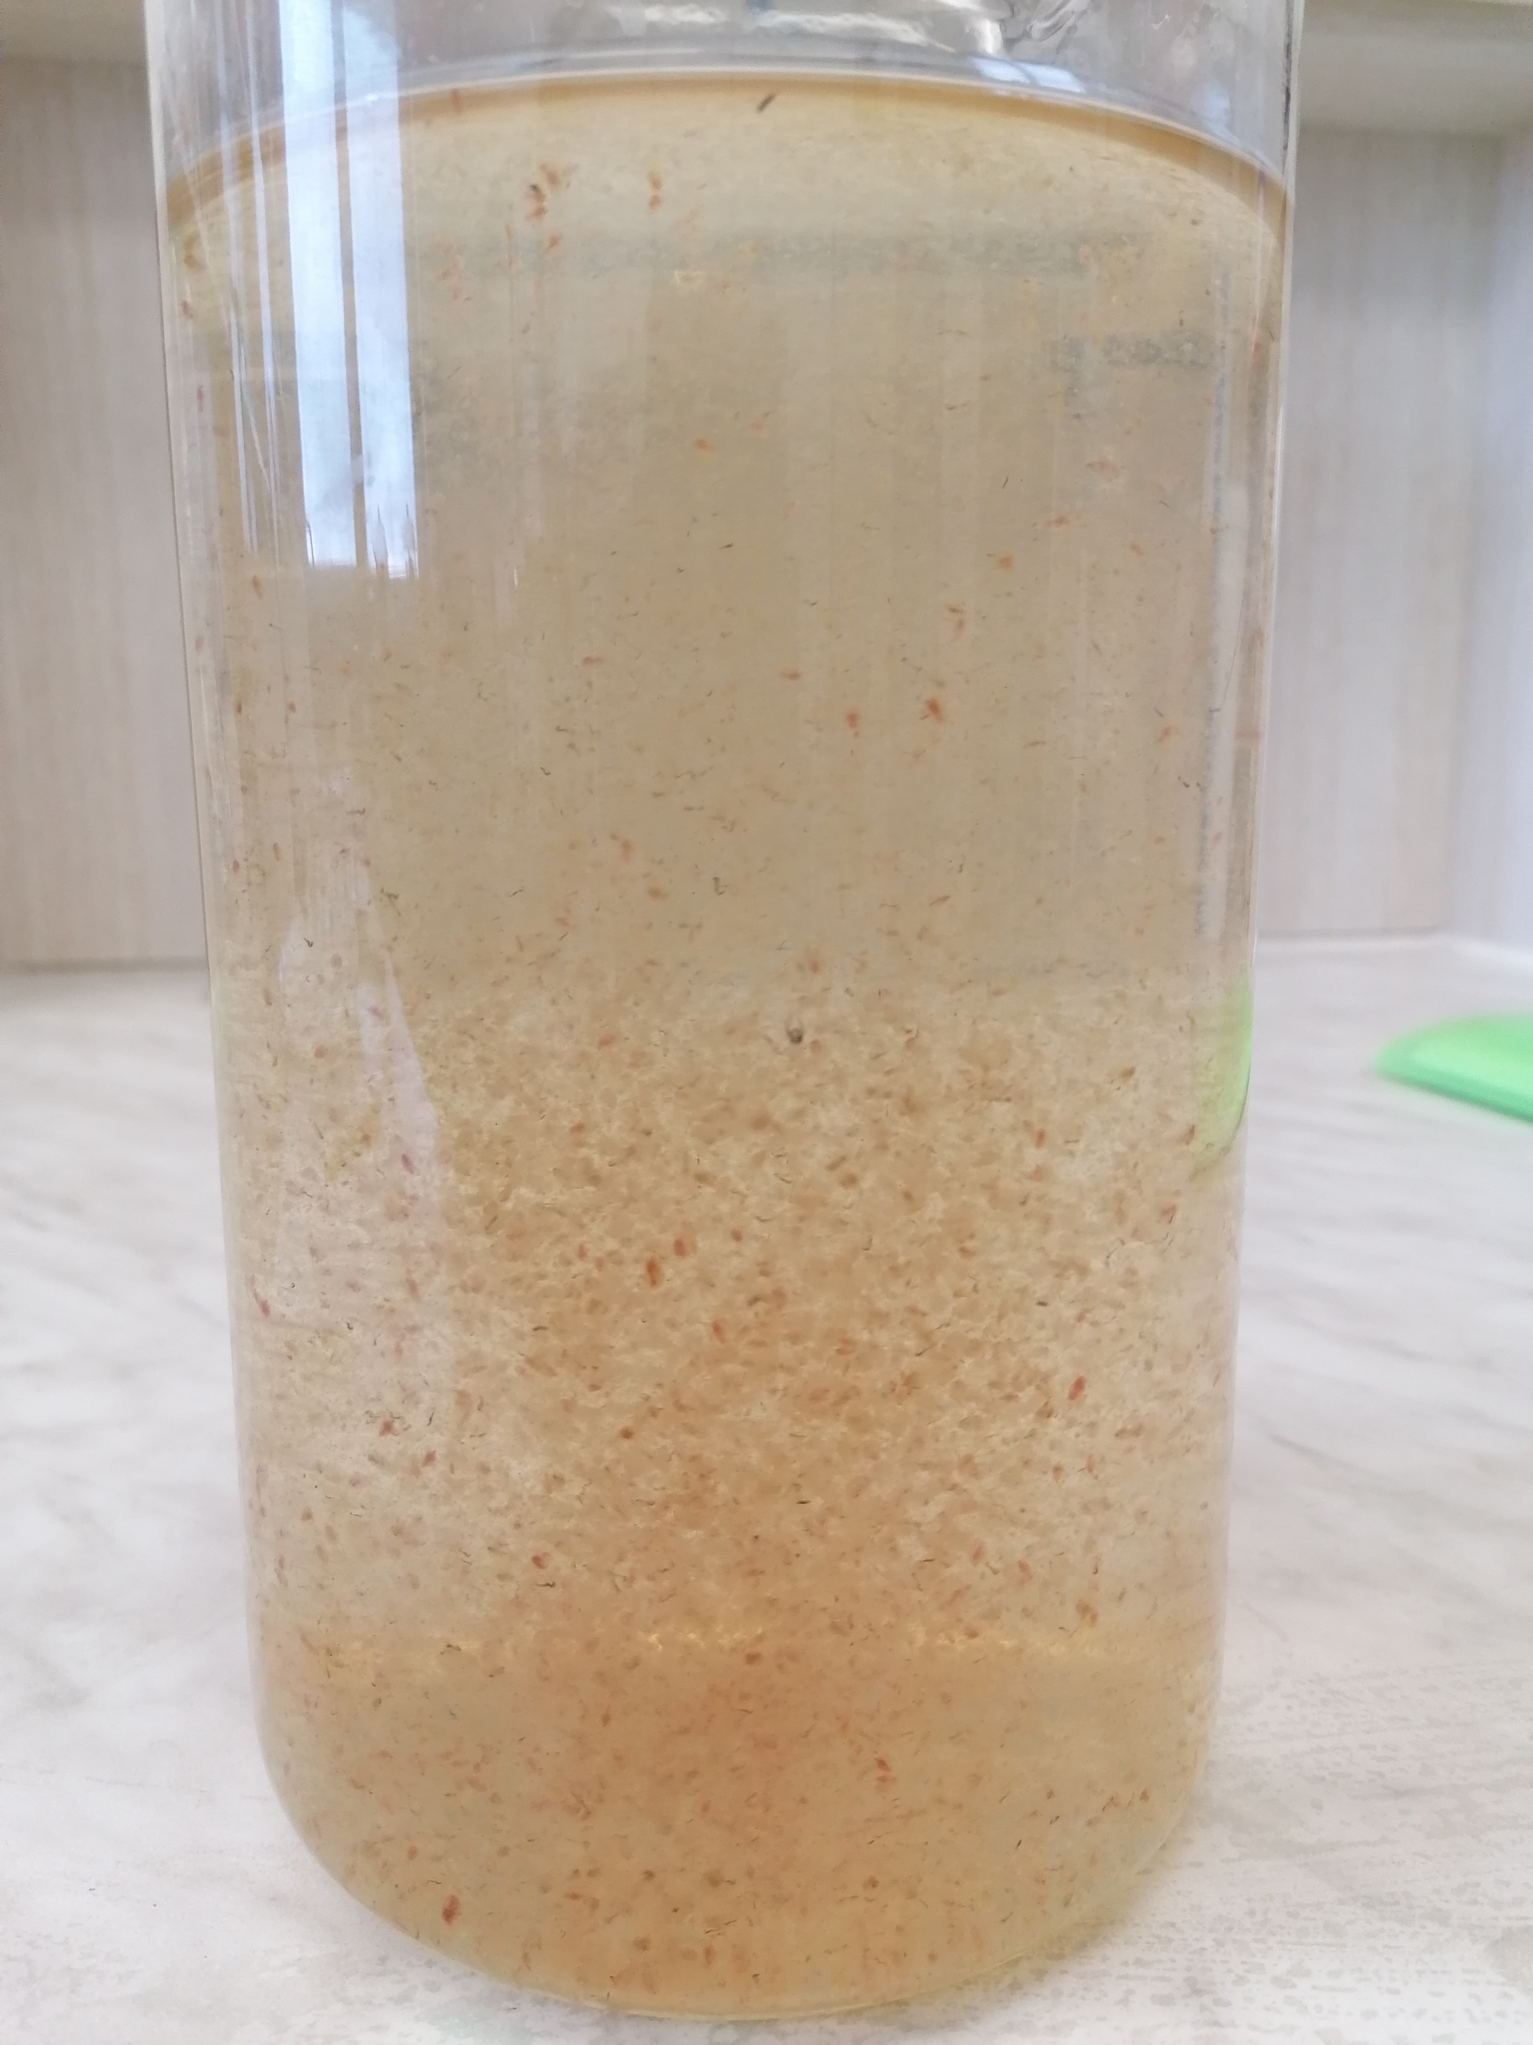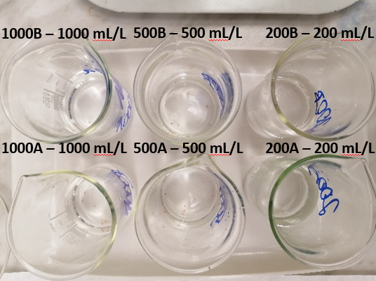
Figure 1: The picture on the left shows a container holding daphnia’s colonies, the picture on the right shows laboratory beakers with daphnia’s before the start of testing.
The chosen test is the acute immobilization test, the principle of which is to trace the immobilization of the tested daphnia’s in different concentrations of aqueous leachates prepared according to CSN EN 12457-4 (838005), 2003, of the test substance for 24 and 48 hours. However, in addition to the aqueous leachates tested, daphnia’s are also stocked into a dilution solution prepared from the chemicals in Table 1. These control (or blank) samples subsequently serve as controls and are subject to special and stricter rules for the number of inhibited individuals allowed. For the test itself, it is necessary to select individuals that are less than 24 hours old, since these young individuals are most sensitive to the effects of the toxic substances in the effluents. The organisms must not be fed during the test, and it is for this reason that the maximum time interval for the duration of the test is 48 hours; longer testing would not give such accurate results, as the daphnia’s would not have enough of the necessary food. After 24 and then 48 hours, the rate of immobilisation or death of daphnia in both control and test samples is recorded. The values obtained are then used to calculate the EC₅₀ (CSN EN ISO 6341, 1997; OECD 202, 2004).

    - Preparation of the test
This acute immobilization test describes the standard CSN EN ISO 6341 – Water quality – Determination of the inhibition of the mobility Daphnia magna Straus – Acute toxicity test (CSN EN ISO 6341, 1997) and OECD 202 (OECD 202, 2004). First, a dilution solution must be prepared, consisting of demineralised water and four chemical solutions of precisely defined concentrations, see Table 1.
Table 1: Dilution solutions of salts for the acute immobilisation test on Daphnia magna S. (CSN EN ISO 6341, 1997; OECD 202, 2004)
Dilution solution | Chemical | Concentration  [g/100 mL]
DS1 | CaCl₂ꞏ2H₂O | 11,76
DS2 | MgSO₄ꞏ7H₂O | 4,93
DS3 | NaHCO₃ | 2,59
DS4 | KCl | 0,23

The dilution solution is prepared by placing approximately one litre of demineralised water into a two litre volumetric flask, which is then made up with 10 mL of each of the four stock solutions and the volumetric flask is filled to the mark. This prepared solution must be thoroughly mixed and then aerated continuously for 18 hours. After aeration, the solution is kept 48 hours to adjust and stabilise the pH to 7.8±0.2. This value is verified using a pH meter. The solution thus prepared is used to obtain the necessary leachate concentrations for the tests (CSN EN ISO 6341, 1997; OECD 202, 2004).
After preparing the dilution solution according to the standard, attention is focused on the aqueous leachates. These were prepared by mixing 100 g of materials with one litre of distilled water and then shaken on a shaker for 24 hours (CSN EN 12457-4 (838005), 2003). Subsequently, the leachates were filtered and their pH was adjusted to give a final value between pH 7.3 and 8.1. After the pH adjustment of the leachates, other values are measured using a special electrode - conductivity, electric resistivity, TDS, solution temperature and salinity. Salinity is an essential variable in determining the amount of dissolved oxygen using the oximeter and the Oxi electrode because it affects the amount of dissolved oxygen and this amount must not fall below 2 mg/L at any stage of the test. Measurements were carried out at temperatures ranging from 21-24 °C (CSN EN ISO 6341, 1997; OECD 202, 2004).
The measured variables are given in the Table 2 below.
Table 2: Values measured before the inhibition test
Material | Conductivity  [µS/cm] | Electric resistivity  [kΩꞏcm] | TDS  [mg/L] | Salinity  [∅]
Nanovia | 28.9 | 34.0 | 30.0 | 0.0
PP-PVDF-PP  PP-PVDF | 23.6  23.2 | 41.5  44.6 | 24.0  22.0 | 0.0  0.0

The next step is to prepare the test solutions themselves. Four control samples were prepared by pouring 50 mL of the dilution solution prepared as described above into 100 mL beakers. The preparation of aqueous leachates of maximum concentration was then started by simply pouring 50 mL of filtered and treated aqueous leachate (concentration 1000 mL/L) into the beakers mentioned above. The other two concentrations were 500 mL/L, which was prepared by mixing the aqueous leachate with the dilution solution in a 1:1 ratio (25 mL of dilution solution and 25 mL of aqueous leachate), and 200 mL/L, which was prepared in the same way but this time in a 4:1 ratio (40 mL of dilution solution and 10 mL of aqueous leachate). All samples were prepared in parallel determinations A and B. Samples for all three types of test materials were prepared using the same procedure (CSN EN ISO 6341, 1997; OECD 202, 2004 and CSN EN 12457-4 (838005), 2003)).
A portion of the daphnia’s in their rearing medium was transferred to a large glass dish, from where they were scooped up with a dropper and transferred to individual beakers so that there were exactly 10 moving individuals in each beaker to meet the requirement of 5 mL of solution for each individual in the beaker (CSN EN ISO 6341, 1997; OECD 202, 2004).
The final step in this preparatory phase of the test was to measure the amount of dissolved oxygen using an Oxi electrode, and this value must never fall below 2 mg/L. In the experiment carried out and prior to testing, it ranged between 6.2 and 7.5 mg/L. After 24 hours the value was 5.7 - 6.3 mg/L, after 48 hours it was 4.5 - 5.3 mg/L. (CSN EN ISO 6341, 1997; OECD 202, 2004).

    - Statistical analysis
The tests were consistently carried out in accordance with EN ISO 6341 - Water quality - Determination of inhibition of mobility of Daphnia magna Straus - Acute toxicity test (EN ISO 6341, 1997), with emphasis on the values of conductivity, electric resistivity, TDS, salinity, pH, temperature and dissolved oxygen according to the standard.
The resulting data were obtained by determining parallel A/B determinations, thus starting from a base number of 20 daphnia’s per given concentration). Temperature at the time of determination ranged from 21- 24 °C, pH was constant and dissolved oxygen was always equal to or greater than 4.5 mg/L. Only immobilised individuals were counted, i.e. not swimming, not moving or possibly moving but not within the beaker, remaining in one place for at least 15 seconds (EN ISO 6341, 1997; OECD 202, 2004).
The results are divided into two parts, because the first immobilisation test performed for all materials and all leachate concentrations on March 28, 2022 did not give very good results, further immobilisation test was started on March 30, 2022, using only those concentrations of selected materials that achieved inhibition higher than 10 % in the previous test. The second test was therefore carried out between March 30, 2022 and April 1, 2022.
For comparison, these experiments were simultaneously performed by an accredited laboratory using two of the three materials tested, and the results obtained by us were then compared with those obtained by the accredited laboratory.
    - The results
After 24 and 48 hours, immobilized organisms were counted at all concentrations and in control samples. However, for the results to be considered as meaningful, several criteria had to be met:
- The dissolved oxygen concentration must never fall below 2 mg/L;
- the concentration of the test substance must be greater than or equal to 80 % of the nominal concentration;
- Immobilisation in control samples must not exceed 10 % after 24 hours and 20 % after 48 hours (CSN EN ISO 6341, 1997; OECD 202, 2004).
Table three shows the results of the first determination experiment.
Table 3: Results of the acute immobilization test on daphnia’s after 24 and 48 h (28. 3. – 30. 3. 2022)
Material | Concentration of leachates  [mL/L] | Immobilization after 24 h  [%] | Immobilization after 48 h  [%]
Nanovia | 0  200  500  1000 | 0/40 (0 %)  4/20 (20 %)  4/20 (20 %)  5/20 (25 %) | 0/40 (0 %)  5/20 (25 %)  7/20 (35 %)  8/20 (40 %)
PP-PVDF-PP  PP-PVDF | 200  500  1000  200  500  1000 | 1/20 (5 %)  0/20 (0 %)  2/20 (10 %)  1/20 (5 %)  3/20 (15 %)  3/20 (15 %) | 3/20 (15 %)  4/20 (20 %)  7/20 (35 %)  1/20 (5 %)  3/20 (15 %)  6/20 (30 %)

As can be seen from the table above, in none of the cases was the 50 % inhibition limit set in the Czech legislation reached. The Nanovia material came closest to this value with 40 % inhibition, followed by PP-PVDF-PP with 35 % and PP-PVDF with 30 %, and it is important to note that these higher figures were achieved at the maximum leachate concentration, i.e. 1000 mL/L. None of the other concentrations tested reached more than 25 %, but there was a noticeable phenomenon where inhibition increased with increasing leachate concentration.
In subsequent tests, the tests were repeated on concentrations of all samples where inhibition exceeded 10 %, i.e. all but the control samples and the 200 mL/L concentration of PP-PVDF.
Table 4: Results of the acute immobilization test on daphnia’s after 24 and 48 h (30. 3. – 1. 4. 2022)
Material | Concentration of leachates  [mL/L] | Immobilization after 24 h  [%] | Immobilization after 48 h  [%]
Nanovia | 0  200  500  1000 | X  4/20 (20 %)  4/20 (20 %)  6/20 (30 %) | X  6/20 (30 %)  7/20 (35 %)  8/20 (40 %)
PP-PVDF-PP  PP-PVDF | 200  500  1000  200  500  1000 | 3/20 (15 %)  1/20 (5 %)  2/20 (10 %)  X  2/20 (10 %)  2/20 (10 %) | 4/20 (20 %)  4/20 (20 %)  5/20 (25 %)  X  2/20 (10 %)  4/20 (20 %)
X – the experiment was not repeated for a given concentration and material

Table 4 shows the results of the second determination of the effects of the selected materials on Daphnia magna S. Similarly to the first determination, the inhibition threshold of 50 % was not exceeded; again, the closest to this value was the 100 % (1000 mL/L) concentration of the Nanovia leachate, which showed an inhibition of 40 % after 48 h. The other results for Nanovia were also a few units of % higher on average than for the other materials, but the results between determinations are comparable. Interestingly, also in this case there was an increase in inhibition with increasing concentration.
Conclusion
During the experiments, an interesting phenomenon was observed, whereby daphnia’s, although the aqueous effluents were filtered, were caught and entangled in the filaments present in the effluents. Once trapped, daphnia’s rarely managed to survive to the next day. These phenomena were clearly observable with a magnifying glass. Sometimes a clump of daphnia’s would form, entangled in filaments, and by the next day, they were all immobilized. However, it should be noted that fibres were present in the aqueous effluents even though the effluents were filtered according to prescribed procedures using prescribed filter papers. Thus, it is debatable whether the immobilization observed was due only to the toxic action of the microplastics in the effluents or whether it was also partly due to mechanical damage. Interestingly, as noted below the results tables themselves, the percentage inhibition also increased with increasing concentration, a finding that supports both the version that the materials tested were toxic to daphnia’s and the version that the leachates contained filaments of nanotextiles in which the daphnia’s became entangled. However, an irregularity is the parallel acute immobilization test on daphnia’s, which was carried out in November 2021 by an accredited laboratory with zero inhibition, which are excellent results. It is worth considering whether the problem was in the storage of the daphnia’s, the breeding conditions or why there was such a high percentage inhibition compared to the laboratory results. Although the laboratory only tested PP-PVDF-PP and PP-PVDF samples, even these samples showed a little inhibition in the tests performed. The prepared aqueous leachate from the Nanovia face mask was certainly the most toxic to daphnia’s.
Summarizing, resulting from daphnia’s test, it is clear that the experiment carried out did indeed give the expected results, with a small number of individuals immobilized (in most cases) after 24 hours and an increase of up to 25 % after 48 hours. The extent to which this is influenced by the presence of non-woven fibers in the aqueous leachates is open to debate. In conclusion, it can be stated that the resulting immobilizations did not reach the limit values specified in the Czech legislation (50 % inhibition rate), therefore the tested materials cannot be declared ecotoxic, because they do not meet the criterion HP 14 – Ecotoxic property (Act no. 541/2020 Coll., Waste Act., 2020). This conclusion is confirmed by the same experiment performed by the accredited laboratory according to CSN EN ISO/EIC 17025:2018 (CSN EN ISO/IEC 17025 (015253), 2018), which subjected 25 individuals of daphnia to identically prepared leachates according to CSN EN 12457-4 (CSN EN 12457-4 (838005), 2003) from PP-PVDF and PP-PVDF-PP materials, and zero immobilization was achieved in this test.
Acknowledgments
The publication was written within the Student grant competition “Release of Nano and Microplastics from Nanotextiles and Determination of Their Effect on the Environment 2” — project number SP2022/119.
References
Act no. 541/2020 Coll. Waste Act, 2020.
Bhatt, I., Tripathi, B. N., 2011, Interaction of engineered nanoparticles with various components of the environment and possible strategies for their risk assessment, Chemosphere, 82(3), 308−317.
Brewer, A., Dror, I., Berkowitz, B., 2021, The Mobility of Plastic Nanoparticles in Aqueous and Soil Environments: A Critical Review, ACS EST Water, 1(1), 48 - 57, doi: 10.1021/acsestwater.0c00130.
CSN EN 12457-4 (838005), 2003, Waste characterization - Leaching - Verification test for leachability of granular wastes and sludges - Part 4: One-stage batch test at a liquid to solid ratio of 10 l/kg for materials with a grain size of less than 10 mm (without or with particle size reduction).
CSN EN ISO 6341, 1997, Water quality. Daphnia magna Straus (Cladocera, Crustacea) motility inhibition test – Acute toxicity test. Prague: Czech Normalization Institute, 16 p.
CSN EN ISO/IEC 17025 (015253), 2018, General requirements for the competence of testing and calibration laboratories.
Farre, M., Gajda-Schrantz, K., Kantiani, L., Barcelo, D., 2009, Ecotoxicity and analysis of nanomaterials in the aquatic environment, Analytical and bioanalytical chemistry, 393(1), 81 - 95.
Gerritse, J., Leslie, H. A., de Tender, C. A., Devriese, L. I., Vethaak, A. D., 2020, Fragmentation of plastic objects in a laboratory seawater microcosm, Sci. Rep. 10(1), doi: 10.1038/s41598-020-67927-1.
Klaine, S. J.; Alvarez, P. J.; Batley, G. E.; Fernandes, T. F.; Handy, R. D., Lyon, D. Y., Lead, J. R., 2008, Nanomaterials in the environment: behaviour, fate, bioavailability, and effects, Environmental Toxicology and Chemistry: An International Journal, 27(9), 1825 − 1851.
Kögel, T., Bjorøy, Ø., Toto, B., Bienfait, A. M., Sanden, M., 2020, Micro-and nanoplastic toxicity on aquatic life: Determining factors, Science of the Total Environment, 709, 136050.
Lei, L., Liu, M., Song, Y., Lu, S., Hu, J., Cao, C., et al., 2018, Polystyrene (nano) microplastics cause size-dependent neurotoxicity, oxidative damage and other adverse effects in Caenorhabditis elegans, Environmental Science: Nano; 5(8), 2009–20, https://doi.org/10.1039/c8en00412a.
Novotna, K., Cermakova, L., Pivokonska, L., Cajthaml, T., Pivokonsky, M., 2019, Microplastics in drinking water treatment – Current knowledge and research needs, Science of The Total Environment, doi:10.1016/j.scitotenv.2019.02.431.
OECD 202. OECD, 2004, Guideline for Testing Chemicals. Daphnia Magna Acute Immobilization Test; OECD Publisher: Paris, France.
Pirsaher, M., Hossini, H., Makhdoumi, P., 2020, Review of microplastic occurrence and toxicological effects in marine environment: Experimental evidence of inflammation, Process Safety and Environmental Protection, doi:10.1016/j.psep.2020.05.050.
Pivokonsky, M., Pivokonska, L., Novotna, K., Cermakova, L., Klimtova, M., 2020, Occurrence and fate of microplastics at two different drinking water treatment plants within a river catchment, Science of The Total Environment, 140236, doi:10.1016/j.scitotenv.2020.140236.
Roupcova, P., Kubatova, H., Batrlova, K., Klouda, K., 2022. Nanotextiles – materials suitable for respiratory tract protection but a source of nano- and microplastic particles in the environment. Ostrava, Technical University of Ostrava, Faculty of Safety Engineering.
Sovova, T., Koci, V., 2012, Ecotoxicology of nanomaterials, Chemical Letters, 106(2).
Sullivan, G. L., Delgado-Gallardo, J., Watson, T. M., Sarp, S., 2021, An investigation into the leaching of micro and nano particles and chemical pollutants from disposable face masks - linked to the COVID-19 pandemic, Water Research, 196, doi:10.1016/j.watres.2021.117033.
Waymana, C., Niemann, H., 2021, The fate of plastic in the ocean environment – a minireview, Environ. Sci.: Processes Impacts, 23(2), 198 - 212, doi: 10.1039/d0em00446d.

