CHEMICAL ENGINEERING TRANSACTIONS  VOL. , 2023 | A publication of
The Italian Association
of Chemical Engineering
Online at www.cetjournal.it

Guest Editors: Paolo Ciambelli, Luca Di Palma
Copyright © 2023, AIDIC Servizi S.r.l.
ISBN 979-12-81206-00-7; ISSN 2283-9216

Production of Nanoliposomes by a Supercritical CO₂ Assisted Process: Application to Cosmetics
Lucia Baldino* and Ernesto Reverchon
Department of Industrial Engineering, University of Salerno, Via Giovanni Paolo II, 132, 84084, Fisciano (SA), Italy
lbaldino@unisa.it
Vesicles are intriguing candidates for the topical administration of cosmetics as they can act as skin penetration stimulators, the individual components of the vesicles can impart additional desired properties to cosmetics, and are biodegradable and minimally toxic. Among the vesicular systems proposed for this application, liposomes are widely investigated. They are constituted of an inner aqueous core and an outer lipid bilayer. This configuration allows the encapsulation of both lipophilic and hydrophilic bioactive drugs. However, the traditional processes proposed for the production of these vesicles suffer from several limits: they are batch and time-consuming techniques, require post-treatments for the purification of vesicles from organic solvent residues and/or for reducing their mean size, do not favour a high encapsulation efficiency of drugs. In this work, SuperSomes, a sustainable and continuous process assisted by supercritical CO₂, was used to produce nanometric liposomes loaded with ascorbic acid for cosmetic applications. Operating at 100 bar and 40 °C, stable liposomes characterized by a spherical morphology and a mean diameter lower than 250 nm, were obtained. An ascorbic acid encapsulation efficiency of 85% was measured and the supercritical process preserved the antioxidant activity of the drug.
  - Introduction
The demand for cosmetic products able to improve the skin properties and health is growing exponentially (Dhawan et al., 2020; Montenegro, 2014). These effects depend on the active principle and kind of formulation used, since it influences the amount and rate of active principle released on the target site (Lohani and Verma, 2017).
Cosmetic formulations containing nanomaterials show several advantages than the conventional ones, mainly due to a deeper penetration of the active principle in the skin and a its controlled release according to the specific application (Katz et al., 2015; Yadwade et al., 2021). The main nanomaterials used in cosmetics are liposomes, niosomes, solid-lipid nanoparticles and nanocapsules. In particular, liposomes are frequently selected for a topical administration of cosmetics.
Liposomes are characterized by a vesicular structure constituted of an external double lipidic layer and an internal aqueous core (Aparajita and Ravikumar, 2014). Thanks to these properties, they show an excellent biocompatibility with human skin and favour its hydration. Bi et al. (Hatahet et al., 2018) produced by ether injection and thin film hydration method, liposomes loaded with vitamin D3 that is an anti-age active principle. The aim of this study was to improve the stability and the transdermal absorption of vitamin D3. The ether injection method allowed the production of smaller liposomes than the thin film hydration method (93 nm vs. 170 nm) and also a larger vitamin D3 encapsulation efficiency (80% vs. 62%). Moreover, these authors demonstrated that the skin penetration of the encapsulated vitamin D3 was larger than the active principle alone. Bochicchio et al. (2020) studied the encapsulation of vitamin D3, K2, and E, and curcumin in liposomes produced by microfluidic. In all cases, vesicles characterized by nanometric dimensions were produced, with a Z-potenzial between -20 and -35 mV, and a good active principle encapsulation efficiency (between 88% and 98%). Çelik et al. (2017) prepared by thin film hydration method, liposomes loaded with coenzyme Q10 (CoQ10) and D-pantenil triacetate (PTA), for anti-age formulations. Liposomes with mean diameters between 155 and 187 nm were produced. Stability analysis showed that liposomes preserved the active principle properties when stored at 4 °C instead of 25 °C, for two months.
Among the active principles used for cosmetic applications, ascorbic acid is frequently selected since it is a hydrosoluble molecule and shows antioxidant properties that favour the synthesis of collagen (Maione-Silva et al., 2019). Maione-Silva et al. (2019) produced by thin film hydration method an anti-age liposomal formulation, containing ascorbic acid. The formulation showed a unimodal dimensional distribution, with a mean diameter lower than 200 nm and an encapsulation efficiency of 58%. Amiri et al. (2019) obtained by reverse phase evaporation liposomes loaded with ascorbic acid, testing different phospholipid amount (from 0 to 50%) and sonication time (20, 25, 30, 35, and 40 min). The results showed that an increase in the sonication time and a decrease in the phospholipid amount produced liposomes with smaller mean dimensions.
However, the works discussed until now reported the production of liposomes loaded with active principles by traditional methods that are: batch and time-consuming processes, require post-treatments to obtain smaller dimensions of the vesicles and to remove the organic solvents used during the preparation steps, and can allow a low encapsulation efficiency of the drug.
SuperSomes is an innovative and continuous process assisted by supercritical CO₂ (SC-CO₂) that overcome the limits previously described thanks to the features of the supercritical fluids, such as a gas-like diffusivity, liquid-like density and negligible surface tension. Using SuperSomes, nanoliposomes loaded with vitamin D3 (Chaves et al., 2022a) and vitamin D3 plus curcumin (Chaves et al., 2022b) were successfully produced, operating at 100 bar and 40 °C.
Therefore, the aim of this work is the production for the first time of nanoliposomes loaded with ascorbic acid for cosmetic applications. In order to demonstrate the feasibility of the process, several characterizations of the samples were performed, such as: dynamic light scattering (DLS), scanning electron microscopy (SEM), UV-Vis spectrophotometry and antioxidant activity tests.
  - Materials and methods
Phosphatidylcholine (PC, in solid form) and ascorbic acid (AA, powder) were purchased from Sigma Aldrich (Milan, Italy); ethanol (anhydrous, ≥99.9% purity) was purchased from Carlo Erba Reagents (Cornaredo (MI), Italy); distilled water was produced in laboratory, using a home-made lab-scale distiller. Carbon dioxide (CO₂, >99.4% purity) was purchased from Morlando Group Srl (Naples, Italy).
    - SuperSomes description
SuperSomes apparatus was formed by three feeding lines: (1) delivered CO₂ from a reservoir to a high-pressure stainless-steel static mixer (or saturator), with an internal volume of 0.15 dm³ and filled with stainless-steel packings (1889 m⁻¹ specific surface, 0.94 voidage, 0.16 inch, Pro-Pak, Scientific Development Company, State College, PA, USA); (2) delivered water or a water solution (i.e., water + 5% w/w AA/PC) directly to the high-pressure stainless-steel formation vessel, with an internal volume of 500 dm³; and (3) delivered the ethanolic solution containing PC to the saturator. A schematic representation of SuperSomes plant can be found in (Baldino and Reverchon, 2021; Baldino and Reverchon, 2022).
A 100 mL volume of ethanolic solution containing PC (20 mg/mL) was prepared under agitation at 500 rpm for 1 h. CO₂ was cooled and, then, was pumped using an Ecoflow® pump (mod. LDC-M-2, Lewa, Leonberg, Germany) to the saturator that was heated by three thin band heating sheaths (240 V, 140 W, Watlow, Corsico (MI), Italy). In the same chamber, the ethanolic solution of PC was pumped using a Gilson pump (mod. 305, Villiers Le Bel, France). The ratio, expressed on mass basis, between the CO₂ flow rate and the ethanolic solution flow rate was about 2.40. The contact between the ethanolic solution of PC and SC-CO₂ promoted the formation of a gas expanded liquid (Baldino and Reverchon, 2021; Baldino and Reverchon, 2022). Subsequently, this expanded liquid was delivered through a capillary tube (8 cm length, 1/8 in. external diameter, 0.028 in. wall thickness) inside the formation vessel that was heated by two heating sheaths (240 V, 800 W, Watlow, Corsico (MI), Italy). Water was pumped using another Gilson pump (mod. 305, Villiers Le Bel, France) to the formation vessel, and was atomized through an 80 µm internal diameter nozzle. At the end of the experiment, the plant was slowly depressurized opening a micrometering valve (mod. 1335G4Y, Hoke, Spartanburg, SC, USA). The mixture ethanol+CO₂ was removed using a separator downstream of the formation vessel, operating at 25 °C and 10 bar. CO₂, before being eliminated from the separator, passed through a rotameter (N5-2500, ASA, Sesto San Giovanni (MI), Italy) that was used to measure the gas flow rate. The produced liposome suspension was collected in a reservoir located at the bottom of the formation vessel that can be withdrawn using an on/off valve (mod. SS-43GS4, Swagelok, Solon, Ohio, USA). Temperature along the plant was measured using thermocouples and controlled using PID controllers (Series 93, Watlow, Corsico (MI), Italy); whereas pressure was measured by pressure gauges (mod. MP1, OMET, Lecco, Italy).
    - Characterization techniques
Liposome suspensions were characterized in terms of mean hydrodynamic diameter (MHD), polydispersity index (PDI) and Z-potential by a dynamic light scattering (DLS, mod. Zetasizer Nano S, Worcestershire, United Kingdom). All measurements were repeated in triplicate.
Morphology was observed by a field emission scanning electron microscope (SEM, mod. LEO 1525, Carl Zeiss SMT AG, Oberkochen, Germany). Before performing this analysis, two or three drops of liposome suspension were deposited on an aluminium stub that was left to dry for 2 days. Then, liposomes were covered by a thin gold layer using a sputter coater (mod. 108 A, Agar Auto Sputter Coater, Stansted, UK) at 40 mA for 120 s and, finally, observed by SEM.
Ascorbic acid encapsulation efficiency (EE%) and release kinetics were measured by an UV-Vis spectrophotometer (mod. Cary 60 UV-Vis, Agilent Technologies, Santa Clara, CA, USA). In particular, for EE% measurement, the supernatant and the vesicles were first separated by ultracentrifugation (mod. Optima XE-100 IVD, equipped with a Type-32 Swinging Bucket Rotor, Beckmann Coulter, Cassina De’ Pecchi (MI), Italy) that was carried out at 32000 rpm for 3 h at 4 °C, and, then, the recovered supernatant was analyzed by the UV-Vis spectrophotometer, reading the AA absorbance at λ= 260 nm. EE% was calculated using the following equation:
EE%= [1 - (supernatant concentration)/(theoretical concentration)]∙100
where the theoretical concentration was the starting concentration of the drug dissolved in the water solution; whereas the supernatant concentration was the unencapsulated drug in the final suspension.
Drug release tests were carried out according to the following method: 5 mL of liposome suspension were inserted in a 14000 Da cut-off dialysis sack (Sigma Aldrich, Milan, Italy) and, then, this sack was immersed in 80 mL of phosphate buffered saline (PBS) at pH 7.4 and 37 °C, continuously stirred at 250 rpm. AA release kinetics from liposomes were measured at λ= 260 nm, in absence of light, by the UV-Vis spectrophotometer previously described.
DPPH radical scavenging assay was performed using the following method: first, a liposome suspension was ultracentrifuged (mod. Optima XE-100 IVD, equipped with a Type-32 Swinging Bucket Rotor, Beckmann Coulter, Cassina De’ Pecchi (MI), Italy) at 32000 rpm for 3 h at 4 °C, and the obtained pellet was resuspended in 2 mL of water. Then, this volume was added to 3 mL of a 4 mM DPPH solution. The final solution was maintained in dark conditions for 1 h. The values of absorbance were obtained at 517 nm, using the UV-Vis spectrophotometer previously described, and the percentage of the DPPH-scavenging activity was calculated using the following equation:
DPPH_{scav%}= [1 - (A_{S} - A_{C})/A_{K}]∙100
where A_{S} is the absorbance of 1 mL of liposome suspension and 3 mL of DPPH solution, A_{C} is the absorbance of 1 mL of liposome suspension and 3 mL of ethanol, and A_{K} is the absorbance of 1 mL of ethanol and 3 mL of DPPH solution.
  - Results and discussion
Unloaded liposomes (Lip1) were produced to obtain a reference sample for AA loaded liposomes (Lip2). The operating conditions used in all SuperSomes experiments were: 100 bar, 40 °C, 6.5 g/min CO₂ flow rate, 7 mL/min water flow rate, 80 μm injector diameter (Baldino and Reverchon, 2021; Baldino and Reverchon, 2022).
    - Morphological and stability results
Lip 1 and Lip2 samples were analyzed by DLS, and the results obtained, in terms of mean hydrodynamic diameter (MHD), polydispersity index (PDI) and Z-potential, are reported in Table 1.
Table 1: DLS results of liposomes produced by SuperSomes
Experiment | MHD, nm | PDI | Ζ-potential, mV
Lip1 | 229 ± 61 | 0.199 | -11.3 ± 2.0
Lip2 | 236 ± 120 | 0.423 | -28.4 ± 2.9
In both sets of experiments, nanometric liposomes were obtained with a unimodal size distribution. The presence of the active principle influenced the mean dimension of liposomes that increased from 229 nm for unloaded vesicles to 236 nm for AA loaded vesicles, accompanied by a larger size distribution, as shown in Figure 1.
Figure 1: Unloaded and AA loaded liposomes size distribution
These results were confirmed by SEM analysis. In particular, SEM images reported in Figure 2 demonstrate that unloaded liposomes (Figure 2a) and AA loaded liposomes (Figure 2b) were characterized by a spherical morphology and a nanometric mean diameter. The presence of some aggregates of liposomes was due to the preparation of the samples for SEM analysis, as observed in previous works (Baldino and Reverchon, 2021; Baldino and Reverchon, 2022).
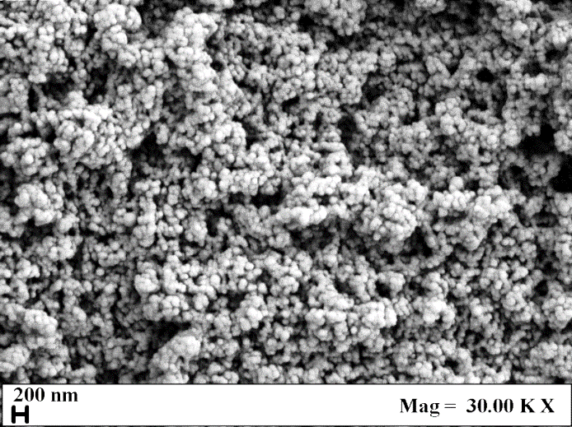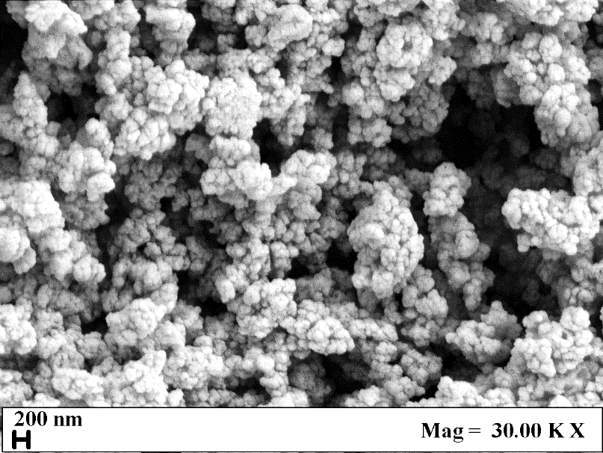
(a) (b)
Figure 2: SEM images of (a) unloaded liposomes and (b) AA loaded liposomes, produced by SuperSomes
DLS analysis was repeated on the samples stored at 4 °C after 15, 30, 60 and 90 days from the production, to determine their stability over time. The results are summarized in Table 2.
Table 2: Stability measurements of unloaded and AA loaded liposomes produced by SuperSomes
Experiment | Stability, days | MHD, nm | PDI | Ζ-potential, mV
 | 0 | 229 ± 61 | 0.199 | -11.3 ± 2.0
 | 15 | 232 ± 67 | 0.217 | -10.3 ± 1.9
Lip1 | 30 | 230 ± 66 | 0.212 | -12.1 ± 1.8
 | 60 | 245 ± 78 | 0.239 | -11.7 ± 1.7
 | 90 | 243 ± 55 | 0.222 | -12.5 ± 2.2
 | 0 | 236 ± 120 | 0.423 | -28.4 ± 2.9
 | 15 | 219 ± 106 | 0.397 | -28.6 ± 2.4
Lip2 | 30 | 232 ± 136 | 0.498 | -25.9 ± 1.8
 | 60 | 237 ± 126 | 0.511 | -25.8 ± 1.7
 | 90 | 221 ± 87 | 0.431 | -23.6 ± 3.5
Stability measurements showed that all samples were stable over time since MHD and PDI values were almost constant up to 90 days. These results were consistent with Z-potential values that indicated a good repulsion among vesicles.
    - AA encapsulation efficiency and release test from nanoliposomes
AA loaded liposomes were analyzed by UV-Vis spectrophotometry to measure the active principle encapsulation efficiency and release rate, following the methods described in section 2.
In particular, ascorbic acid encapsulation efficiency was equal to 86%. This value was larger than the ones reported in the literature (e.g., 57.5% (Maione-Silva et al., 2019)) and can be attributed to the faster SuperSomes process than the traditional methods that favoured the formation of inverted micelles on the fly in the formation vessel. During this step, the active principle was encapsulated and, when they fell at the bottom of the vessel where water plus precipitated PC were present, the double lipidic layer was completed, forming liposomes.
AA release test was performed in a PBS medium at pH 7.4 and 37 °C, in order to simulate the skin; the release rate of AA from liposomes was compared with the one of untreated AA powder, and the results are reported in Figure 3.
Figure 3: Release test of untreated AA powder and AA from liposomes in a PBS medium at pH 7.4 and 37 °C
Untreated AA powder was completely dissolved in PBS in about 70 min; whereas AA was released from nanoliposomes in about 90 min. These final release times were comparable; but the release kinetics of AA from nanoliposomes was slower due to mass transfer resistance opposed by the double lipidic layer of the carrier. In order to increase the release time of the active principle from the nanoliposomes, the phosphatidylcholine concentration can be increased and/or cholesterol can be added to the formulations (Baldino and Reverchon, 2022).
In the last part of the work, the antioxidant activity of AA was verified by the DPPH method. The colour of the DPPH solution changed from violet to yellow, and this observation was a qualitative indication of the antioxidant activity of the active principle; indeed, the measurement carried out by UV-Vis spectrophotometry revealed a 94% antioxidant activity of AA loaded nanoliposomes.
  - Conclusions
This work demonstrated the feasibility of producing by a supercritical CO₂ assisted process nanoliposomes loaded with an antioxidant active compound for potential cosmetic applications. The obtained liposomes were characterized by a regular and spherical morphology, with a mean diameter lower than 250 nm, without using post-treatments to furtherly reduce their dimensions. The AA encapsulation efficiency was larger than 80% and the drug preserved an almost complete antioxidant activity after the supercritical process. The release time of the drug can be increased by using a larger PC concentration in the ethanolic solution and/or adding cholesterol to the formulations.
References
Amiri S., Rezazadeh-Bari M., Alizadeh-Khaledabad M., Amiri S., 2019, New formulation of vitamin C encapsulation by nanoliposomes: Production and evaluation of particle size, stability and control release, Food Science and Biotechnology, 28, 423-432.
Aparajita V., Ravikumar P., 2014, Liposomes as carriers in skin ageing, International Journal of Current Pharmaceutical Research, 6, 1-7.
Baldino L., Reverchon E., 2021, Niosomes formation using a continuous supercritical CO₂ assisted process, Journal of CO₂ Utilization, 502, 101669.
Baldino L., Reverchon E., 2022, Continuous supercritical CO₂ assisted process for the production of nano-niosomes loaded with a second-generation antibiotic for ocular therapy, The Journal of Supercritical Fluids, 188, 105673.
Bochicchio S., Dalmoro A., De Simone V., Bertoncin P., Lamberti G., Barba A.A., 2020, Simil-microfluidic nanotechnology in manufacturing of liposomes as hydrophobic antioxidants skin release systems, Cosmetics, 7, 1-13.
Çelik B., Sağıroğlu A.A., Özdemir S., 2017, Design, optimization and characterization of coenzyme Q10- and D-panthenyl triacetate- loaded liposomes, International Journal of Nanomedicine, 12, 4869-4878.
Chaves M.A., Baldino L., Pinho S.C., Reverchon E., 2022a, Supercritical CO₂ assisted process for the production of mixed phospholipid nanoliposomes: Unloaded and vitamin D3-loaded vesicles, Journal of Food Engineering, 316, 110851.
Chaves M.A., Baldino L., Pinho S.C., Reverchon E., 2022b, Co-encapsulation of curcumin and vitamin D3 in mixed phospholipid nanoliposomes using a continuous supercritical CO₂ assisted process, Journal of the Taiwan Institute of Chemical Engineers, 132, 104120.
Dhawan S., Sharma P., Nanda S., 2020, Cosmetic nanoformulation and their intended use, Nanocosmetics, 8, 141-169.
Hatahet T., Morille M., Hommoss A., Devoisselle J.M., Müller R.H., Bégu S., 2018, Liposomes, lipid nanocapsule and smartCrystals: A comparative study for an effective quercentin delivery to the skin, International Journal of Pharmaceutics, 542, 176-185.
Katz L.M., Dewan K., Bronaugh R.L., 2015, Nanotechnology in cosmetics, Food and Chemical Toxicology, 85, 127-137.
Lohani A., Verma A., 2017, Vesicles: Potential nano carriers for the delivery of skin cosmetics, Journal of Cosmetic and Laser Therapy, 19, 485-493.
Maione-Silva L., Gava de Castro E., Nascimento T.L., Cintra E.R., Moreira L.C., Cintra B.A.S., Valadares M.C., Lima E.M., 2019, Ascorbic acid encapsulated into negatively charged liposomes exhibits increased skin permeation, retention and enhances collagen synthesis by fibroblasts, Scientific Reports, 9, 522.
Montenegro L., 2014, Nanocarriers for skin delivery of cosmetic antioxidants, Journal of Pharmacy & Pharmacognosy Research, 4, 73-92.
Yadwade R., Gharpure S., Ankamwar B., 2021, Nanotechnology in cosmetics pros and cons, Nano Express, 2, 022003.

