CHEMICAL ENGINEERING TRANSACTIONS  VOL. , 2023 | A publication of
The Italian Association
of Chemical Engineering
Online at www.cetjournal.it

Guest Editors: Paolo Ciambelli, Luca Di Palma
Copyright © 2023, AIDIC Servizi S.r.l.
ISBN 978-88-81206-00-7; ISSN 2283-9216

$W/W-SiCH/TaO_{x}N_{y}$ multinanolayers for Concentrated Solar Power
Aïssatou Diop^{a,b}, Audrey Soum-Glaude^{b}, Angélique Bousquetª, Thierry Sauvage^{c}, Laurent Thomas^{b}, Eric Tomasella^{a,*}
ª Université Clermont Auvergne, Clermont Auvergne INP, CNRS, ICCF, F-63000 Clermont–Ferrand, France
^{b} PROMES-CNRS UPR 8521, Rambla de la Thermodynamique, 66 100 Perpignan, France
^{c}CEMHTI-CNRS UPR 3079, 3A rue de la Férollerie, 45071 Orléans, France
Eric.tomasella@uca.fr

Etude ESR et PDF de l'oxynitrure de tatalum

Absorbers for concentrating solar power plants require materials that are resistant to high temperatures and spectrally selective, i.e., highly absorbent in the visible and near infrared range and low-emissive in the infrared range. To improve the absorbing power of the receivers in concentrating solar power plants, an optical end coating based on tantalum oxynitride can be deposited on an absorbing bilayer based on metal and ceramic materials. Antireflective $TaO_{x}N_{y}$coating can maximize the transmission of solar radiation to the $W/W-SiCH$ bilayer absorber material which has been previously studied and ensure a good thermomechanical resistance of the whole coating. For this study, $TaO_{x}N_{y}$ are deposited by reactive sputtering technique. Their chemical composition is investigated by Ion Beam Analysis which shows compositions ranging from tantalum oxide to tantalum nitride depending of the gas flow rate. Optical properties are determined by ellipsometry and UV-Visible spectroscopy. The microstructure determined by the Pair Distribution Function (PDF) reveals a mixture of $TaN$, $TaON$ and ${Ta}_{2}O_{5}$ phases.

  - Introduction
Concentrating solar power plants are booming as a result of the need to produce clean electricity. Numerous studies on the subject have been carried out (Wang Cong et al., 2021), including those on solar receivers. The coatings used for the absorbers must be spectrally selective, i.e. they must be able to modify the coated surface in such a way that it can absorb a maximum amount of solar radiation in the solar visible and near infrared range and emit very low radiation in the thermal infrared range. These selective absorbers must also satisfy other criteria such as high temperature resistance to air and thermomechanical resistance. One interesting solution is to insert them between a metallic underlayer that acts as an infrared reflector to minimize radiative losses and an antireflective top layer that maximizes the transmission of solar radiation. In their study Li et al. (2013) presented a $SiO_{2}$ and $TiO_{2}$ or $ZrO_{2}$ type stack that increases the transmission by more than 3% over a range of 300 to 1000 nm. This transmission can reach 99% in the case of nanostructuration for a wavelength close to 600 nm depending on the grain size. Most of the absorbers existing in the literature have good solar performance and a high temperature resistance of up to 650 °C under vacuum (Bermel et al., 2012)). Increasing the operating temperature (500°C<T<700°C) and using solar receivers in the air and not in vacuum would improve the efficiency of solar power plants and reduce their cost. For that reason, we will focus on tantalum oxynitride antireflective coatings deposited on $W/W-SiCH$ absorbing layers that we have studied previously (Danielle Ngoue, 2017; Diop et al., 2023). Within the family of oxides, tantalum pentoxide, whose chemical formula is ${Ta}_{2}O_{5}$, has interesting optical properties that allow it to be used as an antireflective coating. Work by Rubio et al. (1983) showed that this coating increased the efficiency of silicon from 9.5% to 12.9% when deposited as an antireflective coating with a refractive index close to 2 in the visible range. In the nitride family, work (Wang et al., 1998) has shown that nitrogen incorporated into tantalum layers can be used to obtain $TaN$ as a diffusion barrier. Due to its good mechanical properties, tantalum nitride can be used as a durable protective coating. Tantalum oxynitrides, with the chemical formula ${TaO}_{x}N_{y}$, are a good compromise between oxides and nitrides in that their properties are halfway between those of nitrides and oxides.
In this work, ${TaO}_{x}N_{y}$ thin films were deposited by reactive magnetron sputtering of a tantalum target in a plasma of argon at a fixed flow rate, dioxygen and dinitrogen at variable flow rates. They were then characterised to determine their chemical composition using Ion Beam Analysis techniques and their optical nature using spectroscopic ellipsometry measurements. A structural study was also carried out by Pair Distribution Function (PDF). Finally, optical simulations carried out using an in-house software package was used to show the improvement in the optical properties of the $W/W-SiCH$ absorbing layer when a ${TaO}_{x}N_{y}$ layer is deposited on top.

  - Experimental setting

    - Coatings synthesis
${TaO}_{x}N_{y}$ layers were deposited in a plasma in a vacuum chamber provided by PLASSYS, which can accommodate two magnetron cathodes, each connected to a SEREN radio frequency generator providing a maximum power of 300 W. It is also equipped with a rotating and heating substrate holder, which can also be polarised by radio frequency. The initial pressure in the deposition chamber is of the order of ${10}^{-6}$ mbar. The substrates on which the materials are deposited are cleaned by RF plasma for 10 min under 20 sccm argon flow. During deposition, the pressure in the reactor is about 1 Pa (${10}^{-4}$ mbar). The target used is 99.99% pure tantalum with a 3 inches diameter. According to the type of material characterization, the layers were grown on silicon (N-type, P-doped, 2-sided polished), quartz (transmission range: 0.185~3.50 µm) or glassy carbon (1-sided polished, resistivity: 400 µΩ.cm) substrates. The argon flow rate is fixed at 15 sccm and those of $N_{2}$ and $O_{2}$ are variable. We denoted $RF$the flux ratio which corresponds to the ratio between the flow rate of $O_{2}$ and the total flow rate of reactive gases ($O_{2}$+$N_{2}$) ($RF=\frac{{Φ(O}_{2})}{{Φ(O}_{2}+N_{2})}$). With ${Φ(O}_{2}+N_{2})=2 sccm$. Table 1 presents the different samples obtained according to the reactive gas flow rates and the measured thickness.

Samples | $${ϕ(N}_{2})$$ | $${ϕ(O}_{2})$$ | Thickness (nm)
RF0 | 2 sccm | 0 sccm | 184
RF0.4 | 1.2 sccm | 0.8 sccm | 194
RF0.7 | 0.5 sccm | 1.5 sccm | 194
RF1 | 0 sccm | 2 sccm | 110

Table 1 : Samples obtained according to the reactive gas flow rates

    - Materials characterizations
RBS (Rutherford Back Scattering) was used to determine the depth profile of chemical elements in the material, by bombarding the sample placed in a vacuum chamber with an alpha beam (${}_{2}^{4}{{He}^{+}})$ of 2 MeV energy. RBS analyses were completed by NRA (Nuclear Reaction Analysis) and ERDA (Elastic Recoil Detection Analysis) analyses to get more precise information on the chemical composition of the materials, especially in light elements contents. The depth profiles were extracted from IBA spectra by using SIMNRA software (Mayer, 1999) with SigmaCalc cross section (Gurbich, 2016) for NRA and ERDA. These IBA techniques were carried out using the Pelletron accelerator of CEMHTI laboratory (EMIRA 2022). A Jobin-Yvon Uvisel ellipsometer was used to determine the spectral refractive indices $n$ and extinction coefficients $k$of our materials. Its incident beam (angle of incidence 70°) comes from a Xenon lamp. The device allows studies to be carried out over a range from 0.49 to 4.79 eV (258.8 nm to 2101.4 nm). After measurements, a modelling step by Tauc Lorentz (Gaillet, 2018) using the DeltaPsi 2 software (HORIBA 2016) was applied to determine $n$ and $k$. Transmission measurements were performed with a Perkin Elmer UV-Visible spectrometer scanning wavelengths from 200 nm to 900 nm. It is a dual beam spectrometer equipped with two light sources: a deuterium arc lamp for wavelengths below 350 nm and an incandescent lamp for visible wavelengths. The structural characterization was determined by PDF with a PANalytical X'Pert Pro diffractometer with Bragg-Brentano θ-θ geometry) from PHILIPS equipped with a copper anticathode (${Kα}_{1}/{Kα}_{2}$) and a solid X'celerator detector that covers an angular range of 2.122°. The data are normalised and Fourier transformed using PDFgetX3 software and signal modelling was performed using PDFgui software.
    - Optical simulations
Optical simulations are performed with COPS software which is a Solar Performance Optimization Code developed under Scilab 5.5.2 in the framework of the thesis of A. Grosjean (Grosjean et al. 2021) at the PROMES laboratory. It allows to evaluate the solar performances of nanometric materials via the calculation of the spectral reflectance R(λ), the spectral transmittance T(λ) to then deduce the spectral absorptance A(λ) according to the law of conservation of energy. It supports the modelling of spectral and solar properties of thin films but also the optimization of coating variables (layer thicknesses and compositions) to obtain the best performance of the considered materials. The program is based on the calculation of Fresnel coefficients by the transfer matrix method, to determine the global reflected and transmitted power and the parameters described above.

  - Results and discussions

    - Chemical composition
The chemical composition presented in Figure 1a showed that tantalum varies little with the flux ratio RF, while oxygen ranges from 20% to 70% and nitrogen varies between 0 and 45%. The traces of nitrogen observed for RF1, sample elaborated with 0 sccm of N₂, can be attributed to residues present in the reactor before deposition. For RF0, the oxygen rate above 20% can be explained by a strong oxidation after deposition. Indeed, the hydrogen rate of this sample is higher than for the other samples, according to Figure 1b. This would mean that this sample is very unstable. The stoichiometries obtained cover the range between those of ${TaO}_{x}N_{y}$ and ${Ta}_{2}O_{5}$.

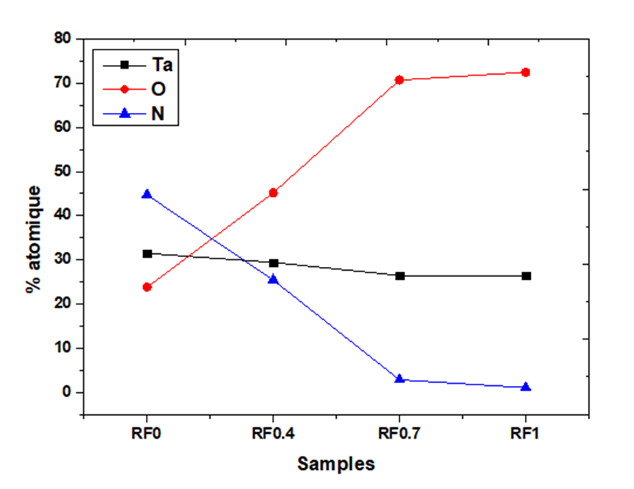
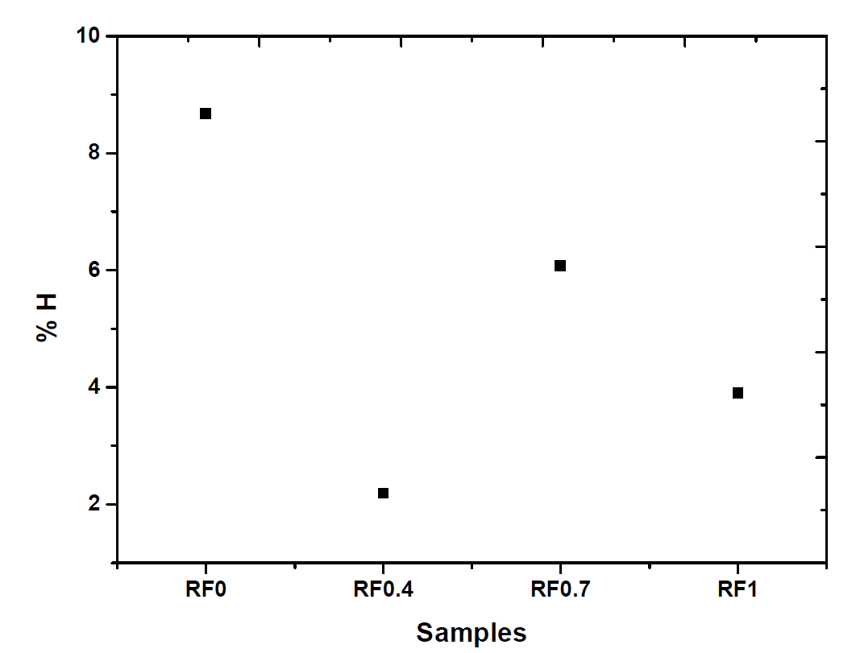
a
b

Figure 1 : Atomic contents (a) according to RBS and NRA, and hydrogen percentage (b) according to ERDA, depending on the flux ratio RF

    - Optical properties
Figure 2 shows the refractive indexes and extinction coefficients of the films at a wavelength of 632.8 nm. The RF0 sample is opaque, with a value of k near 1.25 and has the highest value of n (3.45). As RF increases, n and k decrease, making the samples transparent. This is due to the incorporation of oxygen into the films in that increasing RF is equivalent to increasing the oxygen content, as shown in the chemical composition. The values obtained for RF1 are very close to those obtained by Banakh et al. (2006) for ${Ta}_{2}O_{5}$ (n = 2.5 and k = 0).

The transmission (Figure 3a) and optical gap E_{g} (Figure 3b) curves were obtained by UV-Visible spectrophotometry. The maximum value of the transmission at 632.8 nm is 60%. This value indicates that RF0 has an oxide phase which affects the optical properties as nitrogen-rich materials have a transmittance of about 45% at 633 nm. From RF0.4, the materials are transparent, reaching a transmittance of more than 90% for RF1, as for ${Ta}_{2}O_{5}$ like materials. Eg increases with increasing RF due to the substitution of N atoms by O atoms in the growing film. For RF0, E_{g} is equal to 1.8 eV, which is higher than TaN values (Zoubian et al., 2011). E_{g} reaches a maximum of about 4.1 eV for RF1, a value close to that obtained by Banakh et al. (2006) for ${Ta}_{2}O_{5}$.

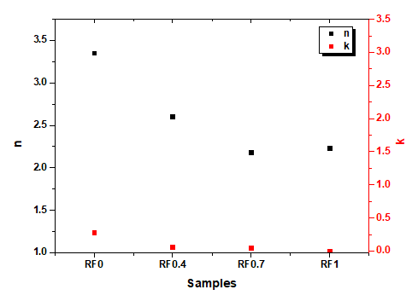

Figure 2 : Refractive index (n) and extinction coefficient (k) at 632.8 nm depending on the flux ratio RF

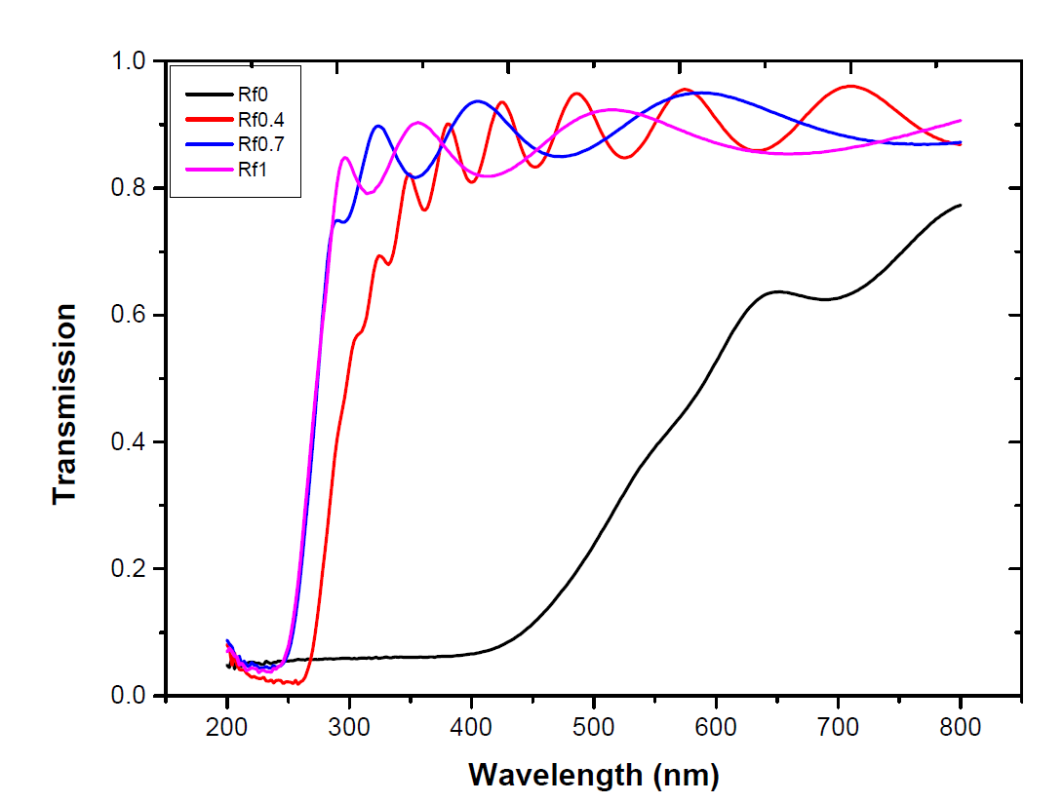
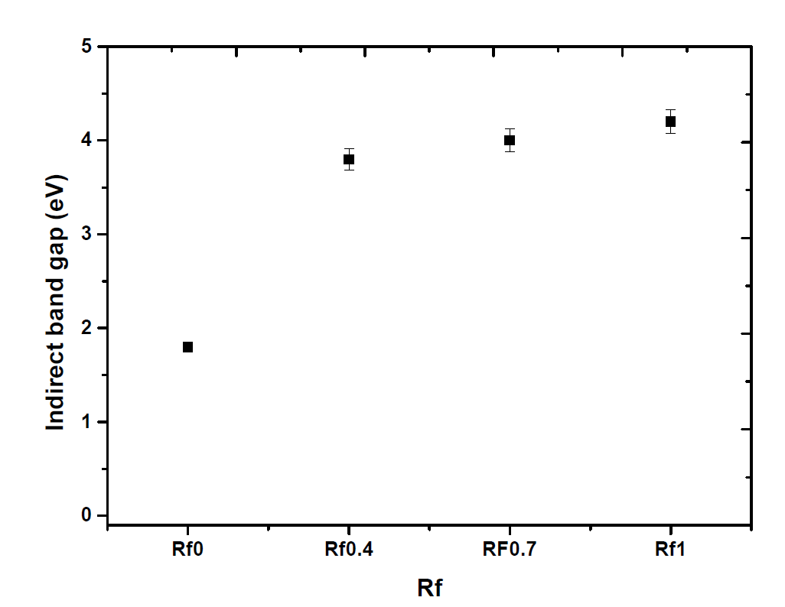
a
b

Figure 3 : Optical transmittance (a) and optical band gap (b) depending on the flux ratio RF

    - Structural characterization
The structural characterization is performed by PDF. The spectra obtained are presented in Figure 4. For sample RF0, we observed Ta-N bonds at 2.13 Å and 3.94 Å which may result from the ${Ta}_{3}N_{5}$ phase respectively. A Ta-Ta bond from the ${Ta}_{3}N_{5}$ phase was also observed at 3.18 Å. This suggests that this sample is close to ${Ta}_{3}N_{5}$. For samples RF0.4, RF0.7 and RF1, the Ta-O, O-O and again Ta-Ta bonds seem to indicate that this is a mixture of ${Ta}_{2}O_{5}$ and ${TaO}_{x}N_{y}$ phases. This is consistent with the stoichiometries obtained from the chemical analysis. The coherence domains of the materials are very limited, so the indexation of the peaks was done on a reduced range of distances. When the RF increases, the size of the domains decreases, which means that by substituting nitrogen by oxygen, one tends towards an amorphous compound.

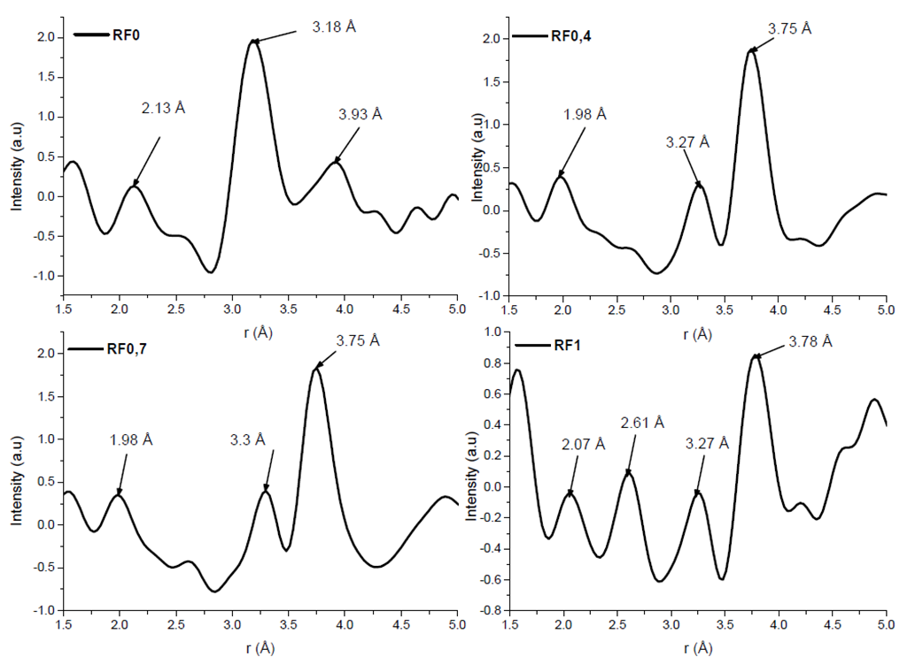

Figure 4 : PDF spectra showing distance and coherence domains of samples depending on the flux ratio RF

    - Optical simulations

To perform optical simulations, we used the optical indexes measured by ellipsometry. Figure 5 shows a simulation of the spectral reflectance of a W/W-SiCH bilayer on silicon (red curve), and that of a trilayer consisting of the same bilayer architecture on which a ${TaO}_{x}N_{y}$ RF0.7 layer was added (blue curve). The optical indexes of the W-SiCH absorbing layer were obtained from a sample synthesized at the PROMES laboratory, by sputtering a W target in a plasma of argon and TetraMethylSilane (TMS) on a silicon substrate previously heated to 350°C, and using 850 W of microwave power to assist the reactive sputtering (Danielle Ngoue, 2021; Diop et al., 2023). The TMS flow rate used was 4.5 sccm for a total gas flow rate in the reactor of 25 sccm. The yellow curve represents the solar spectrum, and the brown dashed curve represents the black body emission spectrum at 500°C. The addition of the antireflective layer reduces spectral reflectance, especially in the visible and near infrared range. Such modification of the reflectance has an impact on the optical properties, in particular on solar absorptance (Grosjean et al., 2018). This sample would thus make it possible to increase the rays transmitted to the absorbing layer and consequently to increase its absorbing capacity.

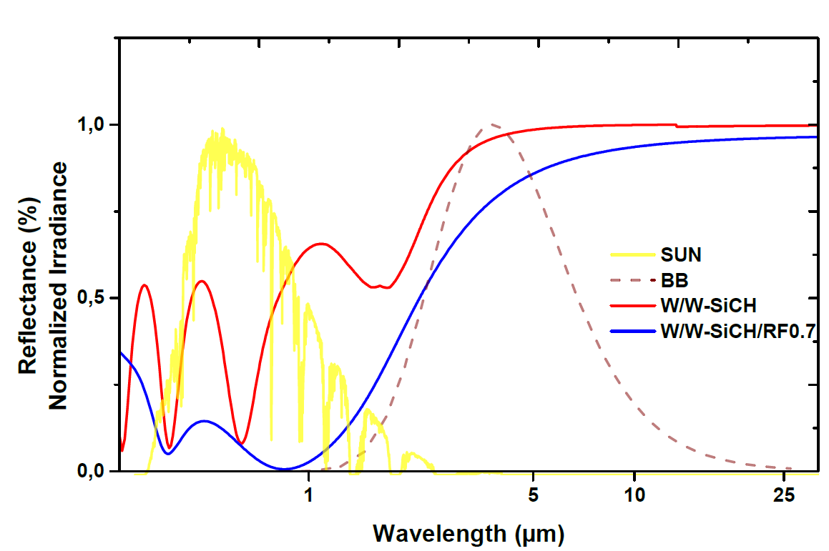

Figure 5 : Optical simulation of an absorbing layer and a stack of the absorbing layer and an additional antireflective layer
  - Conclusions
${TaO}_{x}N_{y}$ thin films were deposited by reactive magnetron sputtering of a tantalum target in an Ar/$N_{2}$/$O_{2}$ plasma. Chemical composition according to RBS reveals stoichiometries ranging from ${TaO}_{x}N_{y}$ to ${Ta}_{2}O_{5}$, depending on the flux ratio RF. Films with high oxygen content show high transparency, according to optical measurements performed by ellipsometry and UV-Visible spectroscopy. The optical band gap is ranging from 1.8 to 4.1 eV and increases with increasing RF (i.e., oxygen content). The optical simulations show that the addition of the RF0.7 antireflective layer, from the tantalum oxynitride range, on the W/W-SiCH absorbing layer increases the solar flux absorption by reducing reflectance in the visible range, due to the increased transmittance of the antireflective layer. This opens several study perspectives for improving the performance of solar radiation harvesting in concentrated solar power plants.

Acknowledgments

This work was financed by the French National Agency for Research (ANR) as part of the NANOPLAST project (award n°ANR-19-CE08-0019, nanoplast-project.cnrs.fr) and of the French “Investments for the future” program managed by ANR under contract ANR-10-LABX-22-01-SOLSTICE. The authors thank B. Diallo, C. Tavio-Geho, O. Wendling, A. Bellamy, A. Grosjean, and all the technical partners for their involvement.

References

Banakh, O., Steinmann, P.-A., Dumitrescu-Buforn, L., 2006. Optical and mechanical properties of tantalum oxynitride thin films deposited by reactive magnetron sputtering. Thin Solid Films 513, 136–141. https://doi.org/10.1016/j.tsf.2006.01.060
Bermel, P., Lee, J., Joannopoulos, J.D., Celanovic, I., Soljacie, M., 2012. SELECTIVE SOLAR ABSORBERS. Annual Rev Heat Transfer 15, 231–254. https://doi.org/10.1615/AnnualRevHeatTransfer.2012004119
Danielle Ngoue, 2021. Plasma deposited (nano)composites for solar energy conversion. University of Perpignan, Perpignan.
DeltaPsi2 Software - HORIBA [WWW Document], n.d. URL https://www.horiba.com/int/products/detail/action/show/Product/deltapsi2-software-1648/ (accessed 3.3.22).
Diop, A., Ngoue, D., Mahammou, A., Diallo, B., Plujat, B., Bousquet, A., Sauvage, T., Quoizola, S., Richard-Plouet, M., Hamon, J., Soum-Glaude, A., Tomasella, É., Thomas, L., 2023. Comprehensive study of WSiC:H coatings synthesized by microwave-assisted RF reactive sputtering. Surface and Coatings Technology 459, 129408. https://doi.org/10.1016/j.surfcoat.2023.129408
Gaillet, M., 2018. Tauc-Lorentz Dispersion Formula - Horiba preview / tauc-lorentz-dispersion-formula-horiba.pdf / PDF4PRO [WWW Document]. PDF4PRO. URL https://pdf4pro.com/fullscreen/tauc-lorentz-dispersion-formula-horiba-4b026b.html (accessed 3.24.23).
Grosjean, A., Soum-Glaude, A., Neveu, P., Thomas, L., 2018. Comprehensive simulation and optimization of porous SiO2 antireflective coating to improve glass solar transmittance for solar energy applications. Solar Energy Materials and Solar Cells 182, 166–177. https://doi.org/10.1016/j.solmat.2018.03.040
Grosjean, A., Soum-Glaude, A., Thomas, L., 2021. Replacing silver by aluminum in solar mirrors by improving solar reflectance with dielectric top layers. Sustainable Materials and Technologies 29, e00307. https://doi.org/10.1016/j.susmat.2021.e00307
Gurbich, A.F., 2016. SigmaCalc recent development and present status of the evaluated cross-sections for IBA. Nuclear Instruments and Methods in Physics Research Section B: Beam Interactions with Materials and Atoms 371, 27–32. https://doi.org/10.1016/j.nimb.2015.09.035
Li, J., Lu, Y., Lan, P., Zhang, X., Xu, W., Tan, R., Song, W., Choy, K.-L., 2013. Design, preparation, and durability of TiO2/SiO2 and ZrO2/SiO2 double-layer antireflective coatings in crystalline silicon solar modules. Solar Energy 89, 134–142. https://doi.org/10.1016/j.solener.2012.12.011
Mayer, M., 1999. SIMNRA, a simulation program for the analysis of NRA, RBS and ERDA, in: AIP Conference Proceedings. Presented at the The fifteenth international conference on the application of accelerators in research and industry, AIP, Denton, Texas (USA), pp. 541–544. https://doi.org/10.1063/1.59188
Pelletron et Cyclotron - EMIRA [WWW Document], n.d. URL https://emira.ijclab.in2p3.fr/pelletron-et-cyclotron/ (accessed 7.20.22).
Rubio, F., Denis, J., Albella, J.M., Martinez-Duart, J.M., 1983. Reactive sputtered Ta2O5 antireflection coatings. Solar cells 8, 263–268. https://doi.org/10.1016/0379-6787(83)90065-0
Wang Cong, Ning Yuping, Song Ping, Wu Yongxin, Xue Yafei, Liu Yu, Bousquet Angelique, Tomasella Eric, 2021. Solar Selective Absorbing Coatings Obtined by Physical Vapor Deposition : Overview of Different Strategies for Increasing Performance and Efficiency of Photothermal Conversion. Chemical Engineering Transactions 84, 31–36. https://doi.org/10.3303/CET2184006
Wang, M.T., Lin, Y.C., Chen, M.C., 1998. Barrier Properties of Very Thin Ta and TaN Layers Against Copper Diffusion. J. Electrochem. Soc. 145, 2538–2545. https://doi.org/10.1149/1.1838675
Zoubian, F., Tomasella, E., Bousquet, A., Sauvage, T., Eypert, C., 2011. Potential of TaOxNy thin films deposited by reactive sputtering as antireflective coatings: composition and optical properties. Advanced Materials Research 324, 73–76. https://doi.org/10.4028/www.scientific.net/AMR.324.73

