CHEMICAL ENGINEERING TRANSACTIONS  VOL. 82, 2020 | A publication of
The Italian Association
of Chemical Engineering
Online at www.cetjournal.it
Guest Editors: Selena Sironi, Laura Capelli
Copyright © 2020, AIDIC Servizi S.r.l.
ISBN 978-88-95608-80-8; ISSN 2283-9216

Sustainable Odour and Greenhouse Gas Emissions Control in Wastewater Treatment Plant by Advanced Biotechnology-Based System
Vincenzo Senatore*^{,a}, Tiziano Zarraª, Rekich R. Pahunang^{b}, Giuseppina Olivaª, Vincenzo Belgiornoª, Florencio C. Ballesteros Jr.^{c}, Vincenzo Naddeoª
ª Sanitary Environmental Engineering Division (SEED), Department of Civil Engineering, University of Salerno, via Giovanni Paolo II, Fisciano, SA, Italy
^{b} Environmental Engineering Program, National Graduate School of Engineering, University of the Philippines, Diliman, Quezon City, Philippines
^{c} Department of Chemical Engineering, University of the Philippines, Diliman, Quezon City, 1101 Philippines

* vsenatore@unisa.it
Odours emissions from various facilities such as wastewater treatment plants (WWTPs), are becoming one of the main issues to face down for the plant operators to avoid complaints and potential impact, especially for the plants located nearby to the residential areas. The need to implement odour control strategies, for instance by using treatment technologies, is therefore a key point in the management of the plant. Moreover, in a world increasingly concerned about sustainability and environmental preservation, the identification of environmentally friendly odour treatment technologies is to be recommended and prescribed. The research presents the development of an advanced sustainable biotechnology-based control system able to treat odour and greenhouse gas emissions (GHG), with the aim to guarantee a sustainable process. The performance of the advanced biotechnology system is highlighted in terms of CO₂ capture and reduction, by analysing different operating conditions (e.g. inlet load; L/G liquid:gas ratio; light intensity etc.). The result shows that the technology can capture up to 80% of CO₂ concentration, but can be enhanced with correct and proper operation with the important parameters. The proposed advanced biotechnology system proves to be effective as a sustainable treatment process. The information presented in this research will be of interest to anyone involved with carbon capture and utilization (CCU) technology.
  - Introduction
Wastewater treatment plants (WWTPs) odours emissions is cause of annoyance and can affect the quality of life for the exposed population (Giuliani et al., 2012; Senatore et al., 2021b). Odour characterization, measurement and treatment are therefore requirements that must be implemented by plant managers to avoid complaints (Fasolino et al., 2016; Zarra et al., 2019). At present, the main odour treatment technologies used, however, cause significant greenhouse gases (GHG) emissions (Oliva et al., 2021).
The accumulation of the GHG in the atmosphere influences the abrupt changing of the climate (Naddeo et al., 2012). CO₂ is the main GHGs and contribute to global warming nearly 60% (Nejat et al., 2015). Accordingly, CO₂ concentration continues its rapid rise in 2019, with peak average values of 414.7 parts per million (ppm_{v}) in May (National Oceanic and Atmospheric Administration 2019). Thus, the need to avoid other CO₂ emissions in the air and adopt capture or storage methods from different sources is vital. One of the possible solutions to minimize GHG emissions such as CO₂ are microalgae–based environmental technologies. It offers an attractive and reliable alternative to conventional technologies to capture CO₂ from wastewater treatment plants (Wu et al., 2018; Zarra et al., 2012), and waste gases from industrial plants (Oliva et al., 2018). The fixation of CO₂ through photosynthesis by microalgae pronounced its potential as it yields added value product like biofuel. It is an alternative to plant crops which does not required large area of land for the production of biofuel, and significant to reduce GHG emissions by replacing fossil fuel. On the other hand, the microalgae-based technologies can also be integrated to wastewater and flue gas mitigation alongside of the production of the biomass (Nayak et al. 2016). It is used for the removal of organic and inorganic nutrients, metals (Gentili, 2014), and aromatic compounds (Anbalagan et al., 2017). Atmospheric CO₂ can be used for the growth of the microalgae, but the concentration is limited thus the algal production. A high concentration of CO₂ can be a good source of the high production of the biomass, however it lowers the pH value of the algal medium (Canon-Rubio et al., 2016), which can also be a limiting factor of the algal growth. The direct aeration of high concentration of CO₂ inhibit the algal cultivation (Mohsenpour & Willoughby, 2016). This may race a question as to how CO₂ will feed into the system, hence a study suggest to inject CO₂ in the separate absorption column with fresh cultivation media as it helps to dissolve CO₂ (Chisti, 2016). Another inhibitory factor of the CO₂ capture efficiency is the high concentration of oxygen (O₂) which is form as the by-product of the photosynthesis. With the high presence of O₂ is a high and low CO₂ concentration, RuBisCO (Ribulose-1,5-bisphosphate carboxylase/oxygenase) acts as oxygenase and catalyze photorespiration reaction which result to the production of 2-carbon molecule phosphoglycolate then inhibit the CO₂ fixation during the photosynthesis (BB Jana 2019). The high O₂ production during the photosynthesis is advantage and it is of high interest to biodegrade aromatic compounds through oxidation. On the other hand, this can also be solved by integrating bacteria in the system which can utilize O₂ that forms during photosynthesis which is significant to treat aromatic compounds (Oliva et al., 2019; Senatore et al., 2020). In this study, an advanced sustainable biotechnology-based control system that combined an absorption column and PBR (photobioreactor) is presented and explored to capture CO₂, evaluate the biomass production and asses the O₂ production. The investigation of the technology is carried out with the aim to capture CO₂, produce biomass and to biodegrade aromatic substances, treating highly odorous compounds, in a vision of highly environmental sustainability.
  - Material and Methods
    - Microalgae and culture medium
Microalgae strain Chlorella vulgaris (CCAP 211/11B) was ordered from the Culture Collection of Algae and Protozoa (CCAP) located at the Scottish Association for Marine Science, Scotland. The Chlorella vulgaris was pre-inoculated for 7 days using the modified Bold Basal Medium solution with the following composition: a stocks solution per 400 mL of (1) 10.0 g of NaNO₃; (2) 3.0 g of MgSO₄·7H₂O; (3) 1.0 g of NaCl; (4) 3.0 g of K₂HPO₄; (5) 7.0 g of KH₂PO₄; (6) 1.0 g of CaCl₂·2H₂O; (7) trace elements solution (g/L); ZnSO₄·7H₂O (8.82 g), MnCl₂·4H₂O (1.44 g), (NH₄)₆MO₇)₄·4H₂O (0.87 g), CuSO₄·5H₂O (1.57 g), CoCl₂·6H₂O (0.38); (8) H₃BO₃ 11.42 g/L; (9) 50.0 g/L of EDTA and 31.0 g/L of KOH; and (10) 4.98 g/L of FeSO₄·7H₂O.
    - Experimental set-up and operating condition
In Figure 1 is reported the experimental set-up composed by a PBR (photobioreactor) made of Plexiglas with a working volume of 40 L and a absorption column made of PVC with a volume of 7 L. As reported in Table 1, three different concentration of pure CO₂ gas (5,10 and 15%) were mixed with the atmospheric air regulated with a flow meter (100 mL/min) and was feed in the system starting from the absorption column and subsequently injected to the PBR.
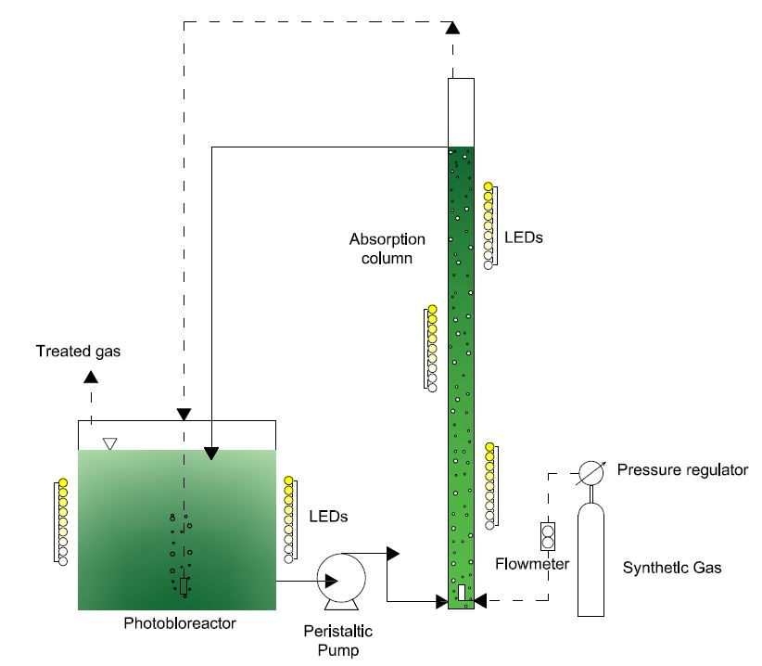
Figure 1: Schematic diagram of the experimental set-up.

The light sources are from the LED bulb with the light intensity of up to 120 µmol m⁻² s⁻¹. A dark-light cycle of 12:12 hours was chosen. The mixture of CO₂ gas and atmospheric air was feed in the system for 8 h (during the 12 hours of light period) and with constant monitoring of inlet load to make sure the precise concentration of CO₂. The system was filled with Bold’s Basal Medium (BBM) and C. vulgaris with a working volume of 40 L, and with the continuous mixing using a magnetic stirrer. The BBM was recirculated using a peristaltic pump from the PBR going to the column and back to the PBR. Three L/G (liquid recirculation: gas flow rate) ratio 2.5, 5 and 10 were used.
In starting the experiment, the culture was pre-adapted with 5% of CO₂ gas to overcome the environmental stress. The initial pH was 7 and it was being monitored insuring the alkalinity of the medium. Liquid samples were taken three times per day for the measurement of total suspended solid (TSS), dissolved oxygen (DO), temperature and pH.
Table 1: Operational conditions evaluated in the photobioreactor.
Stage | CO₂ [%] | EBRT [min] | Q_{gas} [ml·min⁻¹] | Q_{liq} [ml·min⁻¹] | L/G | Light Intensity [µmol·m⁻²·s⁻¹]
I | 5 | 400 | 100 | 250 | 2.5 | 50
II | 5 | 400 | 100 | 500 | 5 | 90
III | 10 | 400 | 100 | 1000 | 10 | 120
IV | 15 | 400 | 100 | 1000 | 10 | 120

    - Analytical method
The measurement of CO₂ concentration was determined using the gas analyzer GA 2000 (Geotechnical instrument). The pH, DO, temperature and conductivity were measured using the multiparameter probe (Hanna HI9829 Multiparameter) while the turbidity was measured using 2100N Turbidimeter-Hach. The biomass concentration was determined by getting the total suspended solids (TSS) according to the standard method 2540 D.
  - Results and Discussion
    - Microalgae production
During the first (I) and second (II) stage the best algae growth conditions were obtained, after that other two stages were performed. In stage II the mineral medium BBM was modified in order to balance the increased carbon load and the nutrients. The third (III) and the fourth (IV) stage were carried out by feeding respectively 10 and 15 % of CO₂ concentrations into the photo-bioreactor. Each stage was performed for 5 days, and the amount of microalgae biomass observed daily at various stages is presented in Figure 2. According to this diagram, it can be seen that by increasing the light intensity from 50 (Stage I) to 120 µmol m⁻² s⁻¹ (Stage III), the microalgae biomass also increased.
Microalgae are photoautotrophic organism, it need light (as energy source) for the biofixation of inorganic carbon sources (e.g. carbon dioxide). Figure 2 shows that in the IV stage a biomass concentration of 742 mg l⁻¹ was achieved at the CO₂ concentration of 15% and 120 µmol m⁻² s⁻¹. Chlorella vulgaris strains are capable of producing high-valuable compounds, which can contribute to the economic sustainability of the photosynthetic CO₂ fixation and utilization process (Senatore et al., 2021a). Carbohydrates, protein and lipids accumulation triggered by nitrogen starvation is an effective ways to obtain added-value biomass (Toledo-Cervantes et al., 2018). Carbohydrate, protein and lipids content in C. vulgaris are 7 ± 1%, 8 ± 2% and 15 ± 3%, respectively (Kong et al., 2013).

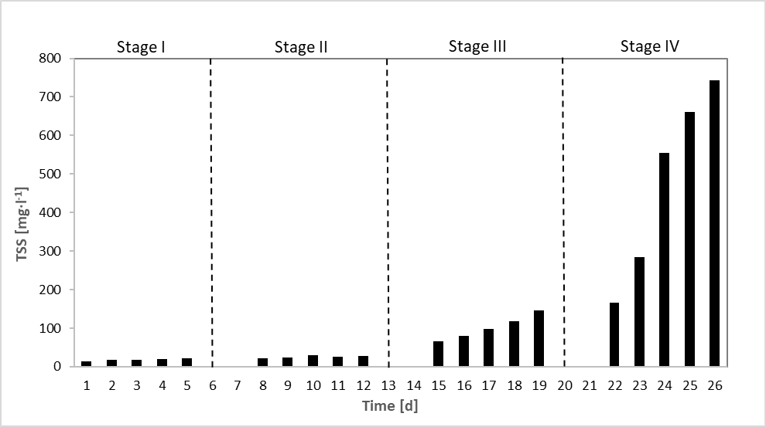
Figure 2: Chlorella Vulgaris biomass concentration during the different stages.
    - Influence of CO₂ on TSS, pH and dissolved oxygen
Changing the pH caused precipitation of dissolved salts and reduce the accessibility of nutrients for the microalgae cells. Different CO₂ concentration have been used. In Figure 3 the pH versus time is plotted during the four different stages, and as it can be seen, at higher microalgae biomass the pH increase. Also, after the weekend, when the feeding of CO₂ is suspended, the pH increased. It confirmed that the high supplied CO₂ might not have been efficiently used by the microalga cells and it can be led to an acidification of the culture medium. Therefore, lower CO₂ levels can be a limitation factors for the growth of the algae. The final biomass concentration and maximum biomass productivity of Chlorella vulgaris were also significantly influenced by the CO₂ concentration supplied into the photo-bioreactor. In fact, as can be seen in Figure 2, the faster growth in the last two stages (III and IV) could be related to the increased availability of carbon as a result of the higher dissolved inorganic carbon (CO₂, H₂CO₃, HCO₃⁻ and CO₃²⁻) concentration. The DO slightly increased in the Stages III and IV reaching value of 8.5 mg l⁻¹, this can be explained thanks to the boosted in the biomass production. Microalgal cells consumed more CO₂ as inorganic carbon source and produced more oxygen as by-product of photosynthesis.

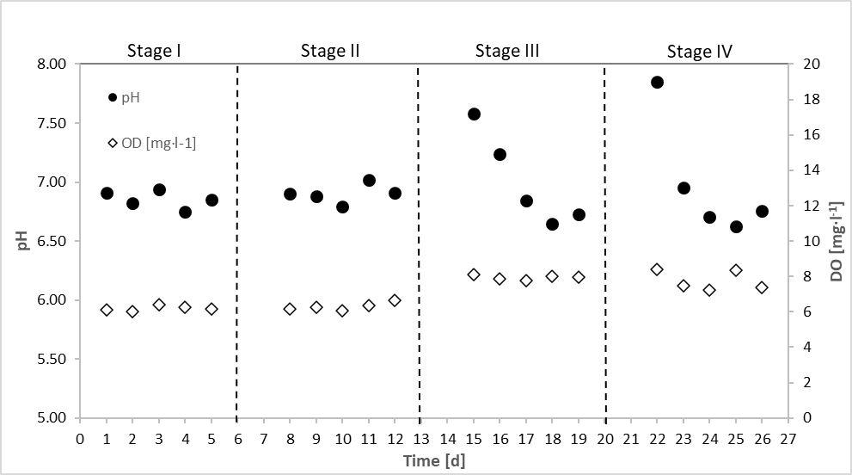
Figure 3: Time course of DO and pH during the different stages.
    - CO₂ removal
Figure 4 reports the results in terms of elimination capacity (EC) and removal efficiency (RE) as function of the inlet load of CO₂ (IL) during the whole operation period.
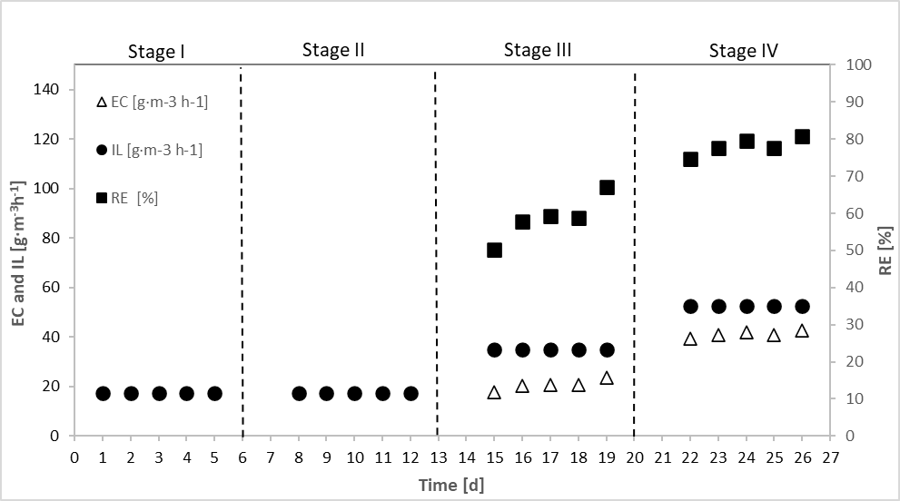
Figure 4: Time course of RE, IL and EC of CO₂ during the different stages.
During the first (I) and second (II) stage, a concentration of 5% of CO₂ was supplied during the acclimation period. As reported in Figure 4, during the third (III) and forth (IV) stages a higher CO₂ concentration was supplied, respectively 10 and 15 %, corresponding to an inlet load (IL) of 35.10 and 52.65 g m⁻³h⁻¹, respectively. The L/G ratio was adjusted at 10, corresponding to a liquid recirculation from the photo-bioreactor and the vertical adsorption column of 1000 ml min⁻¹ and a gas flow of 100 ml min⁻¹. During the III stage, for an IL up to 35.10 g m⁻³ h⁻¹ a 67.1% capture of CO₂ was achieved with a biomass concentration of 145.7 mg l⁻¹. When a microalga biomass concentration of 742.7 mg l⁻¹ was achieved, a removal efficiency of 80.8 % was obtained, at an IL of 52.65 g m⁻³ h⁻¹.
  - Conclusions
CO₂ removal efficiency (RE) by Chlorella vulgaris was boosted through obtaining the best condition in an advanced sustainable biotechnology-based control system considering four parameters: pH, light intensity, inlet load and liquid recirculation rate. The results highlighted that by increasing the CO₂ concentration from 5% to 15%, the maximum concentration of biomass and CO₂ removal efficiency (RE) were increased up to 742 mg l⁻¹ and 80.8 %, respectively. The maximum CO₂ elimination capacity (EC) of Chlorella vulgaris at CO₂ concentration of 15% was 42.5 g m⁻³ h⁻¹. Finally, an optimal L/G ratio of 10 in the absorption column allowed increasing both CO₂ capture and biomass productivity. Research shows a technology useful to capture CO₂ and to biodegrade aromatic substances such as volatile organic compounds (VOC) thanks to the oxidation capability of the microalgae, thus creating a highly environmental friendly system.
References
Anbalagan, A., Toledo-Cervantes, A., Posadas, E., Rojo, E. M., Lebrero, R., González-Sánchez, A., Nehrenheim, E., & Muñoz, R. (2017). Continuous photosynthetic abatement of CO 2 and volatile organic compounds from exhaust gas coupled to wastewater treatment: Evaluation of tubular algal-bacterial photobioreactor. Journal of CO2 Utilization, 21(July), 353–359. https://doi.org/10.1016/j.jcou.2017.07.016
BB, J. (2019). CO2 Mitigation Potentials of Microalgae: Its Expansion to a New Dimension for Closing the Loop of Carbon Between Source and Acquisition Through Food Chain of Phytophagous Fish in Open Ponds. Advances in Biotechnology & Microbiology, 12(1). https://doi.org/10.19080/aibm.2019.12.555827
Canon-Rubio, K. A., Sharp, C. E., Bergerson, J., Strous, M., & De la Hoz Siegler, H. (2016). Use of highly alkaline conditions to improve cost-effectiveness of algal biotechnology. Applied Microbiology and Biotechnology, 100(4), 1611–1622. https://doi.org/10.1007/s00253-015-7208-7
Chisti, Y. (2016). Large-Scale Production of Algal Biomass: Raceway Ponds BT - Algae Biotechnology: Products and Processes (F. Bux & Y. Chisti (Eds.); pp. 21–40). Springer International Publishing. https://doi.org/10.1007/978-3-319-12334-9_2
Fasolino I, Grimaldi M, Zarra T, & Naddeo V. (2016). Odour Control Strategies for a Sustainable Nuisances Action Plan. Global NEST Journal.
Gentili, F. G. (2014). Microalgal biomass and lipid production in mixed municipal, dairy, pulp and paper wastewater together with added flue gases. Bioresource Technology, 169, 27–32. https://doi.org/https://doi.org/10.1016/j.biortech.2014.06.061
Giuliani, S., Zarra, T., Nicolas, J., Naddeo, V., Belgiorno, V., & Romain, A. C. (2012). An alternative approach of the e-nose training phase in odour impact assessment. Chemical Engineering Transactions. https://doi.org/10.3303/CET1230024
Kong, W. B., Yang, H., Cao, Y. T., Song, H., Hua, S. F., & Xia, C. G. (2013). Effect of glycerol and glucose on the enhancement of biomass, lipid and soluble carbohydrate production by Chlorella vulgaris in mixotrophic culture. Food Technology and Biotechnology, 51(1), 62–69.
Mohsenpour, S. F., & Willoughby, N. (2016). Effect of CO2 aeration on cultivation of microalgae in luminescent photobioreactors. Biomass and Bioenergy, 85, 168–177. https://doi.org/10.1016/j.biombioe.2015.12.002
Naddeo, V., Zarra, T., Giuliani, S., & Belgiorno, V. (2012). Odour impact assessment in industrial areas. Chemical Engineering Transactions, 30(i), 85–90. https://doi.org/10.3303/CET1230015
National Oceanic and Atmospheric Administration (NOAA). (2019). Carbon dioxide levels in atmosphere hit record high in May Monthly average surpassed 414 ppm at NOAA ’ s Mauna Loa Observatory in Hawaii. May 2018.
Nayak, M., Karemore, A., & Sen, R. (2016). Sustainable valorization of flue gas CO2 and wastewater for the production of microalgal biomass as a biofuel feedstock in closed and open reactor systems. RSC Advances, 6(94), 91111–91120. https://doi.org/10.1039/C6RA17899E
Nejat, P., Jomehzadeh, F., Taheri, M. M., Gohari, M., & Muhd, M. Z. (2015). A global review of energy consumption, CO2 emissions and policy in the residential sector (with an overview of the top ten CO2 emitting countries). In Renewable and Sustainable Energy Reviews. https://doi.org/10.1016/j.rser.2014.11.066
Oliva, G., Zarra, T., Pittoni, G., Senatore, V., Galang, M. G., Castellani, M., Belgiorno, V., & Naddeo, V. (2021). Next-generation of instrumental odour monitoring system (IOMS) for the gaseous emissions control in complex industrial plants. Chemosphere. https://doi.org/10.1016/j.chemosphere.2021.129768
Oliva, Giuseppina, Ángeles, R., Rodríguez, E., Turiel, S., Naddeo, V., Zarra, T., Belgiorno, V., Muñoz, R., & Lebrero, R. (2019). Comparative evaluation of a biotrickling filter and a tubular photobioreactor for the continuous abatement of toluene. Journal of Hazardous Materials, 380(April), 120860. https://doi.org/10.1016/j.jhazmat.2019.120860
Oliva, Giuseppina, Zarra, T., Naddeo, V., Munoz, R., Lebrero, R., Angeles, R., Belgiorno, V., Ángeles, R., & Belgiorno, V. (2018). Comparative Analysis of AOPs and Biological Processes for the Control of VOCs Industrial Emissions. Chemical Engineering Transactions, 68, 451–456. https://doi.org/10.3303/CET1868076
Senatore, V, Zarra, T., Oliva, G., Belgiorno, V., & Naddeo, V. (2020). Volatile organic compounds (VOCs) control by combining bio-scrubber and ozone pretreatment. Global NEST JournalGlobal NEST: The International Journal, 22(2), 143–146. https://doi.org/10.30955/gnj.003298
Senatore, Vincenzo, Buonerba, A., Zarra, T., Oliva, G., Belgiorno, V., Boguniewicz-Zablocka, J., & Naddeo, V. (2021)a. Innovative Membrane Photobioreactor for Sustainable CO2 Capture and Utilization. Chemosphere. https://doi.org/10.1016/j.chemosphere.2021.129682
Senatore, Vincenzo, Zarra, T., Buonerba, A., Ho, K., Shadi, C., & Gregory, W. H. (2021)b. Indoor versus outdoor transmission of SARS ‑ COV ‑ 2 : environmental factors in virus spread and underestimated sources of risk. Euro-Mediterranean Journal for Environmental Integration, 1–9. https://doi.org/10.1007/s41207-021-00243-w
Toledo-Cervantes, A., Morales, T., González, Á., Muñoz, R., & Lebrero, R. (2018). Long-term photosynthetic CO 2 removal from biogas and flue-gas: Exploring the potential of closed photobioreactors for high-value biomass production. Science of the Total Environment, 640–641, 1272–1278. https://doi.org/10.1016/j.scitotenv.2018.05.270
Wu, X., Zhou, C., Li, K., Zhang, W., & Tao, Y. (2018). Probing the fouling process and mechanisms of submerged ceramic membrane ultrafiltration during algal harvesting under sub- and super-critical fluxes. Separation and Purification Technology, 195(August 2017), 199–207. https://doi.org/10.1016/j.seppur.2017.12.001
Zarra, T, Reiser, M., Naddeo, V., Belgiorno, V., & Kranert, M. (2012). A comparative and critical evaluation of different sampling materials in the measurement of odour concentration by dynamic olfactometry. Chemical Engineering Transactions, 30, 307–312.
Zarra, Tiziano, Galang, M. G., Ballesteros, F., Belgiorno, V., & Naddeo, V. (2019). Environmental odour management by artificial neural network – A review. Environment International, 133(May), 105189. https://doi.org/10.1016/j.envint.2019.105189

