|  |  |
| --- | --- |
| cetlogo ***CHEMICAL ENGINEERING TRANSACTIONS***  ***VOL. , 2024*** | A publication of  aidiclogo_grande |
| The Italian Association  of Chemical Engineering  Online at www.cetjournal.it |
| Guest Editors:  Copyright © 2023, AIDIC Servizi S.r.l. **ISBN** 979-12-81206-XX-X; **ISSN** 2283-9216 | |

Sensitivity analysis of odour exposure from dispersion modelling exercises with different peak-to-mean ratio

Massimo Bressan\*, Alberto Dalla Fontana, Barbara Intini, Rodolfo Bassan, Ugo Pretto, Loris Tomiato

ARPAV, Unità Organizzativa Qualità dell'Aria, UMAVO, Via Santa Barbara 5/a - 31100 Treviso, Italy

\*massimo.bressan@arpa.veneto.it

The odour impact assessment of an anonymized case study revealed occasionally conflicting results when utilizing two model systems, CALPUFF and LAPMOD, with different peak-to-mean ratio (PMR) configurations. Implementing a dynamic PMR with a shorter peak time showed more conservative evaluations in the near-field but resulted in opposite outcomes in the far-field. The choice of model and the approach employed to estimate PMR significantly affected the determination of separation distances and the protection level, highlighting the potential risk for inconsistent conclusions, particularly within regulatory contexts. Increased awareness is crucial for both practitioners and regulators on the consequences of a specific model configuration in odour impact assessments. Achieving consistency in modelling exercises and ensuring an adequate level of protection for sensible receptors remains challenging, highlighting the importance of a strong commitment to reproducibility for effectively quantify uncertainties in odour impact assessments.

* 1. Rationale, scope and motivation

The paramount importance of modelling in the process of odour assessment has been recently emphasized by international experts (Amigo & Olores org, 2023) and, in Italy, by the enactment of a new regulation by the Ministry of Environment (2023). However, there exists little agreement, not only among practitioners but also by local regulatory authorities, regarding the selection of the dispersion models and their optimal fine-tuning.

A critical and still partly unresolved issue is determining the most effective approach to estimate the short-term peak odour concentrations. Recent literature and evidence-based experience suggest that, aside from a handful of promising approaches still in active development, tridimensional Lagrangian puff and particle models are emerging as the preferred choice from an operational standpoint for tackling the challenges of the odour exposure assessment (Amigo & Olores org, 2023). Atmospheric dispersion modelling applications within permitting procedures are typically dealing with the compliance of air quality standards over 1 h.

On the other hand, odour nuisances at receptors occur with a frequency relatively high as human breath, lasting an average of 1 s but conventionally assumed of 5 s. Odour impact assessment needs the accurate reconstruction of short-term concentrations (Capelli et al., 2013) and this entails conceiving a method to estimate odour fluctuations or applying a statistical scaling factor to obtain the odour peak value.

Within this operational framework, the primary objective of the present study is not novel (Invernizzi et al., 2020, Brancher et al., 2020) but aims to offer additional insights into the variability of results from modelling exercises implementing different PMRs. The adoption of a static PMR equal to 2.3, as first defined by the Lombardy Region (2012), represents in Italy a widely accepted operational approach within practitioners as it is, moreover, often explicitly requested by regulatory authorities. It was originally conceived as a clear-cut solution aimed at ensuring consistency and simplicity but, as it will be shown in this study, it can lead to potential biases in assessing odor impact at specific receptors.

* 1. **The study plot, materials and methods**

In an anonymized case study featuring an elevated point source with a continuous and constant emission rate, located within a moderately complex domain, two model systems were employed: CALPUFF, a Lagrangian puff model (Scire et al., 2001), and LAPMOD, a Lagrangian particle model (Bellasio et al., 2017). Both model systems utilized three-dimensional wind and temperature fields, along with the full array of two-dimensional micro-meteorological fields generated by the CALMET pre-processor (Scire et al., 2000).

A meteorological domain of 10 km by 10 km (mesh size 250 m), and a sampling domain of 5 km by 5 km (mesh size 50 m), were considered. Additionally, a transect of 25 discrete receptors positioned at a height of 2 m above ground level was deployed, evenly spaced at intervals of 100 m in both the x and y directions, along the SW transport direction (225 °N), opposite to the prevailing winds.

All model simulations considered the activity over a whole year of a buoyant point source with a stack height of 22.5 m and a diameter of 1 m, temperature and exit velocity of effluents at 50 °C and 13 m/s respectively, and a continuous stationary odour flow rate of 24,000 uoE/s.

Both CALPUFF and LAPMOD were run in different configurations by varying the methods and parameters to estimate the PMRs.

CALPUFF (v. 5.8.5) was utilized with all default parameters, except for the method to compute dispersion coefficients, which relied on micro-meteorological variables (MDISP = 2). Since it does not offer specific methods to evaluate sub-hourly peak odour concentrations, aside from applying a uniform and constant post-processing scaling factor to 1 h model output, it was used as reference for the static PMR = 2.3 scheme. Throughout the text, tables, and figures, the CALPUFF run will be shortly referenced with the label "s\_2.3".

The optimal setup for LAPMOD (v. 20230331) was determined by a comprehensive sensitivity analysis of results from a previous case study (ARPAV, 2023) and then varied across six different configurations with alternative PMR estimation.

LAPMOD runs (configurations and corresponding outputs) will be throughout the text referenced with:

1. "s\_avg\_2.3": this configuration utilized static PMR, a scaling factor of value 2.3 applied to the mean of 1 h odour concentration from 6 sub-hourly samples at 10 min intervals (with sampling frequency set by the user); it closely mirrors the CALPUFF "s\_2.3" run as in fact, both of them, involve the application of a static PMR (i.e. a scaling factor 2.3 applied to 1 h model output);
2. "s\_max\_1.6": similarly, this configuration employed static PMR but with a constant of 1.6 applied to the maximum value of odour concentrations from 6 sub-hourly samples (as above);
3. "d\_avg\_5s": in this configuration, dynamic PMR was employed with a user-defined peak time of 5 s determining a scaling factor internally calculated by the model and applied to the mean of 6 concentration sub-samples (10 min) within each hour of simulation;
4. "d\_max\_5s": this configuration also utilizes dynamic PMR with user-defined peak time of 5 s; however, in this case, the scaling factor was applied to the maximum value of odour concentrations from 6 sub-hourly samples within each hour of simulation;
5. "d\_avg\_60s": this configuration used a dynamic PMR but with a user-defined peak time of 60 s, applied to the mean odour concentration of 6 sub-hourly samples.
6. “d\_max\_60s”: a dynamic PMR with a user defined peak time of 60 s but applied to the maximum value of odour concentrations from 6 sub-hourly samples.

In LAPMOD configurations 3 to 6 the dynamic PMR was internally calculated by the model.

The initial PMR, at the time of particle emissions, was determined by Smith's power law (1973) with an exponent *u*, as in Eq(1), depending on atmospheric stability and following the scheme by Schauberger et al. (2012).

|  |  |
| --- | --- |
| $$\frac{C_{p}}{C_{m}}={\left(\frac{t_{m}}{t_{p}}\right)}^{u}$$ | (1) |

Subsequent downwind PMR, at each time step of particle movement, was computed through the exponential attenuation by Milne & Mason (1991) that depends on the ratio of travel time over Lagrangian time.

In LAPMOD "s\_max\_1.6", the static PMR of value 1.6 was chosen to compensate for the selection of the maximum value rather than the mean from the 6 sub-hourly concentration samples, and therefore referring to an averaging time *tm* = 600 s, instead of 3600 s (1 h). The peak time *tp* is a user-defined parameter available just for the dynamic PMR configurations that defines the average time to which the peak odour concentration *Cp* is referred. A peak time of *tp* = 5 s, as in LAPMOD "d\_avg\_5s" and "d\_max\_5s," was selected to accommodate for the time lapse conventionally associated with a human breath (5 s).

By setting the final result of Smith's power law, *Cp/Cm*=2.3 and further incorporating an average time of *tm* = 3600 s (1 hour) and the empirical constant value *u* = 0.2 (as suggested in the CALPUFF user manual), it implied a peak time *tp* = 60 s. This concept drove the definition of LAPMOD "d\_avg\_60s" and "d\_max\_60s" configurations, where the resulting values were expected to align more closely with "s\_avg\_2.3" and "s\_max\_1.6" compared to configurations with a peak time *tp* = 5 s.

* 1. **Results**

Figure 1 displays the contour maps for the 98th percentile and maximum values of annual peak odour units calculated by the alternative model configurations under study. When considering the odour levels equal to 1 or 2 ouE/m3, it is evident that CALPUFF configuration "s\_2.3" delineates the smaller area within the model domain compared to LAPMOD configuration "s\_avg\_2.3.". This distinctive feature holds true for all LAPMOD configurations. The higher levels of peak odour units (*uoE/m3*) were estimated by LAPMOD configurations with a peak time of 5 s ("d\_avg\_5s", "d\_max\_5s"). Interestingly, but consistently with the model's algorithm, peak odour concentrations estimated by LAPMOD configurations using the maximum value of sub-hourly samples were significantly lower compared to those using the average, for a given peak time.

In LAPMOD configurations with dynamic PMR, the higher the peak time the lower the peak odour concentrations, approaching asymptotically the values of static PMR ("s\_avg\_2.3") at higher distances from the source. Another significant observation from the cross-comparison of the contour maps in Figure 1 is that LAPMOD "s\_max\_1.6", "d\_max\_5s", and "d\_max\_60s" exhibit, to a different extents, some distinct hot spots of peak odour concentrations which seem to replicate the intermittent and short-range localization features of the ambient odour phenomenology.

At the 25 discrete receptors positioned downwind along the southwest transect, several metrics were calculated: the 98th percentile and the maximum value of the peak odour units [uoE/m3], the total number of exceedances for the threshold level of 1 uoE/m3, the number of episodes with consecutive exceedances, and the maximum duration of the episodes (in hours).

Table 1 presents, for the sake of brevity, these metrics just for the most impacted discrete receptor R1, located about 141 meters from source, downwind the SW transport direction (225 °N). Significant differences were evident in the magnitude of peak odour units (*uoE/m3*), with the highest level observed for a peak time of 5 s (LAPMOD “d\_avg\_5s”), and the lowest for CALPUFF static “s\_2.3”. Here, it is also worth noting again, the counter-intuitive feature that model configurations with average sampling returned higher peak odour concentrations than max sampling (for details refer to LAPMOD user manual).

Table 1: Statistics for the discrete receptor R1 along SW direction (225 °N) at 141 m distance from the source.

|  |  |  |  |  |  |  |
| --- | --- | --- | --- | --- | --- | --- |
| Model system | Label run | Max  [uoE/m3] | 98th percentile  [uoE/m3] | N. Exc. 1 h  - | N. Episodes  - | Max dur. Epis. [h] |
| CALPUFF | s\_2.3 | 5.3 | 1.8 | 596 | 330 | 8 |
| LAPMOD | s\_avg\_2.3 | 5.4 | 2.2 | 1663 | 811 | 11 |
| s\_max\_1.6 | 7.9 | 2.8 | 2074 | 949 | 14 |
| d\_avg\_5s | 55.0 | 23.7 | 2480 | 585 | 17 |
| d\_max\_5s | 45.5 | 12.9 | 2885 | 898 | 17 |
| d\_avg\_60s | 11.0 | 5.3 | 1611 | 570 | 12 |
| d\_max\_60s | 9.2 | 3.2 | 1940 | 862 | 14 |

In the upper panel of Figure 2 it is evident how LAPMOD configurations with dynamic PMR ("d\_avg\_5s" and "d\_avg\_60s"), estimated higher values of the 98th percentile of peak odour concentrations at discrete receptors in the near-field (at transport distance up to 400-800 m) compared to static PMR ("s\_avg\_2.3"). This difference amounted of an order of magnitude (Table 1). This trend reverses in the far-field where static PMR revealed higher peak odour concentrations than dynamic PMR, although the discrepancy was somehow negligible. The lower panel of Figure 2 illustrates how LAPMOD configurations “s\_max\_1.6”, “d\_max\_5s”, “d\_max\_60s”, with maximum value of odour concentrations from sub-hourly samples, showed a similar pattern but with a shift of about 200 meters towards the emitting source.

The separation distance can be described as the direction-dependent measure originating from the source and delineating the area of the domain within which odour impact is expected to be constrained at a given level of protection (Piringer et al., 2015, Brancher et al., 2019).

The separation distances for LAPMOD configurations in Figure 3 were determined upon the 98th percentile of peak odour concentrations for transport directions with angles set in increments of 1° N. Focusing on the protection level of 1 uoE/m3, the upper left panel of Figure 3 shows how the configuration "d\_avg\_5s" achieved the maximum separation distance, reaching up 650 m in the transport direction 225 °N (along the downwind transect of discrete receptors). The LAPMOD configurations "s\_avg\_2.3" and “d\_avg\_60s” respectively estimated lower separation distances but with a pattern dependent on the transport direction: "d\_avg\_60s" showed higher values than "s\_avg\_2.3" at angles lower than 90 °N or greater than 250 °N.

In the lower left panel of Figure 3 presenting LAPMOD configurations with PMR derived from the maximum value of sub-hourly samples, the static configuration "s\_max\_1.6" showed the highest separation distance, up to 1,200 m from the source, along the transport direction of 225 °N. The dynamic PMR "d\_max\_5s" and "d\_max\_60s" with peak time of 5 s and 60 s respectively, estimated lower separation distances but with some relevant exceptions depending on the transport direction. It can be said that, as far as the protection level of 1 uoE/m3 is of concern, “s\_max\_1.6” revealed as the most precautionary configuration, at least along the downwind transport direction of 225 °N.

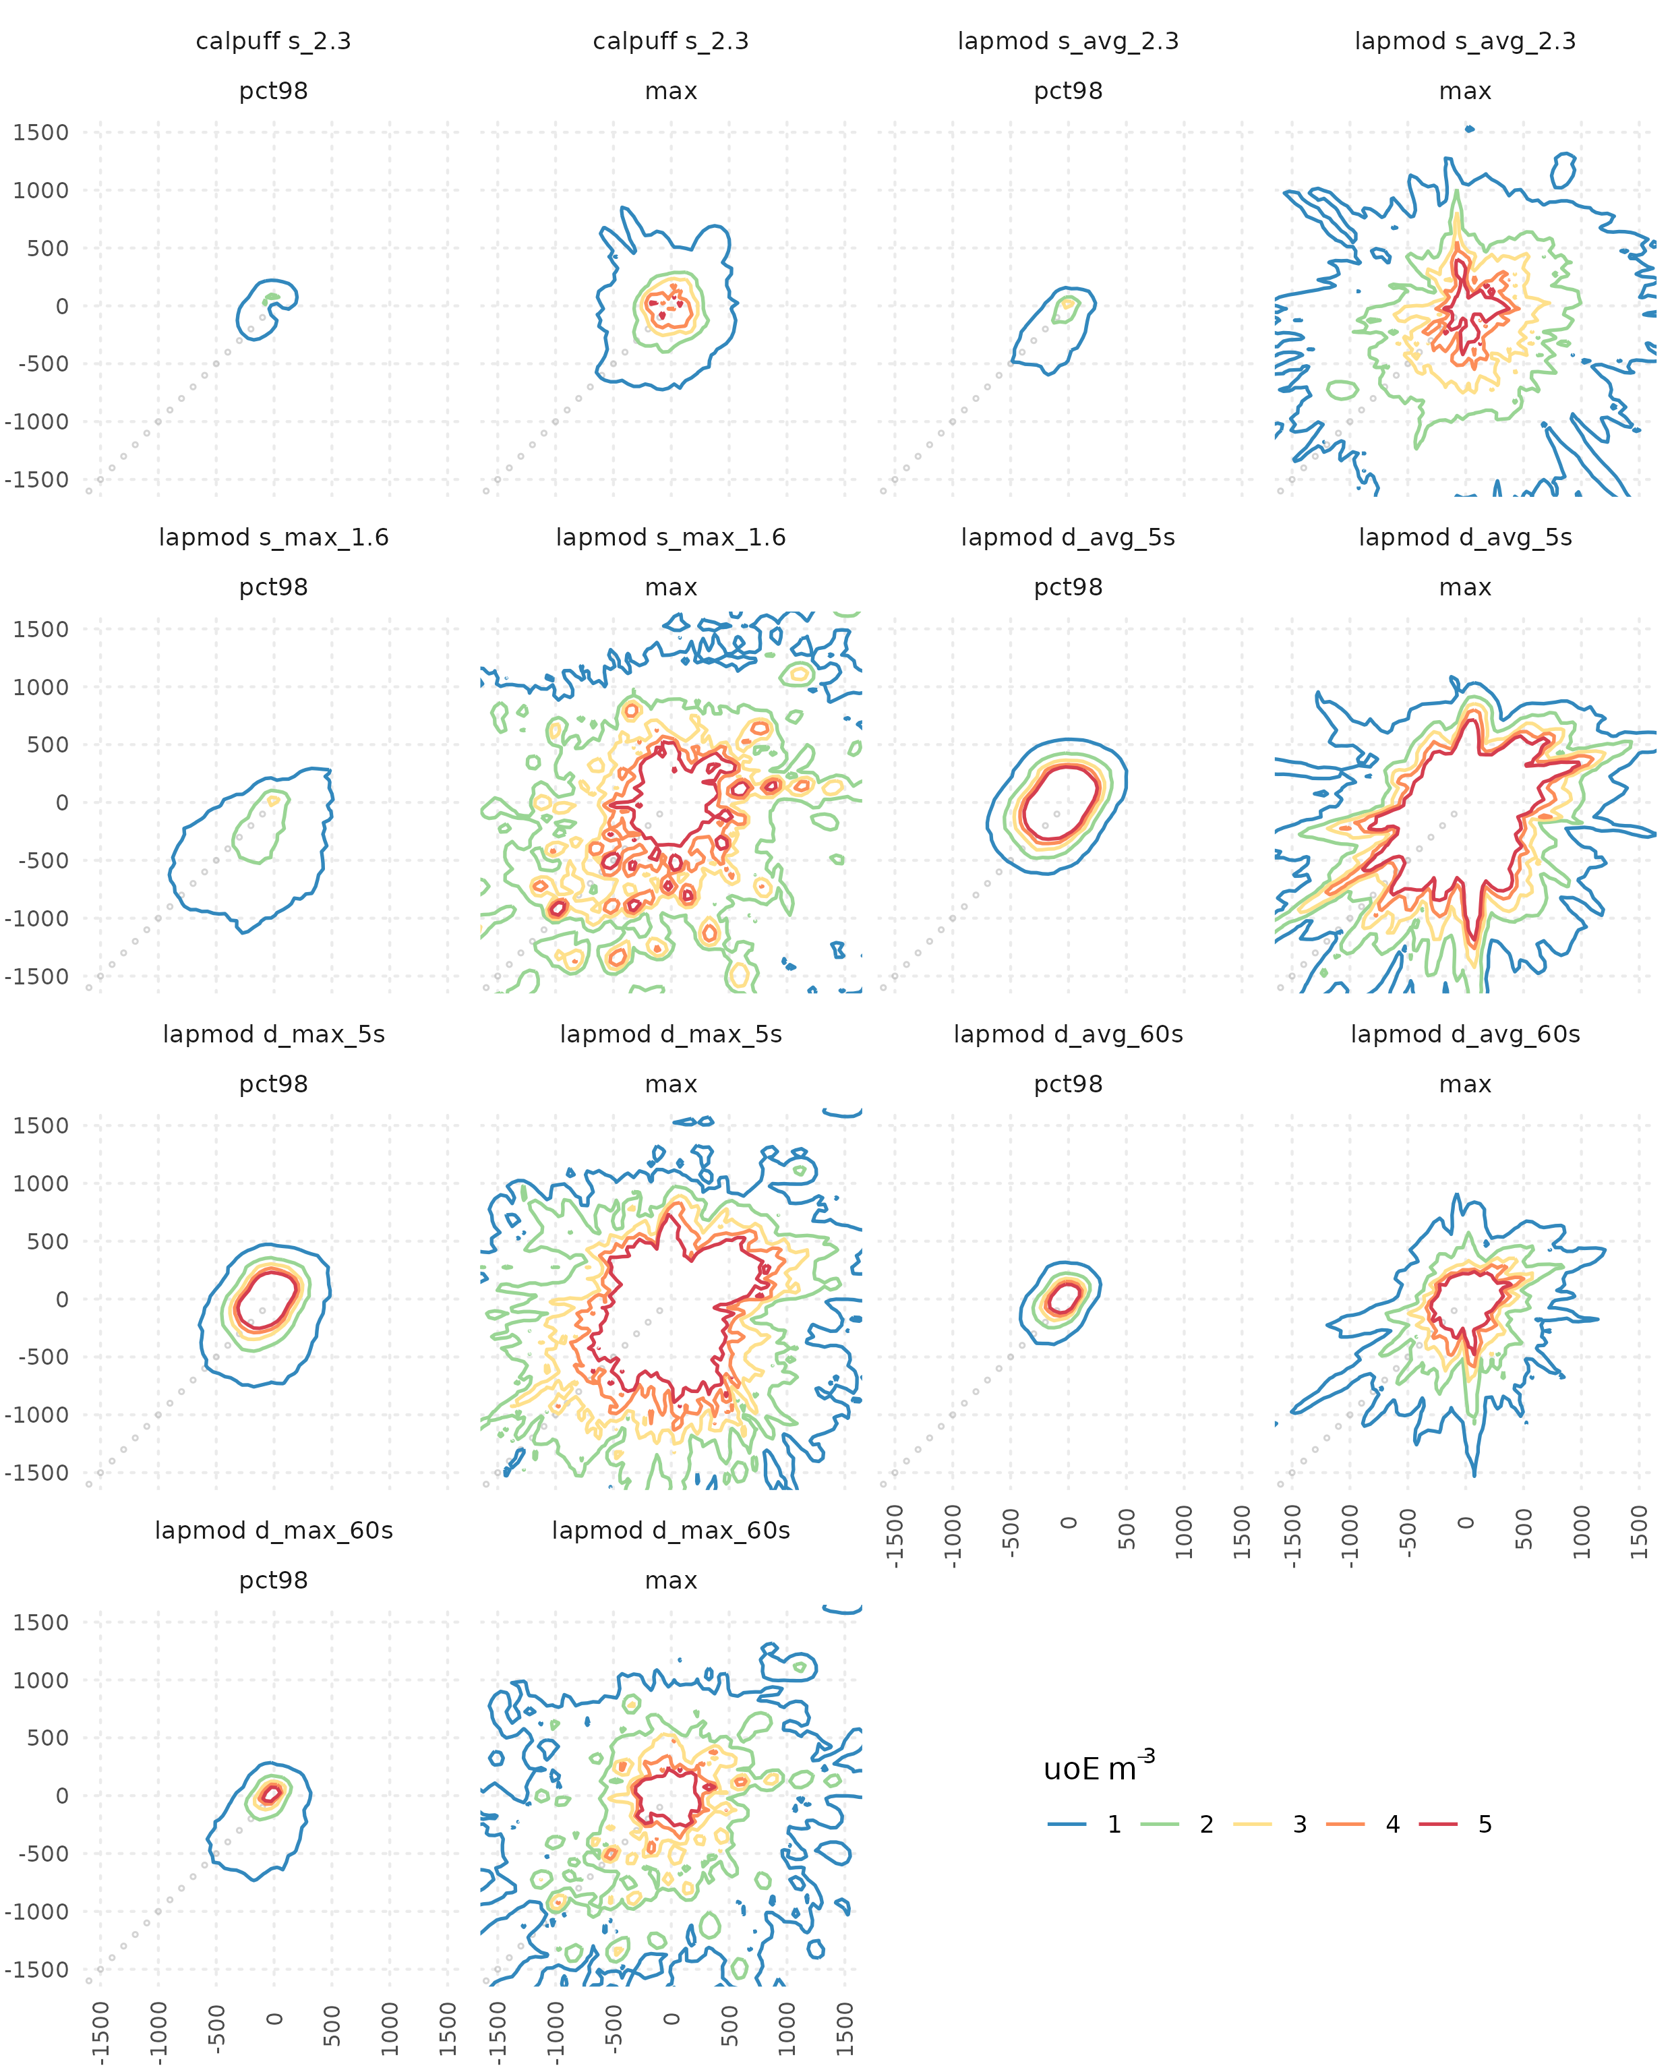*Figure 1: Contour maps of 98th percentile (pct98) and maximum value (max) of peak odour units at 1, 2, 3, 4, 5 uoE*/*m*3*. Point coordinates [0,0] indicates the emission source, discrete receptors are depicted as points (gray) along SW direction (225 °N). The sampling domain is zoomed in along both the x- and y-axes within the range of -1500 to 1500 meters.*

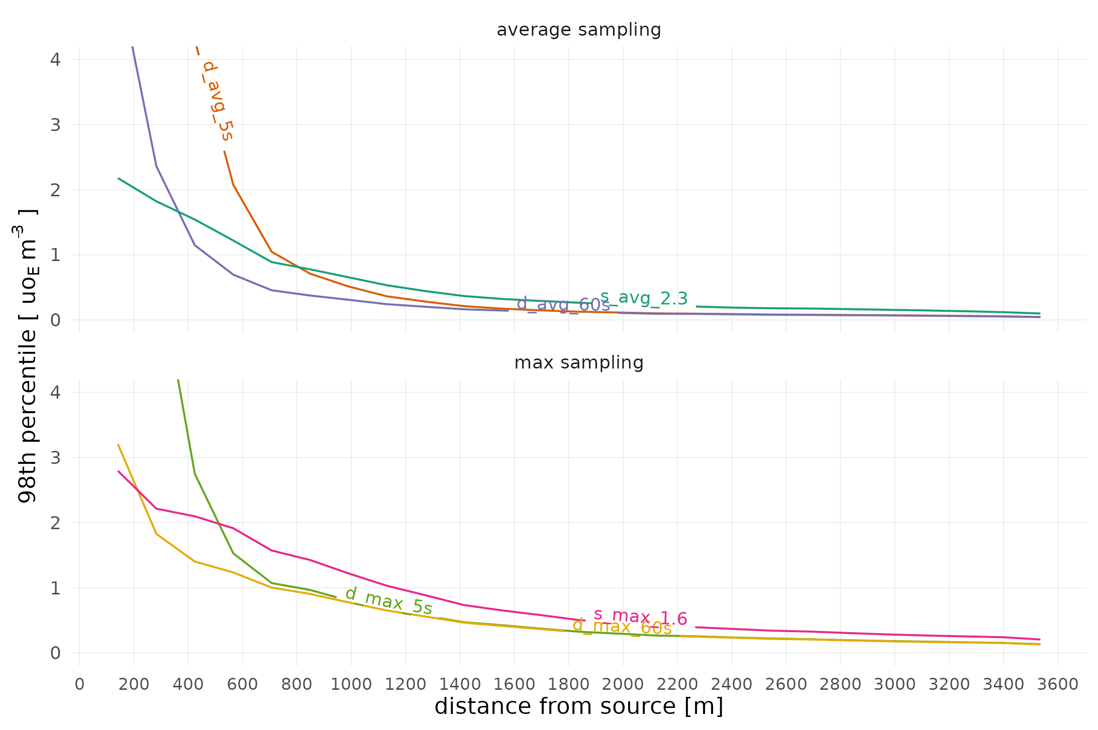*Figure 2: 98th percentile of peak odour units [uoE/m3] for LAPMOD configurations along the transect of discrete receptors in downwind SW direction (225 °N). The y-axis is zoomed in within the range of 0 to 4 uoE/m3.*

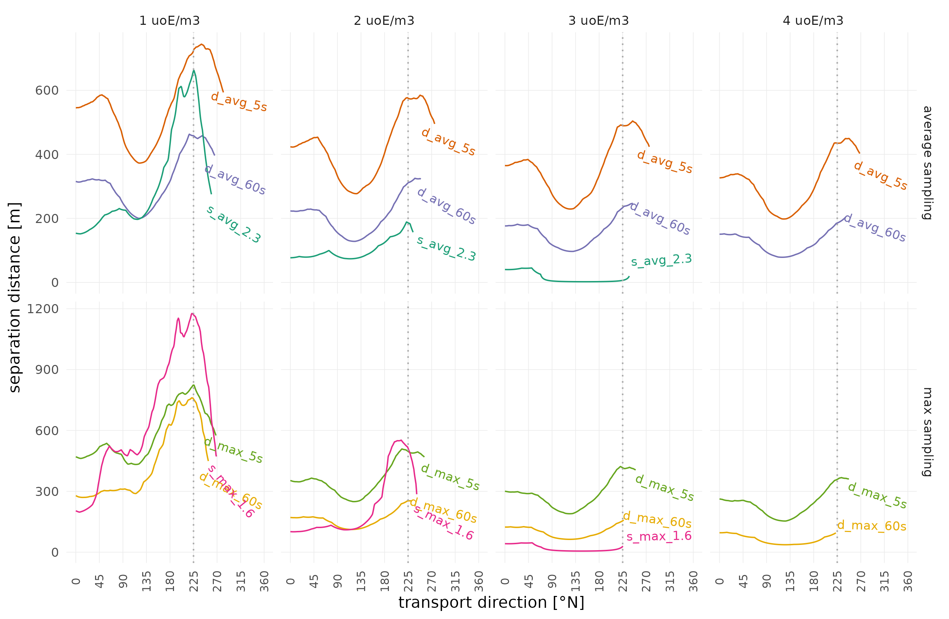*Figure 3: Separation distances at transport directions by angle increments of 1 °N estimated using the 98th percentile of peak odour units [uoE/m3] from LAPMOD configurations under study. The vertical dotted line positioned at 225 °N marks the downwind transport direction along the transect of discrete receptors.*

* 1. Conclusions

Peak-to-mean ratio (PMR) is a widely adopted method for extrapolating short-term odour concentrations from the classical 1 h modelling outputs. It was initially conceived as a swift and basic approach with the main objective of standardizing results to the greatest possible extent.

Considering the findings of the current study for an elevated point source of odour, it is clear that the various modelling configurations resulting from the different approaches of PMR estimation (static vs. dynamic with different peak times) have produced a multitude of occasionally contradictory results. It was observed that the use of dynamic PMR with shorter peak time (5 s) produced in the near-field a more conservative odour impact assessment compared to static PMR approach. The same feature also applied for the dynamic PMR with higher peak time (60 s), but with a smaller difference. Conversely, in the far-field, the evaluation yielded the exact opposite result, despite the magnitude of the observed differences being somewhat negligible.

In very general terms, the separation distance secured by a predefined protection level along a given transport direction was found to be extremely variable as a function of the model specific configuration used for the estimation of the PMR. The variability in modelling results underscores the potential risk of drawing inconsistent conclusions, especially within regulatory frameworks designed to verify the compliance to odour impact criteria and to accurately assess receptor exposure, particularly in the near field where proximity to the emission source and magnitude of the impact is at the highest. The case study lacks objective fact-checking of results (i.e. against local odour complaints), leaving out some uncertainty about the most effective modelling setup also because isolating a specific source's contribution from ambient background remains challenging.

This work highlights the need for an increased awareness, both at practitioners and regulatory levels, on the possible consequences of selecting a particular model configuration for the odour impact assessment.

At the time being, there is not yet clear or definitive solution to ensure consistent results and adequate level of protection from modelling exercises estimating peak odour concentrations through the application of different PMRs. A strong commitment towards reproducibility can offer the potential to clearly assess the evidence and quantify the uncertainties produced by odour modelling in regulatory processes, even when full independent replication is not always feasible. A possible future development is using CALPUFF (v. 7.x) to interpolate meteorological parameters and generate results in the user-defined time step and therefore get additional insights into variability of odour concentrations and short terms impacts.

References

ARPAV, 2023. Air quality and atmospheric modelling of the artistic glassworks in the Isle of Murano (Venice), Project supported by the Italian Ministry of Health, 4145 REACH. Technical report n. 73366 (*in Italian*).

AMIGO & Olores.org, 2023. International Handbook on the Assessment of Odour Exposure using Dispersion Modelling. ISBN 978-84-09-52429-7, DOI: 10.5281/zenodo.8367724.

Bellasio R., Bianconi R., Mosca S., Zannetti P., 2017. Formulation of the Lagrangian particle model LAPMOD and its evaluation against Kincaid SF6 and SO2 datasets. Atmospheric Environment, 163, 87-98.

Brancher M., Hieden A., Baumann-Stanzer K., Schauberger G., Piringer M., 2020. Performance evaluation of approaches to predict sub-hourly peak odour concentrations Atmospheric Environment: X, 7, 100076.

Capelli L., Sironi S., Del Rosso R., Guillot J.M., 2013. Measuring odours in the environment vs. dispersion modelling: a review. Atmospheric Environment, 79, 731-743.

Invernizzi M., Brancher M., Sironi S., Capelli L., Piringer M., Schauberger G., 2020. Odour impact assessment by considering short-term ambient concentrations: A multi-model and two-site comparison. Environment International, 144, 105990.

Lombardy Region, 2012. Guidelines for the characterization odour emissions and permitting of activities. D.G.R. 15/02/2012 n. IX/3018, (*in Italian*). Available online: tinyurl.com/2x9bhrj2 (accessed 20 Feb 2024).

Ministry of Environment, 2023. Guidelines for odour emissions from plants and activities. Decree n. 309 28/06/2023, (*in Italian*), Available online: tinyurl.com/5hax8tcy (accessed 20 Feb 2024).

Mylne K., Mason P., 1991. Concentration fluctuation measurements in a plume dispersing at a range up to 1000. Q. J. R. Meteorol. Society, 117, 177-206.

Schauberger G., Piringer M., Schmitzer R., Kamp M., Sowa A., Koch R., Eckhof W., Grimm E., Kypke J., Hartung E., 2012. Concept to assess the human perception of odour by estimating short-time peak concentrations from one-hour mean values. Atmospheric Environment, 54, 624-628.

Scire J., Robe F., Fernau M., Yamartino R., 2000. A User’s Guide for the CALMET Meteorological Model (Version 5). Earth Tech, Inc., Concord, MA., Earth Tech, Inc., Concord, MA.

Scire J., Strimaitis D., Yamartino R., 2001. A user’s Guide for the CALPUFF Dispersion Model (Version 5). Earth Tech, Concord, MA., Earth Tech, Concord, MA.

Smith M., 1973. Recommended Guide for the Prediction of the Dispersion of Airborne Effluents. ASME Eds, New York.