|  |  |
| --- | --- |
| cetlogo ***CHEMICAL ENGINEERING TRANSACTIONS***  ***VOL.*** | A publication of  aidiclogo_grande |
| The Italian Association  of Chemical Engineering  Online at www.cetjournal.it |
| Guest Editors:  Copyright © AIDIC Servizi S.r.l. **ISBN** 978-88-95608-xx-x **ISSN** 2283-9216 | |

Expert application of VOC chemical analysis techniques in the study of odour problems. Case study of an important episode in Barcelona

Daniel Almarcha (\*), Manuel Almarcha (\*)

(\*) Atmos-Tek. Rosselló 64, 7-1, 08029 Barcelona, Spain.

In order to reliably characterize odour-related problems, to detect the possible sources of odour episodes and to correctly choose and implement the possible solutions (such as deodorisation systems, “ad-hoc” actions, etc.), especially in cases of emissions with highly complex compositions, it is often not sufficient to know the odour concentration in the emissions and/or its extrapolation to immission levels by means of dispersion modelling, as this approach may carry a potential risk that inconclusive or even erroneous conclusions. These drawbacks associated with olfactometric methods can often be overcome by complementing them with the expert use of analytical techniques of odorant speciation (preferably by means of GC-MS or even, in some specific cases such as the one object of this work, GC-HRMS).

In this work, we present a case study of a serious odour episode in Barcelona, where odour emissions from the painting section of an automobile factory, with odour concentrations up to 32,768 uoE/m3 and emission rates up to 8,175 MuoE/h caused significant nuisances near the city centre, about 6 km away from the plant. Water samples from different emission sources of the plant’s painting area were analysed by means of a high-performance analytical technique Head Space-Solid Phase Extraction Gas Chromatography High Resolution Mass Spectrometry (HS/SPME-GC-HRMS) that made it possible to obtain objective analytical evidence that the odour episode was actually caused by emissions of 4-mercapto-4-methyl-2-pentanone (4M4MP, also known as “cat ketone”), which has such a small odour threshold that its presence in process water at concentration levels as low as 24 ng/L was already sufficient, as the substance was stripped into the atmosphere, to cause significant nuisance to the affected population. The low concentration levels made it impossible to detect the 4M4MP presence by means of more conventional analytical methods. For instance, analyses of water and air emission samples using thermal desorption coupled to GC-MS (TD-GC-MS) showed the presence of acetone (first precursor), while 2 intermediate precursors and were found by means of solid/liquid extraction-GC-MS analysis.

The identification of the formation pathway of 4M4MP in the process waters made it possible to determine the causes and conditions leading to this formation. Action on these causes, involving the adoption of better manufacturing practices and the substitution of certain solvents, resulted in an almost immediate and definitive ending of the odour episodes, without the necessity of installing an emission treatment system.

**1. Introduction**

The classical strategy used for the study of odour problems is based on the measurement of the odour concentration levels of the emissions and/or their extrapolation to immission levels by means of dispersion modelling. While this approach is a valuable tool for assessing the compliance of odour limits, it has some limitations that can sometimes hinder its applicability, especially in those cases where the goal is to find out the possible causes of the odour episodes and/or to choose an applicable solution (installation of suitable treatment systems, improved operational practices, etc.), or where the emissions have very complex compositions, as the information provided by these kinds of methodologies can be insufficient by itself to allow for a reliable and representative characterization of the situation (Giungato et al., 2018). In our experience, by narrowing the scope of the studies to a single technique there is a potential risk of obtaining incomplete information or even reaching erroneous conclusions, which can have significant societal and economic repercussions, such as an unnecessary prolongation of the problem (and therefore of the nuisance and the associated complaints) or the implementation of inappropriate solutions, which can be avoided in many cases by complementing the olfactometric methods with the expert application of analytical techniques that allow a thorough characterization of the odorant composition of the emissions, such as GC-MS (Almarcha et al., 2014) or, if necessary, more performant techniques like GC-HRMS (Romero et al., 1998), or equivalent methods with high analytical resolution and sensitivity capabilities, including Gas Chromatography/MS/specific detectors (Polvara et al. 2022), Solid-Phase Microextraction Combined with Gas Chromatography/High-Resolution Time-of-Flight Mass Spectrometry (Hernandez et al., 2007), Gas Chromatography/High Resolution Orbitrap Mass Spectrometry (Dominguez et al, 2020), SIFT-MS (Langford, 2023), etc.

In this work we present an example of a real case study that illustrates the necessity of combining multiple techniques and approaches in highly complex and/or critical situations.

2. Background of the case study

The odour episode object of the present work was caused by a very characteristic and unpleasant smell which originated from a specific plant in a large industrial sector located in the SW part of Barcelona and which affected a significant part of the Barcelona Metropolitan Area (AMB), at times even reaching part of the city’s centre (see figure 4 below). As the recurring episodes involved a remarkably intense odour and covered a large and highly populated area, of approximately ≥25 km2 (and with a population of nearly ≥250,000 inhabitants (by our own estimations), a great number of complaints were made to the municipal and regional governments and the local news agencies. This made the case into an issue of some political relevance, prompting an intervention by said authorities, who demanded an urgent solution to the managers of the plant that was obviously causing the episode, a large facility that carried out painting of metal parts as part of their manufacturing process.

The study object of this paper, described in detail in the following section, was carried out in order to determine the odorant/s causing the problem and to find a solution as soon as possible. As a summary, it can be pointed out that the results indicated that the odour emissions were of a considerably large magnitude, with odour concentrations as large as 32,768uoE/m3 and a total flow rate of approximately 1.6 MNm3/h emitted from 12 paint booths equipped with water curtains and which used paints based on different mixtures of organic solvents. During the initial tentative sampling it was possible to confirm that the odour could be best described as similar to cat urine.

Through a thorough characterization of the composition of the emissions, which required the use of high-resolution mass spectrometry techniques in combination with dynamic olfactometry, it was possible to demonstrate that the odorant at the root of the episode was 4-mercapto-4-methyl-2-pentanone (4M4MP), an organosulfur compound also known as “cat ketone”, which its smell reminds many people of. Other odour descriptors for 4M4MP are “black currant”, “box tree” and “meaty” (The Good scents web site). The 4M4MP can also be found in small amounts in wines of the Sauvignon variety among others (Mateo-Vivaracho et al., 2010) and in some cheeses such as Cheddar (Kleinhenz et al., 2010) and other foodstuffs (McGorrin, 2011), and it is sometimes used as a food additive (Smith et al. 2001). Another relevant characteristic of 4M4MP is that its odour threshold is extremely low, of 0.0001 to 0.005 ppb in water (Kunshan Odowell, Co Ltd web site), which can translate to significant odour episodes even at very low concentration levels in the emissions.

**3. 4M4MP formation pathway**

As indicated above, the most prevalent organoleptic perception of the odour at the root of the episode was associated with the somewhat uncommon “cat urine” descriptor. One of the authors had prior first-hand experience in the analysis of 4M4MP (and its accurate “cat ketone” nickname) due to earlier work in the context of a research project that studied its presence in white Sauvignon wines, and was therefore well aware of the substance’s smell and of the highly intense odour even in very small amounts. This prior knowledge led to the initial hypothesis that this compound might somehow be associated with the odour episode.

A possible formation pathway that could explain its presence in the emissions and which could plausibly take place in the operating conditions of the paint booths was proposed and is shown in figure 1. Briefly, two acetone molecules react via and aldol condensation reaction to form 4-hidroxy-4-methyl-2-pentanone (also known as 4H4MP or diacetone alcohol), which in turn undergoes a dehydration giving 4-methyl-3-penten-2-one (4M3P), that then reacts with the hydrogen sulphide produced by microbial enzymatic activity on the sulphate ions present in the waters, resulting in the formation of 4-mercapto-4-methyl-2-pentanone. Therefore, because of both 4H4MP and 4M3P’s roles as precursors of 4M4MP, they were considered as important target compounds in the analysis campaigns, as a confirmation of their presence in the emissions could provide useful indirect evidence regarding the proposed formation pathway. This entire process took place in solution in the water recirculated in the paint booths to absorb the water-soluble VOCs from the corresponding gaseous emissions.

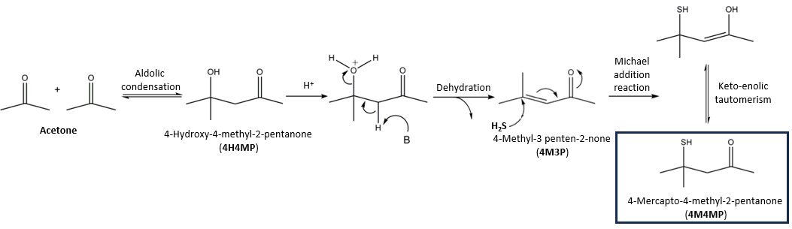

*Figure 1. Proposed pathway for the formation of 4M4MP.*

**4. Sampling and analysis campaigns and atmospheric dispersion modelling**

**4.1. Sampling and analysis**

A summary of the sampling and analysis programs of the 2 campaigns that were carried out (an initial one and a second one after the implementation of corrective measures) is presented in the following table, while figure 2 presents a schematic summary of the sampling methodologies that were used in the present work.

*Table 1 Summary of the sampling and analysis campaigns*

|  |  |  |  |  |  |  |
| --- | --- | --- | --- | --- | --- | --- |
| **Campaign** |  | **Air emission samples** | | | | **Water samples** |
| **Fraction 1** | **Subfraction 1** | **Fraction 2** | **Fraction 3** |
| 1 | Vol. (L) | 5 | 0.5 | 50-85 | 5 | 1 |
|  | N. of samples | 12 | 12 | 12 | 24 | 2 |
| 2 | Vol. (L) | -- | -- | 50-120 | 5 | -- |
|  | N. of samples | -- | -- | 12 | 24 | -- |
| **Sampling support** |  | Nalophan bags | Pre-purged Carbopack B cartridge | Activated carbon tube | Nalophan bags | Bottle |
| **Analysis** |  |  | TD-GC-MS | CS2 extraction + GC/MS | Dynamic olfactometry  (\*) | HS/SPME (CAR/PDMS) - GC-HRMS (\*\*) |

**(\*) Analyses carried out by a laboratory accredited according to the EN-17025 norm.**

**(\*\*) The SPME-GC-HRMS were carried out at the laboratory of the Mass Spectrometry Service of the Research and Development Centre Pasqual Vila of the Consejo Superior de Investigaciones Científicas.**

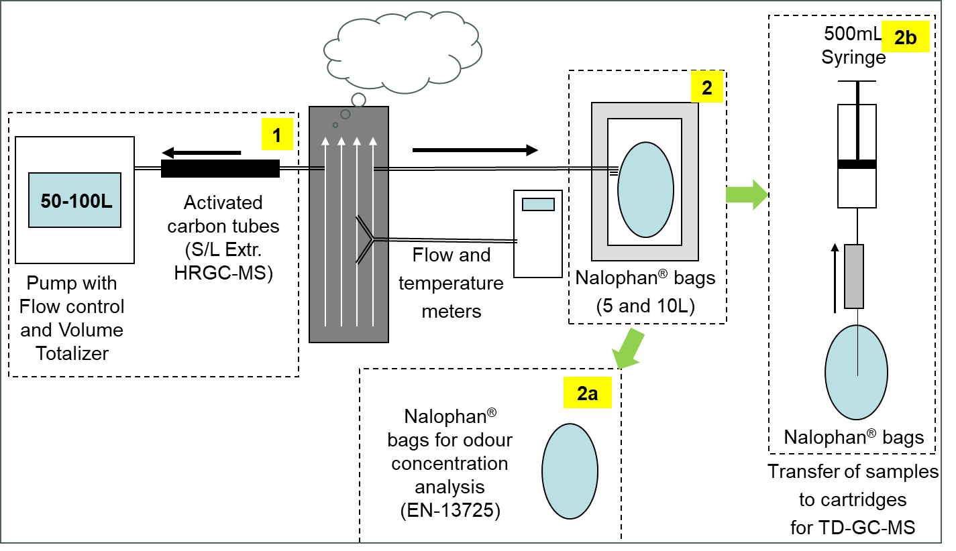

*Figure 2: Schematic of the sampling methodologies used in this work*

The GC-HRMS analysis of water samples was validated by means of a 4M4MP calibration standard, used for assessing the validation parameters in fortified samples with a similar matrix to the real ones. A LOQ of 1 ng/L for 4M4MP was achieved, which allowed detection of the substance at ultra trace levels.

**4.2 Modelling of the atmospheric dispersion of the odour emissions**

The CALPUFF View model (from Lakes Environmental Software, Waterloo, Ontario), processing 3 years of meteorological data (sourced from Meteosim, Barcelona), was used to simulate the atmospheric dispersion of the odour of the emissions from the paint booths carried out in order to gain a wider, general perspective of the magnitude and extension of the odour impact in the affected urban area (Busini V. et al., 2012 and Capelli et al., 2013).

In addition to the modelling of the odour dispersion of the initial situation, a modelling of the final situation after the application of corrective measures was carried out as well in order to assess their effectiveness in reducing the odour impact. The results of both simulations are presented below in figures 4a and 4b, respectively.

**5. Results**

A summary of the results obtained in the present case is included in the following table. Note the high emission rates from the different atmospheric emission sources of the different paint lines.

*Table 2: Analytical results of the 2 campaigns*

|  |  |  |  |  |  |  |  |  |  |  |  |
| --- | --- | --- | --- | --- | --- | --- | --- | --- | --- | --- | --- |
| **Source** | **Flow rate (Nm3/h)** | **1st Campaign (before corrective measures)** | | | | | **2nd Campaign (after corrective measures)** | | | |  |
| **Odour Conc. (ouE/Nm3)** | **Odour Emiss. (MouE/h)** | **Acetone\* (mg/m3)** | **4H4MP\*\* (mg/m3)** | **4M3P\*\* (mg/m3)** | **Odour Conc. (ouE/Nm3)** | **Odour Emiss. (MouE/h)** | **4H4MP\*\* (mg/m3)** | **4M3P\*\* (mg/m3)** |  |
| 38P2 | 122,000 | 2,896 | 354 | 704 | 597 | 27 | 575 | 70 | <6.5 | <6,4 |  |
| 40P2 | 207,000 | 3,444 | 714 | 820 | 617 | 26 | 542 | 112 | <6.7 | <6.6 |  |
| 41P2 | 110,000 | 3,866 | 427 | 746 | 429 | 19 | 542 | 60 | <6.7 | <6.6 |  |
| 42P2 | 96,000 | 3,649 | 352 | 800 | 112 | <10 | 861 | 83 | <6.7 | <6.6 |  |
| 43P1 | 137,000 | 32,768 | 1,370 | 936 | 958 | 54 | 512 | 70 | <6.7 | <6.6 |  |
| 44P1 | 222,000 | 5,161 | 1,146 | 341 | 114 | <10 | 483 | 107 | <4.3 | <4.2 |  |
| 81P1 | 113,300 | 13,004 | 1,473 | 1,156 | 631 | 20 | 512 | 58 | <7.5 | <7.4 |  |
| 85P1 | 145,000 | 512 | 74 | 28 | <6 | <6 | 96 | 14 | <4.3 | <4.2 |  |
| 86P1 | 178,000 | 215 | 38 | 30 | <6 | <6 | 76 | 14 | <7.5 | <7.4 |  |
| 92P1 | 140,000 | 10,935 | 1,531 | 1,983 | 734 | 28 | 2,435 | 341 | <7.4 | <7.4 |  |
| 93P1 | 78,500 | 8,679 | 681 | 353 | 300 | 13 | 724 | 57 | <7.1 | <7.1 |  |
| 94P1 | 80,300 | 181 | 15 | 75 | <6 | <6 | 136 | 11 | <10.3 | <10.3 |  |
| **Total** | **1,629,100** |  | **8,175** |  |  |  |  | **997** |  |  |  |

**(\*) Sampling with 5L Nalophan bags, transferred to thermal desorption tubes + TD GC-MS analysis**

**(\*\*) Sampling with activated carbon cartridges (see table 1) + S/L Extraction-GC-MS analysis**

Regarding the HS/SPME-GC-HRMS analyses of the water samples taken from the paint booths that were performed in order to confirm the expected presence of 4M4MP, it must be pointed out that it was detected at a concentration of 24ng/L. Figures 3a and 3b show the SIM chromatograms corresponding to the exact masses of the molecule (m/z=132.06088) and its main fragmentation ion (m/z=75.02681), which allow an unequivocal confirmation of its identity.

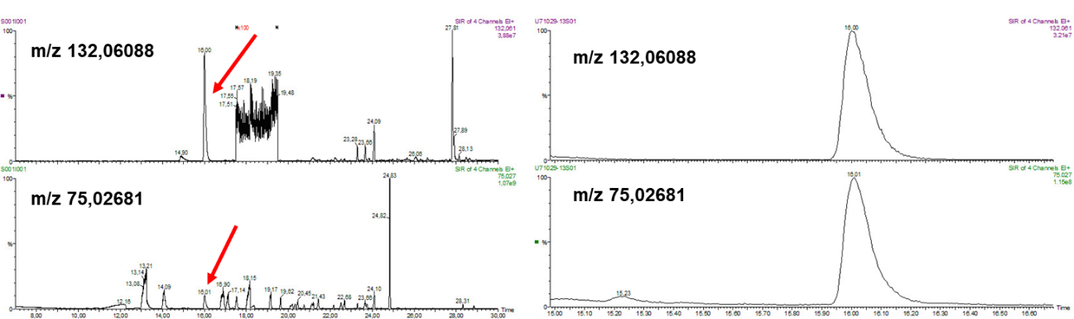

*Figure 3a (left): SIM chromatograms of the HS-SPME GC-HRGC analysis of a paint booth water sample. The upper part corresponds to the molecular ion (m/z=132.06088), and the lower part to a fragmentation ion (m/z=75.02681). Figure 3b (right): Zoomed-in view of the peaks of the same chromatogram.*

It should be taken into account that 4M4MP’s remarkably low odour threshold results in the substance being capable of generating the numerous odour complaints that were received during the episode at the low concentration levels that were determined, while also making it nearly impossible to detect 4M4MP by means of most conventional analytical methods. On the other hand, even though 4M4MP was not detected in any of the atmospheric emission samples that were analysed, it was possible to detect its precursors.

Finally, it must be pointed out that the data obtained allowed to recommend the application of corrective actions: committing to the exclusive use of guaranteed acetone-free solvents and improving the current paint booth cleaning procedures in order to avoid eventual anoxic conditions in the sludge, thus avoiding the possibility of H2S formation by the possible presence of microorganisms. The application of these practices successfully achieved a 90% reduction of the odour emissions, effectively solving the problem in a short time span, as evidenced by the results of the second campaign and the absence of further complaints. The following figure shows the results of the atmospheric dispersion of the odour emissions that were carried out, corresponding to the situation before and after the application of the suggested preventive actions and illustrates the success of these measures in reducing the odour impact of the plant’s emissions.

**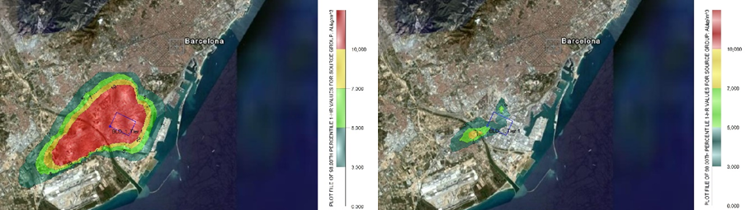**

*Figure 4: CALPUFF modelling of the odour impact of the emissions before (left) and after (right) the implementation of corrective measures (the transverse length of the 10uoE/m3 area (left) is ≅ 8km)*

**6. Comments and conclusions**

As shown by the present work, the information provided by the olfactometric techniques by themselves was not sufficient to reach a definitive conclusion that allowed an effective solution of the problem, especially taking into account the urgency of the situation.

The organoleptic perception of “cat urine”, combined with a previous knowledge of the substance, led to the hypothesis of 4M4MP as the cause of the episode. All the molecule’s precursors were detected in the atmospheric emission samples, with higher 4H4MP levels found in those samples presenting high odour concentrations (43P1, 81P1, 92P1). In contrast, none of the precursors was detected in the samples with low odour concentrations (85P1, 86P1, 94P1), which also showed lower acetone concentrations. Moreover, it must also be pointed out that these precursors were not detected in any of the samples analysed by TD-GC-MS; as the LOQ of this technique was <40mg/m3 in all cases, its use was discarded for the 2nd campaign, which took place at a time when the proposed corrective measures were already in place, and therefore it was estimated that the likelihood of detecting any of the target compounds was very low.

The possible contribution of the precursors 4H4MP and 4M3P to the odour was assessed, but their odour descriptors (faint and minty for 4H4MP and strong peppermint and honey for 4M3P) are very different from the one perceived during the episode and, furthermore, given 4H4MP and 4M3P’s odour thresholds (0.27ppmV and 0.017ppmV, respectively), their corresponding OAV (Odour Activity Values) are low enough that their contribution to the odour can be considered as negligible.

It must be pointed out that the sensitivity of these conventional analysis techniques was not sufficient to detect 4M4MP presence in any of the samples, and its presence therefore its role as the cause of the episode) could only be definitively confirmed by means of a specialized high-performance technique, HS-SPME-GC-HRMS, which allowed detection of the substance in process water samples at concentrations of 24ng/L.

Moreover, a possible formation pathway for the odorant was proposed (and reasonably confirmed), taking into account the operation conditions of the paint booths and a list of the solvents contained in the paints used in the process which was provided by the plant’s management.

The modelling of the odour’s atmospheric dispersion (see figure 4 above) showed a significant impact over a very large area, in agreement with the general public perception of the extension of the problem.

The suitability of different corrective measures was assessed according to the results of the study, including an evaluation of the convenience and/or applicability of installing emission treatment systems (a solution only possible in the medium to long term). Finally, due to the magnitude of the episode and the urgency to put an end to the problem, several measures susceptible of immediate application were proposed, involving the exclusive use of acetone-free solvents and the improvement of the cleaning operations of the paint booths.

The implantation of these relatively simple and inexpensive measures succeeded in achieving a 90% reduction of the odour emissions and the atmospheric impact, as shown by the results of the second campaign and odour modelling (see figure 4), with the benefit of making it unnecessary to install an emission treatment system, which would have resulted both in a delay in reaching a satisfactory end to the situation and a greatly increased cost.

**Acknowledgments**

The authors would like to express their gratitude Josep Caixach and Oscar Palacios for their collaboration in carrying out the analysis of the water samples by HS/SPME GC-HRMS and their help in the interpretation of the results. The authors would also like to thank Pilar Riera, Montserrat Puigcercós and Iban Barrutiabengoa for their field work during the sampling campaigns.

**Bibliography**

Almarcha D., Almarcha M., Nadal S., Poulssen A., 2014, Assessment of odour and VOC depuration efficiency of advanced biofilters in rendering, sludge composting and waste water treatment plants, Chemical Engineering Transactions, 40, 223-228.

Busini V., Capelli L., Sironi S., Nano G., Rossi A.N., and Bonati S., 2012, Comparison of Calpuff and Aermod models for odour dispersion simulation, Chemical Engineering Transactions, 30, 205-210.

Capelli L, Sironi S., Del Rosso R., Guillot J.-M., 2013, Measuring odours in the environment vs. dispersion modelling: A review, Atmos. Environ., 79, 731–743.

Domínguez I., Arrebola F.J., Martínez Vidal J.L., Garrido Frenich A., 2020, Assessment of wastewater pollution by gas chromatography and high resolution Orbitrap mass spectrometry, J. Chromatogr. A.

Giungato P., Di Gilio A., Palmisani J., Marzocca A., Mazzone A., Brattoli M., Giuac R., De Gennaro G., 2018, Synergistic approaches for odor active compounds monitoring and identification: State of the art, integration, limits and potentialities of analytical and sensorial techniques, Trends in Analytical Chemistry, Volume 107, October, 116-129.

Hernández F., Portolés T., Pitarch E., López F.J., 2007, Target and Nontarget Screening of Organic Micropollutants in Water by Solid-Phase Microextraction Combined with Gas Chromatography/High-Resolution Time-of-Flight Mass Spectrometry, Anal. Chem., 79, 9494–9504.

Kleinhenz J.K., Kuo C.J., W.J. Harper, 2007, Evaluation of polyfunctional thiol compounds in aged Cheddar cheese: Estimated concentrations, Milchwissenschaft 62(2),181-183.

Kunshan Odowell, Co Ltd, <<https://www.odowell.com/4-mercapto-4-methylpentan-2-one.html>>

Langford, V.S. SIFT-MS, 2023, Quantifying the Volatiles You Smell. . . and the Toxics You Don’t, Chemosensors, 11, 111.

Mateo-Vivaracho L., Zapata J., Cacho J., Ferreira V., 2010, Analysis, Occurrence, and Potential Sensory Significance of Five Polyfunctional Mercaptans in White Wines, J. Agric. Food Chem., 58, 10184–10194.

McGorrin Robert J., 2011, The Significance of Volatile Sulfur Compounds in Food Flavors An Overview, American Chemical Society Qian et al.; Volatile Sulfur Compounds in Food (Chapter 1), ACS Symposium Series; American Chemical Society: Washington, DC.

Polvara E., Morosini D., Invernizzi M., Sironi S., 2022, Analysis of Odorous VOCs Using TD-GC-MS-FID-PFPD: Development and Applications to Real Samples, Chemical Engineering Transactions, 95, 151-156.

Romero J., Ventura F., Caixach J., Rivera J., Godé Ll., Niñerola J.M., 1998, Identification of 1,3-Dioxanes and 1,3-Dioxolanes as Malodorous Compounds at Trace Levels in River Water, Groundwater, and Tap Water, Environ. Sci. Technol., 32, 206-216.

Smith R.L., Doull J., Feron V.J., Goodman J.I., Munro I.C., Newberne P.M., Portoghese P.S., Waddell W.J., Wagner B.M., Adams T.B., McGowen M.M., 2001, Gras Flavoring Substances 20, Food Technology, Vol. 55, Nº. 12, 12-55.

The Good Scents Company, <http://www.thegoodscentscompany.com/allprod.html>