Development of a complete, fully autonomous on-line cabinet solution for continuous monitoring of odorous compounds

Mathilde Mascles, Jean-Philippe Amiet and Damien Bazin

Chromatotec, 15 rue d’Artiguelongue, 33240 Saint Antoine, France

The presence of odorous compounds presents issues for both ambient air pollution and specific industrial processes. Monitoring these odorous compounds is important because some of them have adverse effects on human health, on the environment and process efficiency even at very low concentrations. In industrial areas, many odorous compounds, such as Volatile Organic Compounds (VOCs), can be emitted, in a wide range of concentration and specific identification and quantification of all these molecules can be a challenge given the number of potential interferences. The goal of this study is to present a complete and fully autonomous on-line cabinet solution for the continuous monitoring of odorous compounds. This solution is composed of several Gas Chromatographs (GC), each specifically designed to target some VOCs and/or odorous compounds. Gas generators were also used, allowing a complete autonomy of the system. All analytical systems and gas generators were integrated in two airtight and waterproof cabinets regulated in temperature. This complete and fully autonomous solution is ideal for industrial processes operating in harsh environmental conditions, ensuring accurate and continuous results.

1. Introduction

The analysis of Volatile Organic Compounds (VOCs) is of increasing interest due to their impact on human health, air quality and the environment (Yu et al., 2022; Zhang et al., 2021). VOCs include a wide variety of compounds and many of them are harmful for human health and/or the environment, even at low concentrations (Hu et al., 2019). VOCs are emitted in the atmosphere from many different sources such as traffic activities, industries, chemicals, or food and waste production processes (Han et al., 2018). Because of their unpleasant smell, odorous VOCs are often associated with poor air quality (Bachelier et al., 2022). In industrial areas, many types of VOCs are often emitted, with various concentrations. Some of these VOCs can be odorous compounds and a source of unpleasant smell. The identification and quantification of the various VOCs can be quite complex given the variety of compounds and the large number of potential interferences. Moreover, some odorous VOCs have very low odor detection threshold which requires the use of sensitive systems capable of analyzing concentrations ranging from ppt to ppm levels. Usually, laboratory GCs are used because of their sensibility and their capacity to identify and quantify molecules even in complex mixtures. However, these systems need laboratory-controlled conditions to perform well, which is often not the case in industrial sites.

In this study, we present a complete cabinet solution for the continuous monitoring of some VOCs and odorous VOCs. Five systems (including 4 auto-GCs and one FT-UV spectrometry module) were integrated into two airtight and waterproof cabinets. The solutions also include gas generator, thus allowing for a full autonomous solution. The cabinet is specifically designed to protect its content from the outside (bad weather and temperature variations) making it ideal for industrial sites. Monitored compounds are automatically identified and quantified. This solution was installed in an industrial site for the monitoring of a deodorization process.

1. Material and Methods
   1. Auto-GC/FID for the monitoring of aldehydes and ketones

An automatic gas chromatograph (chromaFID, Chromatotec, France) equipped with a Flame Ionization Detector (FID) has been used for the monitoring of several aldehydes and ketones. For each analysis, a 250 µl sampling loop is filled and its content is injected into the columns. The columns are positioned in a specific backflush mode, called CP backflush, to prevent potential matrix impurities to go into the analytical column. The CP backflush includes a 1 m MXT 624 (0.53 mm ID, 3 µm dF) and a 29 m MXT 624 column (0.53 mm ID, 3 µm dF) located inside the heated oven of the GC. During the first 7 minutes of the analytical procedure, the temperature rose from 36 °C to 50 °C with a heating rate of 2 °C/min. Afterwards, a constant heating rate of 10 °C/min was applied for 3 minutes followed by a heating rate of 12 °C/min for 8.3 minutes. Finally, a heating rate of 20 °C/min was applied for 1 minute to reach a temperature of 199 °C. The temperature was kept at this value for 2 minutes. Many aldehydes and ketones including acetaldehyde, acrolein, acetone, isopropyl alcohol, methyl tert-butyl ether, vinyl acetate, methyl ethyl ketone, ethyl acetate, 1,4-dioxane, methyl methacrylate and methyl isobutyl ketone can be identified and quantified with this method.

* 1. Auto-GC/FID for the monitoring of amines

For the monitoring of amines compounds, an automatic gas chromatograph (chromaFID, Chromatotec, France) equipped with FID has been used. For each analysis, a 125 µl sampling loop is filled and its content is injected into the columns. The columns are positioned in CP backflush mode to prevent potential matrix impurities to go into the analytical column. The CP backflush includes a 1 m Rtx volatile Amines column (0.32 mm ID, 5 µm dF) and a 30 m Rtx volatile Amines column (0.32 mm ID, 5 µm dF) located inside the heated oven of the GC. During the first 2.5 minutes of the analytical procedure, the temperature rose from 45 °C to 50 °C with a heating rate of 2 °C/min was applied for 6.5 minutes. The temperature reached was 180 °C and the oven was kept at this temperature for 10.3 minutes. Amines such as methylamine, dimethylamine, trimethylamine, ethylamine and diethylamine can be identified and quantified with this method.

* 1. Auto-GC/FID for total hydrocarbon monitoring

For the monitoring of methane and non-methane compounds, an automatic gas chromatograph (chromaTHC, Chromatotec, France) equipped with a FID has been used. For each analysis, a 250 µl sampling loop is filled and its content is injected into the columns. For the separation, two Porapak Q columns (1 m, 100/120 mesh) followed by a 10 m MXT 624 column (0.53 mm ID, 3 µm dF) are used. Only the second Porapak Q and the MXT 624 columns are located inside an oven set at 80 °C. This configuration allows for the monitoring of methane and total hydrocarbon.

* 1. Auto-GC coupled to an electrolytic cell for the monitoring of sulfur compounds

An automatic gas chromatograph (TRSMEDOR, Chromatotec, France) equipped with an electrolytic cell specific for sulfur compounds has been used. Two injection loops are installed to be able to monitor a wider concentration range: a 50 µl loop in used for high concentrations (ppm level) and a 400 µl for lower concentrations (ppb level). The content of the selected loop is injected into the columns. A first MXT-5 column (4m, 0.53 mm ID, 1.5 µm dF) is used to separate the light sulfur compounds from the heavier one. The light compounds are then sent into a 30 m MXT 624 column (0.53 mm ID, 3 µm dF). Both columns are located inside an isothermal oven set at 40 °C.

* 1. NH3 measurement

For the measurement of NH3, a FT-UV spectrometer has been used. The zero was performed once a day and the spectrometer gives one result every 30 minutes, which corresponds to the cycle time of the auto-GCs.

* 1. Calibration

All of the modules are equipped with an internal permeation oven containing one or several permeation tubes. A permeation tube is designed to release a certain quantity of compounds at a given temperature and under a constant nitrogen flow. Permeation rate and gas standard were specifically chosen in accordance with the various modules. Nitrogen flows constantly through all the permeation ovens to ensure a stable concentration over time. This consist in an internal standard gas that can be analyzed periodically to ensure the stability of the system over time

* 1. Integration in a cabinet
     1. Gas supply

Air generator (Airmopure, Chromatotec, France), nitrogen generator (Nitroxychrom, Chromatotec, France) and Hydrogen generator 99.9999 % with dew point below -15 °C (Hydroxychrom, Chromatotec, France) were used for the flames of FIDs, valve actuations of the auto-TD-GC-FIDs and constant flowing through the various permeation ovens.

* + 1. Global cabinet solution

The five analytical modules and the three gas generators were integrated into two shelters. A multiplexer is also integrated for the monitoring of the compounds before and after the deodorization process. These shelters consist of airtight and waterproof cabinets that control the temperature and ensure a relatively low temperature variation. Because of this, the shelters can be placed outdoor and suffer the temperature variations without any consequences on the GCs performances. This was verified experimentally on one GC placed in a shelter located in Bordeaux. The shelter was located outside, without any particular protection. The experiment was made in July and the shelter was directly exposed to the sun for about 8 hours. Temperature measurements were achieved by two temperatures sensors located in the shelter (close to the GC) and directly inside the GC. The temperature was monitored continuously for 24 hours and every second, the temperature value of both sensors was registered. Every 30 minutes (which corresponds to the cycle time of the GC), a file containing the measured temperatures of both sensors was created. To simplify the data treatment, for each file, the maximum, minimum and average temperature was reported. This treatment was realized for a 24 hours period of time.

1. Results and discussion

The aim of this study was to monitor a deodorization process in an industrial area. To that end, four auto-GC/FID and a FT-UV spectrometer were integrated into two shelters, as well as gas generators. In parallel, a study of the temperature stability in the shelter was realized to show the robustness of the shelter and its suitability to protect its content from outdoor temperature variations.

* 1. VOCs monitoring

The four auto-GCs were designed to continuously identify and quantify some aldehydes and ketones, amines and sulfur compounds. A FT-UV spectrometer was added for the measurement of NH3. The four figures below represent examples of chromatograms obtained for each auto-GC:

|  |  |
| --- | --- |
| Figure 1: Internal gas standard chromatogram obtained on the auto-GC/FID monitoring aldehydes and ketones | Figure 2: Internal gas standard chromatogram obtained on the auto-GC/FID monitoring amines |
| Figure 3: Ambient air chromatogram obtained on the chromaTHC | Figure 4: Chromatogram of a mixture of sulfur compounds obtained on the TRSMEDOR |

Table 1 represents the various compounds and/or family of compounds analyzed, their range of concentrations, their low detection limit (LDL) and some values of odor threshold:

Table 1: Compounds and family of compounds analyzed, range of concentrations, LDL and odor threshold

|  |  |  |  |  |
| --- | --- | --- | --- | --- |
| Compounds | Max concentration before the deodorization process (ppm) | Max concentration after the deodorization process (ppm) | Low Detection Limit (ppm) | Odor threshold (ppm) |
| **CH4/NMTHC** | **150** | **2** | **0,025** | **-** |
| **Aldehydes/ketones** | **10** | **1** | **0,01** | **-** |
| Acetaldehyde | - | - | - | 0,05 |
| 2-hexanone | - | - | - | 3 |
| **Amines** | **10** | **10** | **0,02** | **-** |
| Trimethylamine | - | - | - | 0,00021 |
| Diethylamine | - | - | - | 0,14 |
| **H2S and mercaptans** | **50** | **1** | **0,0003** | **-** |
| Methyl mercaptan | - | - | - | 0,002 |
| Ethyl mercaptan | - | - | - | 0,35 |
| Dimethyl disulfide | - | - | - | 0,12 |
| NH3 | 50 | 1 | 0,2 | 5 |

The complete solution is able to analyze all the target compounds that need to be monitored before and after the deodorization process.

* 1. Temperature stability in the shelter

A study of the temperature measured inside the shelter in comparison to the outside temperature was realized. In parallel, the concentration of an internal standard gas of benzene was monitored continuously for the duration of the test. Figure X shows the temperature measured in the shelter and in the GC compared to the outdoor temperature:

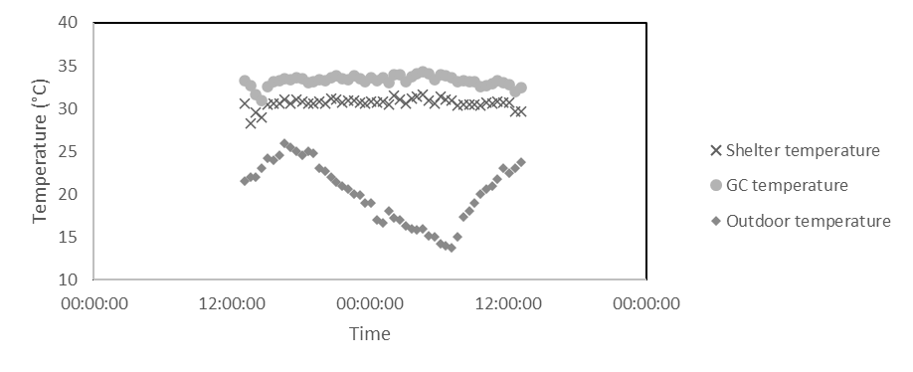

Figure 5: shelter, rack and outdoor temperature

This figure shows the good stability of the temperature in both the shelter and the GC. The small decrease of temperature observed at the beginning in the shelter and in the GC corresponds to a brief opening of the shelter. This clearly demonstrates the ability of the shelter to protect its content from outdoor conditions. Despite the important temperature variations measured outdoor (from 13.7 °C to 25.5 °C), the temperatures measured in the shelter and in the rack are very stable. The relative standard deviation calculated in the shelter and in the GC are respectively 1.3 % and 1.4 %.

In parallel, the stability of the benzene retention time was verified. Figure X shows the retention time of benzene over the 24 hours monitored (the chromatogram where the shelter was opened are not considered in this case).

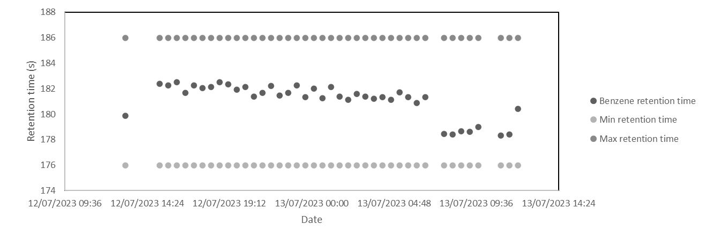

Figure 6: Trend on the benzene retention time

The relative standard deviation on the benzene retention time is 0.7% which is very good. A small temperature drop of less than 3 °C is observed. Min retention time and Max retention time represent the retention time window used for benzene identification. The overall retention time of benzene is quite stable, enough to enable an automatic identification of the compound based on its retention time.

1. Conclusions

In this work, a complete solution designed for the monitoring of odorous compounds was presented. Several auto-GC were used in order to identify and quantify different families of compounds. The solution is completely autonomous thanks to all the gas generators that are able to supply the different modules. The analyzers are designed to work in a continuous mode. All the systems are integrated into two shelters that are able to handle outdoor conditions (precipitations, temperature variations). This is ideal for the monitoring of industrial processes where controlled laboratory conditions can be hard to achieve.

**References**

Yu, B., Yuan, Z., Yu, Z., and Xue-song, F. (2022). BTEX in the environment: An update on sources, fate, distribution, pretreatment, analysis, and removal techniques. Chemical Engineering Journal 435, 134825.

Zhang, K., Chang, S., Fu, Q., Sun, X., Fan, Y., Zhang, M., Tu, X., and Qadeer, A. (2021). Occurrence and risk assessment of volatile organic compounds in multiple drinking water sources in the Yangtze River Delta region, China. Ecotoxicology and Environmental Safety 225, 112741.

Hu, R., Liu, G., Zhang, H., Xue, H., Wang, X., Kwan Sing Lam, P. (2019). Odor pollution due to industrial emission of volatile organic compounds: A case study in Hefei, China. Journal of Cleaner Production 246, 119075.

Han, B., Liu, Y., Wu, J., Feng, Y. (2018). Characterization of industrial odor sources in Binhai New Area. Environmental Science and Pollution Research 25, 140006 - 14017.

Bachelier F., Amiet F., Daële V., Bazin D. (2022). Development of on-line and field dual TD-GC-FID/MS for automatic and continuous VOCs monitoring in ambient air. Chemical Engineering Transactions 95