|  |  |
| --- | --- |
| cetlogo ***CHEMICAL ENGINEERING TRANSACTIONS***  ***VOL. xxx, 2024*** | A publication of  aidiclogo_grande |
| The Italian Association  of Chemical Engineering  Online at www.cetjournal.it |
| Guest Editors: Selena Sironi, Laura Capelli  Copyright © 2024, AIDIC Servizi S.r.l. **ISBN** 979-12-81206-13-7; **ISSN** 2283-9216 | |

PrOlor, a Simplified Way to Communicate Odour Forecasts through a Complex and Reliable Modelling System

Roberto Bianconia,\*, Roberto Bellasioa, Ainhoa Antónb, Cyntia Izquierdob, Carlos N. Díazb

aEnviroware srl, via Dante Alighieri n.142, 20863 Concorezzo (MB), Italy

bAmbiente et Odora S.L.,C/Uribitarte, Nº6, Planta Baja. 48001 Bilbao, Spain

[rbianconi@enviroware.com](mailto:rbianconi@enviroware.com)

Odour pollution is gaining more attention every day because of the immediate nuisance associated to this “pollutant”. Frequent odour episodes give rise to a number of complaints from the people living around the plants from which odorants may be emitted. Therefore, it is in the interest of plant owners and managers to try to reduce odour impact and to decrease the number of odour episodes. In this way, it is possible to establish good relationships with the communities around a plant, and ensure its long-term production.

For this purpose, it is important to have reliable tools capable of forecasting the ambient odour concentration at specific sensible receptors around the plant for the next few days and give alerts when specific thresholds may be exceeded. In this way, if the plant has the possibility to reduce its emissions for those specific hours, odour episodes may be avoided and the complaints may be reduced.

Odour forecasting tools already exist, but they mainly rely on web platforms more or less challenging that, at the end, nobody checks on a day-by-day basis. Some of them have daily alerts included in their packages, but as they are bundled into the system, the cost is usually very high. The strength of the PrOlor system here described is the apparent simplicity of its core module as perceived by the user. Indeed, the user just receives an email up to four times a day, reporting for each sensible receptor the future hours where the exceedance of a specific odour threshold is foreseen. The system is based on the automated model chain composed by GFS, WRF, CALMET and CALPUFF that runs on a cloud server, without the need for the user to install any software or to access any web site. The use of a cloud platform guarantees the uptime of the service, and even complex scenarios can be simulated by adequately configuring the computational resources employed.

There is a need for more simple, cost-effective tools for odour managers to take decisions without the burden of having to operate platforms difficult to understand on a day-by-day basis. That is why a simple cost-effective e-mail system with odour alerts comes in handy to plan processes in order to avoid odour incidents.

* 1. Introduction

Reliable tools are essential for forecasting ambient odour concentrations at specific receptors near a plant that emit odorants. These tools should provide alerts when odour thresholds are likely to be exceeded. By acting on these alerts, plants can potentially reduce emissions during critical hours, thereby preventing odour episodes and mitigating complaints. Plant owners and managers can thus proactively address odour concerns, fostering community goodwill and sustaining efficient production processes.

The PrOlor system is a simple but effective answer to such need. Users receive up to four daily emails, each detailing future hours when specific odour thresholds may be surpassed. PrOlor utilizes an automated modelling chain, incorporating cutting-edge GFS, WRF, CALMET, and CALPUFF models. Remarkably, this system operates seamlessly on a cloud server, eliminating the need for user-installed software or website access.

PrOlor runs automatically on a commercial cloud infrastructure, on multicore Linux instances. This guarantees the uptime of the service, and even complex scenarios can be simulated by adequately configuring the computational resources employed. In this way, quick results can be delivered when new meteorological initialization data are available.

Moreover, PrOlor’s straightforward installation script ensures quick deployment in any global location.

The following paragraph provides an overview of the PrOlor architecture. Then, the initialization data used by PrOlor and each of the models are described. After, the steps taking place for a PrOlor session including the forecast and the email notification delivery is discussed.

* 1. PrOlor architecture

PrOlor requires an initial setup in order to configure the meteorological and atmospheric dispersion models’ domains. This is achieved with a setup configuration script and the editing of some template files to specify sources and receptors.

Assuming that the prognostic meteorological model WRF is already installed on the server running PrOlor, along with the global geophysical data required to run a WRF simulation and a CALMET simulation anywhere on the globe, the setup script is run whenever a new domain for the odour impact forecast is required.

The setup minimal input is the pair of coordinates of the centre of the air dispersion domain. The script runs with defaults that can be overridden by the user, if necessary. These defaults include, for example, the air dispersion domain extent.

Upon execution, the script creates the filesystem structure and the configuration and template files. It also runs the preprocessors that prepare the geophysical input to the high-resolution model CALMET for the domain specified.

The system manager must then edit the template files and input the source(s) parameters – geometrical and emissive - and the coordinates of the sensible receptors to monitor, as well as the recipients of the notification emails. Then the PrOlor is set up and one or more executions (at different times) of a PrOlor forecast session are defined in the crontab file that contains a list of commands intended to be executed automatically at predefined time intervals.

A PrOlor session is generally run every six hours, when new GFS initialization data are available for download.

The starting times are configured to guarantee that the meteorological initialization data use the latest cycle of the GFS. The GFS runs at synoptical hours (0, 6, 12,18 UTC) and PrOlor starts four hours later, when GFS forecasts are available for download.

A complete PrOlor forecast session consists of the following steps of the modelling chain (Figure 4):

* Download of initialization GFS (Global Forecasting System) meteorological data
* Run of the meteorological modelling chain
  + Run of the meteorological prognostic model WRF
  + Run of the meteorological processor CALWRF
  + Run of the meteorological diagnostic model CALMET
* Run of the atmospheric dispersion modelling chain
  + Run of the atmospheric dispersion model CALPUFF
  + Run of the postprocessing tools for analysis of CALPUFF results
* Delivery of email notification

More CALMET domains can coexist within the same WRF output domain and more CALPUFF simulations can be executed within the same CALMET domain, for example to evaluate more emission scenarios.

PrOlor takes full advantage of using a multicore instance. In fact, WRF is intrinsically a parallel code and, also, each CALMET run can be started in parallel upon WRF completion. In the same manner, once a CALMET run completes, the CALPUFF runs using the output of such run can run in parallel, as well.

* 1. Sources of initialization data

PrOlor requires various initialization datasets. They are both dynamical (the meteorological data), and statical (terrain and land cover data). All datasets used by PrOlor are freely available, at no cost.

* + 1. Meteorological data

The NCEP Global Forecast System (GFS) is a weather forecast model developed by the National Centers for Environmental Prediction (NCEP). It provides forecasts up to 384 hours ahead, with updates available four times a day, for the whole globe. The longitude/latitude forecast grid resolution is 0.25° by 0.25°. Gridded data include analysis and forecast time steps at a 3-hour interval from 0 to 240, and a 12-hour interval from 240 to 384.

The GFS runs at synoptical hours (0, 6, 12,18 UTC) and data are freely available for download (<https://www.nco.ncep.noaa.gov/pmb/products/gfs/>) when the run is completed.

These data represent the initial and boundary conditions for running the Weather Research and Forecasting (WRF) model in a specific modelling domain, with higher spatial and temporal resolution. They are used by NCEP for many of their products, as well as the US National Weather Service for the operational forecasts, and by several national weather services around the world.

* + 1. Terrain elevation terrain

PrOlor uses two different terrain elevation datasets, one for WRF (GMTED2010) and one for CALMET (CGIAR-CSI-STRM)

GMTED2010

The GMTED2010 (Global Multi-resolution Terrain Elevation Data 2010) is a global digital elevation model (DEM) dataset that provides elevation information for the Earth’s surface. It was developed by the USGS (U.S. Geological Survey) to support various applications, including environmental modelling, natural resource management, and scientific research. The dataset combines elevation data from various sources, including satellite altimetry, stereo photogrammetry, and topographic maps and offers elevation data at multiple resolutions, ranging from 7.5 arc-seconds (approximately 250 meters) to 30 arc-seconds (approximately 1 kilometre). GMTED2010 is freely available for download (<https://www.usgs.gov/coastal-changes-and-impacts/gmted2010>).

PrOlor uses this dataset to initialize the terrain data in use by WRF, in the simulation domain setup phase.

SRTM

The SRTM3 (Shuttle Radar Topography Mission version 3) digital elevation data, originally developed by NASA, provides high resolution (30 meters at the equator) elevation data for large portions of the globe. The data have been processed to fill gaps and are downloadable in 1° by 1° tiles, in GeoTiff format (https://earthexplorer.usgs.gov/).

PrOlor uses this dataset for the preparation of the geophysical data for CALMET, in the simulation domain setup phase.

* + 1. Land cover data

Both WRF and CALMET require land cover data, at different resolution. These data are provided by MODIS and COPERNICUS

MODIS

PrOlor uses the MODIS products (<https://modis.gsfc.nasa.gov/data/dataprod/mod12.php>) for WRF initialization. These include Land Use (Global 30-arc second, 21-category IGBP-Modified MODIS landuse classification with lakes), Vegetation Fraction (Global 30-arc second monthly Greenness Vegetation Fraction based on 10 years), Leaf Area Index (Global 10-arc minute monthly Leaf Area Index data based on 10 years MODIS), Soil Type (Global 10-arc minute 16-category soil type dataset).

COPERNICUS

For the preparation of the geophysical input to CALMET in the simulation domain setup phase, PrOlor uses the Copernicus Global Land Operations Vegetation and Energy (CGLOPS-1) landcover data with 100 m resolution (<https://lcviewer.vito.be/download>).

* 1. The PrOlor modeling chain components

The modelling chain is based on WRF (<https://www.mmm.ucar.edu/models/wrf>) and the CALWRF, CALMET and CALPUFF components of the CALPUFF modelling system version 7 (<https://www.src.com>).

* + 1. WRF

WRF (Skamarock et al., 2008), the prognostic meteorological model incorporated in PrOlor, is the most commonly used prognostic model by the meteorological modelling community and provides state-of-the-science parameterizations of the atmosphere.

PrOlor incorporates version 4.1 of WRF (ARW core), initialized with the already described GFS and geophysical data and run in a standard configuration at 45 vertical levels, up to 50 mb, with a 3-level one-way domain nesting, with increasing domain resolution of 27 km, 9 km and 3 km, respectively. The innermost WRF domain extends about 200 km along both longitude and latitude and the dimensions on the internal domains are one third of those of their parent domain (Figure 1). An additional innermost fourth domain with 1-km resolution can be activated for simulations in areas with particularly complex orography.

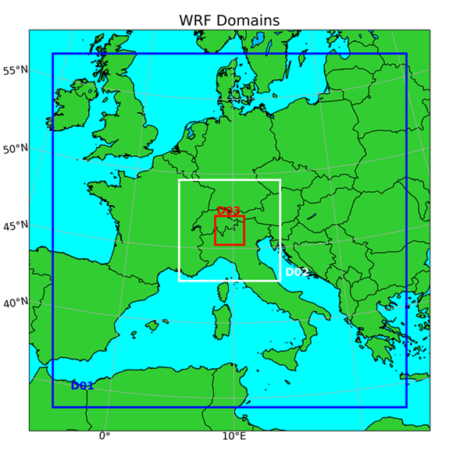

Figure 1*:* Example of the three-nested domains of WRF.

* + 1. CALWRF

CALWRF is a meteorological preprocessor of the CALPUFF modelling system 7. It takes in input the output of the WRF meteorological model and converts it to the four‑dimensional arrays that are given in input to CALMET, the meteorological processor of the CALPUFF modelling system.

* + 1. CALMET

CALMET (Scire et al., 2000a) is a diagnostic meteorological model that reconstructs the 3D wind and temperature fields starting from meteorological measurements, orography and land use data. In addition to wind and temperature, calculates two-dimensional (2D) micro-meteorological variables essential for dispersion simulations. These variables include: mixing height, Monin Obukhov length, friction velocity, convective velocity.

Notably, CALMET can optionally utilize output from prognostic meteorological models like WRF. When running a forecast, this input becomes essential and is the only required and available information.

* + 1. CALPUFF

CALPUFF (Scire et al., 2000b) is a multi-species non-steady-state Lagrangian-puff dispersion model that simulates the effects of time and space varying meteorological conditions on pollutant transport, transformation, and removal. CALPUFF is intended for use on scales from tens of meters from a source to hundreds of kilometres. It includes algorithms for near-field effects such as stack tip downwash, building downwash, transitional buoyant and momentum plume rise, rain cap effects, partial plume penetration, subgrid scale terrain and coastal interactions effects, and terrain impingement as well as longer range effects such as pollutant removal due to wet scavenging and dry deposition, chemical transformation, vertical wind shear effects, overwater transport, plume fumigation, and visibility effects of particulate matter concentrations.

* 1. Postprocessing and email notification

The last step in a PrOlor session is the postprocessing of the dispersion modelling results. The time series of CALPUFF results at each receptor are extracted from the CALPUFF output file and then analysed to identify any situation that requires a notification.

Since odours are perceived in a short time scale, the results are multiplied by a standard scaling factor equal to 2.3, the “peak-to-average” coefficient, to obtain the hourly peak concentrations.

Towards this scope, PrOlor has a JSON configuration file where the peak-to mean is defined, as well as the threshold that triggers the alert and the list of recipients. An example of such configuration file is provided Figure 2.

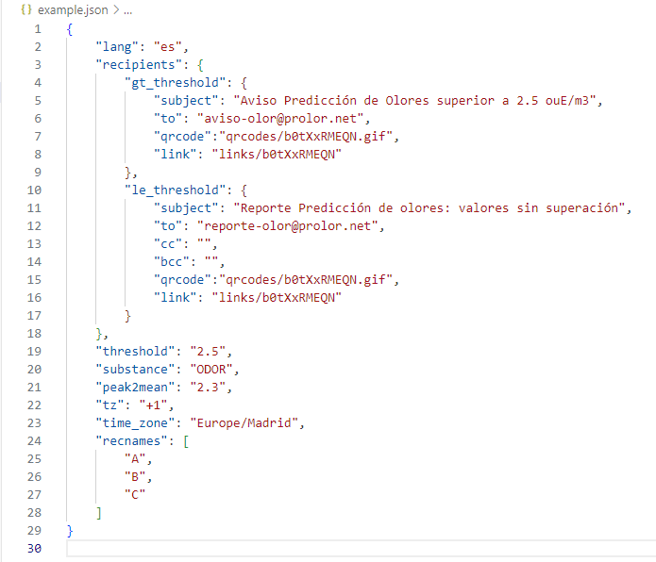

Figure 2: Example of JSON file for configuring the postprocessing and the notification steps.

The procedure evaluates the hourly peak concentration at any time in the timeseries and compares it against the specified threshold. Whenever the threshold is exceeded at any of the receptors, PrOlor sends an email to the recipients configured to receive the alert. When there are not exceedances of the threshold set, the recipients and mail contents can be different.

The email message is very simple but it incorporates all the necessary information:

* Time of the forecast
* Indication for each receptor of any hour in the forecast when the threshold is exceeded
* Indication of the action to be undertaken by the recipient of the message

An example of message when the threshold is exceeded is shown in Figure 3.

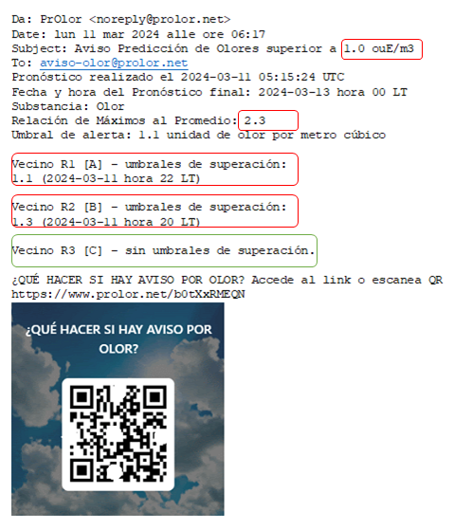

Figure 3: Example of alert email message for odour threshold exceedance.

* 1. Conclusions

PrOlor represents a simple but effective solution for proactively managing potential odour nuisances. It incorporates state-of-the-science components and is cheaper than other solutions based on proprietary interfaces. Also, it does not require personnel training for its use. These aspects make it a valid option especially for small and medium activities.

While being simple as concept, PrOlor can be configured to simulate emission scenarios of any complexity, thanks to the deployment on cloud configurable instances. The use of commercial cloud solutions is also a guarantee for security and sensible data privacy at any required level.

PrOlor is a modular system that can potentially integrate also other air dispersion models, as well as being connected to the in-plant environmental monitoring system to forecast the impact of hypothetically stationary current emissions. Also, the postprocessing can be easily expanded and tailored to the user’s needs with additional email contents and attachments.

References

Scire J.S., Robe F.R., Fernau M.E. and Yamartino R.J.: 2000a, A user's guide for the CALMET meteorological model (Version 5.0).

Scire, J.S., D.G. Strimaitis and R.J. Yamartino, 2000b, A user’s guide for the CALPUFF dispersion model (Version 5). Earth Tech. Inc., Concord, MA.

Skamarock, W. C., Klemp, J. B., Dudhia J., Gill, D. O., Barker, D. M., Duda, M.G., Huang, X.-Y., Wang, W., and Powers, J. G, 2008, A Description of the Advanced Research WRF Version 3, National Centre of Atmospheric Research, Boulder, Colorado.