 CHEMICAL ENGINEERING TRANSACTIONS  VOL. xxx, 2024 | A publication of  
The Italian Association
of Chemical Engineering
Online at www.cetjournal.it

Guest Editors: Selena Sironi, Laura Capelli
Copyright © 2024, AIDIC Servizi S.r.l.
ISBN 979-12-81206-13-7; ISSN 2283-9216

Odour dispersion modelling of ideal sources due to different meteorological condition
Matteo Gazzabin*, Filippo Robbiati, Andrea N. Rossi
Progress S.r.l., Via Nicola A. Porpora 145, 20133 Milano, Italy
*m.gazzabin@olfattometria.com
Meteorological parameters strongly affect atmospheric dispersion which makes developing a simulation to get a prediction of the odour impact significant to understand the effect of the same sources located in different sites. This study evaluates the impact of two ideal sources, one areal on the ground and one point source at altitude, having different meteorological characteristics.
The findings consistently demonstrate that the ground-level source yields the most significant odour impact, while wind speed at altitude primarily influences dispersion from the point source. Despite the areal ground-level source has a greater impact at all locations, the difference between its impact and that of the stack decreases linearly with distance.
  - Introduction
Changes in emission sources, land use and topography influence odour concentrations (Arregocés and Rojano, 2023). However, the greatest contribution to the concentration changes lies predominantly in meteorological parameters (Juneng et al., 2011).
The use of atmospheric dispersion models offers a valid approach to assess odour annoyance in these scenarios. After emission, odours can either disperse and dilute quickly, resulting in low concentrations levels, or concentrate in a relatively small volume, resulting in an odour nuisance episode. The extent of mixture is largely determined by the temperature proﬁle of the atmosphere and the wind speed (Seinfeld and Pandis, 2006).
Air quality models are useful tools to determine the impact of odourous emissions on the environment and for observing any exceedances of reference values established by the various regional guidelines.
The CALPUFF model is a non-steady Gaussian-Lagrangian wind model containing modules for complex terrain effects, coastal interaction effects, building downwash, and wet and dry removal. Additionally, CALPUFF estimates the odour dispersion in space and time using meteorological variations (Scire et al., 2000).
Its meteorological processor, CALMET, generates three-dimensional gridded meteorological data within the computational domain through refined processing and assimilation of available surface and upper air observations, as well as geophysical data.
The outcomes of CALPUFF simulation provide data to create impact maps, referring to the peak odour concentration values, expressed in terms of 98th percentile on an annual basis.
This paper delineates a comparative analysis of odour concentrations from two sources across four different locations. Additionally, meteorological conditions are also discussed.
  - Materials and methods
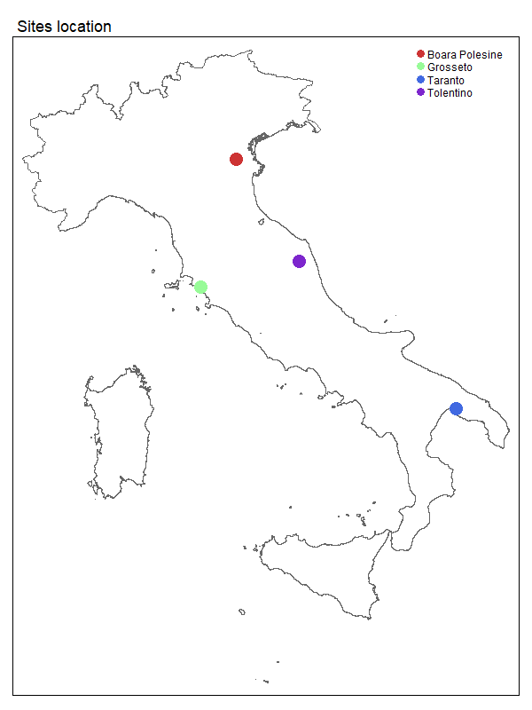
    - Sites location
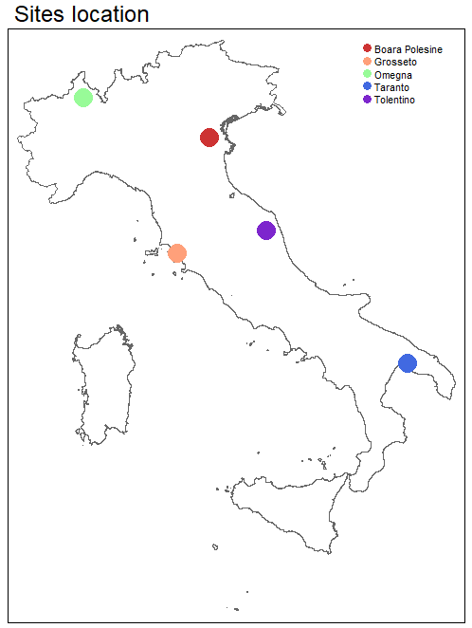
The study is performed by choosing 4 locations on the Italian territory (Figure 1). Three of them are located in a flat terrain, one is located in a hilly terrain. Table 1 shows the elevations of the terrain at the center of the installation and the average height of the terrain in the center of the cell, as well as outlining the predominant terrain types in the respective surrounding area.
Site name | Orography | Mean cell height [m] | Site height [m]
Boara | Flat | 4,1 | 2,0
Grosseto | Flat – near the Sea | 19,7 | 6,0
Taranto | Flat – near the Sea | 38,6 | 15,0
Tolentino | Hilly | 219,7 | 204,0
Table 1: Simulation domain orographic characteristics. Three stations are located in plains, one in a hilly terrain.

Figure 1: Sites location on map. The sea is: 40 km from Boara, 3.5 km from Grosseto, 1.7 km from Taranto, 38 km from Tolentino.
The terrain elevations calculated for each grid point and used as input for the CALMET model are obtained from the EU-DEM v1.1 dataset, while land uses are obtained from the raster database V2020_20u1. Both databases are made under the EU Copernicus program of the European Environmental Agency (Copernicus website).
    - Emission source
For each selected locations, simulations are carried out considering two scenarios spanning a one-year period. The reference simulation grid is set at 3 x 3 km, with a resolution of 100 m.
Twelve vertical layers are identified with the cell face heights from 10 m.
The first scenario involves a point source (stack) with a height equal to 20 m. The exit air flow velocity is 10.4 m/s, and the stack diameter is 0.35 m.
In the second scenario, an areal emissive source measuring 400 m² and placed on the ground is considered.
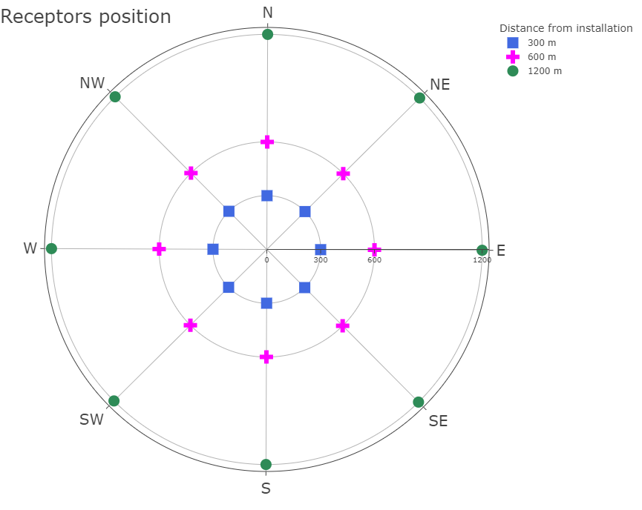
For both scenarios, the odour flow rate is assumed equal to 20,000 ouE/s. Given that the effluent temperature is not significantly higher than the ambient temperature, buoyancy effects are conservatively assumed to be negligible.
The initial puff size on the axis perpendicular to the motion (sigma Y at time t0) is calculated from the area of the source.
As no buildings are planned around the sources, the building downwash effect that might be generated has been neglected.
Results are presented in term of simulated odour concentration at 24 receptors placed every 45° intervals around the sources, and at distances of 300, 600, 1200 m from the central location of the sources location.
Receptors are named according to the direction from N to NW clockwise, and numerically labeled 1 to 3 in increasing distance from the center.
Figure 2: Receptors position around source center. For each location three distances are chosen: 300 m, 600 m, 1200 m.
    - Dispersion model and meteorological data
The atmospheric dispersion model used to perform the simulations is CALPUFF. It includes three main components: 3D meteorological model CALMET, air quality dispersion model CALPUFF and the postprocessing tool CALPOST (Tagliaferri et al., 2023).
Weather data were sourced from LAMA dataset provided by Emilia-Romagna’s Environmental Protection Regional Agency (ARPAE). The dataset generated by the ARPAE-SIMC using the COSMO model, covers the entire Italian territory and incorporates observations from radiosondes, aircraft measurements, oceanographic buoys, satellite data and surface observations. The dataset produced by the COSMO model is integrated with some additional parameters (friction velocity, Monin-Obukhov length, mixing height, stability class) by means of the chemical and transport model meteorological pre-processor Chimere (ARPAE website).
The time span covered by these data is one year: specifically referring to weather data from the year 2017 for the Tolentino site and from the year 2022 for other locations.
Any missing data and instances of wind calm values (Table 2) where handled according to the guidelines outlined for the Lombardy region (D.G.R. n. IX/2018).
Site name | Year weather data | Number of missing data [hours] | Wind calm (v < 0.2 m/s) [hours]
Boara | 2022 | 34 | 50
Grosseto | 2017 | 24 | 52
Taranto | 2022 | 34 | 48
Tolentino | 2022 | 34 | 42
Table 2: Missing data and wind calm in the meteorological dataset.

  - Results and critical discussion
    - Meteorological data analysis
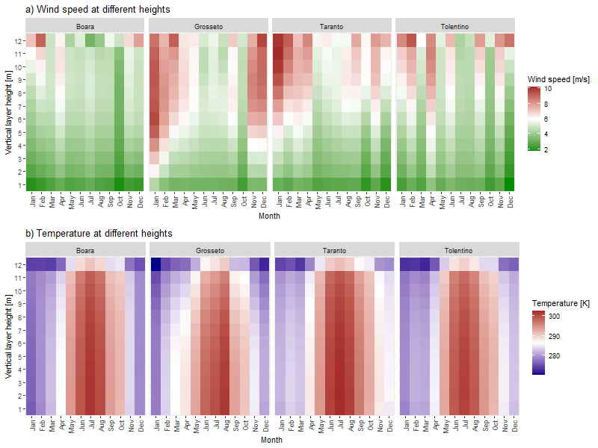
Odor dispersion is strongly influenced by meteorological parameters such as mixing height, wind speed and temperature. Looking at the vertical profiles of the last two variables reveals a consistent pattern across locations: wind speed generally increases with increasing altitude (Figure 3a). A trend particularly marked during winter months. Conversely, temperature profile exhibits an inverse trend with elevation, decreasing as altitude rises. At all sites the highest temperatures are recorded at all elevations in June, July and August. During winter months a notable thermal inversion effect is evident, with lower temperatures recorded in lower atmospheric layers compared to higher elevations, as illustrated in Figure 3b.
Figure 3: a) Wind speed and b) Temperature vertical profiles. Wind speed increases with altitude especially in the colder months; temperature decreases moving away from the first layers near the ground.
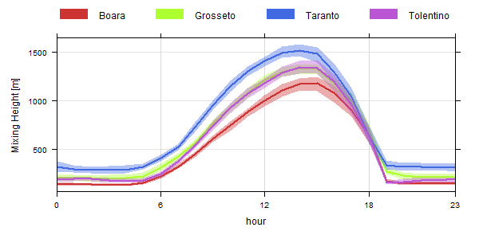
Thermal inversion generates a highly stable atmospheric layer that restricts convection and any vertical mixing. Poor mixing promotes the persistence of odours near the source limiting their dispersion, especially in the case of a ground source. The thickness of planetary boundary layer, commonly referred to as the mixing height, acts as a barrier to the vertical dispersion of odour in the atmosphere. In response to the strong diurnal cycle of heating and cooling of land surfaces in fair-weather conditions, boundary-layer thickness and other characteristics also display strong diurnal variations. Specifically mixing depth ranges from a low value of approximately of 100 m during nighttime and early morning hours to its maximum value of about 1 km in the late afternoon (Figure 4) (Arya, 1999).
Figure 4: Diurnal variation of mixing height. MH are the highest during daytime periods that are characterized by strong solar heating and the lowest during the night.
Analysis of wind directions and relative speeds at 10 m above ground level yield wind roses shown in Figure 5.
The annual wind rose at the Boara location shows prevailing directions toward the southwestern quadrant. The average wind speed is $\overline{v}=2.42 m/s$; winds with speeds $\overline{v}=4 m/s$ also blow toward South-West (SW).
In the case of Grosseto, the most frequent directions are SSW and SW. The anemology is related to the presence of the coast, which is located to the SW with respect to the location of the installation. On the other hand, the northeastern component is related to the sea breeze. The proximity to the sea also influences the average speed, which is $\overline{v}=3.27 m/s$. Winds with $\overline{v}=4 m/s$ also have high frequency in SSW and SW direction.
The Taranto location is also located close to the sea, the predominant wind vectors are those directed towards SE, SSE and S. The sea breeze is less pronounced, and the average wind speed is also lower than the previous site, $\overline{v}=2.69 m/s$.
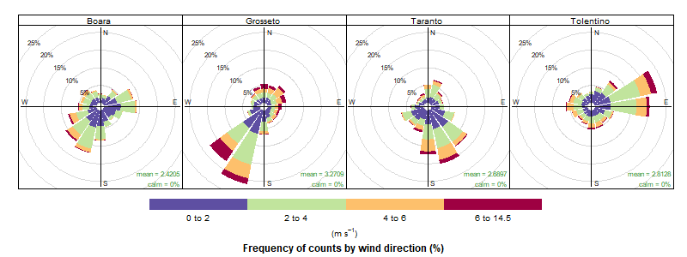
Tolentino's wind rose shows that the predominant wind direction is ENE and E. Winds with high speeds $\overline{v}=4 m/s$ also have the same direction. The average wind speed is $\overline{v}=2.81 m/s$.
Figure 5: Windrose for each site. In the figure is shown the direction in which the wind is blowing. Colours represent wind speed frequency.
    - Odour impact
To perceive an odour, it is sufficient for the concentration of the odour in the air to exceed the threshold of olfactory perception even for the time of one breath. Odour concentration, like any scalar variable in the atmosphere, fluctuates instantaneously due to turbulence. Given that the dispersion model employed produces as output, the hourly average odour concentration for each hour and receptor, it is necessary to derive the peak hourly odour concentration, defined as the concentration that is exceeded for about one second in an hour. In Australia, where extensive studies have been carried out in this regard, the document 'Approved methods for the modelling and assessment of air pollutants in New South Wales' (Department of Environment and Conservation), states that the estimation of the hourly peak concentration should be conducted by multiplying the hourly average concentration by a coefficient (peak-to-mean ratio). In the present study, a peak-to-mean ratio of 2.3 is adopted.
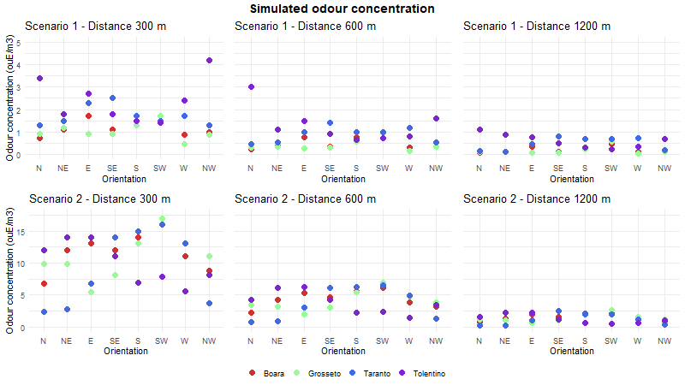
Following Italian regional regulations, odour impact is expressed in terms of ground level odour concentration at the 98th percentile. As expected, in both scenarios the odour concentration decreases with the distance for all locations (Figure 6).
Figure 6: Plot of the simulated odour concentration. Odour impact decreases with the distance.
The second scenario, characterized by a ground-based areal source, has higher simulated odour concentrations at receptors. This phenomenon arises due to the heightened influence of atmospheric stability, reduced mixing height, and decreased wind speed at ground level compared to higher altitudes. The stack emission is also simulated with an exit velocity of 10.4 m/s; momentum plume rise causes greater odour dispersion, reducing its impact on the surroundings. On average, the concentration is for the first scenario between $1.03<C<2.40 {ou}_{E}/m^{3}$ at 300 m, between $0.40<C<1.28 {ou}_{E}/m^{3}$ at 600 m and between $0.16<C<0.60 {ou}_{E}/m^{3}$ at 1200 m. For the second one, the simulated odour concentration is between $9.21<C<11.70 {ou}_{E}/m^{3}$ at 300 m, between $3.71<C<4.41 {ou}_{E}/m^{3}$ at 600 m and between $1.16<C<1.47 {ou}_{E}/m^{3}$ at 1200 m.
Taking the ratio of the averages for each of the 3 distances of the simulated concentration, a linear trend is observed. In the simulation domain, while remaining lower than that of the areal source, the impact of the stack increases with increasing distance from the emission point (Figures 7). This is due to the effect of the fallout of the puff emitted by the stack which impacts more at greater distances.

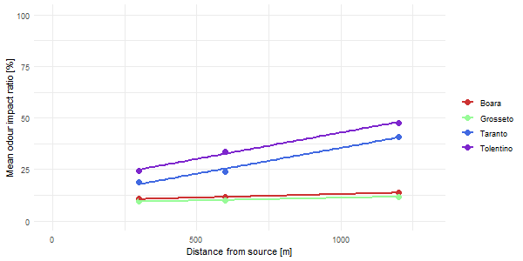
Figure 7: Ratio ${{\overline{C}}_{scenario 1}}/{{\overline{C}}_{scenario 2}}$ of simulated mean values at the receptors. Full line on the plot indicates the linear fit on the three points.
  - Conclusions
This study aimed to simulate odour impact of two ideal sources while examining their trend under different meteorological conditions at four selected sites.
For each scenario analyzed the odour concentration at receptors located in all directions around the sources was simulated.
The results obtained reveal that the impact of the stack is consistently approximately 20 percent compared with the areal source across all locations and receptors. Notably, in the latter case, the odour concentration trend correlated closely with the wind direction, particularly in close proximity to the source (300 m).
Furthermore, it was observed that as distance from the source increased, the ratio ${{\overline{C}}_{scenario 1}}/{{\overline{C}}_{scenario 2}}$ increases linearly.

References
Arregocés H. A., Rojano R., 2023, Sensitivity of the CALMET-CALPUFF model system on estimating PM10 concentrations at a mining site in northern Colombia, Case Studies in Chemical and Environmental Engineering 8, https://doi.org/10.1016/j.cscee.2023.100402
Arya, S. Pal, 1999, Air pollution meteorology and dispersion
Department of Environment and Conservation, 2005, Sydney, New South Wales, document 'DEC 2005/361'
https://land.copernicus.eu/en
https://www.arpae.it/it/temi-ambientali/meteo/scopri-di-piu/il-modello-meteorologico-cosmo-lami
Juneng L., Latif M.T., Tangang F., 2011. Factors inﬂuencing the variations of PM10 aerosol dust in Klang Valley, Malaysia during the summer. Atmos. Environ. 45, 4370-4378.
Nyrén K, Gryning S. E., 1999, Nomogram for the height of the daytime mixed layer, Boundary-Layer Meteorology 91
Regione Lombardia, 2012, D.G.R. n. IX/3018 Determinazioni generali in merito alla caratterizzazione delle emissioni gassose in atmosfera derivanti da attività a forte impatto odorigeno.
Scire J.S., Strimaitis D.G., Yamartino R.J., 2000, A User’s Guide for the CALPUFF Dispersion Model, Earth Tech. Inc., 2000, http://www.src.com/calpuff/download/CALPUFF%7B_%7DUsersGuide.pdf
Seinfeld J.H., Pandis S.N., 2006. Atmospheric Chemistry and Physics from Air Pollution to Climate Change, 2 ed. Wiley, New Jersey.
Tagliaferri F., Facagni L., Invernizzi M, Sironi S., 2023, Variability in odour impact assessment due to different cloud cover estimation approaches: A northern Italy case study, Case Studies in Chemical and Environmental Engineering 8, https://doi.org/10.1016/j.cscee.2023.100492

