|  |  |
| --- | --- |
| cetlogo ***CHEMICAL ENGINEERING TRANSACTIONS***  ***VOL. xxx, 2024*** | A publication of  aidiclogo_grande |
| The Italian Association  of Chemical Engineering  Online at www.cetjournal.it |
| Guest Editors: Selena Sironi, Laura Capelli  Copyright © 2024, AIDIC Servizi S.r.l. **ISBN** 979-12-81206-13-7; **ISSN** 2283-9216 | |

Odour emissions characterization and control as a strategic tool for the sustainable management of the organic fraction of municipal solid waste (OFMSW)

Vincenzo Marino\*,a, Aniello Marinielloa, Maria Rosaria Della Roccab, Vincenzo Belgiornoa, Vincenzo Naddeoa, Tiziano Zarraa

a Sanitary Environmental Engineering Division (SEED), Department of Civil Engineering, University of Salerno, Via Giovanni Paolo II, Fisciano, SA, Italy

b Regione Campania, D.G. Difesa del Suolo e Ecosistema, UOD Sviluppo Sostenibile, Acustica, qualità dell’aria e radiazioni- criticità ambientali in rapporto alla salute umana, Via Roberto Bracco, 15/A - 80113 Napoli, NA, Italia

\* enzomarino91@gmail.com

The continuous increase in the generation of municipal solid waste (MSW) worldwide represents a major challenge for global sustainability efforts. In accordance with the Sustainable Development Goals and the principles of the circular economy, it is essential to manage MSW involving environmental aspects that require careful control to prevent potential environmental impacts. Among the MSW, the organic fraction stands out as a highly fermentable mixed matrix that demands special attention due to the quantities produced and the different management phases, including collection, transportation, and treatment, to which it is subjected. In particular, the collection phase emerges as a linchpin for the overall success of waste management assessment. Various methodologies for the collection of the organic fraction of municipal solid waste (OFMSW) are currently employed, with door-to-door collection being a prevalent approach in many European countries. This method includes the specific collection of the organic fraction, strategically placed in designated surface or underground containers. The time and modalities of organizing the collection of the organic fraction are not universally defined but rather determined by the collection service operator. In Italian regulations, the only indication is that the collected waste must be delivered to the treatment plant within 72 hours of collection, emphasizing the urgency and efficiency required in waste management operations.

Notably, one of the primary environmental pressures linked to the management of the OFMSW is the production of odorous emissions, which can significantly impact the surrounding environment and community well-being.

The research presents and discusses the variation in time of the odour emissions of the OFMSW, aiming to quantify the potential odour production occurring between the collection phase of the OFMSW and their delivery to the plant and therefore provides a useful tool to reduce potential odour impacts and direct towards suitable management strategies. Intensive experimental activities were conducted, considering different samples of OFMSW. Characterization of the principal chemical-physical parameters and odour concentration at different times of the investigated OFMSW were performed. Statistical studies, applying multivariate analysis techniques, were conducted to identify potential correlations between the investigated parameters. Preliminary results indicate a notable increasing trend in odour concentration over time, with an inverse correlation between odour concentration and humidity and a direct correlation with temperature. The research provides valuable insights into the factors influencing odour production in the management of OFMSW.

* 1. Introduction

In recent decades, in relation to an increase in the production of municipal solid waste (MSW) and a simultaneous growth in the need for a higher quality of life and the need to protect human health and the environment (Srinivasan et al., 2023), their management is receiving increasing attention, especially with regards to environmental issues (Wu et al., 2020). MSW management involves a series of activities including collection and transportation (C&T), treatment and disposal (Yadav et al., 2020). Among these activities, C&T is considered the most crucial service in order to ensure the effectiveness of the MSW management (Singh et al., 2024). In many European countries, the most commonly used collection method is door-to-door (DTD), which refers to the system where MSW is separated in different fractions at the source and disposed of in specific containers typically located close to the user’s home according to a well-defined calendar and times(Teerioja et al., 2012). Among the different fractions of MSW collected separately, particular attention is given to the organic fraction of municipal solid waste (OFMSW), as it constitutes a fermentable mixed matrix produced in large quantities. In fact, OFMSW represents the highest percentage of the different fractions that make up the MSW (20–70% of total MSW) (Tyagi et al., 2018). OFMSW consists of several food fractions, among which the main ones are represented by fruits and vegetables, meat, fish, cheese, bread and pasta, finer materials of 20 mm and rejected materials (Alibardi and Cossu, 2015). Waste transfer stations are considered useful solutions in OFMSW management to facilitate the process in areas with different types of settlements and population density (Ağaçsapan and Çabuk, 2020). They are equally useful in the presence of complex territorial and orographic characteristics (e.g. historic centres), in which collection takes place with small trucks, due to access difficulties; and/or where the treatment plants are located very far from the production and collection points (RAFIEE et al., 2011). As regards the management of OFMSW in transfer stations, the Italian legislation (DM 08.04.2008) covers various aspects, but with reference to the storage time, the only requirement is to schedule delivery to the treatment plant by 72 hours from the collection.

Several studies demonstrate that OFMSW changes its composition over time due to degradation of the substrate, generating environmental pressures, such as odour emissions, greenhouse gases (GHG) and leachate (Barreiro-Vescovo et al., 2020). Among these, odour emissions represent the main concern due to their nuisance and significant impacts on the exposed population. Odour emissions affect quality of life, leading to psychological stress and symptoms such as insomnia, loss of appetite and irrational behaviour (Zarra et al., 2013). It is therefore essential to characterize, measure and control the odour emissions associated with the OFMSW collection phase, in order to quantify the pressures and reduce the consequent impacts. The techniques available for odour measurement are classified into analytical, sensorial and sensor-instrumental (Zarra et al., 2010). Among the sensory techniques, the most used is dynamic olfactometry applied in accordance with EN 13725:2022 (Wang et al., 2023). The odor concentration results are expressed in terms of OUE m-3 and obtained by analyzing the gaseous sample at decreasing dilution thresholds using an olfactometer, by a group of appropriately selected people (Oliva et al., 2021). While, in recent years, instrumental odor monitoring systems (IOMS), in the field of sensori-instrumental techniques, have gained popularity and applicability in the field of air quality, in particular thanks to their possibility of continuous monitoring (Fasolino et al., 2016). At present, there are no studies in the scientific literature that analyze the environmental pressures in terms of odor produced by the storage of OFMSW, thus not guaranteeing the availability of useful tools to address this problem proactively.

The research presents and discusses an in-depth study of odour emissions linked to the degradation of OFMSW over time, with the aim of bridging this gap and therefore providing a useful decision-making tool for identifying the best intervention strategies and actions. For experimental activities, synthetic samples, representative of real OFMSW, were prepared and analysed over times in terms of odour emissions. Measured data were elaborated by multivariate statistical techniques. The research aims to improve the collection process and its transport to treatment plants through transfer stations and to provide operators with a tool to adequately plan the management phases.

* 1. Material and Methods
     1. Experimental plan and program

Analysis of synthetic prepared OFMSW loads, at different times, in order to evaluate and identify potential correlations in chemical-physical characteristics and in odour emissions, measured in terms of odour concentration, were carried out. In particular, six samples of OFMSW (P1,1- P1,6) were made, weighing 5 kg each, adopting the same composition in percentage terms of 8 different food fractions (Figure 1) in accordance with literature studies (Zhang et al., 2013). The OFMSW samples, collected in compostable bags, were placed inside a single-use container of 10 L and stored at ambient temperature, in order to replicate the real OFMSW storage conditions in the transfer stations. The samples were then investigated over time, in 8 different steps starting from 0 to 72 hours (time steps: 0, 4, 8, 24, 36, 48, 60, 72 hours). For each sample, chemical-physical characterization and olfactometric analysis were carried out. During the monitoring period, a total of 336 chemical-physical analyzes and 48 olfactometric analyzes were carried out. All investigations were carried out at the Sanitary Environmental Engineering Division (SEED) Laboratory of the Department of Civil Engineering of the University of Salerno.

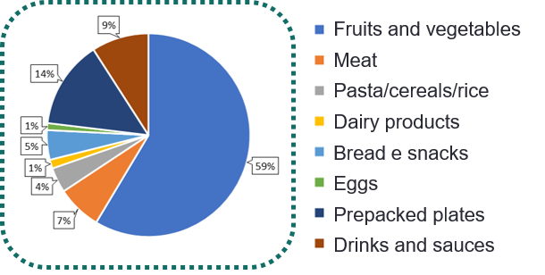

Figure 1: Food composition % of the synthetic prepared and investigated OFMSW

* + 1. Chemical-physics characterization

Table 1 shows the experimental parameters investigated for the chemical-physical characterization of the six investigated samples, along with the respective methods and instrumentation used for their determination.

Representative sample was collected according to the NWTC (National Waste Thematic Centers) Italian technical norm.

Table 1: chemical-physics parameters investigated

|  |  |  |  |
| --- | --- | --- | --- |
| **Parameter** | **measurement unit** | **Instrument** | **Method** |
| **pH** | --- | multiparameter probe  (HI5521-Hanna Instruments) | adapted from APAT CNR IRSA 2060 |
| **Temperature** | °C | adapted from APAT CNR IRSA 2100 |
| **Humidity** | %rh | oven at 105°C | CNR IRSA 2 Q 64 Vol. 2 |
| **Volatile solids** | %VS | muffle furnace at 550°C |
| **Higher Heating Value (HHV)** | kcal/kg | CHNSO analyzer  (Flash 2000-Thermo Fisher Scientific) | ASTM D 5373 |
| **Lower Heating Value (LHV)** | kcal/kg |
| **C/N Ratio** | --- |

* + 1. Olfactometric analysis

The odour samples for olfactometric analysis were collected in Nalophan bags with a volume of 7 L. The sampling was performed using a static vacuum sampler (Ecoma, GmbH, D). While for the odour concentration determination the TO8 olfactometer (Ecoma, Gmbh, D) in accordance with the standard UNI EN 13725:2022, were used.

* + 1. Statistical analysis

Microsoft Excel, box-plots and Principal Component Analysis (PCA) were applied for the data elaboration and analyses. Specifically, Microsoft Excel was employed to analyse the chemical-physical behaviour of the OFMSW samples, while box-plots tool was used to evaluate the odour concentration trends. PCA analysis was instead used to identify correlations among the detected parameters (chemical-physical ones and odour concentrations). Additional correlations studies were performed in Microsoft Excel to better understand the nature of the correlation between the parameters identified in the PCA analysis.

* 1. Results and Discussion
     1. Chemical-physical characterization

Figure 2 shows the trend at the different times of the average values and the relative standard deviations of the chemical-physical parameters detected during the experimental activities conducted for the different samples over the entire monitoring period.

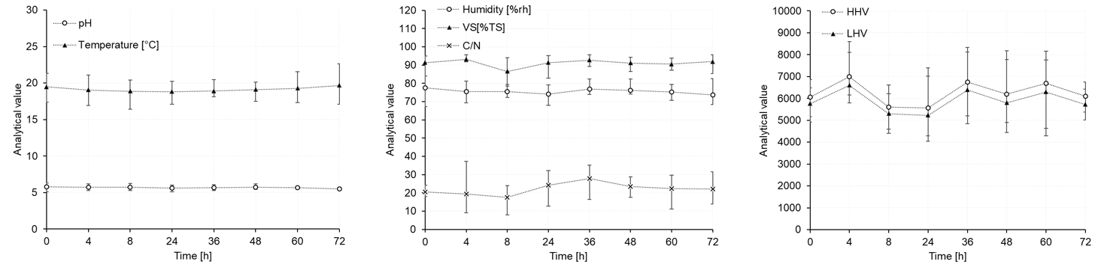

Figure 2: trend at the different times of the average values and the relative standard deviations of the chemical-physical parameters

Results show slightly acidic pH values, around 5.5, which generally remain constant over time. A modest increase in temperature of approximately 1°C is observed after 72 hours. VS exhibit variability between 84% and 93% of total solids, while humidity shows a moderately decreasing trend in the observation period. C/N ratio shows a non-univocal trend characterized by significant fluctuations in mean values and marked variability between minimum and maximum values. The same can be observed for HHV and LHV, which highlight notable standard deviation from the average values.

* + 1. Odour concentration characterization

**Errore. L'origine riferimento non è stata trovata.** shows the trends of the odour concentration over time determined with dynamic olfactometric analysis for the six synthetic samples investigated.

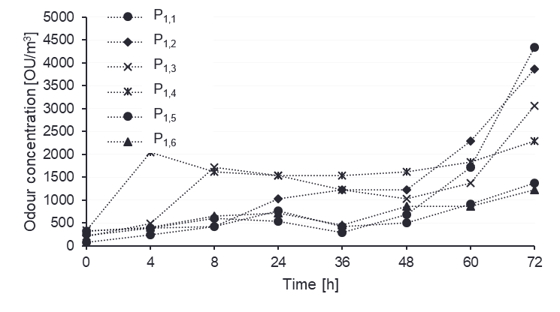

Figure 3 – Trends of the odour concentrations for the investigated samples, at different times

Results show an overall increasing trend for all the investigated samples. In particular, for each sample, the most significant increase was recorded between 60 and 72 hours. Odour concentrations ranging from 81 to 342 OU/m3, at time t=0 hours, and from 1218 to 4340 OU/m3 at time t=72 hours.

Figure 4 shows the box-plots of the odour concentration of the different samples at different times, also highlighting the values of each samples using different colors.

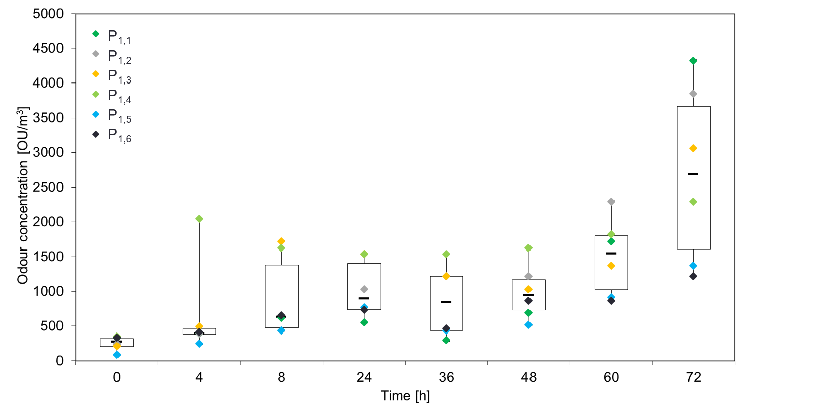

Figure 4 – Box-plots of odour concentration at different times

Results show an increasing of the median value over time, for each sample, moving from 275 OU/m3 at time t=0 hours to 2683 OU/m3 at t=72 hours. Furthermore, at t=72 hours, the highest increase in variability between minimum and maximum values is observed.

* + 1. Statistical analysis and correlation studies

Figure 5 shows the PCA (Principal Component Analysis) analysis, on the totality of the investigated samples, times and detected parameters.

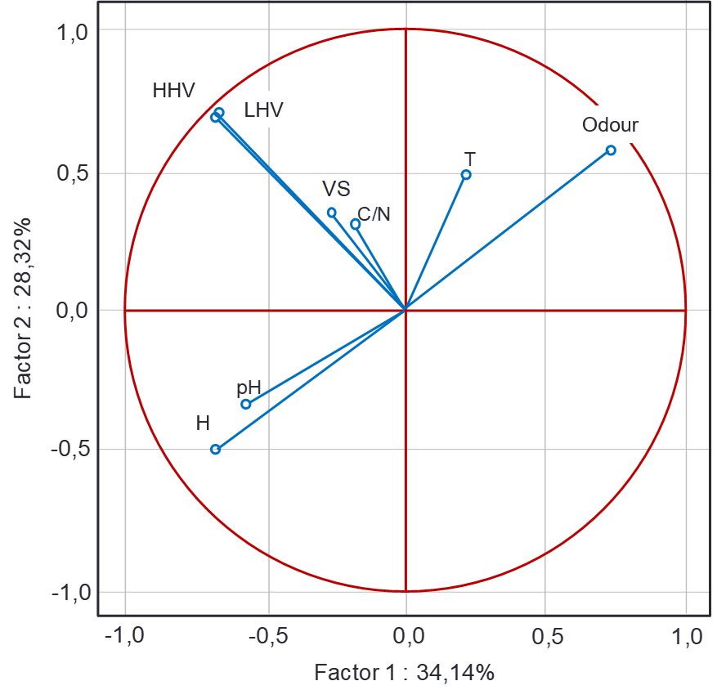

Figure 5 –PCA analysis of the whole detected data

The analysis proved to be representative as the main components managed to describe the model by 62.46%. The results indicate a direct relation of the odour concentration with the temperature and an inverse potential relation with pH and humidity. For these three parameters correlation studies have been deepened also using Microsoft Excel tool.

Figure 6 shows the correlation graphs of the odour concentration with temperature, humidity and pH.

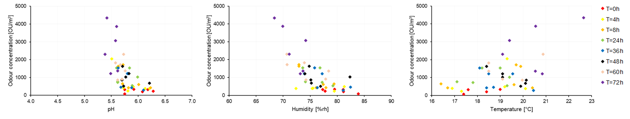

Figure 6 – Correlation studies between odour concentration and pH (left), humidity (middle) and temperature, respectively (right)

The results show a linear correlation between odour concentration and temperature of 0,25%. While an inverse linear correlation between odour concentration and humidity and temperature is highlighted, respectively of 0,51% and of 0,38%.

* 1. Conclusions

OFMSW management is essential in order to prevent and control odour emissions, avoiding significant negative impacts. Temporal variations in odour concentrations from OFMSW storage samples has been identified and proved trought the experimental analyses. Preliminary results indicate relation between odour concentration and pH, temperature and humidity parameters. Specifically, an inverse relation between odour concentration and pH and humidity could be noted. While between odour concentration and temperature the relation is proved to be directly. The overall analyses demonstrate, in any case, that there is an increase in the odor concentration measured as the storage time of the OFMSW. This result therefore confirms the opportunity to reduce the maximum time foreseen by the legislation for the storage of OFMSW in the transfer sites, to a more suitable period of 48 hours, in order to avoid potential impacts from odor in the sites themselves and/or then in the plants of treatment, in which the waste would arrive with a higher emission potential and therefore difficult to manage. The research provides useful results for separate waste collection managers and control bodies, with a view to reviewing the regulations for the storage of OFMSW, in a proactive action to avoid odor impacts.

References

Ağaçsapan, B., Çabuk, S.N., 2020. Determination of suitable waste transfer station areas for sustainable territories: Eskisehir case. Sustainable Cities and Society 52, 101829. https://doi.org/10.1016/j.scs.2019.101829

Alibardi, L., Cossu, R., 2015. Composition variability of the organic fraction of municipal solid waste and effects on hydrogen and methane production potentials. Waste Management 36, 147–155. https://doi.org/10.1016/j.wasman.2014.11.019

Barreiro-Vescovo, S., Barbera, E., Bertucco, A., Sforza, E., 2020. Integration of Microalgae Cultivation in a Biogas Production Process from Organic Municipal Solid Waste: From Laboratory to Pilot Scale. ChemEngineering 4. https://doi.org/10.3390/chemengineering4020025

Fasolino, I., Grimaldi, M., Zarra, T., Naddeo, V., 2016. Odour control strategies for a sustainable nuisances action plan. Global NEST Journal 18, 734–741. https://doi.org/10.30955/gnj.002109

Oliva, G., Zarra, T., Pittoni, G., Senatore, V., Galang, M.G., Castellani, M., Belgiorno, V., Naddeo, V., 2021. Next-generation of instrumental odour monitoring system (IOMS) for the gaseous emissions control in complex industrial plants. Chemosphere 271, 129768. https://doi.org/10.1016/j.chemosphere.2021.129768

RAFIEE, R., KHORASANI, N., MAHINY, A.S., DARVISHSEFAT, A.A., DANEKAR, A., HASAN, S.E., 2011. Siting Transfer Stations for Municipal Solid Waste Using a Spatial Multi-Criteria Analysis. Environmental & Engineering Geoscience 17, 143–154. https://doi.org/10.2113/gseegeosci.17.2.143

Singh, D., Dikshit, A.K., Kumar, S., 2024. Smart technological options in collection and transportation of municipal solid waste in urban areas: A mini review. Waste Manag Res 42, 3–15. https://doi.org/10.1177/0734242X231175816

Teerioja, N., Moliis, K., Kuvaja, E., Ollikainen, M., Punkkinen, H., Merta, E., 2012. Pneumatic vs. door-to-door waste collection systems in existing urban areas: a comparison of economic performance. Waste Management 32, 1782–1791. https://doi.org/10.1016/j.wasman.2012.05.027

Tyagi, V.K., Fdez-Güelfo, L.A., Zhou, Y., Álvarez-Gallego, C.J., Garcia, L.I.R., Ng, W.J., 2018. Anaerobic co-digestion of organic fraction of municipal solid waste (OFMSW): Progress and challenges. Renewable and Sustainable Energy Reviews 93, 380–399. https://doi.org/10.1016/j.rser.2018.05.051

Wang, B., Li, X., Chen, D., Weng, X., Chang, Z., 2023. Development of an electronic nose to characterize water quality parameters and odor concentration of wastewater emitted from different phases in a wastewater treatment plant. Water Research 235, 119878. https://doi.org/10.1016/j.watres.2023.119878

Wu, C., Shu, M., Liu, X., Sang, Y., Cai, H., Qu, C., Liu, J., 2020. Characterization of the volatile compounds emitted from municipal solid waste and identification of the key volatile pollutants. Waste Management 103, 314–322. https://doi.org/10.1016/j.wasman.2019.12.043

Yadav, V., Kalbar, P.P., Karmakar, S., Dikshit, A.K., 2020. A two-stage multi-attribute decision-making model for selecting appropriate locations of waste transfer stations in urban centers. Waste Management 114, 80–88. https://doi.org/10.1016/j.wasman.2020.05.024

Zarra, T., Naddeo, V., Belgiorno, V., 2013. A novel tool for estimating the odour emissions of composting plants in air pollution management. Global NEST Journal 11, 477–486. https://doi.org/10.30955/gnj.000484

Zarra, T., Naddeo, V., Belgiorno, V., Reiser, M., Kranert, M., 2009. Instrumental characterization of odour: a combination of olfactory and analytical methods. Water Science and Technology 59, 1603–1609. https://doi.org/10.2166/wst.2009.125

Zarra, T., Naddeo, V., Giuliani, S., Belgiorno, V., 2010. Optimization of field inspection method for odour impact assessment, in: DelRosso, R. (Ed.), University of Salerno. Presented at the NOSE 2010: INTERNATIONAL CONFERENCE ON ENVIRONMENTAL ODOUR MONITORING AND CONTROL, pp. 93–98. https://doi.org/10.3303/CET1023016

Zhang, Y., Arnold, R., Paavola, T., Vaz, F., Correia, C., Cavinato, C., Kusch-Brandt, S., Heaven, S., 2013. Compositional analysis of food waste entering the source segregation stream in four European regions and implications for valorisation via anaerobic digestion.