|  |  |
| --- | --- |
| cetlogo ***CHEMICAL ENGINEERING TRANSACTIONS***  ***VOL.*** | A publication of  aidiclogo_grande |
| The Italian Association  of Chemical Engineering  Online at www.cetjournal.it |
| Guest Editors:  Copyright © AIDIC Servizi S.r.l. **ISBN** 978-88-95608-xx-x **ISSN** 2283-9216 | |

Powdered bioactivators for the control of odorous emissions produced by the organic fraction of municipal solid waste (OFMSW) collected in surface street containers.

Federica Pasquarellia, Angelo D’alvanob, Aniello Marinielloa, Mariarosaria Benedettob, Giuseppina Olivaa, Vincenzo Naddeoa, Tiziano Zarra\*,a

a Sanitary Environmental Engineering Division (SEED), Department of Civil Engineering, University of Salerno, Via Giovanni Paolo II, Fisciano, SA, Italy

b Mb Group Expertise solution srl Unipersonale, Via Stabia, snc– 84012 Angri, SA, Italy

\* tzarra@unisa.it

Population growth is closely linked to the increase in the number of citizens who consume resources and thus to the production of municipal solid waste (MSW). Integrated waste management is a key element for sustainable urban development and environmental protection. Reduction, reuse, recycling, and energy recovery are fundamental actions to implement the principles of community management strategy and circular economy, reducing the quantity of waste to be disposed of in landfills and the consequent impacts on the environment. For this purpose, the separate collection phase represents the most important action. Odour emissions from MSW management are among the main negative pressures perceived by the population. Odour emissions originate mainly from the decomposition of the organic fraction of municipal solid waste (OFMSW), which occurs during the collection, transport, and treatment phases of the waste, and are the cause of many complaints. Therefore, the control of odour emissions in the treatment of municipal waste represents a key action in all the management phases and for all involved actors, which must be carried out to preserve air quality, health, and well-being of the population.

The research presents and discusses the development and evaluation of advanced powdered bioactivators aimed at reducing the odorous emissions produced by the separate collection of the organic fraction of municipal solid waste in surface street containers. The bioactivators used consist of a mixture of spores, microorganisms, enzymes, and nutrients. An extensive experimental plan and program have been carried out. Different bioactivators have been studied and analyzed. The concentration of odours emitted at different investigated times were carried out according to UNI EN 13725:2022. The bioactivators investigated showed different behaviors on the odours, including “masking” and abatement, depending on their composition and over time. The research aims to be a useful study for operators in the waste management sector to avoid odour impacts and as a basis for the development of technologies and methods for managing odorous emissions.

* 1. Introduction

Municipal solid waste (MSW) production has grown exponentially in proportion to population growth, urbanization and industrialization. This phenomenon is further accentuated by a growing demand for goods needed to improve living standards in urban communities and unsustainable consumption patterns (Malinauskaite et al., 2017). The overall production of MSW in the European Union has increased by 2.6% from 225.3 million tonnes in 2019 to approximately 231.3 million tonnes. Analysing per capita production data, the average European per capita value of MSW has been on the rise from 500 kg per person per year in 2018, to 517 kg in 2020 (+3.4%) (Botti et al., 2020). It is estimated that global annual MSW production will double by 2050 (Kaza et al., 2018), fuelling a cycle of consumption and disposal that presents a series of challenges to be addressed. The European Union has set the goal of 65% of MSW recycled and less than 10% of MSW disposed of in landfills by 2035 (Rolewicz-Kalińska et al., 2020). The growing of MSW production represents thus a significant challenge for local authorities, policymakers and all actors involved in the management process. The adoption of effective management strategies for the collection and treatment are required (Fasolino et al., 2016). To address this challenge, it is crucial to adopt management strategies at the European community level and implement the principles of the circular economy, which promote the reduction, reuse and recycling of materials (Bertanza et al., 2021). Source separation of different fractions through separate collection plays a crucial role in this context. There are various methods and methodologies to implement separate collection such as, drop-off sites, door-to-door and large-volume containers. Each of these have advantages and disadvantages (Gallardo et al., 2015). In general, among the different fractions that make up MSW and are subject to collection, the Organic Fraction raises the greatest concerns with odour emissions and potential negative impact (Zarra et al., 2009). The odours emitted from the organic fraction of municipal solid waste (OFMSW) are due to the decomposition of organic materials present, such as food residues, plant scraps, and other biodegradable materials (Gutiérrez et al., 2017; Oliva et al., 2021). The time elapsed between waste production and its treatment in the specific plants (composting plants or anaerobic digestion plants) is crucial in the process, as it is associated with the production of odour emissions (Zarra et al., 2010). In Italy, among the different collection schemes, the main adopted by the waste management company for the collection of OFMSW is door-to-door (DTD), with containers of different volumes distributed to individual users or present in multi-family residences, and collected according to a well-defined calendar (Botti et al., 2020). Generally, in this scheme of collection, citizens deposit the containers containing organic waste in the evening hours on defined days, and then the waste management company picks them up during the night or early morning to transport them to treatment plants. The emptying of the containers by waste management workers into the transport vehicle generally doesn’t involve any cleaning or sanitization actions. This lack of action is one of the main causes of odour annoyance, potential sanitary negative effects on human health and on the environment and cause of numerous of complaints by the citizens (Cheng et al., 2019; Zarra et al., n.d.). Currently different technological solutions for the control of the odour emissions of the collected OFMSW from collection containers are proposed, such as the use of containers designed with special materials or coatings, absorption technologies using porous materials, controlled ventilation systems, and the use of chemical or biological products. However, these solutions are not fully sustainable and do not cover all issues. For instance, current technologies do not take into account the use and consumption of materials. Challenge is therefore to identify alternative and advanced, more sustainable solutions.

The research addresses these issues by presenting an alternative and sustainable solution in line with the sustainable development objectives promoted by the 2030 Agenda. The development and experimental activities of new powdered bioactivators for the control of the odour emissions produced by the organic fraction of municipal solid waste (OFMSW) collection in surface street containers, are presented and discussed.

* 1. Materials and methods
     1. Experimental Set up

Figure 1 shows the system carried out for conducting experimental analysis and testing activities of advanced powdered bioactivator solutions.

The experimental setup consists of number 2 surface street containers of 120 liters each, called R1 and R2, used for the collection of the OFMSW. In the experimental activities, R1 was used without bioactivators, to define the background condition, while R2 was used to evaluate the different powdered bioactivators.

Both containers are equipped with a sampling point to collect gaseous emissions at different times.

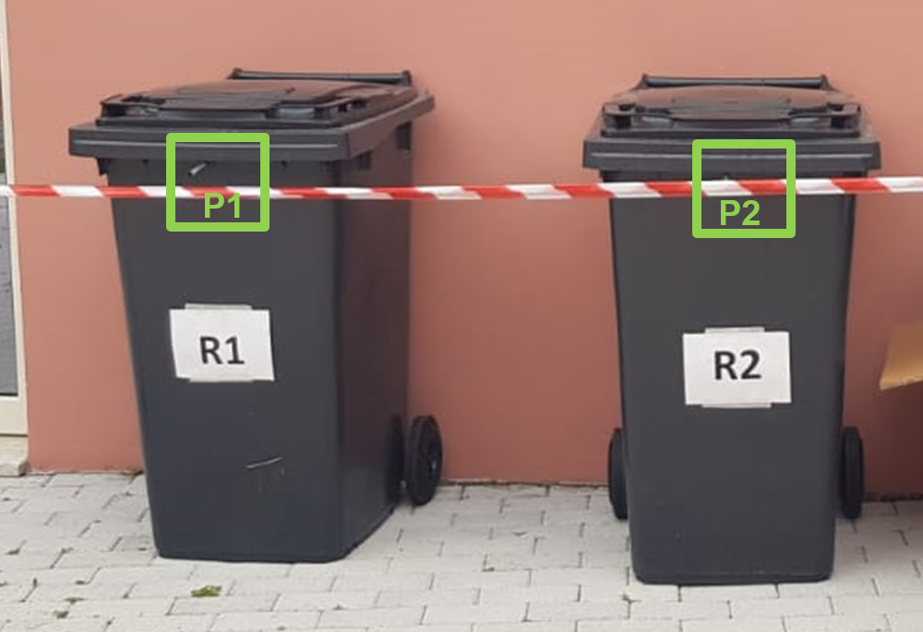

Figure 1 – Experimental set up

* + 1. Plan and Program

Two experimental campaigns (I and II) were carried out, by changing the bioactivator in R2 (B1 and B2), maintaining all other experimental conditions. Each experimental campaign had a duration of total four days. For every day OFMSW were provided in each surface containers at 6:00 p.m. and emptied at 10.00 of the next day. After the empty of booth of the containers, only for R2 a dosage of 20g of bioactivators were dispensed, while no action was taken for R1. Gaseous samples were collected at booth containers at different times in order to evaluate the bioactivators effects in terms of different odour characterization parameters. Three different samples for each day and for each container were carried out after +0.10h, +4.00h, +8.00h of their emptying. Twenty samples for each campaign were collected and analysed in terms of odour characterization parameters. Table 2 shows the plan and program of the experimental activities conducted for each campaign.

Table 2 – Plan and program of each experimental campaign

|  |  |  |  |  |  |
| --- | --- | --- | --- | --- | --- |
| **Parameter** | **Time** | | **Main activity description** | **Sampling** | **Odour characterization** |
| **Hour** | **Progressive** |
| **0** | 18:00 |  | Containers filling with OFMSW |  |  |
| **1** | 10:00 | 0h | Containers emptying and bioactivator\* dispensing in R2 |  |  |
| 10:10 | +0.1h | Gaseous sample collection |  |  |
| 14:00 | +4h |  |  |
| 18:00 | +8h |  |  |
| 18:10 |  | Containers filling with OFMSW |  |  |
| **2** | 10:00 | 0h | Containers emptying and bioactivator\* dispensing in R2 |  |  |
| 10:10 | +0.1h | Gaseous sample collection |  |  |
| 14:00 | +4h |  |  |
| 18:00 | +8h |  |  |
| 18:10 |  | Containers filling with OFMSW |  |  |
| **3** | 10:00 | 0h | Containers emptying and bioactivator\* dispensing in R2 |  |  |
| 10:10 | +0.1h | Gaseous sample collection |  |  |
| 14:00 | +4h |  |  |
| 18:00 | +8h |  |  |
| **4** | 10:00 | +24h |  |  |

\*Two different bioactivators were investigated; one for each experimental campaign

* + 1. OFMSW and Bioactivators characterization

The OFMSW used in the experimental activities were collected from the municipality of Angri (Salerno Province, Campania Region, Italy). The OFMSW were collected using biodegradable bags. A sequence of 10 kg on the first day, 15 kg on the second and 20 kg on the third day, for each container were used. Increasing OFMSW daily quantities were deposited in the surface street containers, in order to replicate different conditions relevant to reality. Similarly, no merceological composition characterization of OFMSW was conducted in accordance with the reproduction of a real-life situation.

*ODOR PULV PR BIO MB* (mbGroup Srl, Italy) is the powdered bioactivator used for the experimental activity. The B1 bioactivator, in particular, has a limited number of bacterial strains, a poor presence of enzymes and an amplification of non-biological components (cyclodextrins and natural extracts and essential oils). While the B2 bioactivator is characterized by a formulation of multi-strain bacteria and enzymes in highly concentrated powder for the neutralization and sanitization of odors. The probiotics contained in the formulation are of the non-genetically modified Bacillus Subtilis genus, belonging to class 1 of the European legislation which classifies them. Bioactivators produce specific enzymes depending on the organic substrate they come into contact with. While.

* + 1. Gaseous samples collection

The gaseous samples from the surface street containers were collected by means of a vacuum sampler (Ecoma GmbH, D), using Nalophan® bags of 10-liter volume, in accordance with EN 13725:2022.

* + 1. Odour characterization

For each collected sample two different odour characterization parameters were determined: odour concentration and hedonic tone. Odour concentration was carried out, in accordance with EN 13725:2022, with a dynamic olfactometer of the TO8 series (Ecoma, GmbH, D), adopting the yes/no method and a panel of 4 trained people, always maintaining the same time between sampling and the analysis phase to avoid potential influences on the determination (Zarra et al., 2012).

Hedonic tone, referring to the pleasant or unpleasant sensation associated with an odour, was determined according to VDI 3882 (Sucker et al., 2008) on the basis of a rating scale with scoring from -4 to 4 (nine-point scale with values ranging from “-4 – extremely unpleasant” to “+4 – extremely pleasant”).

All analyses were carried out at the Olfactometric Laboratory of the Sanitary and Environmental Engineering Division (SEED) at the University of Salerno (Italy).

* 1. Results and discussion
     1. Odour characterization with B1 (I experimental campaign)

Figure 2 shows the graphical trend of the odour concentrations and hedonic tone detected in R1 and R2 during the first experimental campaign using the bioactivator B1 in R2.

The results show trends in odour concentrations always decreasing, with increasing progressive time from the emptying phase for all days investigated, with a more marked decrease within the first 4 hours and a lower decrease in the subsequent time. The odour concentrations detected in the container R2 are always higher than those detected for the container R1. These differences are minimized with the time: the greatest differences are recorded in the initial phase, while after 8 hours from emptying they are practically minimal.

The analysis of the hedonic tone, however, shows how the adoption of the bioactivator is such that the perception of the odour is always more pleasant compared to the case of a container without the bioactivator (R1): the values of the hedonic tone are always pleasant in the first phase after emptying and, in any case, remain higher, in absolute value, than those of the case in the absence of use of the bioactivator, even after 8 hours and, even after 24 hours on the fourth day.

Overall, a strong enzymatic component of bioactivator B1 is demonstrated, characterized by an intense fragrance, which volatilizes during its initial application phase. This element significantly influences the odour concentration of the analyzed samples, with higher values observed in the samples collected from R1 compared to those from R2. On the other hand, the presence of the volatile, perfume component acts on the sensorial perception of odour emissions, particularly at the beginning of its application, with increasingly pleasant hedonic tone values. The results allow us to conclude how the B1 bioactivator acts in terms of masking unpleasant odours, making the samples more pleasant.



Figure 2 – Concentration and Hedonic Tone trends in R1 and R2 during first experimental campaign

* + 1. Odour characterization with B2 (II Experimental Campaign)

Figure 3 shows the graphical trend of the odour concentrations and hedonic tone detected in R1 and R2 during the second experimental campaign using the bioactivator B2 in R2.



Figure 3 – Concentration and Hedonic Tone trends in R1 and R2 during second experimental campaign

The results confirm the decreasing trends in terms of daily odour concentration, with time, for the container without bioactivator (R1). For the system using the bioactivator, however, they show lower odour concentrations values in the initial step, higher in the central phase and comparable again at the end of the test.

Similarly, in terms of hedonic tone, the unpleasant values are always confirmed for the samples detected by the system without bioactivator. While for the system with the use of the B2 bioactivator, in this case, there is no evidence of an odour pleasant trend reversal, for all analyses, but in general there is an unpleasantness hedonic tone, comparable and generally lower in the first initial phase compared to the R1 system.

Overall, for bioactivator B2 the lower presence of the volatile component is now demonstrated in favor of the greater presence of an enzymatic component. This enzymatic component acts primarily on reducing odour concentration and no longer significantly on odour perception. The results allow us to conclude how the B2 bioactivator primarly acts in terms of odour concentration abatement and not more significantly on the hedonic tone.

* 1. Conclusions

Through the implementation of a targeted experimental activity, the effectiveness of advanced bioactivators in controlling odour emissions from surface street containers using for the collection of OFMSW was evaluated. The results highlighted the importance of adopting innovative approaches to address this environmental and social problem. In particular, the possibility of adopting and modifying the composition of bioactivators in order to obtain pleasant odour perceptions (bioactivator B1), or to focus more on reducing odour concentration (bioactivator B2) has been demonstrated. Still challenges need to be further be addressed and are in progress at the research. The study opens new perspectives for the waste collection sector, providing a basis for the development of innovative strategies and technologies aimed at mitigating unwanted odours and promoting a healthier and more sustainable urban environment for local communities.

References

Bertanza, G., Mazzotti, S., Gomez, F.H., Nenci, M., Vaccari, M., Zetera, S.F., 2021. Implementation of circular economy in the management of municipal solid waste in an Italian medium-sized city: A 30-years lasting history. Waste Management 126, 821–831. https://doi.org/10.1016/j.wasman.2021.04.017

Botti, L., Battini, D., Sgarbossa, F., Mora, C., 2020. Door-to-door waste collection: Analysis and recommendations for improving ergonomics in an Italian case study. Waste Management 109, 149–160. https://doi.org/10.1016/j.wasman.2020.04.027

Cheng, Z., Sun, Z., Zhu, S., Lou, Z., Zhu, N., Feng, L., 2019. The identification and health risk assessment of odor emissions from waste landfilling and composting. Science of The Total Environment 649, 1038–1044. https://doi.org/10.1016/j.scitotenv.2018.08.230

Fasolino, I., Grimaldi, M., Zarra, T., Naddeo, V., 2016. Odour control strategies for a sustainable nuisances action plan. GlobalNEST International Journal 18, 734–741.

Gallardo, A., Carlos, M., Peris, M., Colomer, F.J., 2015. Methodology to design a municipal solid waste pre-collection system. A case study. Waste Management 36, 1–11. https://doi.org/10.1016/j.wasman.2014.11.008

Gutiérrez, M.C., Siles, J.A., Diz, J., Chica, A.F., Martín, M.A., 2017. Modelling of composting process of different organic waste at pilot scale: Biodegradability and odor emissions. Waste Management 59, 48–58. https://doi.org/10.1016/j.wasman.2016.09.045

Kaza, S., Yao, L., Bhada-Tata, P., Woerden, F.V., 2018. What a Waste 2.0: A Global Snapshot of Solid Waste Management to 2050. World Bank Publications.

Malinauskaite, J., Jouhara, H., Czajczyńska, D., Stanchev, P., Katsou, E., Rostkowski, P., Thorne, R.J., Colón, J., Ponsá, S., Al-Mansour, F., Anguilano, L., Krzyżyńska, R., López, I.C., A.Vlasopoulos, Spencer, N., 2017. Municipal solid waste management and waste-to-energy in the context of a circular economy and energy recycling in Europe. Energy 141, 2013–2044. https://doi.org/10.1016/j.energy.2017.11.128

Oliva, G., Zarra, T., Pittoni, G., Senatore, V., Galang, M.G., Castellani, M., Belgiorno, V., Naddeo, V., 2021. Next-generation of instrumental odour monitoring system (IOMS) for the gaseous emissions control in complex industrial plants. Chemosphere 271, 129768. https://doi.org/10.1016/j.chemosphere.2021.129768

Rolewicz-Kalińska, A., Lelicińska-Serafin, K., Manczarski, P., 2020. The Circular Economy and Organic Fraction of Municipal Solid Waste Recycling Strategies. Energies 13, 4366. https://doi.org/10.3390/en13174366

Sucker, K., Both, R., Bischoff, M., Guski, R., Winneke, G., 2008. Odor frequency and odor annoyance. Part I: assessment of frequency, intensity and hedonic tone of environmental odors in the field. Int Arch Occup Environ Health 81, 671–682. https://doi.org/10.1007/s00420-007-0259-z

Zarra, T., Naddeo, V., Giuliani, S., Belgiorno, V., 2010. Optimization of field inspection method for odour impact assessment. Chemical Engineering Transactions 23, 93–98. https://doi.org/10.3303/CET1023016

Zarra, T., Naddeo, V., Oliva, G., Belgiorno, V., 2016. Odour Emissions Characterization for Impact Prediction in Anaerobic-Aerobic Integrated Treatment Plants of Municipal Solid Waste. Chemical Engineering Transactions 54, 91-96. https://doi.org/10.3303/CET1654016.

Zarra, T., Naddeo, V., Belgiorno, V., 2009. A novel tool for estimating the odour emissions of composting plants in air pollution management. Global NEST Journal 11, 477–486. https://doi.org/10.30955/gnj.000484.

Zarra, T., Reiser, M., Naddeo, V., Belgiorno, V., Kranert, M., 2012. A comparative and Critical Evaluation of Different Sampling Materials in the Measurement of Odour Concentration by Dynamic Olfactometry. Chemical Engineering Transactions 30, 307–312. https://doi.org/10.3303/CET1230052.