|  |  |
| --- | --- |
| cetlogo ***CHEMICAL ENGINEERING TRANSACTIONS***  ***VOL. xxx, 2024*** | A publication of  aidiclogo_grande |
| The Italian Association  of Chemical Engineering  Online at www.cetjournal.it |
| Guest Editors: Selena Sironi, Laura Capelli  Copyright © 2024, AIDIC Servizi S.r.l. **ISBN** 979-12-81206-13-7; **ISSN** 2283-9216 | |

Influence of stack terminal configurations on odour dispersion

Roberto Bellasio\*, Roberto Bianconi

Enviroware srl, Via Dante Alighieri 142, Concorezzo (MB), Italy

rbellasio@enviroware.com

Odor emissions are a common environmental problem that can have significant impacts on quality of life. Odor emissions are due to a variety of sources, including industrial processes, agriculture, and waste management facilities. When released into the air, these odorous compounds are often cause of nuisance and complaints.

Industrial plants responsible for the emission of odours are often characterised by the presence of stacks with relatively low height and small diameter. Therefore, it is important to simulate as precisely as possible the emissions from these stacks, because their impact may be close to the point of release.

In particular, the exit of these stacks is not always vertical and free, more often than not a rain cap may be present, or the terminal may be horizontal or with any inclination with respect to the vertical, including gooseneck tips pointing toward the ground. When sensitive receptors are close to the stacks, the terminal configuration may play an important role on the final impact.

There are some methods to consider non vertical or obstructed stacks within atmospheric dispersion models. Some methods require the adoption of a very low exit speed and the calculation of an equivalent diameter; one of these methods has been incorporated in AERMOD. Another well-known model, CALPUFF, allows nullifying the momentum flux factor. Finally, the Lagrangian particle model LAPMOD simulates exit terminals with any slope and direction thanks to the numerical plume rise algorithms adopted in its formulation.

In this work an inter- and intra-comparison of model results for different exit terminals have been performed. The results of different models (CALPUFF and LAPMOD) for stacks with the same exit terminal have been examined, as well as the results obtained for the same model with different stack terminals. The analysis was limited to CALPUFF and LAPMOD because they use exactly the same meteorological input deriving from CALMET. The comparison with AERMOD would have been interesting, but that means to use another set of meteorological data, making it more difficult to understand if possible different results are due to the way the stack terminal is simulated or to the meteorological input to the models.

* 1. Introduction

Stacks (i.e., point sources) are among the most used source types within plants with emissions into the atmosphere. They are identified by their geometrical parameters (coordinates, height and diameter), and emission parameters (exit speed, exit temperature, emission rate of each pollutant). Point sources are usually identified as vertical stacks that emit freely into the atmosphere, but other configurations of the stack terminal are not infrequent. Indeed, stacks often present a rain cap, or are horizontal, or tilted with a specific orientation; gooseneck stacks are also used. Temperature and exit velocity are important variables for calculating plume rise which may be reduced when a rain cap is present, or when the stack terminal is horizontal. In these situations the initial vertical velocity of the plume is reduced or null, and the plume rise is due only to the thermal buoyancy if the exit temperature exceeds the ambient temperature.

Some atmospheric dispersion models contain algorithms to simulate this kind of emissions. However, when the simulation is carried out with a dispersion model without specific algorithms for rain caps and horizontal stacks, US-EPA (1993) suggests to force the exit velocity to 0.001 m/s. For vertical stacks with rain caps, in order to maintain volumetric flow and buoyancy, an equivalent stack diameter must be given in input to the model. As shown for example in Barclay et al. (2023), the equivalent diameter may be very large with respect to the actual diameter. Therefore, it can be used only when dealing with models with parametric plume rise algorithms. On the contrary, if the atmospheric dispersion model adopts a numerical plume rise algorithm, it solves a set of differential equations and needs the stack diameter as one of the initial conditions. The use of the equivalent diameter as initial condition in a numerical plume rise algorithm gives unrealistic results.

Among the atmospheric dispersion models with explicit algorithms to treat obstructed vertical stacks or non-vertical stacks there are AERMOD, CALPUFF and LAPMOD. After a brief discussion of the characteristics of these models, the paper presents the results obtained with CALPUFF and LAPMOD for a stack with six different terminals and different exit temperatures. The simulations have been performed for two sites characterized by different meteorology.

* 1. Stack terminals treatment by different models

The plume rise algorithms adopted by three dispersion models are briefly summarised in this paragraph. AERMOD is discussed due to its importance, but it is not used in the simulations because it does not use exactly the same meteorology, as done by CALPUFF and LAPMOD.

* + 1. AERMOD

AERMOD (US-EPA, 2022a) can simulate both rain-capped stacks and horizontal stacks, which are associated to the POINTCAP and POINTHOR source types, respectively. AERMOD uses two different methodologies to simulate these kinds of stacks.

When the stacks are not subject to building downwash and parametric equations are used to calculate the plume rise, the approach suggested by US-EPA (1993) and summarised in the previous paragraph is used. Therefore, the plume momentum is suppressed by imposing an exit velocity of 0.001 m/s, and an equivalent stack diameter is calculated in order to maintain the plume buoyancy. When the stacks are subject to building downwash, the PRIME algorithm (Schulman et al., 2000) is used, which incorporates a numerical plume rise algorithm. Therefore, for capped stacks (POINTCAP option), AERMOD sets the initial diameter of the plume equal to twice the actual stack diameter in order to simulate the initial spread of the plume due to the presence of the cap. Additionally, the initial velocity of the plume is set along the horizontal direction with an intensity equal to the exit velocity divided by 4. For horizontal stacks (POINTHOR option) the initial plume velocity is horizontal with the intensity of the stack exit speed. Additionally, as reported in US-EPA (2022b), AERMOD assumes that the release is oriented with the wind direction.

* + 1. CALPUFF

For point sources with a rain cap or with a horizontal exit, CALPUFF (Scire at al., 2000) allows the use of a momentum flux factor (input variable FMFAC) to simulate the reduction in vertical momentum. This variable can only assume two values: 1, indicating full momentum (i.e., stack with vertical exit and without any cap), or 0, indicating the complete deletion of mechanical momentum. Then, when FMFAC=0, the plume rise is generated only by the thermal buoyancy if the exit temperature exceeds the ambient temperature. Both horizontal and rain-capped stacks must be simulated using FMFAC=0.

* + 1. LAPMOD

LAPMOD includes two numerical plume rise algorithms named JJ (from Janicke and Janicke, 2001) and WT (from Webster and Thomson, 2002). Both the two plume rise algorithms of LAPMOD are in compliance with the German standard VDI 3782 Part 3. The difference between them is that JJ also simulates wet plumes, while WT has been developed for dry plumes. The validation of LAPMOD using these two algorithms has been described in Bellasio et al. (2018). LAPMOD describes the orientation of the stack tip by means of two angles: the azimuthal angle specifies the stack orientation on the horizontal plane, and the polar angle specifies the tilting of the stack with respect to the vertical. Then, horizontal stacks with any azimuthal orientation can be simulated by LAPMOD. This is a difference for example from AERMOD, for which the initial plume direction is always downwind. Rain-capped stacks are simulated as done by AERMOD: 1) the initial diameter of the plume is set equal to twice the actual stack diameter to simulate the initial spread of the plume, and 2) the initial velocity is horizontal and with an intensity equal to the exit velocity divided by 4. For capped stacks it is assumed that the initial plume direction is the opposite of wind direction. In calm conditions (i.e., wind speed lower than 0.5 m/s) the initial plume direction is determined randomly.

* 1. Simulations setup

The simulations have been carried out in two sites separated by a distance of about 330 km with different meteorology. Both sites are located in northern Italy: Site 1 is in the eastern part, it is characterised by almost flat terrain, while Site 2 is in the western part and is characterised by hilly terrain. The wind roses of the two sites for year 2022 are reported in Figure 1. In both sites an 8 m high stack with a diameter of 0.5 m has been considered. Six different exit terminals have been simulated: vertical unobstructed, vertical with rain cap, horizontal pointing north, east, south and west. The dry volumetric flow is 8000 Nm3/h, and the OER is 9540 ouE/s. Two different exit temperatures have been considered: 30 °C and 70 °C, and the exit velocity has been calculated accordingly.

In order to make comparable simulations between CALPUFF and LAPMOD, the probability distribution function method for dispersion under convective conditions has been activated in CALPUFF (MPDF=1), and the plume rise has been simulated with the numerical method (MRISE=2). In LAPMOD the WT plume rise method has been activated, and the concentration fields have been calculated with the Gaussian kernel.

|  |  |
| --- | --- |
|  |  |

*Figure 1: Wind roses of the two sites. Year 2022.*

* 1. Results

Figure 2 and Figure 3 show the 1 ouE/m3 isolines of the 98th percentiles of peak concentration for Site 1 and Site 2, respectively. The stack is placed in the origin (0,0) and the labels on the axis represent the distance in meters. In each figure, the left panel shows the results for a vertical unobstructed stack, while the right panel represents the results for a rain-capped stack. For Site 1 the results of the two models are very different, particularly when the emission temperature is 30 °C. In this situation the CALPUFF isolines extend about 150 m more than those of LAPMOD along the E and NW directions. When the exit temperature is 70 °C the differences are still present but reduced. Even for Site 2 (Figure 3) the differences between CALPUFF and LAPMOD are larger for the lower emission temperature. Considering 1 ouE/m3, the effect of a rain cap (right panels of the figures) is not well visible; it would be more evident for higher concentration levels. However, since LAPMOD tends to predict higher concentration values with respect to CALPUFF, it was not possible for these simulations to compare other levels. The different results of CALPUFF and LAPMOD have already been noticed in other works (e.g., Invernizzi et al., 2020).

Focusing on LAPMOD, for Site 1, Figure 4 and Figure 5 represent the maps of the 98th percentiles of peak concentrations corresponding to 3 ouE/m3 and 5 ouE/m3, respectively. As expected, when the release temperature is lower (Figure 4a and Figure 5a) the impacted area is larger. The smaller impacted area is always associated to a vertical stack. A vertical stack with rain cap impacts an area similar to the unobstructed vertical stack when considering the 3 ouE/m3 level, while the differences increase considering 5 ouE/m3, as shown for example in Figure 5a. The worst impact is always related to the horizontal stacks. Figure 4a shows that the farthest impact toward north is due to the horizontal stack pointing north, the farthest impact toward east is due to the horizontal stack pointing east, the farthest impact toward south is due to the horizontal stack pointing south and the farthest impact toward west is due to the horizontal stack pointing west. However, in other situations this is not always true because the impact is also related to a balance between exit speed and wind speed, and to the plume buoyancy (see for example Figure 4b).

Similarly, for Site 2, Figure 6 and Figure 7 show the isolines of the 98th percentiles of peak concentrations corresponding to 3 ouE/m3 and 5 ouE/m3, respectively. As for Site 1, the vertical unobstructed stack has the lower impact, followed by the rain-capped stack. The greatest impacts are predicted for the horizontal stacks. The reason for this behaviour might be that, while the algorithm applied to simulate rain-capped stacks doubles the actual stack diameter and assumes a horizontal exit speed component equal to one fourth of the actual exit speed directed according to the wind, the speed of a horizontal stack is at full intensity and directed as the stack. Therefore, for a fixed emission temperature, the odour is more effectively dispersed into the atmosphere by a rain-capped stack than by a horizontal stack.

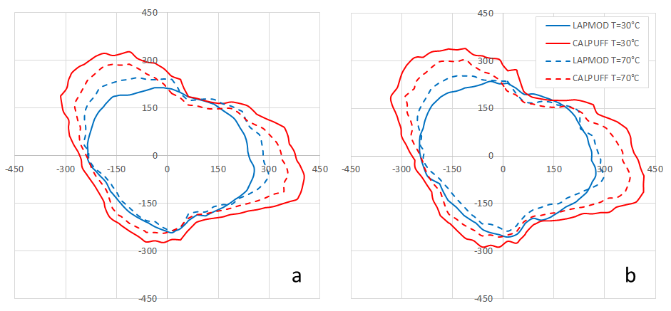

*Figure 2: Site 1. 98th percentile of peak concentrations corresponding to 1 ouE/m3 for LAPMOD and CALPUFF. (a) Unobstructed vertical stack; (b) Rain-capped stack.*

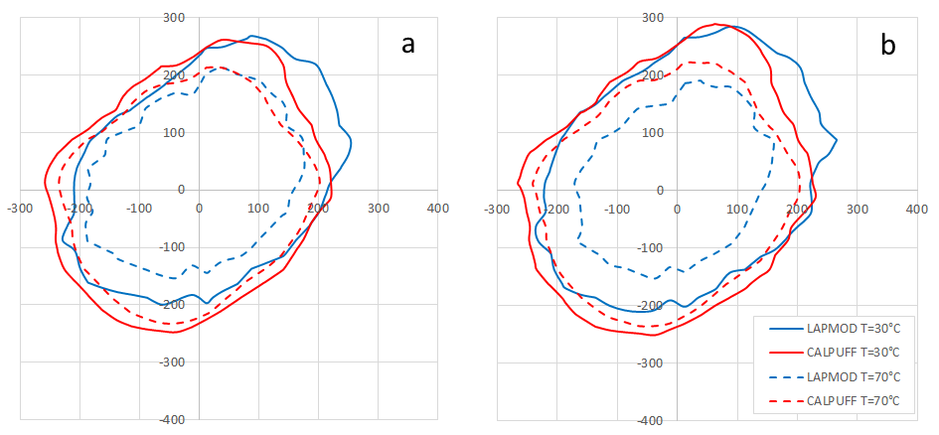

*Figure 3: Site 2. 98th percentile of peak concentrations corresponding to 1 ouE/m3 for LAPMOD and CALPUFF. (a) Unobstructed vertical stack; (b) Rain-capped stack.*

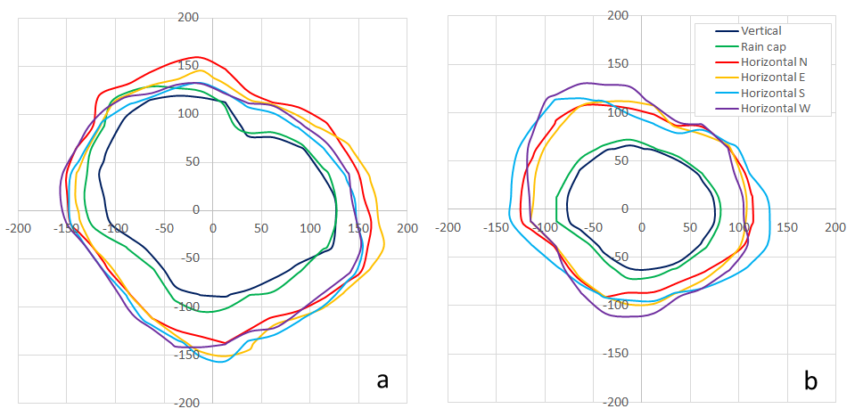

*Figure 4: Site 1. LAPMOD 98th percentile of peak concentrations corresponding to 3 ouE/m3 for different stack terminals. (a) Exit temperature 30 °C; (b) Exit temperature 70 °C.*

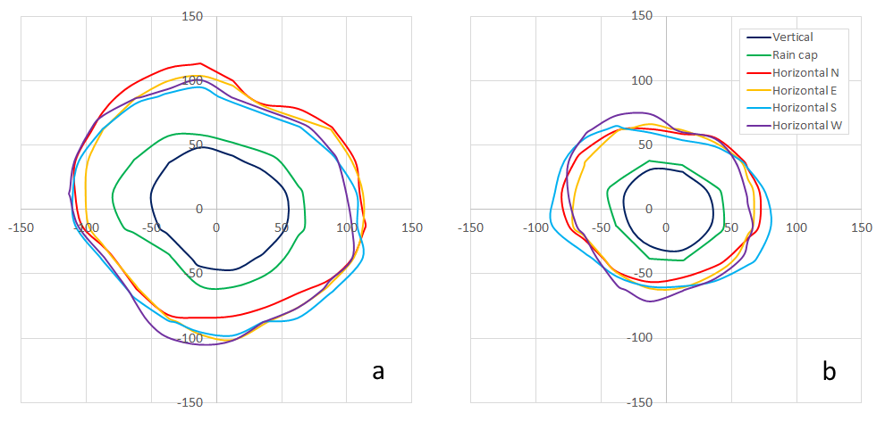

*Figure 5: Site 1. LAPMOD 98th percentile of peak concentrations corresponding to 5 ouE/m3 for different stack terminals. (a) Exit temperature 30 °C; (b) Exit temperature 70 °C.*

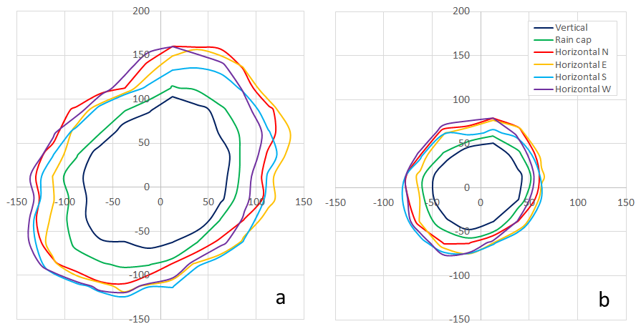

*Figure 6: Site 2. LAPMOD 98th percentile of peak concentrations corresponding to 3 ouE/m3 for different stack terminals. (a) Exit temperature 30 °C; (b) Exit temperature 70 °C.*

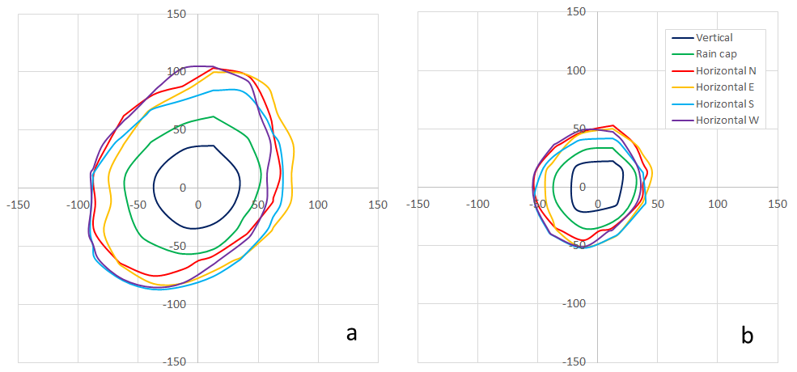

*Figure 7: Site 2. LAPMOD 98th percentile of peak concentrations corresponding to 5 ouE/m3 for different stack terminals. (a) Exit temperature 30 °C; (b) Exit temperature 70 °C.*

* 1. Conclusion

The results of this study confirmed once more the differences between CALPUFF and LAPMOD results, as already noticed in other works. Comparisons of the two models against measured odour data would be very useful to understand which model performs better and under what conditions.

The LAPMOD results show that the effects of rain-capped stacks are very different with respect to those of horizontal terminals. Therefore, it is a great simplification to simulate them in the same way, as done for example in CALPUFF by setting FMFAC=0 for both horizontal and rain-capped stacks. Moreover, even the orientation of the horizontal stack is important, because it could determine the exceedance or the respect of a specific threshold at some receptors. Despite the importance of the orientation of horizontal stacks, typically it is not considered in dispersion models. For example, AERMOD which explicitly simulates horizontal stacks, assumes that the release is always oriented with the wind direction. This assumption may be acceptable when the exit speed is very small with respect to the wind speed, but it is not generally acceptable.

The results illustrated in this document do not have general validity, but are strictly related to the meteorology of the two sites and the characteristics of the stacks analysed. Additional work (modelling and measurements) is needed to get a broader view about the importance of stack terminal configurations.

Acknowledgments

The authors are grateful to Loren C. Trick for the useful comments about the paper.

References

Barclay J., Diaz C.N., Shanahan I., Trick L., Bellasio R., Tinarelli G., Brusasca G., Rosales R., Galvin G., Trini Castelli S., Balch A., Romain A.C., Escoffier C., Öttl D., Duthier E., Berbekar E., Oliva G., Schauberger G., Hauschildt H., Lauerbach H., Arichábala H., Guillot J.M., Hinderink L., Yosef O., Diosey P., Prandi R., Zarra T., 2023, International Handbook on the Assessment of Odour Exposure using Dispersion Modelling. Ed. AMIGO and Olores.org. DOI: 10.5281/zenodo.8367724.

Bellasio R., Bianconi R., Mosca S., and Zannetti P., 2018, Incorporation of Numerical Plume Rise Algorithms in the Lagrangian Particle Model LAPMOD and Validation against the Indianapolis and Kincaid Datasets. Atmosphere, 9(10), 404.

Invernizzi, M., Brancher, M., Sironi, S., Capelli, L., Piringer, M., & Schauberger, G. (2020). Odour impact assessment by considering short-term ambient concentrations: A multi-model and two-site comparison. Environment International, 144, 105990.

Janicke, U.; Janicke L. A three-dimensional plume rise model for dry and wet plumes. Atmos. Environ. 2001, 35, 887–890.

Schulman, L. L., Strimaitis, D. G., & Scire, J. S. (2000). Development and evaluation of the PRIME plume rise and building downwash model. Journal of the Air & Waste Management Association, 50(3), 378-390.

Scire, J.S., D.G. Strimaitis and R.J. Yamartino, 2000, A user’s guide for the CALPUFF dispersion model (Version 5). Earth Tech. Inc., Concord, MA.

US-EPA, 1993, Model Clearinghouse Memorandum, dated July 9, 1993, “Proposal for Calculating Plume Rise for Stacks with Horizontal Releases or Rain Caps for Cookson Pigment.

US-EPA, 2022a, AERMOD Implementation Guide. EPA-454/B-22-008. June 2022. <gaftp.epa.gov/Air/aqmg/SCRAM/models/preferred/aermod/aermod\_implementation\_guide.pdf> accessed 18.02.2024.

US-EPA, 2022b, User’s Guide for the AMS/EPA Regulatory Model (AERMOD). EPA-454/B-22-007. June 2022. <gaftp.epa.gov/Air/aqmg/SCRAM/models/preferred/aermod/aermod\_userguide.pdf> accessed 18.02.2024.

VDI 3782 Part 3 (2022) Dispersion of air pollutants in the atmosphere - Determination of plume rise. September 2022.

Webster, H.N.; Thomson D.J. Validation of a Lagrangian model plume rise scheme using the Kincaid data set. Atmos. Environ. 2002, 36, 5031–5042.