 CHEMICAL ENGINEERING TRANSACTIONS  VOL. xxx, 2024 | A publication of  
The Italian Association
of Chemical Engineering
Online at www.cetjournal.it

Guest Editors: Selena Sironi, Laura Capelli
Copyright © 2024, AIDIC Servizi S.r.l.
ISBN 979-12-81206-13-7; ISSN 2283-9216

Comparison of the effectiveness of Nitrosolobus Multiformis and Nitrosomona Europea in reducing ammonia concentration during the composting process

Thalia M. Ponce Zavala*, Eusterio H. Acosta Suasnabar, Elmer G. Benites-Alfaro, Carlos A., Castañeda olivera, Verónica Tello Mendivel, Sixto S. Mendoza Vilca.

University Cesar Vallejo, Av. Alfredo Mendiola 6232, Los Olivos, Lima
Corresponding: eacostas@ucv.edu.pe

Composting is considered a viable alternative for the management and treatment of various organic wastes. However, during this process, ammonia (NH3) volatilization occurs, restricting its implementation in unauthorized areas and having negative impacts on the environment and human health. The research aimed to compare the bacteria Nitrosolobus Multiformis and Nitrosomona Europea in reducing ammonia (NH3) concentration in compost. Three compost samples were tested, and a strain of nitrifying bacteria was used, identified through Gram staining technique and morphological analysis. In the case of Nitrosolobus Multiformis, a higher colony production was observed, with 18 CFU and a higher ammonia consumption, reaching 0.3 ppm at a pH of 8.5 and a temperature of 40°C. In the case of Nitrosomona Europea, it showed a colony production of 28 CFU, with a higher ammonia consumption of 0.6 ppm at a pH of 8.1 and a temperature of 39°C, both incubated for 48 hours. The optimal dose was 50 CFU per sample each week. These bacteria contributed to the increase in nitrogen, nitrogen oxide, C/N ratio, and electrical conductivity. Nitrosomona Europea proved to be more effective, achieving a 92.86% reduction in ammonia concentration, surpassing Nitrosolobus Multiformis, which reached 71.43%.

- Introduction
In the face of increasing population, composting has become a highly popular technique in agriculture and gardening due to its environmental advantages and contribution to sustainability. By transforming organic waste into compost, we not only reduce the amount of waste ending up in landfills but also generate a resource to improve the quality of our soils and promote plant health (Rojas, 2019). Composting has emerged as a very popular alternative for managing biowaste (Fernández, 2023). Aspects such as its affordability and simple method have contributed to this technique being widely accepted in developing nations (Osorio, 2020).
Ammonia, a form of nitrogen generated by the decomposition of proteins present in organic materials such as food waste, manure, or plant residues, has a strong odor and can be toxic at certain concentrations (Aprea, 2021). Ammonia leachate poses a threat to the environment, as it can contaminate groundwater sources or cause eutrophication problems in nearby water bodies (Droppelman and Oettinger, 2009). In the production of quality compost, it is important to maintain moderate levels of ammonia, as high concentrations can be detrimental to plants and suggest incomplete decomposition or imbalances in the composting process (Lucas de Jesús et al., 2021).
Emissions and the decrease in the fertilization value of compost are consequences of nitrogen losses in composting processes (Soto-Herranz et al., 2021). Biofiltration emerges as a cost-effective and effective option to neutralize unpleasant odors originating from hydrogen sulfide, ammonia, and volatile organic compounds present in composted combinations including poultry manure and lignocellulosic materials such as pruning residues, sugarcane bagasse, and rice husk. This positions it as a more favorable alternative for the removal of these gases (Huan et al., 2021). Emissions of malodorous gases and the prolonged duration of the composting process are the main concerns in managing food waste digestate (DFW). To address these issues, various amounts of biochar obtained from DFW (BC-DFW) were incorporated during the DFW composting process, aiming to reduce ammonia (NH3) and sulfur volatile compounds (VSC) emissions, as well as shorten the composting duration (Wang et al., 2022).
In the study conducted by Kim I-Tae, Park Jae-Roh (2022), the bacterium Nitrosomona europea was identified as the primary halophilic ammonia-oxidizing bacteria in the environment. It was observed that this bacterium was preserved within a pH range of 8.2 to 8.3 and at a temperature of 25°C. Zeolite was used as an agent for ammonia retention, effectively absorbing ammonia NH3. Additionally, the bacterial inoculation method was applied to investigate the presence of ammonia NH3 among the bacteria colonizing zeolite, highlighting the importance of the interaction between these bacteria and zeolite in the ammonia retention process.
The research aimed to use the bacteria Nitrosolobus Multiformis and Nitrosomona Europea to reduce ammonia in compost made from organic waste.

- Methodology
To carry out the research, the following procedure was conducted.
2.1 Compost preparation
Organic waste was collected, and 3 compost piles of 84 kg each were formed.
2.2 Cultivation of Nitrosolobus Multiformis and Nitrosomona Europea
The cultivation of Nitrosolobus Multiformis and Nitrosomona Europea was performed by enriching 5 g of agar-agar with 0.006 g of ammonium chloride, 0.2 g of dipotassium phosphate, 0.006 g of ferrous sulfate, 0.06 g of sodium chloride, 0.06 g of magnesium sulfate, 0.666 g of calcium chloride, 200 mL of distilled water, and 1 g of ammonia hydroxide. This enrichment was carried out according to the procedure of the research conducted by Calabria de Araujo et al. (2018).

2.3 Compost sample characterization - pre-application
The compost characterization was performed by measuring: pH, temperature, electrical conductivity, ammonia, nitrogen, phosphorus oxide, sulfur oxide, and C/N ratio.

2.4 Application of bacteria to compost
The procedure for the direct application of Nitrosolobus Multiformis bacteria to compost is a process that requires periodicity (Mondaca et al., 2019). For each bacterium, the pH and temperature were modified for a period of 48 hours in each of the 4 samples. All of this was done to determine the environment in which the bacteria have the highest colony formation (CFU) and highest ammonia consumption. A concentrate was prepared from these cultures, which was subsequently applied to the compost.

2.5 Compost sample characterization - post-application
During the same week, the prepared compost was used. This compost was separated into three different piles: pile 1 without bacteria, pile 2 with Nitrosolobus Multiformis, and pile 3 with Nitrosomona Europea. Over a period of 12 weeks, successive additions of measured quantities of Nitrosolobus Multiformis and Nitrosomona Europea in corresponding piles were carried out.
The cultivation of Nitrosolobus Multiformis and Nitrosomona Europea was diluted in clean, chlorine-free water. Different doses of Nitrosolobus Multiformis were applied to pile 2 and doses of Nitrosomona Europea to pile 03 each week. A sprayer was used to apply the bacterial solution to the compost, thus avoiding excessive application that could cause runoff or loss of the product.

2.6 Data analysis and comparison of results
In the last week of the experiment, 1 kg samples were extracted from each compost pile to carry out measurements of compost characteristics in each case. Subsequently, data analysis and comparison of results were conducted with the aim of determining the decrease in ammonia in each compost pile.

- Results
3.1 Characteristics of Nitrosolobus Multiformis and Nitrosomona Europea Bacteria
The characteristics of Nitrosolobus Multiformis and Nitrosomona Europea bacteria were examined in four samples. The colony formation and ammonia consumption are presented in Table 1 and 2, respectively.
Table 1: Characteristics of Nitrosolobus Multiformis Bacteria
Nitrosolobus Multiformis
Parameter | Unit | Samples
 |  | 1 | 2 | 3 | 4
pH | 0 - 14 | 7 | 7.8 | 8.1 | 8.5
Temperature | °C | 30 | 38 | 39 | 40
Ammonia | ppm | 0.1 | 0.2 | 0.3 | 0.4
Colonies | UCF | 10 | 15 | 15 | 18

In Table 1, it can be observed that for the Nitrosolobus Multiformis bacteria, there was a higher ammonia consumption of 0.4 ppm in sample 4, with a pH of 8.5 at 40 °C, and a greater colony formation of up to 18 CFU.
Table 2: Characteristics of Nitrosomona Europea Bacteria
Nitrosomona Europea
Parameter | Unit | Samples
 |  | 1 | 2 | 3 | 4
pH | 0 - 14 | 7 | 7.8 | 8.1 | 8.5
Temperature | °C | 30 | 38 | 39 | 40
Ammonia | ppm | 0.2 | 0.5 | 0.6 | 0.4
Colonies | UCF | 10 | 20 | 28 | 25

In Table 02, the Nitrosomona Europea bacteria exhibited a significant increase in ammonia consumption, reaching 0.6 ppm in sample 3, with a pH of 8.1 at 39 °C over a 48-hour incubation period. From this point, a decrease in the amount of consumed ammonia was observed as the pH increased. Additionally, a greater number of colonies, up to 28 CFU, were generated under conditions of equal temperature and incubation time.

3.2 Optimal Dosage
The optimal dosage (CFU) and ammonia concentration (ppm) in the compost without bacteria, compost with Nitrosolobus Multiformis, and compost with Nitrosomona Europea are shown in Table 3 and Figure 1.
Table 3: Optimal Quantity of Nitrosolobus Multiformis and Nitrosomona Europea Bacteria
Parameter |  | Unit | Time (Weeks) |  |  |  |  |  |  |  |  |  |  |  | Ammonia Reduction Efficiency 5th Week (%).
 |  |  | 1 | 2 | 3 | 4 | 5 | 6 | 7 | 8 | 9 | 10 | 11 | 12
Dose |  | UFC | 23 | 30 | 36 | 45 | 50 | 49 | 46 | 41 | 36 | 29 | 18 | 16
Ammonia Concentration | Compost without Bacteria | ppm | 0.6 | 1.3 | 2.0 | 2.5 | 2.8 | 2.7 | 2.6 | 2.3 | 2.0 | 1.6 | 1.0 | 0.9
 | Compost with Nitrosolobus Multiformis |  | 0.6 | 0.9 | 0.8 | 0.7 | 0.8 | 0.6 | 0.7 | 0.9 | 0.8 | 0.6 | 0.8 | 0.7 | 71.43
 | Compost with Nitrosomona Europea |  | 0.6 | 0.3 | 0.2 | 0.2 | 0.2 | 0.1 | 0.1 | 0.2 | 0.2 | 0.1 | 0.2 | 0.2 | 92.86
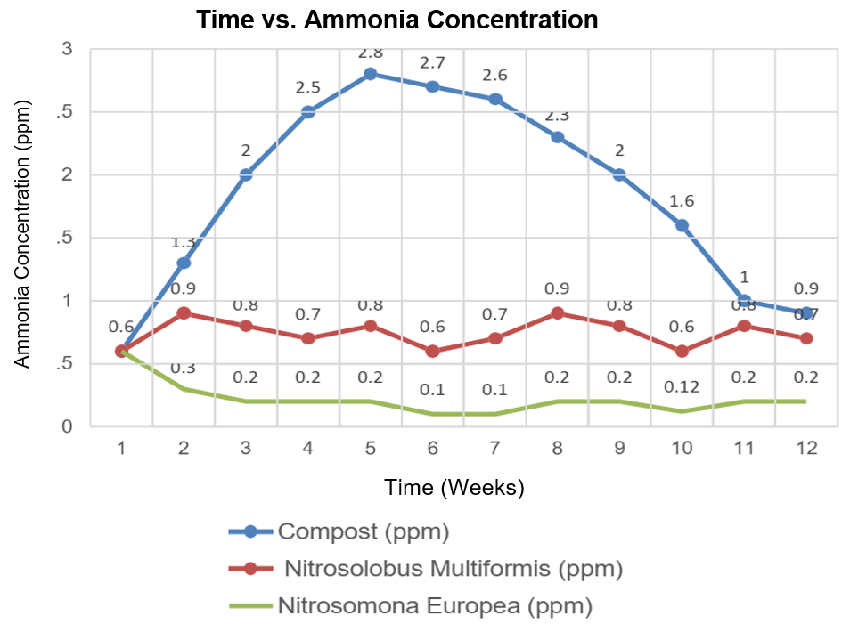
Figure 1. Time vs Ammonia Concentration

In Table 3 and Figure 1, it was observed that, from the second week onwards, ammonia concentrations began to decrease in the compost piles where both Nitrosolobus Multiformis and Nitrosomonas Europea bacteria were added. However, it is important to note that Nitrosomonas Europea managed to reduce concentrations to 0.2 ppm by week 12, compared to Nitrosolobus Multiformis bacteria which reduced it to only 0.7 ppm. This indicates that Nitrosomonas Europea is more effective in reducing ammonia concentration.

On the other hand, a clear difference was evident in the decrease of ammonia concentration in the traditional compost without application. The maximum concentration of ammonia was reached in week 5 with a value of 2.8 ppm. In the same week, Nitrosomonas Europea reduced the concentration to 0.2 ppm. Finally, it was observed that the maximum dose applied was in week 5 with 50 CFU, and the application in the other weeks was proportional to the production of ammonia in the compost without application.

3.3 Characteristics of compost with bacteria
The characterization of the compost before and after adding the Nitrosolobus Multiformis and Nitrosomonas Europea bacteria can be seen in Table 4.
Table 4: Before and after application of Nitrosolobus Multiformis and Nitrosomonas
Parameters | Unit | Without Addition | Nitrosolobus Multiformis | Nitrosomona Europea.
Nitrogen | % | 0.38 | 0.41 | 0.33
Phosphorus oxide | % | 0.38 | 0.36 | 0.33
Potassium oxide | % | 0.64 | 0.73 | 0.63
Sulfur | % | 0.09 | 0.1 | 0.09
C/N ratio |  | 9.67 | 11.39 | 10.14
pH | 0-14 | 8.1 | 7.4 | 7.8
Ammonia | ppm | 0.9 | 0.7 | 0.2
Electrical conductivity | µS/cm | 600 | 750 | 801
Temperature | °C | 23 | 25 | 24

In Table 4, it was observed that upon adding the Nitrosolobus Multiformis bacteria, the parameters of nitrogen, potassium oxide, sulfur, C/N ratio, electrical conductivity, and temperature increase, whereas with the addition of the Nitrosomonas Europea bacteria, these same parameters decrease, except for sulfur, C/N ratio, electrical conductivity, and temperature. It is reiterated that the concentration of ammonia decreases after the application of doses of Nitrosolobus Multiformis bacteria, from 0.9 to 0.7 ppm, and with the dose of Nitrosomonas Europea, it decreased from 0.9 to 0.2 ppm.
4. Discussion
The optimal incubation conditions for Nitrosolobus Multiformis and Nitrosomonas Europea bacteria in this research coincide with findings observed by Másmela Lizarazo (2020) regarding alkalinity under operational conditions. It was found that the pH at which they exhibit the greatest development is pH 8.5 for Nitrosolobus Multiformis and pH 8.1 for Nitrosomonas Europea, values similar to those reported by Kim I-Tae (2022), who mentions that the cultivation of these bacteria is maintained within a pH range of 8.2 to 8.3. Furthermore, according to Pereira Samaniego (2021), the optimal incubation time is between 3 to 6 weeks. However, our research highlighted a significant modification in the incubation time, which was reduced to 48 hours. This change aligns with the research conducted by Rasche and Hyman (2018), where it is mentioned that the doubling time of these bacteria ranges from 12 to 48 hours, due to modifications in operational conditions and enrichment in the Agar-Agar used. Regarding the development of Nitrosomonas Europea bacteria up to 28 CFU at a temperature of 39 °C, our tests were conducted within a range of 30 to 40 °C. This finding is supported by the results obtained by Pereira Samaniego (2021), who highlighted that the efficiency in the incubation of nitrifying bacteria is achieved at a temperature of 30 °C.
Regarding the addition of Nitrosolobus Multiformis and Nitrosomona bacteria to the compost, minimal consumption was observed compared to the research conducted by Sun Yo and Liping (2019), where the nitrogen content reached a value of 0.894%. This phenomenon is explained by the consumption of ammonia by the bacteria. However, for Nitrosolobus Multiformis, an increase in nitrogen up to 0.41% was recorded, suggesting that this bacterium is not consuming enough ammonia.
According to Osorio (2012), the optimal pH to increase nutrient availability should be in the range of 6 to 6.5, slightly acidic. However, in the results after the application of the bacteria, we obtained a value of 7.4 for Nitrosolobus Multiformis and 7.8 for Nitrosomonas Europea, indicating a trend towards alkalinity. This is due to the alkaline environment in which these bacteria develop. However, alkalinity can inhibit the availability of nutrients such as potassium, sulfur oxide, and phosphorus oxide. Although an increase in these nutrients was observed according to the results, this situation can still be improved through adjustments in pH conditions or compost.

- Conclusions
Regarding the characteristics of Nitrosolobus Multiformis bacteria, a pH of 8.5 at 40°C was observed, with an incubation time of 48 hours. This bacterium exhibited colony growth of 18 CFU with an ammonia consumption of 0.3 ppm. On the other hand, for Nitrosomonas Europea bacteria, a pH of 8.1 at 39°C was recorded, with the same incubation time of 48 hours, and colony growth of 28 CFU with an ammonia consumption of 0.6 ppm, surpassing Nitrosolobus Multiformis in terms of ammonia consumption. The optimal dosing of bacteria was 50 CFU in week 5. The maximum concentration of ammonia in the compost was 2.8 ppm, but with Nitrosomonas Europea, the concentration was reduced to 0.2 ppm, while with Nitrosolobus Multiformis, it was reduced to 0.8 ppm. This indicates that Nitrosomonas Europea was more effective in reducing the concentration of ammonia, achieving a reduction of 92.86 %, surpassing Nitrosolobus Multiformis, which reached 71.43 %.

Acknowledgments
The authors express their gratitude to the Research Vice-Rectory of Universidad César Vallejo and the Teacher Research Support Fund for the financial support provided for the publication of this research.

References
Aprea J. L., 2021, A look at ammonia. Past, present, and future of a unique molecule. Knowledge Leaflets. Environment, 12. Spanish.
Calabria de Araujo J., Campos A. P., Carvalho S. E., Oliveira R. C., Chernícharo C. A., Comparison of methods for quantifying nitrifying bacteria, Sanitary and Environmental Engineering, 23, 2. Spanish
Droppelmann, C. V., & Oettinger M., 2009, Activated sludge treatment of landfill leachate. Technological Information, 2019, 20, 1, 11–19. Spanish.
Fernández H. C., 2023, Evaluation of the quality of community compost produced in a pilot project on the island of Tenerife and improvement plan. 2023, Bachelor's Thesis. University of La Laguna. Spain. Spanish.
Huan C., Fang J., Tong X., ... Lyu Q., Yan Z., 2021, Simultaneous elimination of H2S and NH3 in a biotrickling filter packed with polyhedral spheres and best efficiency in compost deodorization, Journal of Cleaner Production, 284, 124708.

Kim I-Tae, Park Jae-Roh, 2022, Analysis of Simultaneous Ammonium/Nitrate Denitrification in Salt Water Using Physical and Biological Regeneration Methods with Zeolite and Halophilic Bacteria, Journal of the Korean Society of Water and Wastewater, 30. 4, 3-10.
Lucas de Jesús G., Volnei P., Cassilha Z. M., Lorena C. F., 2021, Strawberry quality affected by the nitrate: ammonium ratioin the nutrient solution, Mexican Journal of Agricultural Sciences, 12, 5.
Másmela-Mendoza J. E., Lizarazo-Forero L. M., Aranguren R. N., 2019. Culturable nitrifying bacteria from the littoral zone of Lake Tota, Boyacá. U.D.C.A Journal of Scientific Update and Disclosure, 22, 2, 1378. Spanish
Mondaca T. M., Morales B. I., Miranda C. R., 2019, Application of biofertilizer with halophilic bacteria and gypsum on chemical-biological characteristics of a saline-sodic soil. Apthapi, 5, 1,1450-1456. Spanish.
Osorio C. G., 2020, Application of composting as a method of transforming organic waste in an urban center like Bogotá, Bachelor's Thesis. Universidad de América Foundation. Colombia. Spanish.
Osorio G. E., 2020, Application of composting as a method of transforming organic waste in an urban center like Bogotá, Bachelor's Thesis, Universidad de América Foundation. Spanish.
Pereira S, S., 2021, Evaluation of the nitrification potential of cultivable bacterial strains isolated from compost from a native forest and pine forest located in the Machángara micro-basin, Graduation thesis. Catholic University of Cuenca. Ecuador. Spanish.
Rasche, M. E., Hyman M. R., ARP D. J., 2018, Biodegradation of halogenated hydrocarbon fumigants by nitrifying bacteria. Applied and Environmental Microbiology, 56, 8, 2568-2571.
Rojas J. M., 2019, Composting for urban and peri-urban agriculture: is municipal-scale organic waste composting possible in Sáenz Peña (Chaco, Argentina) to allocate the obtained organic matter to food production? Master's thesis, International University of Andalusia. Spain.
Soto-Herranz M., Sánchez-Báscones M., Antolín-Rodríguez J. M., Martín-Ramos P., 2021, Reduction of ammonia emissions from laying hen manure in a closed composting process using gas-permeable membrane technology, Agronomy, 11, 12, 2384.
Sun Y., Zhu L., Xu X., Meng Q., Men M., Xu B., Deng L., 2019, Correlation between ammonia-oxidizing microorganisms and environmental factors during cattle manure composting, Argentine Journal of Microbiology, 51, 4, 371-380.
Wang N., Huang D., Bai X., ... Shao M., Xu Q., 2022, Mechanism of digestate-derived biochar on odorous gas emissions and humification in composting of digestate from food waste, Journal of Hazardous Materials, 434, 128878

