 CHEMICAL ENGINEERING TRANSACTIONS  VOL. xxx, 2024 | A publication of  
The Italian Association
of Chemical Engineering
Online at www.cetjournal.it

Guest Editors: Selena Sironi, Laura Capelli
Copyright © 2024, AIDIC Servizi S.r.l.
ISBN 979-12-81206-13-7; ISSN 2283-9216

Mitigating odour nuisance caused by soil remediation processes: A case study
Niels J. F. De Baerdemaeker*, Preben Van Overmeiren
OLFASCAN (a brand of Milvus Consulting NV), Wondelgemkaai 159, 9000 Ghent, Belgium
niels.de.baerdemaeker@olfascan.com
Odour emissions from soil remediation processes are often a cause for concerns from neighboring residents, sometimes leading to community complaints and scrutiny by the overseeing authorities.
At a soil remediation site in Belgium, there are frequent reports of an odour described as “fishy” in the surroundings of the site. Upon initial site inspection, the fishy odour was not immediately evident. However, subsequent air sampling above stabilized sludge heaps revealed a high concentration of trimethylamine (TMA) as confirmed by thermal desorption gas chromatography-mass spectrometry (TD-GC-MS) analysis. TMA is associated with a pungent fishy smell and a very low odour threshold of 0.076 µg.m⁻³. It became apparent that the fishy smell, initially masked by the smell of wet earth, began to dominate upon dilution in the environment.
Further experiments conducted focused on elucidating which process led to the formation of TMA within the remediation site. A microchamber thermal extractor (Markes µ-CTE) was used to simulate the high temperatures occurring in the sludge heaps caused by the exothermic hydration reaction of quicklime (CaO) used as a binder agent. N₂-air was purged through the microchamber and collected in a Nalophan air sample bag, after which the sample was again analyzed using TD-GC-MS and a sensory odour evaluation panel. This methodology proved very powerful as it allowed for a rapid throughput of small-scale tests using only minimal amounts of sludge and chemicals.
Different combinations of sludge, drying agents, and flocculants revealed that a specific polyacrylamide (PAM) based flocculant, in conjunction with the basic conditions generated by the drying agent (CaO), facilitated the production of TMA. Subsequent efforts to identify alternative combinations of drying agents and flocculants capable of mitigating TMA emissions while remaining effective for the sludge treatment were made by systematic testing. Again, the above-described small-scale screening methodology was successfully applied.
This case study underscores the importance of proactive odour management strategies in soil remediation projects and the potential of the rapid screening of the applied chemicals. By understanding the underlying mechanisms of odour generation at soil remediation sites and employing mitigation measures, environmental impacts on the surroundings can be minimized.
  - Introduction
Soil remediation is a key process in up-lifting contaminated sites by industrial pollution, hence contributing to the protection and sustainment of viable environmental conditions. When considering soil remediation as an “ex-situ” process, the contaminated soil is preliminary removed from site and treated at a different location. The main advantage of this tactic is that higher and faster clean-up efficiencies can be achieved, as present contaminants in the soil will be more accessible to treatment processes by intimate mixing of reagents and contaminants (Petruzzelli et al., 2016). However, by treating the contaminated soil off-site, a risk of shifting the environmental impact might occur, as the environment surrounding the treatment location can be negatively impacted by noise and odour nuisance coming from the soil remediation process (Cappuyns, 2013). In the presented case-study, an ex-situ soil remediation site in Belgium, where soils contaminated by historical industrial pollution are treated using a physiochemical process, is affected by frequent reports from the surrounding environment of an odour described as “fishy”. During a preliminary investigation it became apparent that, while the fishy odour could be detected in the environment alongside the smell of wet earth, at the site location the fishy odour was not immediately evident, leaving the site operators unaware of the odour emission. To determine the origin of the fishy odour, the physiochemical process at the site was scrutinized. The process consists of five phases: (I) sifting soil, (II) rinsing sifted soil with water, (III) separating sand from sludge via cyclones, (IV) drying sludge by adding flocculant and (V) adding lime to and milling sludge to make sludge solid. During the on-site investigation, it became clear that manipulation of stabilized sludge heaps resulted in more fishy-like odour. Thermal desorption gas chromatography-mass spectrometry (TD-GC-MS) analysis on air samples taken above manipulated stabilized sludge heaps revealed the presence of high concentrations of trimethylamine (0.165 mg.m⁻³). Trimethylamine (TMA) is associated with a pungent fishy smell and a very low odour threshold of 0.076 µg.m⁻³ (Leonardos et al., 1969). It became apparent that the fishy smell, initially masked by the smell of wet earth, began to dominate upon dilution in the environment.
This study investigated which conditions promote the release of fishy odourous components by simulating the sludge stabilization process under laboratory conditions, with the sub-processes being isolated. The air collected from each sub-process was analyzed sensory (odour character and intensity) and the five most important components were quantified by means of TD-GC-MS. In addition, ammonia and hydrogen sulfide concentrations were also determined in each sample.
  - Materials and methods
    - Investigated sub-processes and alternatives
Various samples of sludge, stabilizing agents and flocculants were delivered by the soil remediation site in the period of November 2023. At the soil remediation site, the sludge is extracted via subsequent processes of sifting, rinsing and separating soils that originate from the ‘Oosterweel project’. The delivered sludge samples were divided into “old sludge” (approximately one month old) and “fresh sludge" (one day old). Both the old and fresh sludge were already treated with a mixture of solid (ZETAG 8127) and liquid (FLOC PAM) flocculant. The transition of fresh to old sludge occurs by air drying the sludge in storage houses at the site location. Afterwards the sludge is stabilized by adding quicklime (CaO). In addition, various alternatives to stabilize the sludge were provided by the soil remediation site (paper ash, Apromud 150/G250 and Calstarite) to evaluate the effect of replacing the quicklime with one of these products on the formation of amines. Via weight distribution, ten combinations were made from which a headspace via microchamber was taken and analyzed (Table 1):
Table 1: Description and weight distribution of sludge, stabilizing agent and flocculant combinations
Headspace ID | Description | Weight distribution
ID 1 | Fresh sludge | 21 g fresh sludge
ID 2 | Old sludge | 21,1 g old sludge
ID 3 | Solid flocculant + quicklime | 1 g ZETAG 8127 + 1 g CaO
ID 4 | Liquid flocculant + quicklime | 1 g FLOC PAM + 1 g CaO
ID 5 | Mixture sludge (50/50) + solid flocculant + quicklime | 10,3 g fresh sludge + 10,3 g old sludge + 1 g ZETAG 8127 + 1 g CaO
ID 6 | Mixture sludge (50/50) + mixture flocculant + quicklime | 10 g fresh sludge + 10 g old sludge + 1 g ZETAG 8127 + 1 g FLOC PAM + 1 g CaO
ID 7 | Mixture sludge (50/50) + mixture flocculant (50/50) + paper ash | 10 g fresh sludge + 10 g old sludge + 1 g ZETAG 8127 + 1 g FLOC PAM + 1 g paper ash
ID 8 | Mixture sludge (50/50) + mixture flocculant (50/50) + Calstarite | 10 g fresh sludge + 10 g old sludge + 1 g ZETAG 8127 + 1 g FLOC PAM + 1 g Calstarite
ID 9 | Mixture sludge (50/50) + mixture flocculant (50/50) + Apromud 150 | 10 g fresh sludge + 10 g old sludge + 1 g ZETAG 8127 + 1 g FLOC PAM + 1 g Apromud 150
ID 10 | Mixture sludge (50/50) + mixture flocculant (50/50) + Apromud G250 | 10 g fresh sludge + 10 g old sludge + 1 g ZETAG 8127 + 1 g FLOC PAM + 1 g Apromud G250

Headspace ID 1 and ID 2 are descriptive of the background in the sludge and the thermal decomposition of the small amount of flocculants already added to the sludge at the site location before sampling. These are considered as the reference samples. Headspace ID 3 and ID 4 describe the effect of the quicklime on both flocculants separately. For headspace ID 5, only solid flocculant is added to examine the influence of solid flocculant in the sludge matrix. Headspace ID 6 simulates the situation as it is currently used, and which causes the described odour nuisance to the environment due to the release of TMA. Headspace ID 7 to ID 10 examines the effect of replacing quicklime as a stabilizer with a supplied alternative. Although only small quantities are used for the microchamber extraction, an attempt was made to simulate realistic doses as closely as possible (i.e. dosage of 5 w% flocculant, 5 w% of the chalky substances and 2 w% in the case of the Apromuds).
    - Headspace sampling via µ-CTE (Markes)
To determine which and how many volatile organic components (VOC) are emitted from the different sludge samples, a dynamic headspace sampling was carried out. This method makes it possible to capture the released components under controlled temperature conditions. This process is carried out using a Micro-Chamber Thermal Extractor (Markes µ-CTE). By heating the microchamber to 80 °C, the conditions in the sludge piles are simulated, which heat up due to the exothermic reaction of CaO with water. A standard stream of pure gas (N₂) at a flow rate of 50 mL.min⁻¹ was sent over the surface of the sludge samples in order to collect the emitted VOCs in a Nalophan air bag. In this study, two micro-chambers were filled per sludge test and the air from the two chambers was combined into one air bag. A schematic representation of the micro-chamber setup is given in Figure 1.
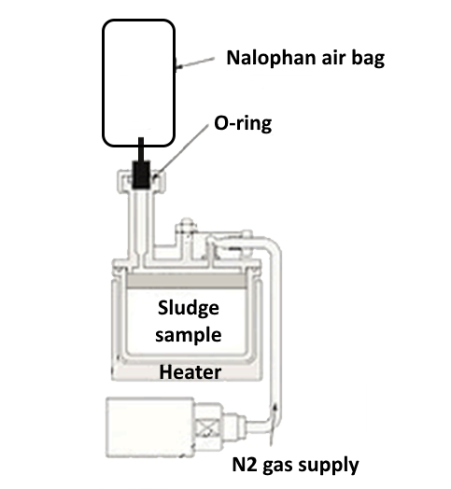
Figure 1: Schematic representation of micro-chamber setup for extracting VOCs from the sludge samples
    - Chemical analysis
The collected air samples from the different sludge samples were transferred onto a Carbon Graphitised sorbent tube. The sorbent tubes were then analysed directly with the TD-GC-MS (Markes TD100, Shimadzu GC 2010-plus and Shimadzu MS GP2010 SE), to identify and quantify concentrations of the five most relevant volatile organic compounds (VOC) that contribute to the formation of unpleasant fishy odour according to literature.
Aside from the volatile compound screening, ammonia (NH₃)- and hydrogen sulfide (H₂S) concentrations were also measured via GASTEC detector tubes.
    - Sensorial analysis
The collected air samples from the different sludge samples were also subjected to sensorial analysis. This analysis is conducted in an odour-free area and executed by at least six odour calibrated panel members (odour calibration in accordance to EN 13725). The panel members gently press on the air samples to release the odour and sniff directly from the sample. The purpose of this analysis is to obtain a description of the odour character and to determine two parameters, namely odour intensity and odour (un)pleasantness. The evaluation of these parameters is done using a score (Table 2).
Table 2: Score scaling of odour intensity and odour (un)pleasantness
Odour intensity | Odour (un)pleasantness
Undetectable (0) | Neutral to pleasant (0)
Very weak (1) | Slightly unpleasant (-1)
Weak (2) | Unpleasant (-2)
Clear (3) | Very unpleasant (-3)
Strong (4) | Extremely unpleasant (-4)
Very strong (5)
Extremely strong (6)
  - Results and discussion
    - Chemical analysis results
Based on literature data (Liu et al., 2024), the five most relevant components contributing to the formation of unpleasant fishy odour were selected and determined using TD-GC-MS: (I) methanol, (II) ethanol, (III) dimethyl sulfide (DMS), (IV) trimethylamine (TMA) and (V) aziridine. In addition, H₂S- and NH₃-concentrations were also determined.
Table 3 shows the measured values for H₂S and NH₃. Ammonia in particular is important as it may be linked with the formation of amines. Based on the ammonia results, headspace ID 3 and ID 5 were excluded from sensorial analysis due to concerns regarding negative health effects for the odour panel members.
Table 3: H₂S- and NH₃-concentration results of the different headspaces taken from the sludge samples
Parameter | ID 1 | ID 2 | ID 3 | ID 4 | ID 5 | ID 6 | ID 7 | ID 8 | ID 9 | ID 10
H₂S (mg.m⁻³) | 1,44 | < d.l. | 5,19 | 1,44 | 3,46 | 0,43 | 3,32 | 1,59 | < d.l. | < d.l.
NH₃ (mg.m⁻³) | 0,14 | 0,29 | 3.601 | 74 | 4.322 | 1.441 | 555 | 1.441 | 0,43 | 0,14
* detection limit (d.l.) H₂S = 0,07 mg.m⁻³; NH₃ = 0,14 mg.m⁻³
Figure 2 shows the trending of the measured concentrations of the target VOCs for the headspaces taken from the different sludge samples. For reference, the concentrations measured in the air sample taken during the preliminary investigation study at the soil remediation site are also added to Figure 2 (ID 0).
Figure 2: VOC-concentration results of the different headspaces taken from the sludge samples

When the ratio of the components to methanol is calculated for ID 0 (conditions at soil remediation site) and ID 6 (simulation of conditions at soil remediation site), it showcases that the concentrations on laboratory scale are a factor 20 higher, but the components do occur in roughly the same proportions. This states that the air sample prepared under laboratory conditions is representative for the air sample taken at the soil remediation site. Aziridine is an exception (relatively more in laboratory samples) to this statement, which can be explained by the reactivity of the component (time between generation and measurement is lower on laboratory scale).
The VOC-concentration also indicates that a considerable amount of methanol is already present in the headspace of the fresh and old sludge (ID 0 and ID 1). In addition, these samples also contain an amount of TMA (8 and 14 µg.m⁻³ respectively) that is above the odour threshold value of 0.076 µg.m⁻³. These quantities may mainly originate from the dosage of both flocculants in the sludge. However, the amount of TMA is low and it is clear that the addition of flocculants to the treated sludge and its aging, without a stabilizer, does not constitute to an amount of TMA that can explain the fishy odour in the environment.
For headspace ID 3 and ID 4, a quantity of flocculant was added to the quicklime. These samples highlight that only when combining liquid flocculant with CaO (ID 4) a large amount of TMA is formed (4.2 mg.m⁻³) compared to only 0.1 mg.m⁻³ when solid flocculant reacts with CaO (ID 3). The results indicate that the presence of liquid flocculant in combination with CaO facilitates the formation of TMA (Abu-Orf et al., 2005). In contrast to the ammonia concentration results the opposite is visible; 3.601 mg.m⁻³ in headspace ID 3 compared to 75 mg.m⁻³ in headspace ID 4 (Table 3). This suggests that the formation of either TMA or ammonia is related to the acrylamide polymer chemical structure (Chang et al., 2005). There is no information available on the chemical structure of the polymer in the liquid and solid flocculant. It can however be assumed that the end-group of the structure of the liquid flocculant will be mostly methyl-based, giving rise to the formation of trimethylamine (Ruhland et al., 2021), while the end-group of the solid flocculant will be mostly amide-based, giving rise to the formation of ammonia (Xiong et al., 2018).
For headspace ID 5 and ID 6 the sludge factor was added (50/50 mixture of fresh and old sludge). The results again illustrate that adding liquid flocculant leads to an increased concentration of TMA (5.28 mg.m⁻³ compared to 3.36 mg.m⁻³), despite the already high amount of TMA in headspace ID 5 (without liquid flocculant). This may be due to liquid flocculant that was already present in the sludge upon delivery. However, the high amounts of methanol in ID 5 and ID 6 compared to the sludge samples and the combination of flocculant with CaO are difficult to explain. The sludge, and therefore perhaps also the type/origin of the sludge, has an influence on the reactions that take place. The ammonia concentration in ID 5 (4.322 mg.m⁻³) is a factor 3 higher than the concentration in ID 6 (Table 2). So, the same hypothesis can be presented that the assumed amide-based polymer of the solid flocculant gives more rise to the formation of ammonia (ID 5), while the assumed methyl-based polymer of the liquid flocculant gives more rise to the formation of TMA.
For headspace ID 7 to ID 10 the alternatives for CaO are evaluated. The concentrations obtained from these experiments are best compared with headspace ID 6 (simulation of conditions at soil remediation site). The use of paper ash causes an increase in the measured concentration of TMA. The amounts of methanol, ethanol, DMS and aziridine remain of the same order of magnitude compared to the application of CaO. The measured ammonia concentration is somewhat lower compared to the other stabilizing agents, which indirectly indicates more formation of TMA.
The use of Calstarite reduces the TMA concentration (from 5.28 mg.m⁻³ to 2.86 mg.m⁻³), although the overall TMA concentration remains relatively high. The concentrations of methanol, DMS and aziridine decrease by 1 to several orders of magnitude. This indicates a favorable effect towards odour reduction.
Finally, by using both Apromuds as stabilizing agent the amount of TMA formed is extremely minimal. The amount of methanol formed is in the same line as when using Calstarite (ID 8) and the amount released by combining solid flocculant with CaO (ID 3). This indicates that a limited amount of methanol is released when heating solid flocculant.
With both Apromuds the measured concentration of ammonia is very low and comparable to the fresh and old sludge (< 0,72 mg.m⁻³). Based on these results, the usage of Apromud instead of CaO as stabilizing agent seems to completely avoid the release of TMA (i.e. fishy odour) and ammonia. This suggests that Apromud hinders the reduction of polyacrylamide polymers to TMA and ammonia.
    - Sensorial analysis results
Except the air samples of ID 3 and ID 5 (due to high ammonia concentrations), the air samples of the different headspaces taken from the sludge samples were analyzed sensorial by a panel of seven odour calibrated members. The odour was scored in accordance to its odour intensity and odour (un)pleasantness (Figure 3).
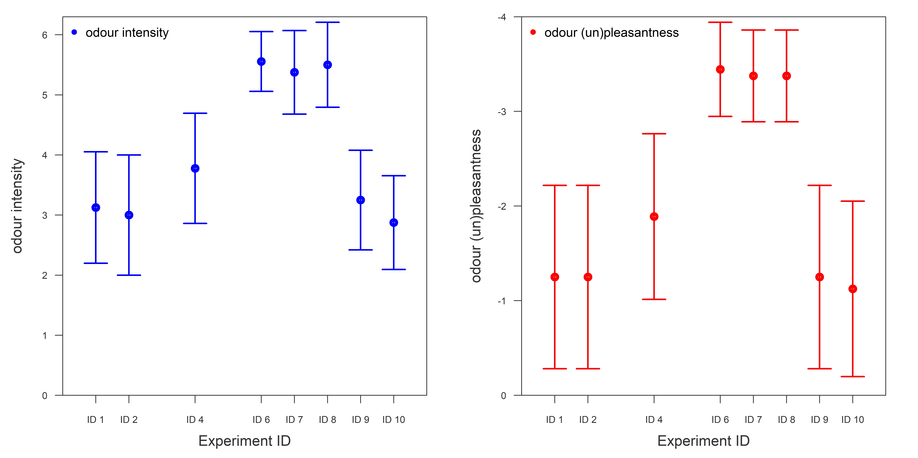
Figure 3: Sensorial analysis results of the different headspaces taken from the sludge samples
Both the fresh and old sludge (headspace ID 1 and ID 2) are characterized by a comparable intensity and described by the panel members as cement, sludge and soil. Headspace ID 4 (liquid flocculant + CaO) is given an intensity of 3.8 and is described as wet cement, rotten fish, ammonia, pungent and amines. Headspace ID 6 (sludge + solid and liquid flocculant + CaO) is given an intensity of 5.6, an unpleasantness of -3.4 and is described as mainly ammonia. Both the paper ash (ID 7) and the Calstarite (ID 8) are also described as very to extremely strong (intensity of 5.6 and 5.7) and very to extremely unpleasant (unpleasantness of -3.4 and -3.4). These odours were described as ammonia and cement. The application of Apromud (ID 9 and ID 10) reduces the perceived intensity of the odour to 3.4 for Apromud 150 and 3.0 for Apromud G250. Both samples were experienced as slightly unpleasant (unpleasantness of -1.3 and -1.1) and the odour was described as soil, silt, slightly sweet, warm sand and wet earth. The difference in odour description between the samples treated with Apromud compared to the fresh and old sludge sample is striking. The described cement odour may be (partly) linked to the TMA and aziridine present, while this was not found in the samples treated with apromud.
  - Conclusions
The chemical analyzes showed that the used liquid flocculant (FLOC PAM) in combination with quicklime (CaO) gives rise to high concentrations of TMA when this combination takes place on a laboratory scale in a microchamber. The combination of solid flocculant (ZETAG 8127) with CaO primordially leads to the formation of methanol and ammonia. This suggests that the end-group of the polyacrylamide polymer of the liquid flocculant is likely more methyl-based, while the end-group of the solid flocculant is likely more amide-based.
The use of paper ash instead of CaO does not lead to a reduction in the TMA concentration, but rather to an increase. This sample was also rated via sensorial analysis as very to extremely strong and very to extremely unpleasant. The use of Calstarite as a stabilizing agent leads to a comparable assessment by the odour panel. Despite lower concentrations of TMA are formed with Calstarite, it may result in a limited improvement in the perceived odour (fishy) when applied in practice.
Both Apromuds (150 and G250) emerged from the laboratory tests as very efficient in preventing the formation of ammonia and TMA, and the resulting fishy odour. The application of apromuds will probably lead to an elimination of the current odour problem to the environment surrounding the soil remediation site. Since the stabilization mechanism of these gel-forming polymers differs significantly from the current methodology, it must be determined whether this is technically and economically feasible.
References
Abu-Orf M., Dentel S.K., Chang J.-S., Hepner S., Turkmen M., Fagerstrom A. 2005, Odour reduction using alternative polymers and dewatering equipment, Proceedings of the Water Environment Federation, 9, 6566–6581.
Cappuyns V., 2013, Environmental impact of soil remediation activities: Quantitative and qualitative tools applied on three case studies, Journal of Cleaner Production, 52, 145–154.
Chang J.-S., Abu-Orf M., Dentel S.K., 2005, Alkylamine odours from degradation of flocculant polymers in sludges, Water Research, 39, 3369–3375.
Leonardos G., Kendall D., Barnard N., 1969, Odour threshold determinations of 53 odourant chemicals, Journal of the Air Pollution Association, 19, 91–95.
Liu L., Zhao Y., Zeng M., Xu X., 2024, Research progress of fishy odor in aquatic products: from substance identification, formation mechanism, to elimination pathway, Food Research International, 178, Article 113914.
Petruzelli G., Pedron F., Grifoni M., Barbafieri M., Rosellini I., Pezzarossa B., 2016, Soil remediation technologies towards green remediation strategies, International Journal of Geological and Environmental Engineering, 10(6), 654–658.
Ruhland K., Horny R., Wanzel A., Reisach S., Nizamutdinova A., Kirchhain H., Rehfuss U., van Wüllen L., Fischer A., Sheliga F., Hübner T., 2021, Investigation of the chemical changes during the thermal treatment of acrylonitrile-co-methyl acrylate polymer (polyacrylonitrile-precursor) focusing on the fate of the methyl acrylate moiety, Journal of Applied Polymer Science, 139(18), e52074.
Xiong B., Dettam Loss R., Shields D., Pawlik T., Hochreiter R., Zydney A.L., Kumar M., 2018, Polyacrylamide degradation and its implications in environmental systems, NPJ Clean Water, 1, 17.

