 CHEMICAL ENGINEERING TRANSACTIONS  VOL. xxx, 2024 | A publication of  
The Italian Association
of Chemical Engineering
Online at www.cetjournal.it

Guest Editors: Selena Sironi, Laura Capelli
Copyright © 2024, AIDIC Servizi S.r.l.
ISBN 979-12-81206-13-7; ISSN 2283-9216

The use of sensor-based system to measure accurate low odorant concentrations
Irene Lara-Ibeas*, Javier Fernández-Huerta, Edurne Ibarrola-Ulzurrun
Kunak Technologies, Polígono Parque Empresarial la Muga, 9, 31160 Orcoyen, Navarra
ilara@kunak.es
Odour pollution has become a growing concern due to industrialization and public awareness of the importance of preserving a clean environment. Although odours may not pose immediate health risks at low concentrations, prolonged exposure can lead to various adverse effects on human health and socio-economic conflicts. In response to this concern, Instrumental Odour Monitoring Systems (IOMS) are emerging as a solution for real-time monitoring of odour emissions. The present work shows the performance of sensor-based Kunak AIR Pro instrument for odour monitoring at different sites including a WWTP, a sludge treatment plant and a petrochemical plant by accurately measuring low concentrations of H₂S, VOCs and NH₃. In the WWTP, the performance of the system to monitor H₂S in terms of precision and accuracy was evaluated against a H₂S analyser showing a high correlation coefficient of 0.77 and a low MAE of 6.9 ppb. Considering an H₂S odour threshold of 8 ppb, the TPR and FPR were calculated to be 0.87 and 0.34. By setting a more conservative alarm threshold (20 ppb), TPR and FPR can be improved to 0.89 and 0.16, respectively. Moreover, by combining the complementary responses of different sensors, such as those for H₂S and VOCs, emissions of additional compounds can be inferred, increasing the capabilities of these systems. In a sludge treatment and a petrochemical plant, the deployment of monitoring devices for VOCs, H₂S, and NH₃ and meteorological data provided valuable insights into the temporal variations and spatial distribution of these compounds within the studied facilities as well as into the potential identification of emission sources. This information is crucial for implementing proactive measures to minimize environmental impact and address potential odour issues demonstrating the importance of sensor-based monitoring systems in providing real-time data for informed decision-making.
  - Introduction
The odour, as a form of environmental pollution, has become a growing concern due to industrialization and public awareness of the importance of preserving a clean environment. While common air pollutants may go unnoticed by the general population, even when concentrations exceed exposure limits, odours can be detected at very low levels. Even though odours are not toxicologically harmful at those low concentrations, prolonged exposure may have adverse effects on human health, leading to symptoms such as nausea, headaches, insomnia, reduced appetite, and respiratory problems (Naddeo et al., 2012). Additionally, persistent exposure to unpleasant odours may contribute to socio-economic conflicts, affecting the quality of life in nearby communities and economic value of neighbouring properties.

As a result, odour impact studies are becoming increasingly common, typically conducted through dynamic olfactometry, the reference method for odour monitoring (UNE-EN 13725:2022). However, these methods require specialized personnel and provide only point-in-time measurements, limiting their practical application. To overcome this limitation, in recent years new technologies have emerged, such as Instrumental Odour Monitoring Systems (IOMS), including electronic noses (e-Noses), which not only eliminate the need for specialized personnel but also enable continuous and real-time odour measurements at reduced cost. Currently, most of the IOMS in the market are sensor-based instruments designed for the identification of fugitive emissions and industrial odorants, becoming valuable tools for the implementation of fenceline monitoring. These systems have been used for odour monitoring in different activities characterized by emissions of odorants, such as wastewater treatment plants (WWTP), landfills, pulp and paper, petrochemical and compost management and fertilizers plants (Burgués et al., 2022; Prudenza et al., 2023). Nevertheless, monitoring odour emissions in industrial settings with IOMS presents some challenges that limit their current application. Odour emissions in industrial and waste management plants are characterised by the presence of a large number of chemicals such as hydrogen sulphide (H₂S), organic sulphur compounds, aldehydes and ketones, ammonia and amines, among others, due to the complex reactions that occur in the different processes. Various compounds can interfere with the detection of target odorants, leading to false readings or inaccurate assessments, reducing the performance of monitoring systems. Moreover, low-cost gas sensors integrated into IOMS are susceptible to environmental variations. Without proper correction, diurnal or seasonal fluctuations in temperature and humidity can induce false positives or baseline drifts, compromising the accuracy of the measurements (McKercher et al., 2017). Given that some odour thresholds start at few ppb, mitigating environmental influences and interferents is imperative to accurately measure low odorant concentrations (Leonardos et al., 1974).

This work presents the application of a Kunak AIR Pro monitoring system for odour monitoring at different sites including a WWTP, a sludge treatment plant and a petrochemical plant by accurately monitoring low concentrations of H₂S, VOCs and NH₃. During the monitoring campaign at the WTTP, the performance of this system was evaluated comparing the measurements with those obtained from an H₂S analyser. In this facility, a joint analysis of VOCs and H₂S measurement data was also conducted to identify potential odour emissions to get a more comprehensive understanding of the odorants present in the facility. At the sludge treatment plant and the petrochemical industry, a combined analysis of odorant concentrations and wind speed and direction was carried out to characterize emissions and identify their sources.
  - Materials and methods
    - Kunak AIR Pro monitoring system
The Kunak AIR Pro monitoring system (Figure 1a and b) is a multi-contaminant monitoring device, capable of simultaneously measuring up to five pollutants and particles, providing real-time data. Each pollutant is monitored by a different sensor, easily configurable through a plug-and-play cartridge system. In this study, multiple Kunak AIR Pro systems were utilized, equipped with electrochemical sensors for hydrogen sulfide (H₂S) and ammonia (NH₃), and photoionization detectors (PID) for volatile organic compounds (VOCs). Additionally, integrated probes allowed the monitoring of meteorological variables, including pressure, temperature, relative humidity, and wind speed and direction. The sensors were factory calibrated and a baseline correction was performed once the instrument was deployed before the monitoring campaigns started. A built-in battery and a solar panel make the device totally autonomous from the power grid, allowing the installation anywhere including remote locations.

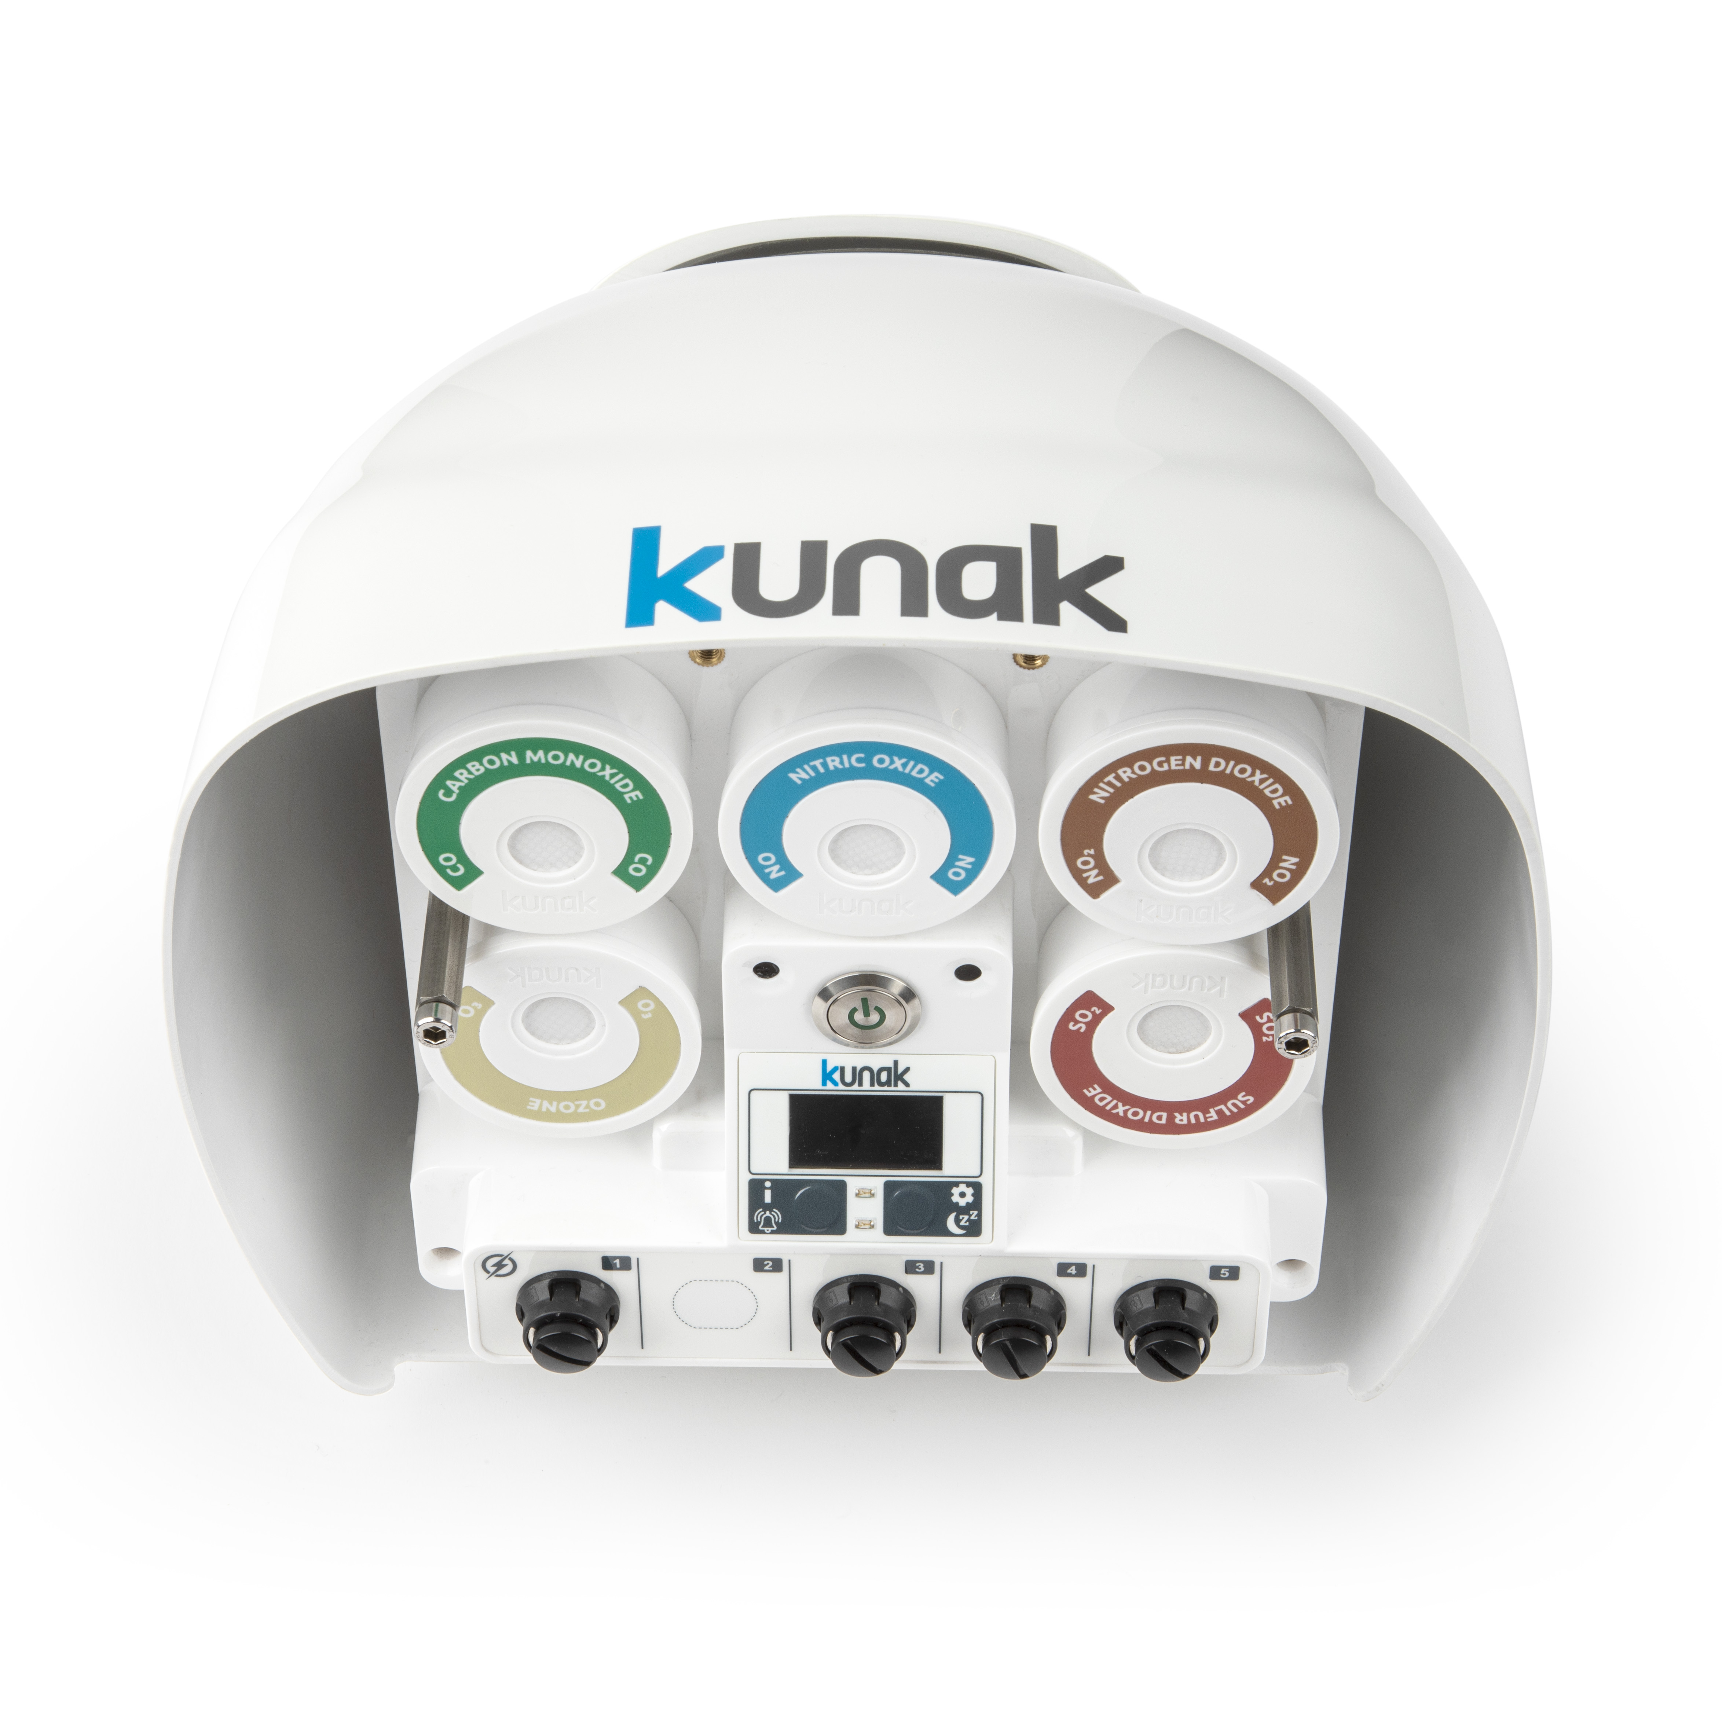  (a) |   (b)
Figure 1. Kunak AIR Pro monitoring system (a) and the system installed in a WTTP (b)
    - Monitoring sites
A monitoring campaign was conducted at a WWTP located in Community of Madrid (Spain), spanning from December 22nd 2022, to January 17th 2023. A Kunak AIR Pro monitoring system was employed to measure accurate low odorant concentrations (H₂S, NH₃, and VOCs) as well as meteorological variables throughout the study period. The system was installed inside the WWTP, close to the pretreatment stage. In addition to this device, an H₂S analyser (Medor, Chromatotec) was installed at the same location to serve as a reference instrument for comparative analysis. Data from the Kunak AIR Pro monitoring system was collected at 5-minute intervals throughout the study period and hourly averages were computed to align with the data collection frequency of the H₂S analyser. A separate monitoring campaign was conducted at a sludge treatment plant located in Community of Madrid (Spain), in which two Kunak AIR Pro monitoring systems were used to monitor H₂S, NH₃, and VOCs from August 4th 2023 to 1st February 2024. Additionally, meteorological variables including pressure, temperature, relative humidity, and wind speed and direction were also monitored. A third monitoring campaign was conducted at a petrochemical plant located in Valparaíso Region (Chile) from August 1st to 31th 2023. Three Kunak AIR Pro monitoring systems were employed to monitor VOCs as well as wind speed and direction among other meteorological variables.
  - Results and discussion
    - Water waste treatment plant
The temporal variation of H₂S concentrations measured by both the Kunak AIR Pro (blue line) and the H₂S analyser (red line) are illustrated in Figure 2. Overall, H₂S levels remained below 100 ppb, with a mean concentration of 15 ppb. Occasional peaks, notably observed on January 4th, reached levels ranging between 200 and 956 ppb.

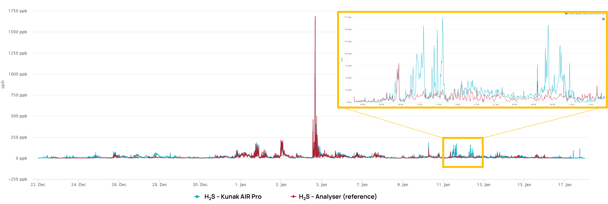
Figure 2. H₂S levels measured by the Kunak AIR Pro (blue line) and the H₂S analyser (red line). A zoomed-in view of H₂S levels measured on January 11th and 12th (yellow box)
H₂S levels measured by the Kunak device were very similar to those recorded by the H₂S analyser, indicating a high degree of agreement between the two systems. The data obtained with this analyser was plotted against the Kunak device 1-hour average data (Figure 3) showing a high correlation (R²: 0.77) despite the low concentrations measured through the study. Besides, the slope of the linear regression equation was close to 1 indicating a strong agreement between the two datasets. In addition, Mean Absolute Error (MAE) and Mean Absolute Percentage Error (MAPE) were calculated to be 6.9 ppb and 125%, respectively. Considering the low concentrations, it is not surprising since an error of 1 ppb in 1 ppb already represents a 100%. It is important to note that while the H₂S sensor can detect low concentrations of H₂S in ambient conditions, its accuracy can be affected by temperature and humidity variations. Although Kunak algorithms effectively mitigate these effects, it is not recommended to use this sensor to detect levels below 10 ppb. During the study, temperature ranged from 0 to 18.3 ºC and relative humidity varied between 37 and 96 %. If only H₂S concentrations above 20 ppb are considered, the correlation coefficient increases to 0.81. Besides, it must be considered that the differences observed between the sensor and the H₂S analyser might be also due to the presence of organic sulfur compounds, such as methyl mercaptan, to which the H₂S sensor is also responsive. These chemicals are usually present in WWTPs, and their response is discussed later in this paper.

Given the H₂S odour threshold starting at 8 ppb (Levels, 2010), it is crucial to evaluate the binary classification performance of the sensor (below/over the odour threshold) to assess its suitability for raising potential odour alarms. To do that, True Positive Rate (TPR) and False Positive Rate (FPR) have been calculated, being 0.87 and 0.34, respectively. The high TPR indicates that the sensor rarely misses true exceedance events which is crucial for addressing odour complaints effectively. However, the moderate FPR suggests that in 34% of the cases where the actual concentration is below the threshold, the sensor incorrectly measures that it is above the threshold. Part of these false positives could be explained by the response of the H₂S sensor to other organic sulfur compounds to which the H₂S analyser is not sensitive. A more conservative alarm threshold (20 ppb) would increase the TPR to 0.89 and reduce significantly the FPR to 0.16.

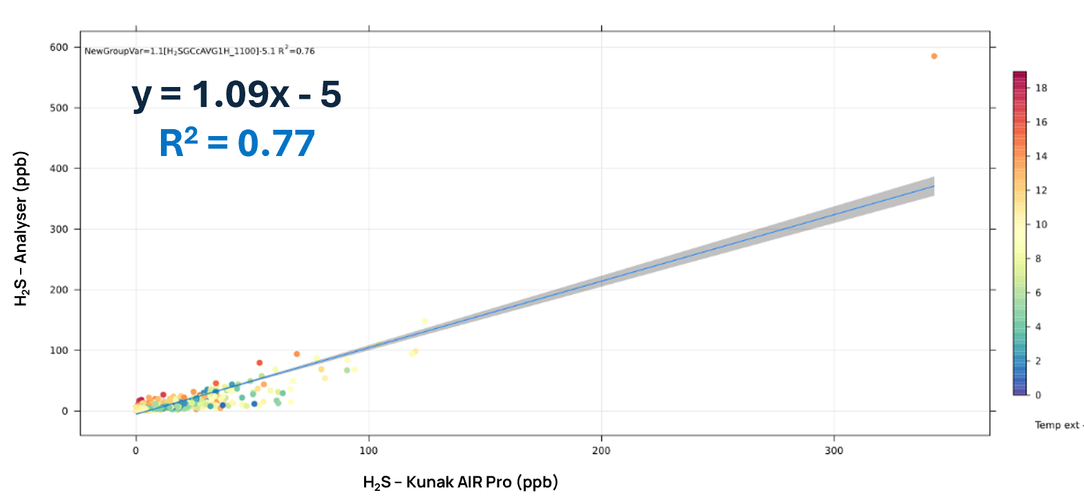
Figure 3. Correlation between H₂S levels measured by the Kunak AIR Pro and the H₂S analyser.
It is particularly interesting the H₂S levels observed during the January 11th and 12th, highlighted within the yellow box in Figure 2. During this period, the Kunak AIR Pro detected certain peaks that were not measured by the H₂S analyser. This discrepancy may be attributed to the cross-sensitivity of the H₂S sensor to organic compounds, such as Methyl mercaptan, one of the typical gases commonly emitted within WWTP known to cause odour issues (Li et al., 2021). To further confirm this hypothesis, the VOC sensor data was plotted altogether with the H₂S data (see Figure 4). As observed in the figure, when the H₂S peaks are detected, VOCs peaks are also observed, and the response of both sensors coincides directly and perfectly in this period. This combination of H₂S with VOC sensors within the same device can provide additional information on odour sources that can be useful for source identification.

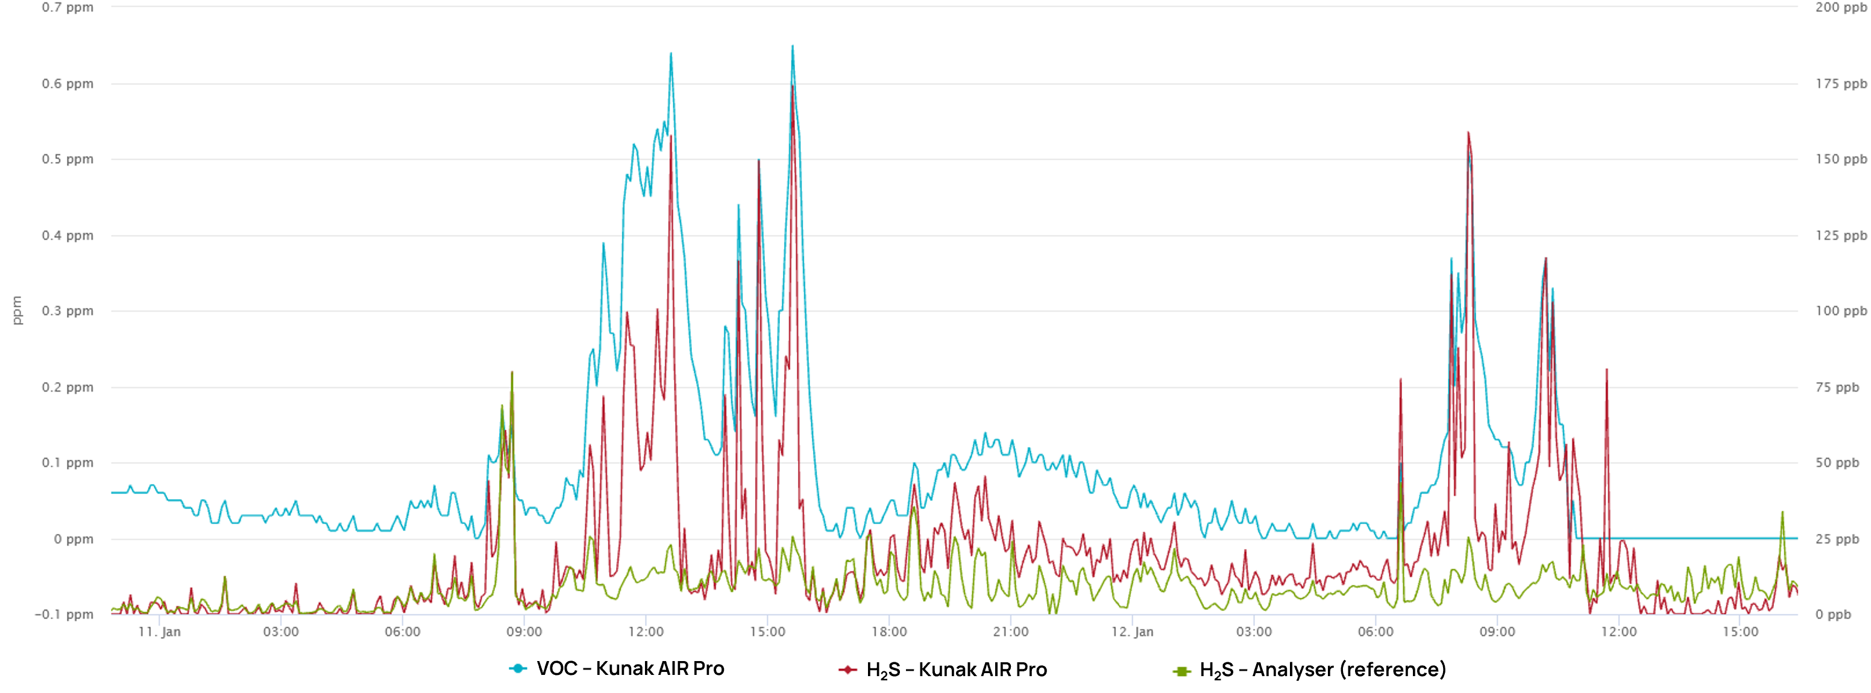
Figure 4. VOC levels (blue line) and H₂S levels measured by the Kunak AIR Pro (red line) and the H₂S analyser (green line).
    - Sludge treatment plant
Two monitoring systems were installed in a sludge treatment plant to monitor NH₃. The temporal trends of NH₃ levels during the initial months of the measurement campaign are depicted in Figure 5a, revealing fluctuations between months. Higher concentrations were recorded in August are likely attributed to increasing ambient temperature during this month, consistent with prior findings (Han et al., 2018). Overall, NH3-1 device consistently measured higher NH₃ concentrations (>30 ppm) compared to NH3-2. Considering that NH₃ is a known odorant whose odour threshold ranges from 5 to 53 ppm (Levels, 2008), the detected concentrations may trigger odour complaints in the vicinity of the plant. Pollution roses were used to illustrate the frequency distribution of NH₃ concentration relative to wind direction (see Figure 5b). As can be observed, in NH3-1 device, high concentrations of NH3 (>8 ppm) were frequently detected from the southwest direction more than 25% of the period in which the device was installed. In contrast, NH3-2 exhibited few NH₃ concentrations above 4 ppm, all of them coming from the northeast direction with a frequency of 20%. The average period of the NH3-1 device of the whole period is 3.6 ppm, while the average concentration monitored by the NH3-2 device is lower (1.2 ppm).

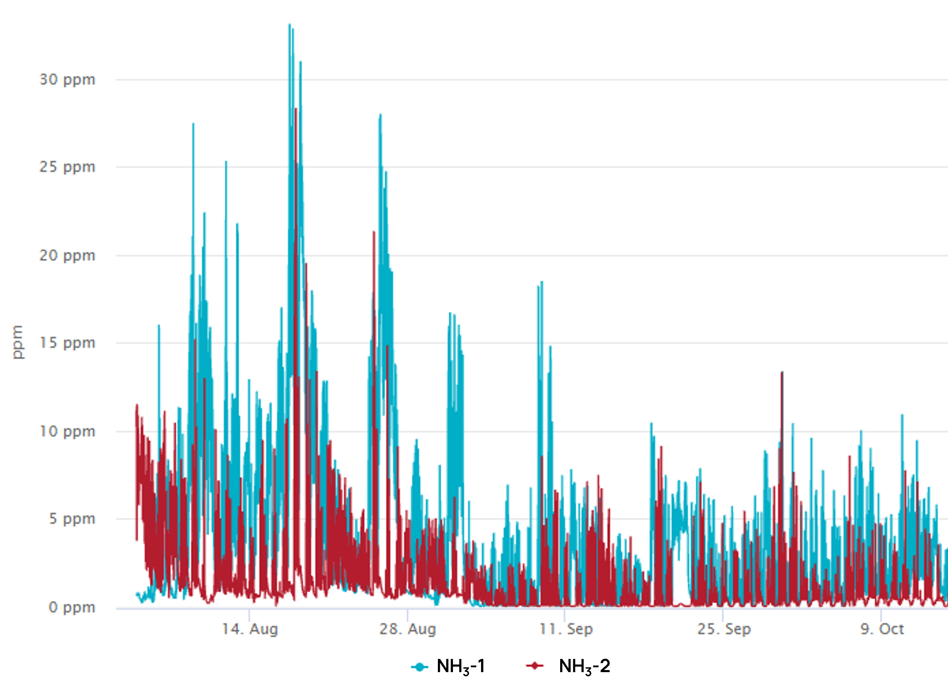  (a) | 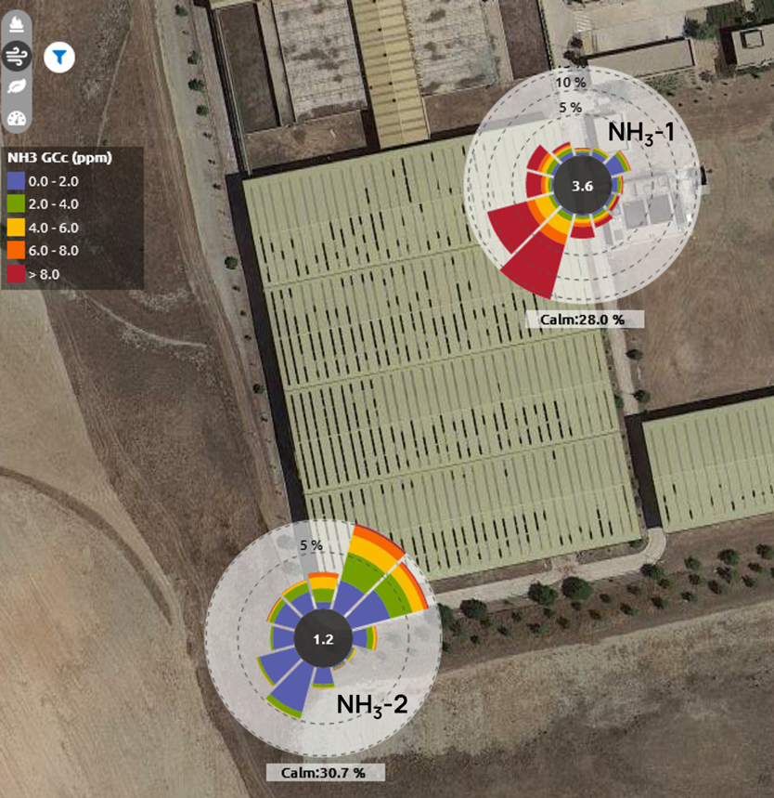  (b)

Figure 5. Time variation of NH₃ levels (a) and pollution rose plot (b) in a sludge treatment plant.
    - Petrochemical plant
Three monitoring systems were used to monitor VOC at the perimeter of a petrochemical plant. The temporal variations in VOC levels during the third week of the monitoring campaign are shown in Figure 6a. VOC levels exhibit a repetitive pattern probably associated with the plant’s operational processes. VOC concentration reached 2500 ppb in one location, highlighting significant emissions within the facility.

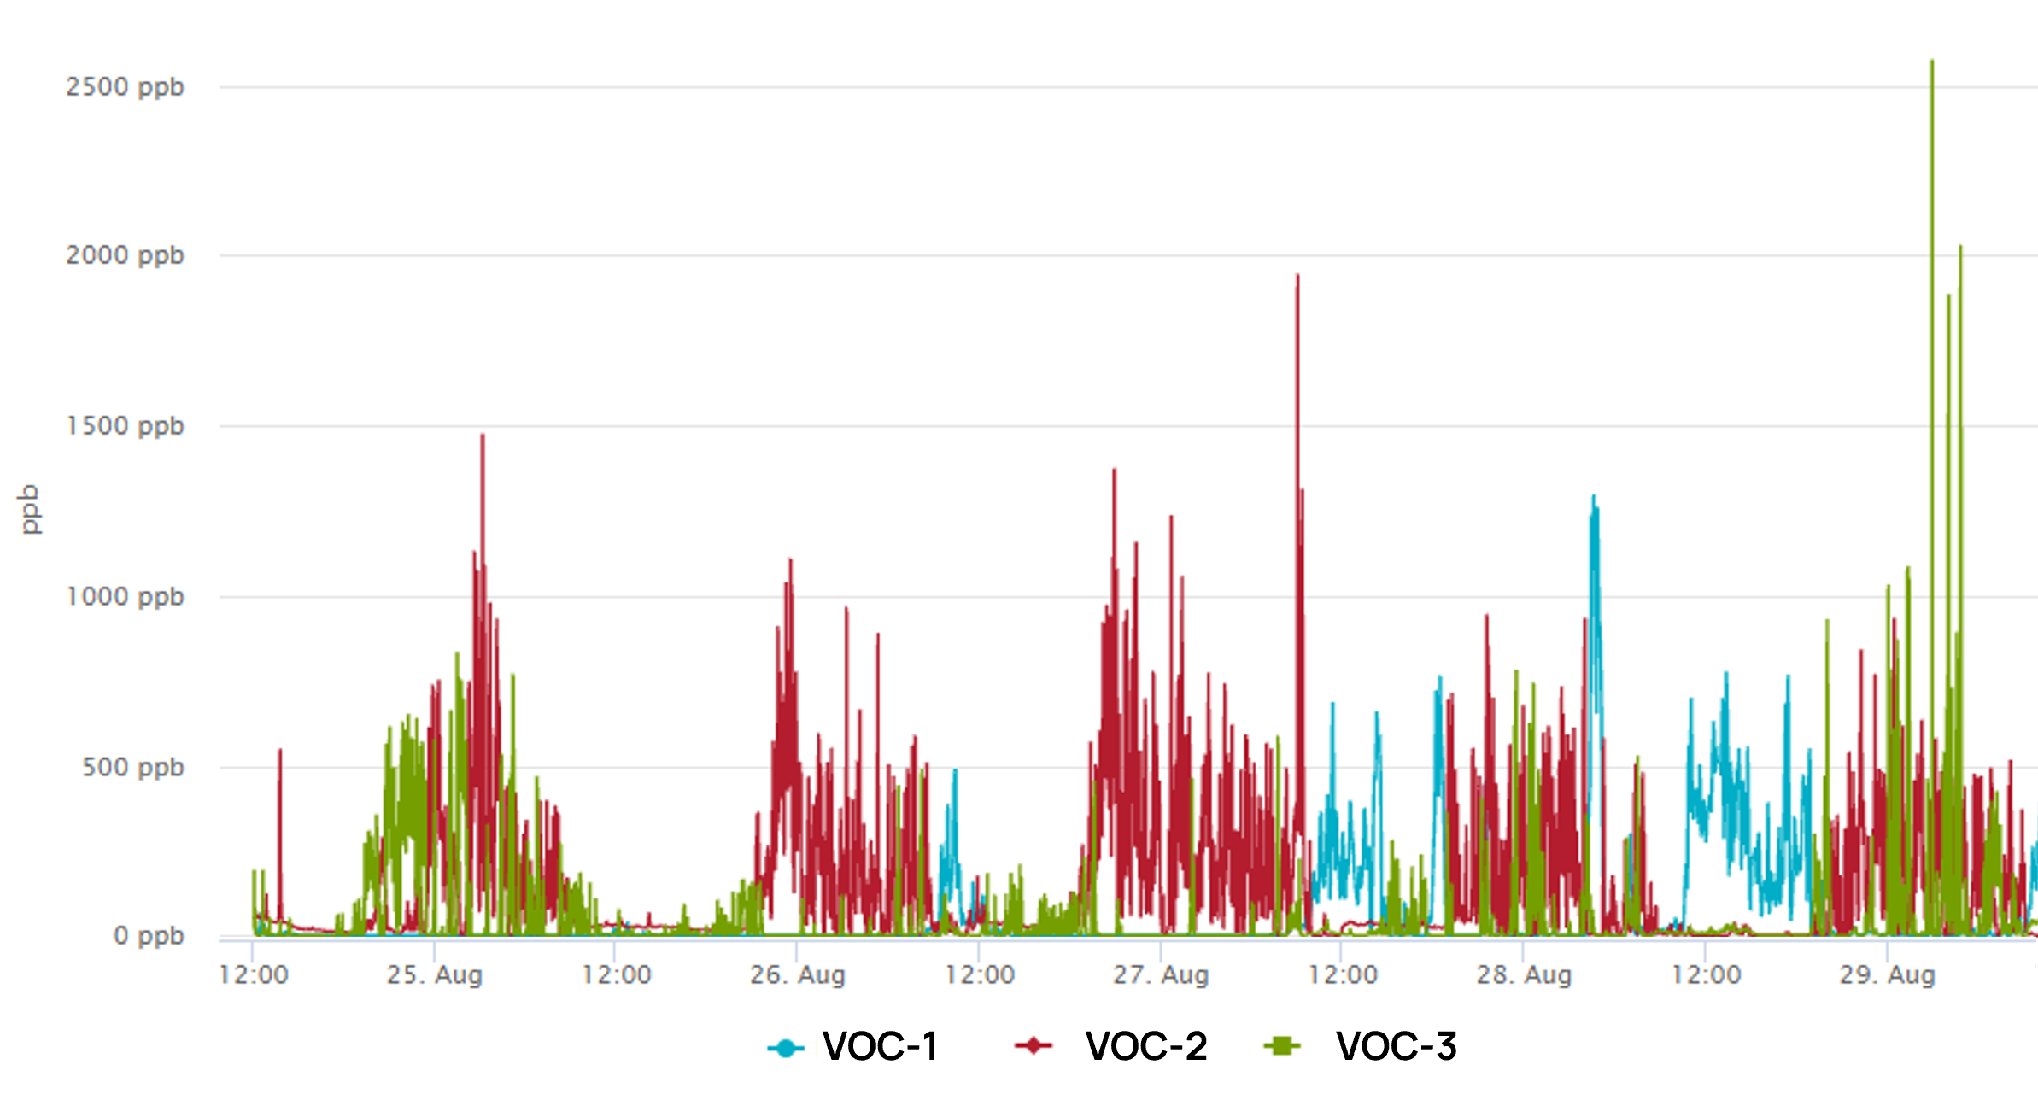  (a) | 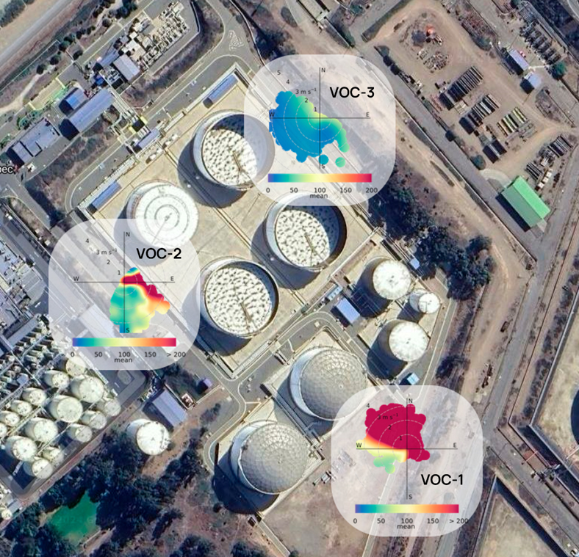  (b)
Figure 6. Time variation of VOCs levels (a) and polar plot (b) from a petrochemical industry.
Mean VOC concentrations were very similar in the three locations ranging from 53 to 87 ppb. A polar plot was used to investigate the spatial distribution of main VOC emission sources (see Figure 6b). The plot aggregates VOC concentrations by wind speed categories and direction, revealing distinct emission patterns associated with each monitoring device. VOC-1 consistently registered high VOC levels when winds originated from the northwest, at almost any wind speed, indicating proximity to a localized emission source. Conversely, VOC-2 detected elevated VOC concentrations from the east during low wind speeds, suggesting another nearby emission point. Interestingly, VOC-3 recorded lower concentrations consistently from northwest and southwest directions across all wind speed ranges, suggesting a more distant emission source from this monitoring location. These observations indicate that VOC levels measured are due to the emissions originated within the petrochemical plant, with a concentration gradient evident between VOC-1 and VOC-2 locations. These emissions could be due to the chemical processes carried out in the plant as well as operational issues such as inefficiencies and leakages. The use of sensor-based monitoring instruments offers a valuable tool for identifying emission sources and mitigating odour-related issues promptly. This enables informed decision-making to address operational challenges, ultimately reducing associated costs and enhancing air pollution management within industrial settings.
  - Conclusions
This work underscores the performance of sensor-based Kunak AIR Pro system in monitoring and characterizing the low concentrations of odorous compounds within different applications (WWTP, sludge treatment and petrochemical plants). In the WWTP, the performance of the system to monitor H₂S was evaluated against a H₂S analyser showing a high correlation coefficient of 0.77 and a MAE of 6.9 ppb demonstrating the reliability and accuracy of this system for H₂S monitoring. Considering an H₂S odour threshold of 8 ppb, the TPR and FPR were calculated to be 0.87 and 0. 34. These rates suggest that the sensor rarely misses true exceedance events, however, it has a relatively high rate of false positives due to the effects of ambient conditions in sensors and the presence of other compounds that interfere with the H₂S sensor. Setting a more conservative alarm threshold (20 ppb) could avoid unnecessary alarms, improving the TPR and FPR to 0.89 and 0.16, respectively. Moreover, the observed correlation between H₂S and VOC levels highlights the potential of this type of systems to provide comprehensive odour monitoring solutions. By leveraging the complementary responses of different sensors, such as those for H₂S and VOCs, facilities can enhance their capacity for identifying and mitigating odour sources effectively.

In a sludge treatment and a petrochemical plant, it was shown how the deployment of monitoring devices for VOCs, H₂S, and NH₃ and meteorological data provided valuable insights into the temporal variations and spatial distribution of these compounds within the studied facilities as well as into the potential identification of emission sources. This information is crucial for implementing proactive measures to minimize environmental impact and address potential odour issues. This study demonstrates that sensor-based monitoring systems can provide a useful solution for continuous monitoring, offering real-time data on various pollutants, which helps reduce the environmental impact of the operations and contributes protection of the health of workers and nearby populations. Additionally, the use of sensor-based instruments results in cost savings by quickly identifying inefficiencies or malfunctions in the industrial processes, allowing for immediate interventions to solve them, and avoiding any economic losses.
References
Burgués, J., Doñate, S., Esclapez, M.D., Saúco, L., Marco, S., 2022. Characterization of odour emissions in a wastewater treatment plant using a drone-based chemical sensor system. Science of The Total Environment 846, 157290. https://doi.org/10.1016/j.scitotenv.2022.157290
Han, Z., Qi, F., Wang, H., Liu, B., Shen, X., Song, C., Bao, Z., Zhao, X., Xu, Y., Sun, D., 2018. Emission characteristics of volatile sulfur compounds (VSCs) from a municipal sewage sludge aerobic composting plant. Waste Management 77, 593–602. https://doi.org/10.1016/j.wasman.2018.05.049
Leonardos, G., Kendall, D., Barnard, N., 1974. Odor threshold determination of 53 odorant chemicals. Journal of Environmental Conservation Engineering 3, 579–585.
Levels, N.R.C. (US) C. on A.E.G., 2010. Hydrogen Sulfide Acute Exposure Guideline Levels, in: Acute Exposure Guideline Levels for Selected Airborne Chemicals: Volume 9. National Academies Press (US).
Levels, N.R.C. (US) C. on A.E.G., 2008. Ammonia Acute Exposure Guideline Levels, in: Acute Exposure Guideline Levels for Selected Airborne Chemicals: Volume 6. National Academies Press (US).
Li, R., Han, Z., Shen, H., Qi, F., Ding, M., Song, C., Sun, D., 2021. Emission characteristics of odorous volatile sulfur compound from a full-scale sequencing batch reactor wastewater treatment plant. Science of The Total Environment 776, 145991. https://doi.org/10.1016/j.scitotenv.2021.145991
McKercher, G.R., Salmond, J.A., Vanos, J.K., 2017. Characteristics and applications of small, portable gaseous air pollution monitors. Environmental Pollution 223, 102–110.
Naddeo, V., Belgiorno, V., Zarra, T., 2012. Odour Characterization and Exposure Effects, in: Odour Impact Assessment Handbook. John Wiley & Sons, Ltd, pp. 7–29. https://doi.org/10.1002/9781118481264.ch2
Prudenza, S., Bax, C., Capelli, L., 2023. Implementation of an electronic nose for real-time identification of odour emission peaks at a wastewater treatment plant. Heliyon 9.

