|  |  |
| --- | --- |
| cetlogo ***CHEMICAL ENGINEERING TRANSACTIONS***  ***VOL. xxx, 2024*** | A publication of  aidiclogo_grande |
| The Italian Association  of Chemical Engineering  Online at www.cetjournal.it |
| Guest Editors: Selena Sironi, Laura Capelli  Copyright © 2024, AIDIC Servizi S.r.l. **ISBN** 979-12-81206-13-7; **ISSN** 2283-9216 | |

Dynamic olfactometry measurements of geothermal endogenous gas emissions

Marzio Invernizzi\*,a, Giacomo Domenico Scolieria, Francesca Tagliaferria, Alessandro Bettinib, Marcello Cincib, Alessandro Lenzib, Selena Sironia

a Politecnico di Milano, Department of Chemistry, Materials and Chemical Engineering “Giulio Natta” - Piazza Leonardo da Vinci 32, 20133 Milano, Italy

b Enel Green Power S.p.A., Via Andrea Pisano 120, 56126 Pisa, Italy

marzio.invernizzi@polimi.it

Gaseous emissions which may be of odour impact and interest are not solely derived from industrial processes or agricultural fields, but also from natural sources. Natural odorous gaseous emissions are often present in geothermal areas. In these cases, the inventory and the measurement of the emitted gas flows are not trivial. This work presents the experience of an olfactometric survey conducted in a geothermal-interest area, specifically around Mt. Amiata, Tuscany, Italy. Dynamic olfactometry analyses showed odour concentrations in the order of millions of ouE/m3. While the main constituent of these natural gas emissions was CO2, the very high odour concentration data primarily resulted from the high portion of H2S in these emissions, with detected concentrations ranging from 1,000 to 10,000 ppmv. This not only indicates the presence of odour impact potential but also the high risk for people in the nearby area due to the high concentration of this gas. In parallel with the measurement of representative concentration data of these spot vents, a flexible and innovative approach was established for the measurement of emitted gas flow. The main breakthrough was obtained via the revamping of a balometer, a tool used for the measurement of indoor airflows, in the measurement of the gas flow of large spot vents (i.e. mine gates). Thanks to this stretchy approach, it was possible to estimate the OER of these emissions: the overall OER of all the inventory of the investigated spot vents in the area was impressive, and reached almost 10 million of ouE/s.

* 1. Introduction

Dynamic olfactometry is the sensory technique widely used for the assessment of odour nuisance from industrial plants and agricultural operations (Barczak et al., 2022). The standardized approach is to conduct an olfactometric campaign at the emitting sources, estimate Odour Emission Rates, OER, and compute the fallout through atmospheric dispersion models (Bokowa and Bokowa, 2017; Tagliaferri et al., 2024). The investigation of the environmental background odour is rarely conducted, due to technical difficulties deriving from the sensitivity of the olfactometric technique (Boeker et al., 2014; Kasper et al., 2018). The background odour derives from the overlapping of all the sources present in an area, which are not directly measured and taken into account in an odour impact assessment: these may derive from vehicular traffic, emissions from vegetation, domestic heating etc. There are, however, geographical areas where there are particular additional odorous sources: geothermal sites. A geothermal area is a location on Earth's surface where geothermal activity occurs, characterised by excess heat in the subsurface. These areas can exhibit various phenomena such as elevated surface temperatures, hydrothermal activity, fumaroles emitting volcanic gases, hot springs, steam vents, and more. In these sites, the environmental background odour may be strongly affected by the gases which are released by these sources. The present work aims to present the results of the first olfactometric field campaign conducted in the geothermal area. Specifically, the case-study site was Mt. Amiata, Tuscany, Italy.

* 1. Material and Methods
     1. Investigated area

The Mt. Amiata geothermal area, in southern Tuscany, Italy, is a well-known and extensively studied geothermal system (Marroni et al., 2015). The area was historically known for the exploitation of cinnabar mines. Further exploration of the area began in the 1950s, and it has since become an important source of geothermal energy production in Italy (Barelli et al., 2010; Fulignati et al., 2014). The geothermal system of Mt. Amiata is characterized by deep and shallow geothermal reservoirs that are separated by a low permeability layer, although they are in hydrostatic equilibrium. The deep geothermal reservoir is exploited for electricity generation through flash-type power plants, while the shallow reservoir supplies heat for direct-use applications. There exist different kinds of natural endogenous gas emissions on the site: the diffuse and the spotted ones. In the present study, only spot-vented emissions were considered. For further details about the diffuse emission please refer to Sbrana et al. (2020).

Several are the spot vents present in the area: after preliminary field inspections, only the most interesting spot vents have been considered. The results obtained by the major 15 sources, over the more than 50 discovered, are presented here. Figure 1 presents some examples of sampled spot vents.

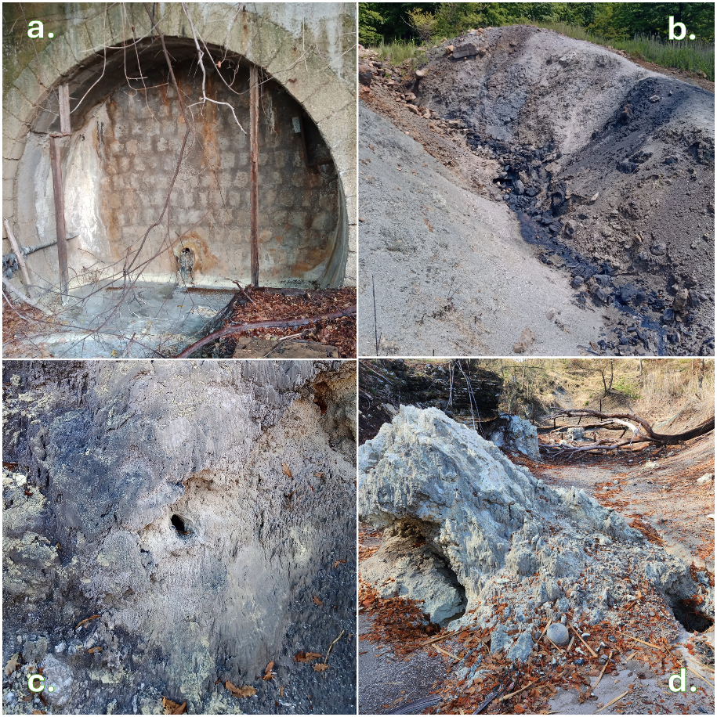

Figure 1. Example of investigated spot vents: a. Anteie 1 (Anteie tunnel) (Lat. 42.8231°; Long. 11.5472°); b. Selvena 1 (Lat. 42.7748°; Long. 11.6276°); c. The Hole (Lat. 42.9227; Long. 11.6866°); d. Campo la Villa (Lat. 42.9325°; Long. 11.6886°).

* + 1. Odour concentration measurement

Dynamic olfactometry is the standardized sensorial method used to objectively measure the odour concentration of gaseous mixtures. It involves presenting an odorous air sample to a panel of trained assessors and determining the dilution factor required to reach the odour detection threshold, where 50% of the panel can perceive the odour (Bax et al., 2020; Harreveld, 2021). The samples, withdrawn at the emission sites in 6-litre NalophanTM bags via a vacuum pump, were diluted with odour-free air in an olfactometer device, and the panellists indicated when they first detect a perceivable odour. According to the requirements of the technical standard EN13725:2022, the odour concentration was then expressed in European odour units per cubic meter (ouE/m3), which, in a few words, represents the number of dilutions needed to reach the detection threshold. The bags were analysed at the Olfactometric Laboratory of Politecnico di Milano university the morning after the collection. The used olfactometer was a 4-port ECOMA TO8.

* + 1. Chemical characterization

Odorous gas flows are often constituted by several different compounds, with may contribute or not to the odour potential of the emission. Often, the odorants are mainly organic (Polvara et al., 2023; Tagliaferri et al., 2024) and present in trace concentrations. In the present case, only main constituents of the mixture have been investigated (CO2, CH4, N2, O2, H2, H2S): among these components, only H2S was a compound perceptible by smell. Glass gas sampling flask, sealed with PTFE valves, were used to collect gaseous samples. Gas chromatographic techniques were used at Larderello's Enel Green Power Laboratory, to measure the composition of gas. For the analysis, an AGILENT model 7890B gas chromatograph with two channels, both coupled with TCD detector, was used.

* + 1. Emitted gas flow measurements

After the localisation of the spot vents, the most challenging part of the field campaign was the quantitative characterisation of these gas sources. A specific method for the quantification of gas flow emitted by geothermal sources is not available: a crucial part of the project was the research into methods that could be used to measure flows under these particular application conditions. As shown in Figure 1, these emissions could be very disparate and, above all, had an inhomogeneous structure: in these situations, the measurement of an exit velocity and a cross-section seemed an arduous task. In a few cases, due to the well-defined shape of the spot vent, like for and Anteie 1 (Anteie tunnel) and The Hole spot vent (Figure 1.a and Figure 1.c respectively) or in old-mine ventilation chimneys, the measurement of the flux was conducted simply by using a Pitot tube and measuring the cross-sectional area of passage. In other cases, as in localised releases from the ground, such as Selvena 1 and Campo la Villa (Figure 1.b and Figure 1.d respectively) or old mine entrances, the estimation of a precise emission cross-sectional area was not possible. In order to obtain a quantitative measure of the emitted gas flux, a balometer, typically used for indoor ventilation fluxes, was retrofitted with plastic films and utilised. An example of its application in this field campaign, during olfactometric sampling, is presented in Figure 2. The revamped introduction of this tool was a turning point in obtaining useful results for the characterisation of Mt. Amiata's natural emissions.

Figure 2. Balometer application for the measurement of the gas flow of Selvena 2 spot vent (Lat. 42.773°; Long. 11.6252°), during olfactometric sampling.

* 1. Results and Discussion

In Table 1 the concentration results, detected in field campaigns at Mt. Amiata area, are summarized.

Table 1. Concentration and gas flow data obtained during field campaigns at Mt. Amiata’s spot vent gaseous emissions. The gas flows are expressed in m3/h, normalised for dynamic olfactometry measurements, 101,325 Pa and 293 K.

|  |  |  |  |  |
| --- | --- | --- | --- | --- |
| Measurement | Average | Standard deviation | Minimum | Maximum |
| H2 [%v/v] | 0.11 | 0.24 | <0.01 | 0.92 |
| O2 [%v/v] | 1.06 | 2.15 | 0.01 | 8.56 |
| N2 [%v/v] | 5.8 | 7.6 | 1.3 | 31.5 |
| CH4 [%v/v] | 4.3 | 3.1 | 0.85 | 12.9 |
| CO2 [%v/v] | 88.5 | 9.0 | 58.9 | 96.1 |
| H2S [ppmv] | 2,962 | 2,618 | 93 | 8,242 |
| Odour concentration [ouE/m3] | 2.6 ∙ 106 | 2.0 ∙ 106 | 1.4 ∙ 105 | 8.0 ∙ 106 |
| Gas flow [m3/h] | 626 | 898 | 12 | 2,885 |

As expected, CO2 was the main constituent of endogenous gas emissions (Tassi et al., 2009). CH4 concentrations were generally in the range of a few percentage points, and not negligible concentrations of O2 and N2 were usually detected. H2 concentrations were always < 1%v/v. From the odorant point of view, the concentration of H2S reached levels that are rarely encountered in industrial or agricultural atmospheric emissions. These values are indeed characteristic not strictly of a potential olfactory impact in the surrounding area but are so high as to pose a high health risk, and even survival, in the vicinity. Moreover, the detected odour concentrations are far higher than the ones usually detected in industrial emissions: despite the few available emission limits, expressed in odour concentration, are in the order of 102÷103 ouE/m3 (Pinasseau et al., 2018), the values found in endogenous gas emissions are in the order of millions of ouE/m3.

To estimate the impact which this kind of emissions may have in the nearby, in Table 2 the overall Mt. Amiata’s spot vents emission rates, ER, are reported.

Table 2. Overall Mt. Amiata measured spot vent emission rates.

|  |  |  |  |  |  |  |
| --- | --- | --- | --- | --- | --- | --- |
| ER H2 [kg/h] | ER O2 [kg/h] | ER N2 [kg/h] | ER CH4 [kg/h] | ER CO2 [t/h] | ER H2S [kg/h] | OER [ouE/s] |
| 1.6 | 49 | 290 | 280 | 15.8 | 55 | 7.6 ∙ 106 |

Both the values of ER of H2S and OER appeared to be extremely high: just to have a brief comparison, both the H2S ER and OER may be equal to 3÷5 oil refineries (Motalebi Damuchali and Guo, 2020; Onakpohor et al., 2024). Figure 3 shows how the H2S ER and OER were distributed between completely natural and archaeo-industrial sources: the contribution of mining remnants appeared to be central in the overall odour emission inventory of spot vents in the area.

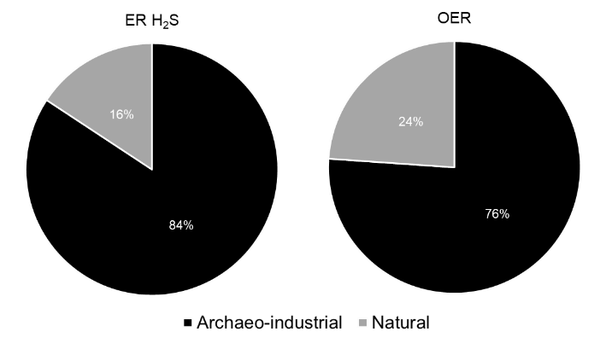

Figure 3. Distribution of H2S ER and OER between natural and archaeo-industrial spot vents

Due to all these findings, natural spot vents resulted to play a central role in the characterisation of environmental background odour in the Mt. Amiata area.

* 1. Conclusions

Field campaigns on Mt. Amiata have shown the presence of several endogenous gas spot vents, both completely natural and archaeo-industrial, derived from the old cinnabar mining swellings in the area. These emissions are rich in CO2 but also show not negligible amount of CH4 and H2S. In particular, H2S is present at concentrations even dangerous for humans. These very high H2S concentrations lead to millions of ouE/m3. The first conclusion of this study is that these spot vents must be clearly identified, in order to avoid the possible random and dangerous approach of passers-by. In addition to the installation of fences, continuous maintenance is necessary, given the corrosiveness of the discharged endogenous gases. A further conclusion is the possibility to include these sources of gases in the atmospheric dispersion modelling of the area: given their ground-level emission height, and nearly null plume rise, these emissions may be scarcely diluted by the atmosphere before the fallout at receptors. The use of these tools may provide useful information for the control and the estimation of H2S in the investigated area. Further development may be needed in order to consider the atmospheric chemistry of H2S: this gas may be oxidized in the atmosphere and the very high concentrations may enhance the reactions kinetic.

A final consideration refers to the update of this emission inventory: even within the conduction of the here-presented field campaigns, an evolution in the emissions was noted. The authors underline the importance of continuous monitoring of these emissions and eventually further explorations to find the possible presence of further spot vents, which were not discovered (and considered) in the present study.

References

Barczak, R. J., Możaryn, J., Fisher, R. M., Stuetz, R. M., 2022, Odour concentrations prediction based on odorants concentrations from biosolid emissions. *Environmental Research*, *214*, 113871, https://doi.org/10.1016/j.envres.2022.113871

Barelli, A., Ceccarelli, A., Fiordelisi, A., Giorgi, N., Lovari, F., Romagnoli, P., 2010, A review of the Mt. Amiata geothermal system (Italy), *Proceedings World Geothermal Congress*, http://www.geothermal-energy.org/pdf/IGAstandard/WGC/2010/0613.pdf

Bax, C., Sironi, S., Capelli, L., 2020, How can odors be measured? An overview of methods and their applications, *Atmosphere*, *11(92)*, https://doi.org/10.3390/atmos11010092

Boeker, P., Leppert, J., Lammers, P. S., 2014, Comparison of odorant losses at the ppb-level from sampling bags of NalophanTM and TedlarTM and from adsorption tubes, *Chemical Engineering Transactions*, *40*, 157-162, https://doi.org/10.3303/CET1440027

Bokowa, A. H., Bokowa, M. A., 2017, Odour assessment methods: appropriate uses to obtain the most accurate results, *Austrian Contributions to Veterinary Epidemiology*, *9*, 21-35

Fulignati, P., Marianelli, P., Sbrana, A., Ciani, V., 2014, 3D geothermal modelling of the Mount Amiata hydrothermal system in Italy, *Energies*, *7*, 7434-7453, https://doi.org/10.3390/en7117434

Harreveld, A. P., 2021, Update on the new EN 13725:2021, *Chemical Engineering Transactions*, *85*, 115-120, https://doi.org/10.3303/CET2185020

Kasper, P. L., Hansen, M. J., Feilberg, A., 2018, Impact of saturation effects during dynamic olfactometry on low-concentration environmental odour samples, *Chemical Engineering Transactions*, *68*, 37-42, https://doi.org/10.3303/CET1868007

Marroni, M., Moratti, G., Costantini, A., Conticelli, S., Benvenuti, M. G., Pandolfi, L., Bonini, M., Cornamusini, G., Laurenzi, M. A., 2015, Geology of the Monte Amiata Region, Southern Tuscany, Central Italy, *Italian Journal of Geosciences*, *134*(2), 171-199, https://doi.org/10.3301/IJG.2015.13

Motalebi Damuchali, A., Guo, H., 2020, Developing an Odour Emission Factor for an oil refinery plant using reverse dispersion modeling, *Atmospheric Environment*, *222*, 117167, https://doi.org/10.1016/j.atmosenv.2019.117167

Onakpohor, A., Fakinle, B. S., Adesanmi, A. J., Sonibare, J. A., Oke, M. A., Akeredolu, F. A., 2024, Determination of air emission factor of pollutants from local crude oil refineries, *Results in Engineering*, *22*, 102036, https://doi.org/10.1016/j.rineng.2024.102036

Pinasseau, A., Zerger, B., Roth, J., Canova, M., Roudier, S., 2018, *Best Available Techniques (BAT) Reference Document for Waste Treatment Industries*, https://doi.org/10.2760/407967

Polvara, E., Gallego, E., Invernizzi, M., Perales, J. F., Sironi, S., 2023, Chemical characterization of odorous emissions: A comparative performance study of different sampling methods, *Talanta*, *253*, 124110, https://doi.org/10.1016/j.talanta.2022.124110

Sbrana, A., Marianelli, P., Belgiorno, M., Sbrana, M., Ciani, V., 2020, Natural CO2 degassing in the Mount Amiata volcanic-geothermal area, *Journal of Volcanology and Geothermal Research*, *397*, 106852, https://doi.org/10.1016/j.jvolgeores.2020.106852

Tagliaferri, F., Facagni, L., Invernizzi, M., Ferrer Hernández, A. L., Hernández-Garces, A. Sironi, S., 2024a, Odor Impact Assessment via Dispersion Model: Comparison of Different Input Meteorological Datasets, *Applied Sciences*, *14*, 2457, https://doi.org/10.3390/app14062457

Tagliaferri, F., Panzeri, F., Invernizzi, M., Manganelli, C., Sironi, S., 2024b, Characterization of diffuse odorous emissions from lignocellulosic biomass storage, *Journal of the Energy Institute*, *112*, 101440, https://doi.org/10.1016/j.joei.2023.101440

Tassi, F., Vaselli, O., Cuccoli, F., Buccianti, A., Nisi, B., Lognoli, E., Montegrossi, G., 2009, A geochemical multi-methodological approach in hazard assessment of CO 2-rich gas emissions at Mt. Amiata Volcano (Tuscany, Central Italy), *Water, Air, and Soil Pollution: Focus*, *9*, 117-127, https://doi.org/10.1007/s11267-008-9198-2