 CHEMICAL ENGINEERING TRANSACTIONS  VOL. xx, 2024 | A publication of  
The Italian Association
of Chemical Engineering
Online at www.cetjournal.it
Guest Editors:
Copyright © AIDIC Servizi S.r.l.
ISBN 978-88-95608-xx-x ISSN 2283-9216

Evaluation of the Odour Emission Rate from Wastewater Aerated Tanks: a Methodological Approach
Giacomo Scolieri, Marzio Invernizzi*, Selena Sironi
Politecnico di Milano, Department of Chemistry, Materials and Chemical Engineering “Giulio Natta”, Piazza Leonardo da Vinci 32, 20133 Milano, Italy
marzio.invernizzi@polimi.it
Accuracy in the characterisation of odour-emitting sources is particularly significant for the implementation of a truly representative odour impact study. The selection of sampling techniques to measure odour concentrations, along with an accurate method to assess Odour Emission Rate, is closely linked to the type of source under investigation. The distinction between active and passive sources is not always obvious, such as in the case of biological oxidation tanks. This kind of emissive source, commonly classified as a passive source, is characterised by convective flow that is generally not intense. Indeed, the flushing of a known airflow within a dynamic hood, such as a wind tunnel system, necessary to simulate the wind action on the surface of the tank, may not be the driving force of the system.
The aim of the present study is to evaluate the emissive contributions of biological oxidation tanks, focusing on the phenomenon of aeration and the effect of wind on the liquid surface of an oxidation basin.
Using different sampling methodologies, through different field measurements, the Specific Odour Emission Rates, associated with each contribution, were measured and compared. The results indicate that the stripping phenomenon due to the convective flow generated by aeration can account for up to 96% of the odorous emission contribution.
  - Introduction
In recent times, there has been a heightened global emphasis on safeguarding the environment, particularly regarding the adverse effects of industrial operations as a significant source of pollution. This increased focus has led to growing concerns about environmental odours, prompting complaints from the public and evolving into a worldwide social concern (Brancher et al., 2017). Prolonged exposure to odours from industrial activities can lead to negative health effects, both physiological and psychological. As a result, the scientific community has created tools to evaluate and address this issue. Olfactory nuisance, often linked to inadequately managed waste disposal, animal farming, and industrial and environmental protection facilities, is identified as the main reason for public complaints (Invernizzi et al., 2016; Piccardo et al., 2022). Odorous emissions are a relevant contributor to air pollution and the exclusive study of concentration may not fully represent the environmental nuisance, as it neglects various parameters that need to be considered to quantify the effective impact of the odours (Bokowa and Bokowa, 2017).
The characterisation of an emissive source can be a complex issue within an odour impact study. The estimation of an appropriate Odour Emission Rate (OER) expressed in ou_{E}/s, is crucial to implement an atmospheric dispersion model, for the assessment the influence of an odorous source on the neighbouring area (Tagliaferri et al., 2024). The choice of the best sampling technique, aimed at obtaining an odour concentration value and a consistent method for estimating the odour flow, is closely related to the source being investigated (Gostelow et al., 2003; Invernizzi et al., 2024).
Among the various odour emissive sources, the area sources emit from extended surfaces (e.g. liquid or solid), where there is not a well-defined volume flow to be associated to an odour concentration, with the aim of the evaluation of an OER. Generally, the scientific literature proposes two different approaches to assess the OER of this kind of emission: indirect measurement and direct measurement (Hudson and Ayoko, 2008a). The first group is represented by micrometeorological methods (Lotesoriere et al., 2023), while the second one, more practical and economical, is based on a hood that enclose totally or partially the emitting surface. This technique combines the collection of gas samples with the physical dimensions of the hood and its operating conditions, to evaluate OER.
From a technical perspective, area sources can be classified as active (e.g. biofilter) or passive (e.g. landfill surfaces, wastewater treatment tanks) depending on the presence or absence of a gas flow directed outward. The sampling method varies too: the EN 13725:2022 suggests the use of a static hood for active area source, while for passive one, the standard does not prescribe a specific method, but provides guidance for the use of a dynamic hood (e.g. low-speed wind tunnel (LSWT) or flux chamber) (CEN, 2022).
Nevertheless, the clear distinction between the two types of sources is not always trivial. There are recurring cases in which a convective flow is present, but not intense; the most emblematic example is represented by aerated basins as biological oxidation tanks. In terms of regulations, EN 13725:2022 establishes that the minimum expulsion velocity at which a source can be considered active is 0.008 m/s. This value is consistent with the 30 m/h stated in the German technical standard VDI 3880:2011 (VDI, 2011). Considering this value within the collection surface of the WT, built according to the design illustrated in the attachments of Italian guidelines, whose covered surface is 0.125 m² (MASE, 2023), a flow rate of 3600 L/h is obtained. The execution of a sampling on a passive area source involves the flow inside a dynamic hood of a known quantity of neutral gas, that has the aim to simulate the wind effect on the surface of the investigated source. The Italian LSWT commonly use a flow of 2500 L/h, which corresponds to a sweep velocity of 3 cm/s, according to the geometry of the WT (Tagliaferri et al., 2021). Observing the values of the involved flows, it is possible to comprehend how the controlling emissive phenomenon is not strictly associated with the flow sent into the hood through the ventilation system, because of the comparability with the flow produced by the aeration system of the oxidation basin. In other words, assuming a borderline case of an aerated basin with an aeration flow inside the dynamic hood of 3600 L/h, the usage of a WT operated with a gas flow of 2500 L/h does not ensure a forced ventilation-controlled system. Based on these assumptions, the value present in the standard, chosen by convention, seems to be not entirely solid. Specifically, biological oxidation tanks can have specific surface aeration rates (SSAR) up to 50 m³/m²/h (Gillot and Héduit, 2008). On the other hand, it is recurrent that, based on the criterion established by the standard, most of them can be formally classified as a passive area source; therefore, the sampling should be carried out using a dynamic hood. However, the utilisation of an additional flow, i.e. the gas flow necessary to operate a WT, would not be the controlling element of the system, because it could potentially be smaller than the value of the aeration system flow rate.
The goal of this work is to critically highlight the weak points of the characterisation of surface sources based on the experience of real field situations, exposing the various evaluations that must be considered to choose the most suitable approach for sampling and characterising an area emission source. The importance of this exposure is also evidenced by a recent regulatory advance in Italy with the introduction of the national decree on odour sources monitoring and control (Settimo and Avino, 2024).
  - State of the art of passive surface sources sampling
Basins within a wastewater treatment plant, lagoons and landfill soil fall under this category of emissions. For instance, primary and secondary settlement tanks, aerated and non-aerated sequencing batch reactors and compost heaps represent some examples of passive surface sources. Typically, these emissions are devoid of an outward airflow, or it is minimal, with an exit velocity below 0.008 m/s. Comprehending the emission mechanism is complex, drawing attention from the scientific community (Liu et al., 2022).
In general, the most widely used sampling device within the scientific community to characterise the passive surface emissions is the WT. However, the European standard for olfactometry does not fix specific rules for treating and sampling passive area sources, which face unstable conditions and uncertainties due to various influencing factors (i.e. meteorological and physical). The standard suggests the use of direct measurement methods, like a dynamic hood, operated with a low-sweep air velocity. The number of samples that should be collected is not clearly declared, but they must be representative for the entire area. Factors such as the homogeneity of the emissive area or the presence of foams should be considered during the organisation of the sampling plan. If it would be used a WT sampling method, the EN 13725:2022 provides some consideration from scientific literature that should be considered. Specifically, it shall be to guarantee a laminar flow regime inside the hood and a low sweep air velocity. Consequently, the design of the dynamic hood is fundamental to obtain these conditions (Capelli et al., 2009a). However, the EN 13725:2022 does not mention anything regarding the estimation of the OER for this typology of emissions.
Making a comparison between the German and Italian guidelines, some similarities appear in sampling principles and OER evaluation methodology, but differences in hood design and operational parameters. The German dynamic hood is like a rectangular duct with a specific covered area (0.5 m²) and it is exerted at a fixed mean flow velocity (6.4 cm/s), while the Italian one, operated in a range of low sweep air velocity (Frechen et al., 2004), follows the design described by Capelli et al. (2009b), but it is not strictly imposed.
The estimation of the OER requires the calculation of another significant parameter, the Specific Odour Emission Rate (SOER) expressed in ou_{E}/m²/s, according to the following definition:
$$SOER=\frac{C_{od}∙Q_{out} }{A_{hood}}$$ | (1)
where C_{od} [ou_{E}/m³] is the measured odour concentration; Q_{out} [m³/h] is the flux at the outlet of hood; A_{hood} [m²] is the base area of the hood.
The associated OER is obtained by multiplying the SOER for the emitting surface of the considered source.
    - External factors affecting passive area surface sampling
The information provided by the official guidelines regarding the characterisation of passive surface sources, offering practical suggestions for monitoring odour emissions from such sources, can be very useful. However, some critical aspects may arise. Various preliminary studies show that natural conditions are characterised by a wind speed over the emitting surface in the order of m/s, with an optimal value of 0.33 m/s (Jiang et al., 1995). This research led to the configuration of the University of New South Wales WT, which covers an area of 0.32 m² and is characterised by a turbulent regime (Martins et al., 2018). However, issues related to the olfactometer detection limit can occur with a high sweep air velocity rate, leading to uncorrected estimation of emission rates. The common LSWT operates with a lower velocity inside the ventilation chamber, by one order of magnitude, to maintain stable aerodynamic conditions, ensuring a laminar regime and preventing the decrease of the concentration values below 50-100 ou_{E}/m³ at the outlet of the sampling hood (Frechen et al., 2004; Capelli et al., 2009a).
EN 13725:2022 reports the difficulty of comparing results obtained using WTs with different geometries, unless duly demonstration, because the shape of the hood affects the fluid-dynamics, and so, odour outcome. The same applies to the operating conditions (Hudson and Ayoko, 2008b), which are difficult to be uniquely defined and controlled.
Another issue is the choice of sampling time, due to the limited information available in literature. Suggestions only indicate waiting for the achievement of the steady-state conditions inside the hood. German standard imposes a sampling time of at least 30 minutes to obtain a representative sample. Other studies about WT, suggest that stationary conditions are reached within 5-8 minutes with a sweep air velocity of 0.3 m/s (Jiang and Kaye, 1996; Pedersen et al., 2020).
External factors such as temperature variability, influenced by meteorological season and process conditions, also affect OER of passive surface sources. Tagliaferri et al. (2023) emphasizes the attention on the evaluation of the VOC emission rate, where the influence of temperature appears to be significant with respect to the wind effect. In view of this, it seems very important to collect odorous sample at least in two different seasons (e.g. winter and summer) to improve the characterisation.
In the case of biological oxidation tanks, additional considerations are necessary to define a suitable OER, particularly regarding the impact of aeration blowers. Invernizzi et al. (2020) highlights that the stripping contribution, related to the flow rate of diffusers, and the aerosol generation by rising bubbles, are crucial contributions to the overall emission rate of this kind of basins. As reported in Eq. (1), SOER is a function of the airflow rate at the outlet of the dynamic hood, so the volume flow rate of the aeration system must be considered in its evaluation. The purpose of this paper is to investigate, through a field analysis, the variability of the SOER of an aerated tank as a function of the contributions that are considered for its definition.
  - Experimental field data
    - Aeration data
Table 1 shows an example of SSAR values for a sample of 16 oxidation tanks installed in full-scale industrial plants. Given these values, assuming a uniform distribution of the air blown into the tank and fixing the sweep air flow rate at which the WT is operated, it is possible to calculate the contribution of the aeration, %Q_{aeration}, in the overall flowrate at the outlet of the hood:
$${\%Q}_{aeration}= \frac{SSAR∙A_{hood}}{Q_{out}}= \frac{SSAR∙A_{hood}}{SSAR∙A_{hood}+Q_{in}}$$ | (2)
Q_{in} is the value of the sweep airflow rate of neutral air sent to the hood: considering the typical Italian value, i.e. equal to 2500 L/h, Table 1 reports the contribution of the aeration in the overall balance in for the reported cases. From these field data, it can be observed that the aeration produced by blowers can influence the SOER by up to 54%.
Table 1. SSAR and %_{aeration} for 16 full-scale biological oxidation tanks.
N° | SSAR  [m³/m²/h] | %Q_{aeration} |  | N° | SSAR  [m³/m²/h] | %Q_{aeration}
1 | 11.1 | 36% |  | 9 | 0.8 | 4%
2 | 15.7 | 44% |  | 10 | 7.5 | 27%
3 | 16.7 | 46% |  | 11 | 7.7 | 28%
4 | 17.0 | 46% |  | 12 | 0.1 | 1%
5 | 23.2 | 54% |  | 13 | 22.0 | 52%
6 | 16.7 | 46% |  | 14 | 9.7 | 33%
7 | 22.9 | 53% |  | 15 | 16.8 | 46%
8 | 5.8 | 23% |  | 16 | 14.6 | 42%

The analysis of reported values, even without taking odour measurements, highlights that if the contribution of the diffusers were neglected in the calculation of Q_{out}, the SOER (and consequently the OER) would be underestimated by an average of 36%.
In addition, the biological oxidation tank n.7 of Table 1, the second with the maximum value of SSAR, has been investigated with an olfactometric study. Considering its SSAR (22.9 m³/m²/h), and given the threshold of the technical standard, even this tank should be classified as passive (< 28.8 m³/m²/h).
    - Field sampling campaign
The olfactometric campaign at the aeration basin n.7 has been conducted on two different days. A comparison was made through two distinct sampling approaches used to collect the gaseous aliquot inside Nalophan™ bags. The hoods used for this comparison are reported below:
- a LSWT, whose details are described in Capelli et al., (2009b);
- a floating static hood (FSH) with a circular base area of 1.8 m².
These two parallel sampling techniques were utilised to evaluate the main contribution to the odour emission of the source: the stripping phenomenon of the rising bubbles or the wind action over the liquid surface. In particular, samples 1 and 3 were collected via a floating LSWT (Figure 1a), operated with a Q_{in} = 2500 L/h, while samples 2 and 4 were collected via FSH (Figure 1b).

a. | b.  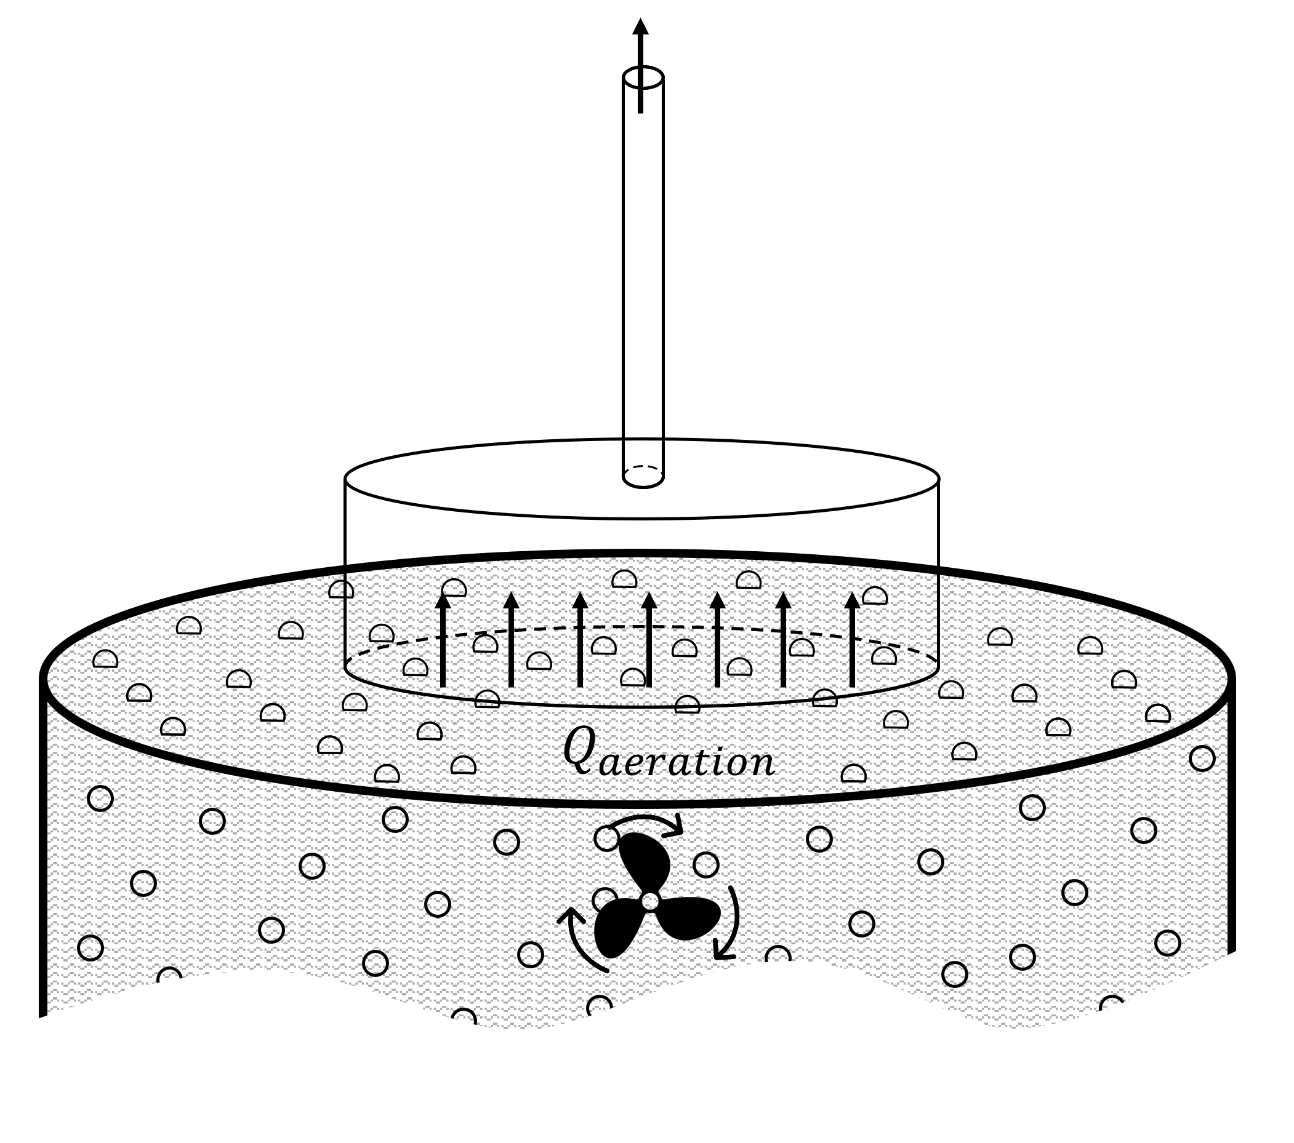
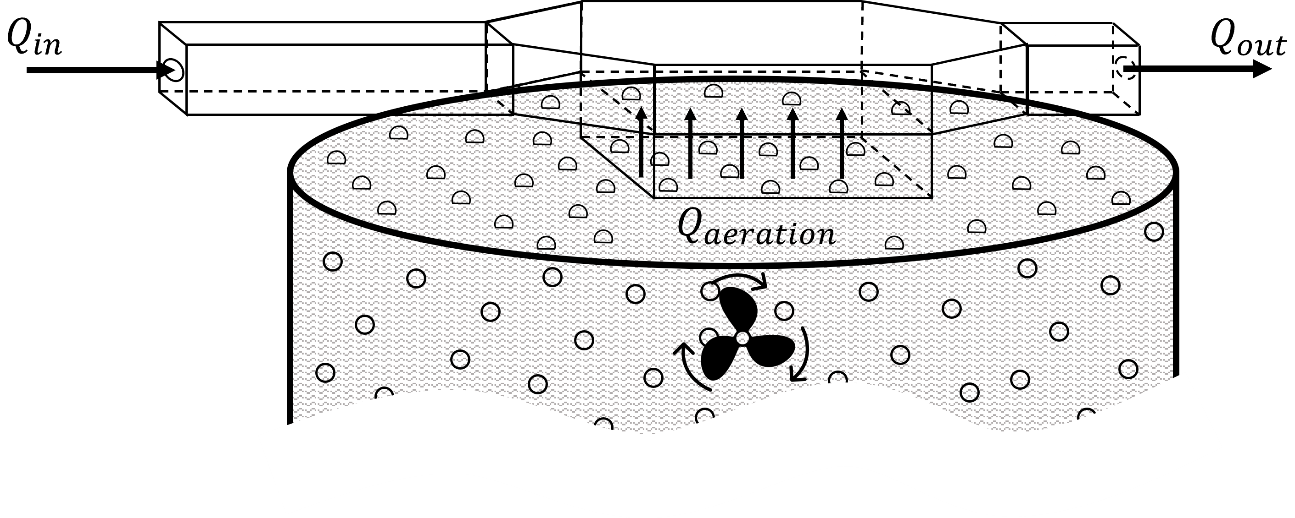
Figure 1. Simplified sketch of the fluxes within the implemented sampling systems: a. LSWT; b. FSH.
    - SOER evaluation
The odour concentration of the 4 gas samples is measured using the yes/no method of dynamic olfactometry. Due to the structure of LSWT, the SOER_{LSWT}, over an aerated source, considers both the contribution of the bubbles’ stripping and the emission of the surface, and can be calculated via Eq. (3):
$$SOER_{LSWT}=\frac{C_{od}∙\left(Q_{in}+SSAR∙A_{hood}\right) }{A_{hood}}$$ | (3)
On the other hand, the FSH considers only the contribution of the stripping. The SOER_{FSH} may be evaluated with Eq. (4):
$$SOER_{FSH}=C_{od}∙SSAR$$ | (4)
Table 2 presents the field results of the two sampling methods. These data highlight how the wind action on the liquid surface, which is artificially simulated within LSWT, does not represent the prevailing contribution of the odorous emissive phenomenon characterising the aeration tank. In fact, the SOER obtained via FSH, which accounts only the stripping contribution, almost overlaps the one obtained via LSWT. Therefore, the effect of air provided by the blowers significantly influences the OER by this kind of source. In particular, the stripping phenomenon, due to bottom aeration, represents a major contribution (72÷96%) to the overall odour emission of biological oxidation basins.
Table 2. Results of the odour monitoring using the two sampling approaches.
N° | Day of sampling | Sampling method | C_{od}  [ou_{E}/m³] | SOER  [ou_{E}/m²/s] | %OER_{aeration}
1 | Day 1 | LSWT | 845 | 10.1 | 96%
2 | Day 1 | FSH | 1,524 | 9.70
3 | Day 2 | LSWT | 1,154 | 13.8 | 72%
4 | Day 2 | FSH | 1,575 | 10.0

  - Conclusions
The present work aimed to highlight some critical points related to the olfactometric characterisation of a specific kind of wastewater treatment tank: the bubbling oxidation basins.
This study shows firstly, from a theoretical point of view, that the neglection of the bottom aeration flow may lead to a systematic underestimation of the OER of these potential odour sources. Moreover, field tests had confirmed this consideration, showing that also from a physical point of view the bottom aeration may be the controlling phenomenon of the odour emission. From this information, it can be concluded that the threshold between passive and active surface sources, as defined by the European standard for olfactometry (EN 13725:2022), does not appear to be as exhaustive as it is claimed to be.
Future developments of this study may be oriented to enlarge the experimental dataset of comparative sampling over aerated basins, and the coupling with chemical characterisation, in order to assess in the different behaviour of the emission contributions may also be linked to chemical-physical characteristics of odorants (i.e. solubility).
References
Bokowa A. H., Bokowa M., 2017, Odour assessment methods: appropriate uses to obtain the most accurate results, Austrian Contributions to Veterinary Epidemiology, 9, 21-35.
Brancher M., Griffiths K. D., Franco D., de Melo Lisboa H., 2017, A review of odour impact criteria in selected countries around the world, Chemosphere, 168, 1531-1570, https://doi.org/10.1016/j.chemosphere.2016.11.160
Capelli L., Sironi S., Del Rosso R., Centola P., 2009a, Design and validation of a wind tunnel system for odour sampling on liquid area sources, Water Science and Technology, 59(8), 1611-1620, https://doi.org/10.2166/wst.2009.123
Capelli Laura, Sironi S., Del Rosso R. Centola, P., 2009b, Predicting odour emissions from wastewater treatment plants by means of odour emission factors, Water Research, 43(7), 1977–1985, https://doi.org/10.1016/j.watres.2009.01.022
CEN, 2022, EN13725:2022 - Stationary source emissions - Determination of odour concentration by dynamic olfactometry and odour emission rate, Brussels
Frechen F. B., Frey M., Wett M., Löser C., 2004, Aerodynamic performance of a low-speed wind tunnel, Water Science and Technology, 50(4), 57-64, https://doi.org/10.2166/wst.2004.0220
Gillot S., Héduit A., 2008, Prediction of alpha factor values for fine pore aeration systems, Water Science and Technology, 57(8), 1265-1269, https://doi.org/10.2166/wst.2008.222
Gostelow P., Longhurst P. J., Parsons S., Stuetz R. M., 2003, Sampling for measurement of odours, IWA publishing, https://doi.org/https://doi.org/10.2166/9781780402819
Hudson N., Ayoko G. A., 2008a, Odour sampling 1: Physical chemistry considerations, Bioresource Technology, 99(10), 3982-3992, https://doi.org/10.1016/j.biortech.2007.04.034
Hudson N., Ayoko G. A., 2008b, Odour sampling. 2. Comparison of physical and aerodynamic characteristics of sampling devices: A review, Bioresource Technology, 99(10), 3993-4007, https://doi.org/10.1016/j.biortech.2007.03.043
Invernizzi M., Capelli L., Sironi S., 2016, Quantification of Odour Annoyance-Nuisance, Chemical Engineering Transactions, 54, 205-210, https://doi.org/10.3303/CET1654035
Invernizzi M., Scolieri G. D., Tagliaferri F., Bettini A., Cinci M., Lenzi A., Sironi S., 2024, Chemical and olfactometric inventory of gaseous spot vents in Mt. Amiata volcanic-geothermal area (Italy), Science of the Total Environment, 931(November 2023), 172607, https://doi.org/10.1016/j.scitotenv.2024.172607
Invernizzi M., Teramo E., Busini V., Sironi S, 2020, A model for the evaluation of organic compounds emission from aerated liquid surfaces, Chemosphere, 240, 124923. https://doi.org/10.1016/j.chemosphere.2019.124923
Jiang K., Bliss P. J., Schulz T. J., 1995, The development of a sampling system for determining odor emission rates from areal surfaces: Part i. aerodynamic performance, Journal of the Air and Waste Management Association, 45(11), 917-922, https://doi.org/10.1080/10473289.1995.10467424
Jiang K., Kaye R., 1996, Comparison study on portable wind tunnel system and isolation chamber for determination of VOCs from areal sources, Water Science and Technology, 34(3-4-4 pt 2), 583-589. https://doi.org/10.1016/0273-1223(96)00599-9
Liu L., Abdala Prata Junior A., Fisher R. M., Stuetz R. M., 2022, Measuring volatile emissions from biosolids: A critical review on sampling methods, Journal of Environmental Management, 317(May), 115290, https://doi.org/10.1016/j.jenvman.2022.115290
Lotesoriere B. J., Invernizzi M., Panzitta A., Uvezzi G., Sozzi R., Sironi S., Capelli L., 2023, Micrometeorological Methods for the Indirect Estimation of Odorous Emissions, Critical Reviews in Analytical Chemistry, 53(7), 1531-1560, https://doi.org/10.1080/10408347.2022.2036092
Martins R. S., Siqueira M. A., Toniato I. V. F., Cupertino K. F., Prata A. A., Reis N. C., Stuetz R. M., Santos J. M., 2018, Evaluating the flow inside of portable wind tunnels for odour measurements, Chemical Engineering Transactions, 68, 55-60. https://doi.org/10.3303/CET1868010
MASE 2023. Indirizzi per l’applicazione dell’articolo 272-bis del dlgs 152/2006 in materia di emissioni odorigene di impianti e attività. 28/07/2023 https://www.mase.gov.it/pagina/indirizzi-lapplicazione-dellarticolo-272-bis-del-dlgs-1522006-materia-di-emissioni-odorigene
Pedersen J. M., Feilberg A., Kamp J. N., Hafner S., Nyord T., 2020, Ammonia emission measurement with an online wind tunnel system for evaluation of manure application techniques, Atmospheric Environment, 230(December 2019), 117562, https://doi.org/10.1016/j.atmosenv.2020.117562
Piccardo M. T., Geretto M., Pulliero A., Izzotti A., 2022, Odor emissions: A public health concern for health risk perception. Environmental Research, 204(PB), 112-121, https://doi.org/10.1016/j.envres.2021.112121
Settimo G., Avino P., 2024, State-of-art of the legislation on odour emissions with a focus on the Italian studies, Environmental Pollution, 123525, https://doi.org/10.1016/j.envpol.2024.123525
Tagliaferri F., Facagni L., Invernizzi M., Ferrer Hernández A. L., Hernández-Garces A., Sironi S., 2024, Odor Impact Assessment via Dispersion Model: Comparison of Different Input Meteorological Datasets, Applied Sciences, 14, 2457, https://doi.org/10.3390/app14062457
Tagliaferri F., Invernizzi M., Sironi S., 2021, Influence of wind velocity on the emission rate of acetone aqueous solution at different concentrations, Chemical Engineering Transactions, 85(December 2020), 127-132, https://doi.org/10.3303/CET2185022
Tagliaferri F., Invernizzi M., Sironi S., 2023, Experimental evaluation on liquid area sources: Influence of wind velocity and temperature on the wind tunnel sampling of VOCs emissions from wastewater treatment plants, Chemosphere, 312(November 2022), https://doi.org/10.1016/j.chemosphere.2022.137337
VDI, 2011, VDI 3880. Olfactometry - Static sampling, Vol. 31, Issue 0, pp. 0-25

