|  |  |
| --- | --- |
| cetlogo ***CHEMICAL ENGINEERING TRANSACTIONS***  ***VOL. xx, 2024*** | A publication of  aidiclogo_grande |
| The Italian Association  of Chemical Engineering  Online at www.cetjournal.it |
| Guest Editors: Selena Sironi, Laura Capelli  Copyright © 2024, AIDIC Servizi S.r.l. **ISBN** 978-88-95608-94-5; **ISSN** 2283-9216 | |

Panellists and Exposure Risk: What Should Be Considered?

Elisa Polvaraa, Andrea Spinazzèb, Marzio Invernizzia,\*, Andrea Cattaneob, Domenico Maria Cavallob, Selena Sironia

a Department of Chemistry, Materials and Chemical Engineering “Giulio Natta”, Politecnico di Milano, Milano, Italy

b Department of Science and High Technology DiSAT, Universita` degli Studi dell’Insubria, Como, Italy

[marzio.invernizzi@polimi.it](mailto:marzio.invernizzi@polimi.it)

Dynamic olfactometry involves human examiners for quantifying odour. Examiners directly inhale, although diluted, the increasingly concentrated odorous samples and, during the analysis, they are thus exposed to substances potentially dangerous to human health. EN 13725 still does not propose a protocol for assessing the risk related to such activities. In the scientific literature, only few studies have addressed this issue, with discrepant approaches based on a deterministic risk assessment. However, the risk assessment needs the definition of exposure parameters that are strictly linked to their specific working time and the activity of the olfactometric laboratory, in terms of hours worked, number and type of samples analysed. Therefore, a deterministic risk assessment method remains limited to the experience of a single laboratory. Despite the importance of the topic, many aspects of the subject still remain unexplored. This paper aims to highlight the critical aspects of deterministic approaches available in the scientific literature (mainly due to the variability of exposure parameters connected with the specific working activity of every single panellist and each olfactometric laboratory and the necessity of conducting risk assessment within 30 h permitted by EN 13725) and evaluate the possible new solutions to conduct risk assessment for olfactometric workers.

* 1. Introduction

Dynamic olfactometry is currently the most diffuse and the only technique standardised at the European level (EN 13725:2022) to quantify the odour concentration (Cod), expressed in terms of European odour units per cubic meter, ouE/m3. This is a sensorial analysis, involving human examiners to determine the Cod of samples collected at the emission odour source. Due to this, the olfactometric examiners are exposed, during the analysis, to emission samples, which potentially may contain health-threatening compounds. Therefore, during the olfactometric analysis, an occupational exposure problem exists. This topic, despite its relevance, is still unresolved and understudied both in the technical and scientific literature. Indeed, the standard, also in its last revision in 2022 (EN 13725:2022, 2022), prescribes general information about the occupational safety for assessors and olfactometric operators, but the guidelines provided appear extremely general, especially considering the specificity of the work of olfactometric examiners. In addition, only a few scientific papers have deepened this argument in the literature (Davoli et al., 2016, 2012; Polvara et al., 2021b; Spinazzè et al., 2022). These studies, however, are based on the individual exposure case (applying a *deterministic model*), both in terms of nature of the olfactometric samples and working activity of the specific olfactometric laboratory. However, this specificity is a significant problem in the context of risk assessment of olfactometric panellists. Indeed, as emphasised in Spinazzè et al. (2022), if different exposure parameters are adopted in the evaluation, different results can be obtained. This is extremely relevant for olfactometric examiners, as their exposure cannot be treated and compared to models commonly used in industrial hygiene. Indeed, the work activity of an olfactometric examiner does not correspond to the work activity of an ordinary worker (8 hours/day and 40 hours/week): olfactometric examiners usually work in sessions of 1 or 2 hours to avoid nose fatigue and each samples presentation lasts for a maximum of 15 seconds. For all these reasons, the assessment of exposure time for the individual examiner becomes crucial. However, in the literature, a consistent evaluation of the working activity of olfactometric examiners has never been performed to properly assess the exposure time and variability of agents to which they may be exposed during their activities as panellists. By considering the working activity of different olfactometric examiners and olfactometric laboratories, it appears clear that the critical point of risk assessment for panellists is, at the practical level, the specificity of their specific working activity or laboratory, in terms of work hours, number of samples analysed and the type of samples. Indeed, these parameters significantly influence the type of chemical compounds and their concentration to which these workers are exposed. So, for now, it is not possible to assume the results of a single scientific study or analysis of a specific odorous sample/sample category as general references. In addition, it is necessary to define, for every olfactometric laboratory, the working activity of its group of examiners. Lastly, to estimate the exposure risk for panellists, the chemical analysis of the individual sample needs to be conducted and, starting from this analysis, the minimum dilution value (MDV) not to be exceeded is then defined. At present, this observation implies that theoretically for each sample, an evaluation should be carried out by assessing the exposure time of the single panellist. However, this is a significant limitation of the approach, especially considering the necessity to estimate the risk, including chemical analysis of the olfactometric sample and data processing, within the 30 hours required by the standard between sampling and olfactometric analysis (Section 9.1.5 - *Transport and storage of odorant gas samples before analysis* EN 13725:2022). This makes extremely complicated, if not impossible, to conduct a preliminary assessment combined with each olfactometric analysis: the most practicable strategy is to carry out preliminary analyses, based on literature or field data, anticipating olfactometric analyses and, on the basis of obtained results, assess the MDV to be adopted during the analysis of the same emission point in a second moment. However, despite all these practical difficulties, this problem and, above all, a possible solution regarding its solution, has not been clearly reported in the literature.

For these reasons, to deepen the investigation this topic, this paper aims to explore the variability, in terms of exposure time, of panellists involved in olfactometric analysis, based on the real-case occupational exposure scenario of the 40 panellists working at *Laboratorio Olfattometrico* of Politecnico di Milano, and propose a possible solution to overcome the emerged criticalities.

* 1. Critical aspects of deterministic models applied to real odorous samples

In the scientific literature, three scientific papers have proposed occupational risk assessment methods for olfactometric examiners and the definition of MDV (Davoli et al., 2016, 2012; Polvara et al., 2021b). Despite the differences between the proposed methodologies, these are based on a *deterministic* risk assessment, i.e. related to the determination of MDV based on the chemical composition of a specific olfactometric sample/category of samples and the activity of the single olfactometric laboratory.

These deterministic models available in the scientific literature were applied in the evaluation of MDV for real odorous samples from refinery plant (Polvara et al., 2021a; Spinazzè et al., 2022). Among the results obtained and the observations conducted in this study, it became evident that a critical point of risk assessment for panellists is, at the practical level, the definition of a specific exposure scenario, both in terms of hazardousness of the samples and exposure dose for examiners during their working activity.

Firstly, every application of the deterministic methods currently available in the literature is based on a limited number, for practical reasons, of samples analysed. In addition, the heterogeneity of olfactometric samples implies that the conducted assessments may not correspond to similar scenarios or could be considered representative.

Discussing the parameters necessary to estimate the exposure dose, their values may vary considerably depending on the exposure scenario, highly impacting the risk assessment results. This is particularly evident when comparing the exposure scenario described in two previous studies (Davoli et al., 2016, 2012) obtained from two distinct olfactometric laboratories (Table 1): a "commercial" laboratory (owned by a private corporation) and an "institutional" laboratory (owned by an environmental inspection agency).

Table 1: Exposure parameters for panellists’ risk assessment, from Davoli et al., 2016.

|  |  |  |
| --- | --- | --- |
| Parameter [unit] | “Commercial Lab” Scenario | “Institutional Lab” scenario |
| Exposure Frequency - EF[day/year] | 90 | 10 |
| Exposure Duration - ED[year] | 10 | 7 |
| Exposure Time - ET[hours/day] | 0.073 | 0.17 |

The variability of these parameters produces, as expected, a significant difference in final evaluation output. As highlighted in the application study to refinery odorous samples (Spinazzè et al., 2022), considering both the exposure scenarios, a slightly more critical situation regarding the evaluation of Inhalation Risk (IR) parameter is observed in the case of the “commercial laboratory”, mainly due to the highest value of EF.

This variability in terms of exposure scenario (type and number of analysed samples and activity time) exists not only between laboratories, but also among different examiners that, during their respective activities, will never be equally exposed to the identical risk. However, in the available literature, the exposure values, although considering different exposure scenarios (“commercial” and “institutional” laboratory), always consider parameters averaged over the overall activity of the laboratory when computing the exposure time. In a conservative manner, it is possible also to consider the maximum values of exposure parameters among the laboratory activity. However, considering the panellists' activities, these two different approaches (average of maximum values) appear to be a possible source of uncertainty.

Therefore, to deepen this problem and critically discuss this variability in terms of working exposure among examiners in the same laboratory, a survey of the working activity of panellists of *Laboratorio Olfattometrico* of Politecnico di Milano was conducted. Different data are collected to evaluate the potential variability of different exposure parameters (Exposure time (ET), exposure frequency (EF) and exposure duration (ED)):

* *Exposure time* (ET, expressed in hours/sample): evaluated by collected data about the number of presentations of each olfactometric sample and presentation time;
* *Exposure frequency* (EF): evaluated by collecting information about the number of analysed samples (total and split among industrial categories);
* *Exposure duration* (ED): calculated from the number of working years as panellists, based on the year of starting work as an olfactometric examiner.

In the next figures, the results of this survey were reported. The survey was conducted on the working activity of 43 panellists of *Laboratorio Olfattometrico* of Politecnico di Milano during the first five months of 2024. The total amount of olfactometric samples analysed during this period is equal to 430, divided into 12 industrial sample types.

Figure 1 shows the exposure time (ET), expressed in hours/sample, for the different samples taken into consideration.

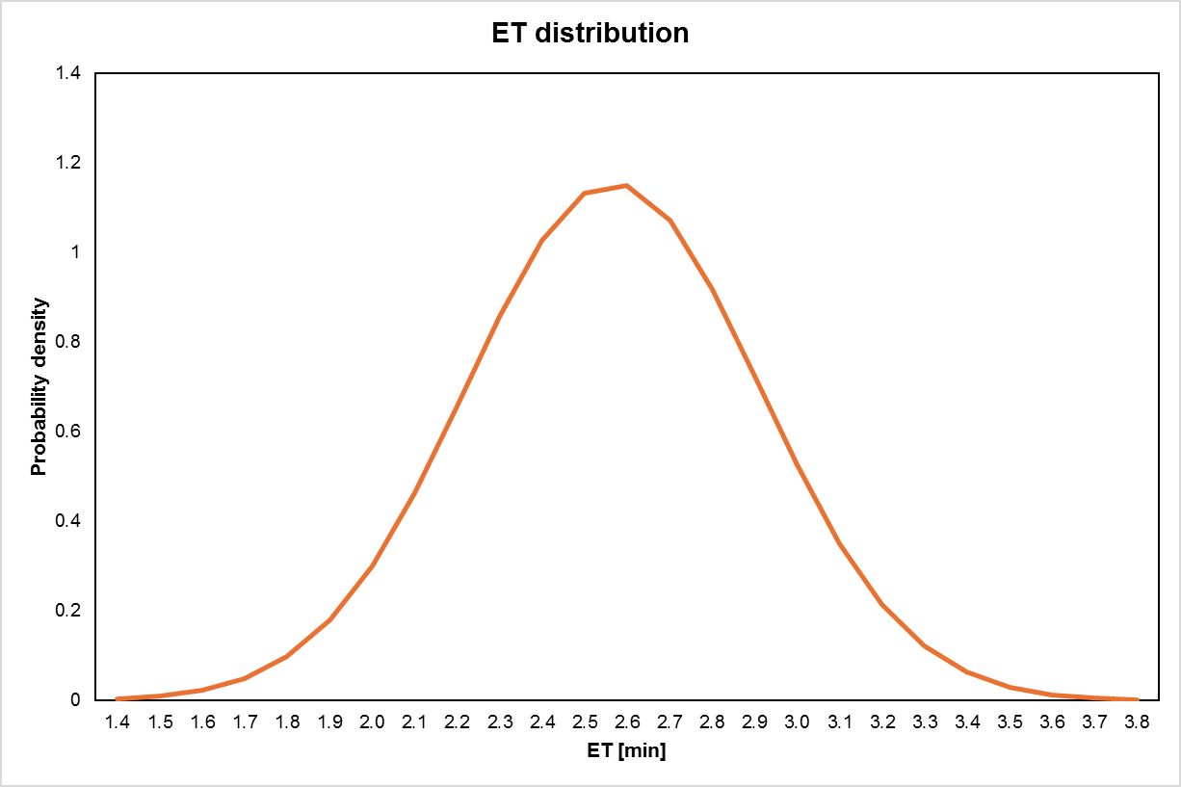

Figure 1:ET distribution – case study panellists working in Laboratorio Olfattometrico PoliMi.

Figure 1 highlights that 80% of ET values are around 2.5 min/sample. From this result, it appears that this parameter is not significantly influenced by the activity of the individual panellist, because the experimental data are well distributed as a gaussian distribution, with a standard deviation of 0.4.

Regarding the number and type of samples submitted to olfactometric examiners, Figure 2 reports the distribution of the analysed samples and type by panellists during the survey. The reported data show a great variability in terms of total amount of analysed sample (it ranges between 1 and 140) and types of samples analysed, by a single panel. This great variability, in terms of number and types of olfactometric samples per panellist, need to be someway considered in the general exposure scenario of olfactometric workers.

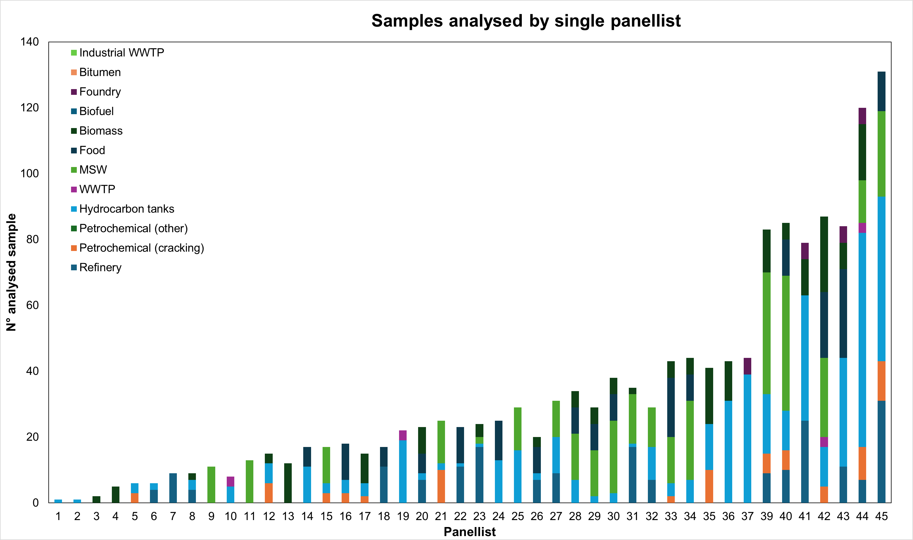

Figure 2: Number and type of samples analysed by panellists working in Laboratorio Olfattometrico PoliMi.

Discussing the exposure duration (ED) reported in Figure 3, also we observed great variability: the working activity as panellist varied significantly between the single workers. Consequently, even in this case, using an average or maximum value to estimate ED can lead to an error in assessing the actual risk.

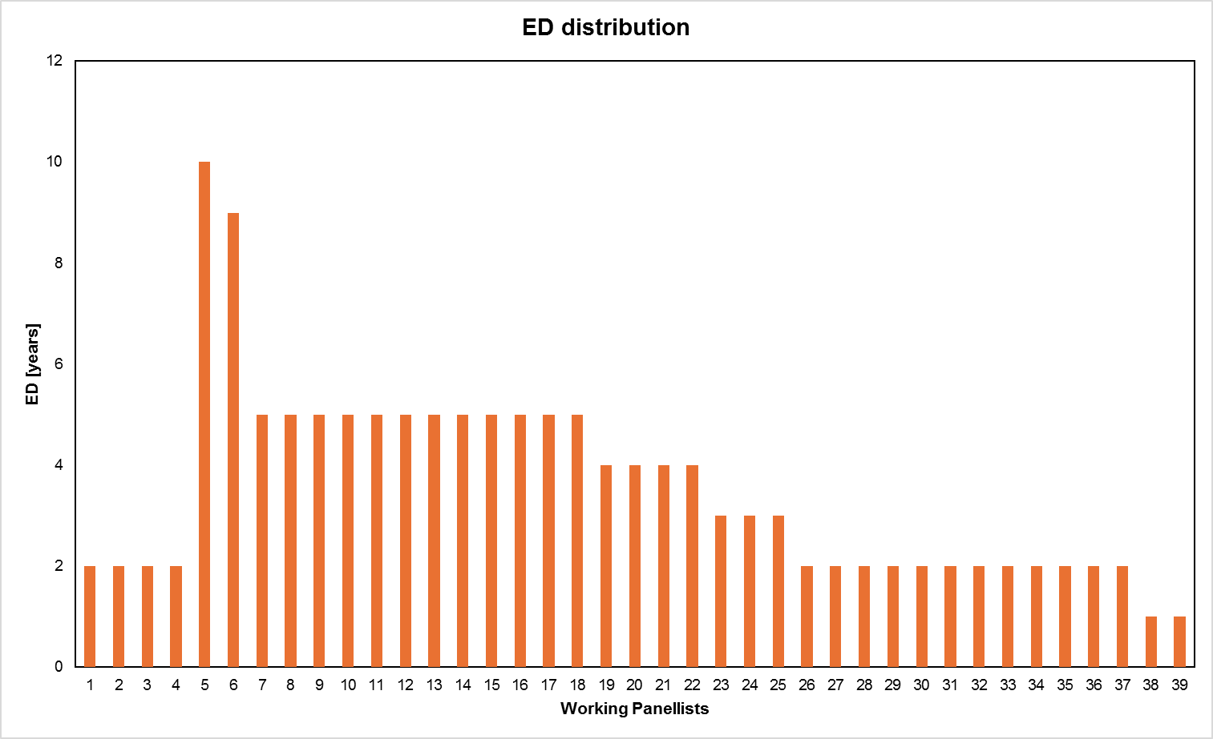

Figure 3: Years of work for panellists of Laboratorio Olfattometrico (updated to 2024).

After all the experimental observations, it is possible to affirm that a standard values for all the exposure parameters necessary to conduct risk assessment cannot be defined in the case of exposure risk of panellists.

That being the case, paradoxically, a specific risk assessment should be carried out on each individual examiner, based on his/her specific exposure parameters.

Therefore, for the activity of workers involved in olfactometric analysis, the risk assessment methods available in the literature, based on a deterministic approach (i.e. using medium/maximum exposure parameter values in the evaluation) still presents a degree of uncertainty due to the particular activity performed by these workers.

However, establishing for every single case the risk, and calculating it before olfactometric analysis, render the risk assessment nearly impossible, particularly considering the limitations defined in EN 13725. Indeed, the greatest limitation imposed by the standard is the need to conduct the risk assessment, including full chemical analysis and data processing, within the 30 hours between sampling and olfactometric analysis.

* 1. A possible solution: *probabilistic* risk assessment

To address these problems, the adoption of a probabilistic approach for performing panellists’ health risk assessments, based on real-case occupational exposure scenarios, appears a useful solution to overcome these criticalities (Spinazzè et al., 2019; Tsang et al., 2017). Indeed, probabilistic risk methodology adopts parametric distributions, instead of single deterministic values, to assess the risk.

The vantages of probabilistic risk assessment method are multiple and briefly described below:

1. *Reflects real-world variability*: probabilistic approaches take into consideration the inherent unpredictability and uncertainty in occupational exposure scenarios. Instead of relying exclusively on deterministic values, such as set exposure concentrations or time, probabilistic approaches include distributions of potential exposures, which better reflect the variability present in real situations.
2. *Quantifies uncertainty and increases robustness*: probabilistic approaches improve comprehension of the range of probable outcomes and related confidence levels, by characterising uncertainty using probability distributions. By this, probabilistic methods provide a clearer understanding of the range of possible outcomes and associated confidence levels. This enables decision-makers to assess the robustness of their conclusions and identify areas where further data collection or analysis may be needed.
3. *Accommodates complex scenarios and adaptable to changing conditions*: occupational exposure assessments of olfactometric examiners involve, as previously described, numerous variables and factors that interact in complex ways. Probabilistic methods can handle these complexities by allowing for the incorporation of multiple sources of variability and dependencies among variables, providing a more comprehensive evaluation of exposure risks. In addition, probabilistic methods provide a flexible framework for continuously updating exposure assessments based on new data and insights, ensuring that risk management efforts remain effective in response to changing conditions.
4. *Supports risk management*: by quantifying the likelihood of different outcomes, it is possible to reduce exposure risks where they are most significant.
5. *Enhances communication*: communicating risk and uncertainty to stakeholders is essential for informed decision-making and effective risk management. Probabilistic methods provide transparent and interpretable results, enabling clearer communication of the potential range of exposure risks and associated uncertainties to workers, regulators, and the public.
6. *Forecasting future scenarios*: probabilistic methods allow for the modelling of future scenarios by considering a range of possible outcomes and their associated probabilities. This predictive capability enables decision-makers to anticipate potential exposure risks under different conditions. This is extremely important in the context of the occupational risk of panellists, where the assessment must be conducted within the 30 hours required by EN 13725.

For all these reasons, the use of probabilistic risk description models for olfactometric examiners appears to be an optimal solution, if not the only viable one, to be able to describe the risk, and thus protect the health of workers, without impairing or limiting the normal performance of olfactometric analyses.

* 1. Conclusions

The topic of the occupational risk assessment of olfactometric examiners has been known for a long time and, unfortunately, is still little researched and investigated. Standard EN 13725, even in its latest revision, still does not describe in unambiguous detail how to deal with the problem, but leaves the question open, highlighting the need for each olfactometric laboratory to assess the risk for its panellists. In the literature, unfortunately, a few studies have yet focused on this topic. However, these papers adopted a deterministic approach to risk assessment for these workers. However, due to several critical issues, related to the variability of the compounds/exposure concentrations, even due to the nature of the samples, and the specific activity of each examiner/laboratory, the use of a deterministic approach is limiting from the point of view of risk assessment for these workers. As an alternative, a case-by-case evaluation should be conducted on the individual sample. However, this evaluation must be conducted within an extremely limited time frame (olfactometric analyses must be conducted within 30 h of sampling). This complicates the performance of analyses and a correct risk assessment for examiners. Therefore, considering all these problems, a probabilistic determination of risk appears to be the most useful and viable solution to resolve these critical issues. Indeed, this allows to obtain a description of the risk in terms of probability, thus considering the variability of exposure scenarios. In addition, probabilistic models can also be applied also for future exposure scenarios and, therefore, for choosing the most effective risk management option to protect panellists’ heath.

References

Davoli, E., Zuccato, E., Bianchi, G., Il Grande, M., Bonati, S., Rossi, A.N., Porporato, C., Pereno, M., Soldati, S., 2016. Dynamic olfactometry and sample toxicity. a case study for a MSW incinerator odour assessment project. Chem Eng Trans 54, 13–18. https://doi.org/10.3303/CET1654003

Davoli, E., Zuccato, E., Bianchi, G., Palmiotto, M., Il Grande, M., Bonati, S., Rossi, A.N., 2012. Dynamic Olfactometry and Potential Sample Toxicity. Guidelines for a Safe Occupational Health Approach. Chem Eng Trans 30, 7–12. https://doi.org/10.3303/CET1230002

EN 13725:2022, 2022. Stationary source emissions - Determination of odour concentration by dynamic olfactometry and odour. https://doi.org/10.31030/3290685

Polvara, E., Invernizzi, M., Sironi, S., 2021a. Occupational Safety for Panellists Involved in Dynamic Olfactometry: a Comparison of Available Risk Assessment Models. Chem Eng Trans 85, 91–96. https://doi.org/10.3303/CET2185016

Polvara, E., Spinazzè, A., Invernizzi, M., Cattaneo, A., Sironi, S., Cavallo, D.M., 2021b. Toxicological assessment method for evaluating the occupational risk of dynamic olfactometry assessors. Regulatory Toxicology and Pharmacology 125, 105003. https://doi.org/10.1016/j.yrtph.2021.105003

Spinazzè, A., Cattaneo, A., Borghi, F., Del Buono, L., Campagnolo, D., Rovelli, S., Cavallo, D.M., 2019. Probabilistic approach for the risk assessment of nanomaterials: A case study for graphene nanoplatelets. Int J Hyg Environ Health 222, 76–83. https://doi.org/10.1016/j.ijheh.2018.08.011

Spinazzè, A., Polvara, E., Cattaneo, A., Invernizzi, M., Cavallo, D.M., Sironi, S., 2022. Dynamic Olfactometry and Oil Refinery Odour Samples: Application of a New Method for Occupational Risk Assessment. Toxics 2022, Vol. 10, Page 202 10, 202. https://doi.org/10.3390/TOXICS10050202

Tsang, M.P., Hristozov, D., Zabeo, A., Koivisto, A.J., Jensen, A.C.Ø., Jensen, K.A., Pang, C., Marcomini, A., Sonnemann, G., 2017. Probabilistic risk assessment of emerging materials: case study of titanium dioxide nanoparticles. Nanotoxicology 11, 558–568. https://doi.org/10.1080/17435390.2017.1329952