|  |  |
| --- | --- |
| cetlogo ***CHEMICAL ENGINEERING TRANSACTIONS***  ***VOL. xxx, 2024*** | A publication of  aidiclogo_grande |
| The Italian Association  of Chemical Engineering  Online at www.cetjournal.it |
| Guest Editors: Selena Sironi, Laura Capelli  Copyright © 2024, AIDIC Servizi S.r.l. **ISBN** 979-12-81206-13-7; **ISSN** 2283-9216 | |

The ESCAPE Project: Sensor Selection for the Development of a Portable System for Landfill Surface Emission Monitoring

Veronica Villaa, Dario Vernolab, Stefano Robbianic, Beatrice J. Lotesorierea,\*, Christian Rattia, Stefano Prudenzaa, Gabriele Viscardib, Manuel Roverib, Raffaele Dellacàc, Yuri Ponzanid, Laura Capellia

aPolitecnico di Milano, Department of Chemistry, Materials and Chemical Engineering “Giulio Natta”, Piazza Leonardo da Vinci 32, Milan, Italy

bPolitecnico di Milano, Department of Electronics, Information, and Bioengineering, Via Giuseppe Ponzio 34, 20133 Milan, Italy

cPolitecnico di Milano, Department of Electronics, Information, and Bioengineering, Via Giuseppe Colombo 40, 20133 Milan, Italy

dRecycle2Trade Ltd, Sussex Innovation Centre, Science Park Square, Brighton BN1 9SB, UK

\*beatricejulia.lotesoriere@polimi.it

The ESCAPE (Environmental Sites CH4 Assessment Platform Europe) has the aim to develop an innovative environmental monitoring system based on a cloud-based online platform, combining ground and space-based datasets with AI-based solutions and algorithms for spotting emissions from landfill sites. This paper presents the research activities related to the selection of the sensors for the implementation of a portable sensor system for monitoring gaseous emissions over the landfill surface. Specifically, 6 gas sensors (2 MOX, 3 digital MOX and 1 NDIR) were selected based on a technology scouting involving the study of scientific literature and technical documentation, and then tested towards different concentrations (i.e., 10, 100, 1,000 and 10,000 ppm) of CH4 and CO2. Test results show that the MOX sensors TGS2611, SGP40 and BME688 are sensitive to CH4 at concentrations down to 10 ppm, and have no (or low) cross-sensitivity to CO2, making them suitable for the considered application. The NDIR sensor, despite being sensitive only to CH4 concentrations >1000 ppm, could be nonetheless included in the sensors toolbox because of its selectivity.

* 1. Introduction

The ESCAPE (Environmental Sites CH4 Assessment Platform Europe) project has the aim to develop an innovative environmental monitoring system based on a cloud-based online platform, combining ground and space-based datasets with AI-based solutions and algorithms for spotting emissions from landfill sites.

Landfills are becoming more and more of interest for scientific communities, authorities and citizens because of their greenhouse gases (GHG) and pollutant volatile organic compounds (VOC) emissions. Measuring and estimating such gaseous emissions from landfills is particularly challenging due to their extended surface (often in the range of few tens of hectares) and the high temporal and spatial variability over the landfill surface. Different methods have been proposed especially for methane (CH4) emission monitoring over landfills, both quantitative and qualitative (Mønster et al., 2019). Quantitative methods are either rather complex and expensive (e.g., DIAL, eddy covariance, tracer gas dispersion, indirect micrometeorological methods) or they enable to obtain information over a limited portion of the surface (e.g., surface flux chambers), the latter resulting in an underestimation of emissions (Lotesoriere et al., 2022) (Mønster et al., 2019). On the other hand, qualitative methods have limited accuracy, and their deployment in non-favourable circumstances may lead to significant errors (Mønster et al., 2019). Therefore, there is still a need for low-cost methods and devices for monitoring landfill emissions.

In this context, the ESCAPE project aims at the combination of existing technologies (i.e., low-cost gas sensors and Earth Observation satellite products) to enable wider and deeper understanding of landfill sites behaviour over time. The power of complementary satellite instruments with different spatiotemporal coverage and resolution has already been demonstrated to detect, locate, and quantify methane emissions from strong methane sources around the world (Maasakers et al., 2017), and even from landfills (Maasakers et al., 2022). Thus, satellite measurements could be combined with ground-based measurements using low-cost sensor to develop a novel system for landfill emission monitoring.

Such novel monitoring tool to be used also by operators (and not by specialized external personnel) directly on the sites of interest may represent an interesting solution for the identification of the plant’s emission patterns or anomalies in the investigated areas, identifying the pollutant gases concentrations in ambient air during walkover surveys. This would contribute to providing a more accurate picture of the emissive scenario of such sites that, in general, are difficult to be characterized because of their extension.

The ESCAPE project is structured in the following Work Packages (WP):

* WP1: Project Management and Ethics Management
* WP2: Remote Sensing Model; creation of analysis models of Earth Observation products based on machine/deep learning algorithms that allow the identification of features in the area of interest in order to identify, using only remote sensing tools, the sites where it is necessary to carry out field surveys using the Sensors Toolbox (developed in WP3)
* WP3: Field Gas Sensors Toolbox; realization of an embedded portable sensor device able to monitor fugitive emissions, collecting data during walkovers on landfill sites and providing it to a centralized digital platform that will deliver data intelligence to end-users in WP4
* WP4: Digital Platform Design and Development; design and realization of a digital platform that allows the Stakeholders to retrieve, interact with, explore, and visualize satellite and ground data
* WP5: Pilots Use Case; test of the developed tools in pilots use cases to validate their performance directly in the field prior to their refinement for the commercial exploitation phase
* WP6: Exploitation, Dissemination and Impact

This paper presents the outcomes of Task 3.1, dealing with the technology scouting and preliminary lab testing activities related to the selection of the sensors for the implementation of the portable Sensors Toolbox for the ground measurements over the landfill surface. Such activities included: (1) identification of environmentally relevant gases associated with landfill site surface emissions and their concentration ranges; (2) technology scouting of the commercial sensors available on the market and selection of a first set of gas sensors suitable for this application, which were evaluated based on their cost, power consumption, and detection range, as declared by the manufacturer and/or by the scientific literature; (3) preliminary lab testing with relevant gases of the sensors identified in (2) for a first screening and further selection of a subset of sensors to be effectively implemented in the first version of the Sensors Toolbox.

* 1. Identification of the gaseous compounds and concentrations of interest

Because landfills have been always considered environmentally impactful, due to their gaseous emissions, in terms of GHG, VOC, and odours, several papers have been published discussing GHG emission from landfills (Zhang et al., 2019) or trying to investigate the pollutant gaseous compounds present in landfill emissions to the atmosphere (Duan et al., 2021; Polvara et al., 2021). In particular, Polvara et al. (2021) identified ammonia, hydrogen sulphide and ethanol as the most abundant compounds that can be found over landfill surfaces, with concentrations ranging up to a maximum of the ppm level (ca. 5 ppm for ammonia, and 0.5 ppm for ethanol and hydrogen sulphide, respectively).

The main components of GHG released from landfills are CH4 (50-60%) and CO2 (40-50%) (Aghdam et al., 2019; Lucernoni et al., 2016). It should be considered that, on an equivalent mass basis, CH4 is 28 times more powerful than CO2 in terms of global warming potential (IPCC, 2013). Thus, considering CH4 emissions, literature studies report concentration ranging from few ppm (1-10) up to thousands of ppm, even within a few meters of the landfill surface (Gonzalez-Valencia et al., 2015; Kormi et al., 2018; Mosher et al. 1999).

* 1. Technology scouting and selection of a first set of gas sensors to be tested

Considering the outcomes of the bibliographic research study focused on the identification of the gaseous compounds in landfill surface emissions and their expected concentrations in ambient air over the landfill surface, we decided to focus on CH4 as main target compound to be detected, both because of its relative abundance (about 50% in landfill gas) and because of its high GH potential. Traditional methods for measuring CH4 emissions typically involve the use of complex and expensive instrumentation (e.g., Dengel et al., 2011; You et al., 2021), which are not suitable with the purposes of the ESCAPE project. Therefore, we focused our technology scouting on low-cost gas sensors.

Commercial MOX sensors, despite being non-specific for CH4 detection, have been proven to be sensitive to CH4 at low concentrations. In particular, the Figaro TGS2611 has been tested by some researchers in laboratory and field conditions to CH4 concentrations in the order of 2-10 ppm, showing reproducible results by implementing software compensation for temperature and humidity interferences (e.g., van den Bossche et al., 2017). Based on the scientific literature, and by further looking at the datasheets of MOX sensors produced by Figaro and MQ, we decided to include the TGS2611 by Figaro and the MQ4 by Henan Hanwei Electronics Co. in our study (see Table 1), because of their high sensitivity to CH4.

Moreover, over the last years, despite being originally produced for indoor air quality monitoring, digital MOX sensors integrated on microhotplates are more and more frequently used in sensor systems for environmental air quality monitoring (e.g., Arroyo et al., 2020), because of their desirable properties of extremely low power consumption and reduced dimensions, making them suitable for portable devices. For this reason, we decided to include also three of these sensors in our study (i.e., BME688 by Bosch, ENS160 by Sciosense and SGP40 by Sensirion). Finally, we decided to include also one specific sensor for CH4 based on NDIR technology, i.e. the MH-441D by Winsen Electronics.

Table 1 summarizes the first set of sensors selected for the preliminary screening tests described in this study, together with their cost and main features, as per technical datasheet.

Table 1: List of 6 sensors selected for preliminary screening test; cost, main features, and sensitivity to CH4

|  |  |  |  |  |  |
| --- | --- | --- | --- | --- | --- |
| Technology | Supplier | Model | Cost (ind.) | Features | Sensitivity to CH4 |
| MOX | Figaro; Tokyo, Japan | TGS2611-E00 | 30 € | Very high sensitivity to CH4. TGS2611-E00 uses filter material in its housing which eliminates the influence of interference gases, resulting in highly selective response to CH4. | 500-10,000 ppm |
| MOX | Henan Hanwei Electronics Co.; Zhengzhou, China | MQ4 | 3 € | MQ4 has high sensitivity to CH4, also to Propane and Butane. It can be used to detect different combustible gas, especially CH4, low cost, and suitable for different applications. | 300-10,000 ppm |
| Digital MOX | ScioSense; Eindhoven, Netherlands | ENS160 | 10 € | Integrated intelligent algorithms to process raw sensor measurements and implementing RH and T compensations on-chip.  4 gas sensor elements  Operating ranges:  T = -40 to 95°C  RH = 5 to 95% | 200-1,100 ppm |
| Digital MOX | Sensirion AG; Zurich, Switzerland | SGP40 | 10 € | VOC sensor. On-chip RH compensation with current RH and T values (can be deactivated)  Operating ranges:  T = -20 to 55°C  RH = 0 to 90% | Not specified.  Limit of detection to Ethanol: 50 ppb |
| Digital MOX | Bosch Sensortec; Reutlingen, Germany | BME688 | 10 € | Integrated T and RH sensors  Operating ranges:  T = -40 to 85°C  RH = 10 to 95% | Not specified.  Limits of detection to other compounds not specified. |
| NDIR | Winsen Electronics Technology Co.; Zhengzhou, China | MH-441D | 90 € | Intelligent infrared gas sensor to detect CH4 in air; it has the advantages of no oxygen dependence and good selectivity.  Operating ranges:  T = -20 to 60°C  RH = 0 to 95% (no condensation) | 100-100,000 ppm |

* 1. Laboratory tests for preliminary sensors’ screening
     1. Objectives

After selection of a first set of sensors based on their characteristics of sensitivity to CH4 and cost retrieved in the scientific literature and technical documentation, as described in the previous paragraph, we decided to carry out some preliminary tests in the lab to experimentally assess their response to CH4 under controlled conditions. Since the other main component of landfill gas is CO2, which is typically present in comparable concentrations as CH4 (Aghdam et al., 2019; IPCC, 2013; Lucernoni et al., 2016), we decided to include also CO2 in this preliminary testing phase.

* + 1. Hardware

The 6 sensors selected (Table 1) were hosted in a custom-made 3D-printed parallelepipedal case together with a fan, which has the function of improving gas homogeneity within the case (Figure 1). A microcontroller (NUCLEO FE411RE by ST Microelectronics, Italy) was used to acquire the sensors synchronously and a Labview interface was developed to acquire and visualize data in real time.

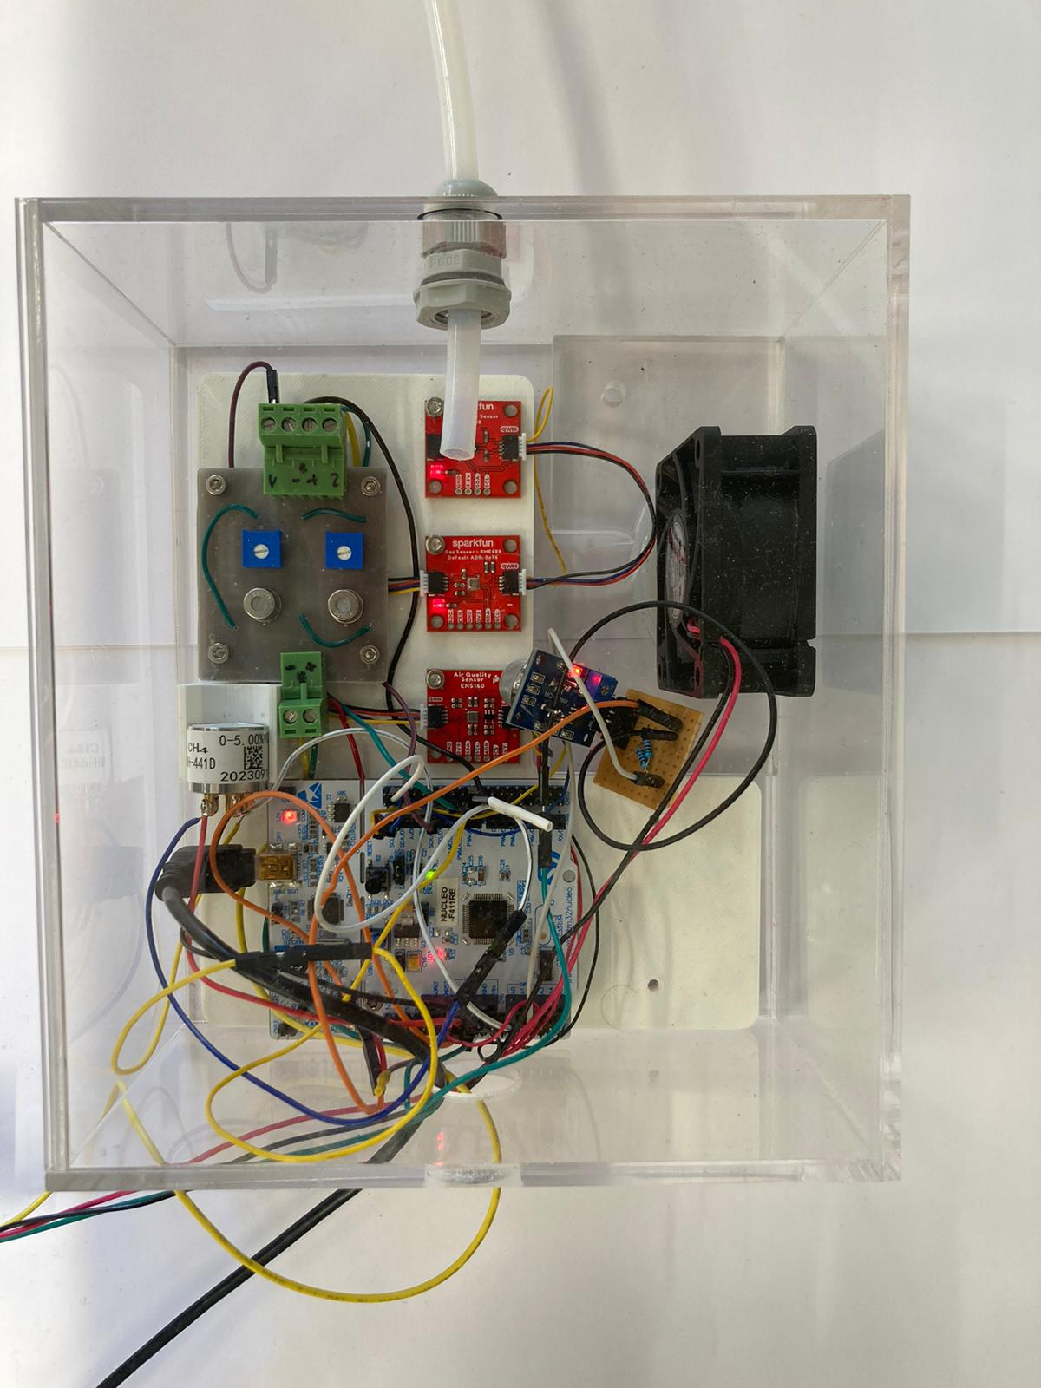

Figure 1. Custom-made sensor chamber for the preliminary laboratory tests with CH4 and CO2

We also realized a dedicated sample delivery system enabling the alternate injection into the sensor chamber of the target gas sample and air at a controlled humidity level, avoiding any contact of the target gas samples with mechanical parts or pumps. The system consists of a sealed cylinder and an air line (Figure 2). The cylinder contains the target sample, which is stored in a NalophanTM bag. Compressed air is injected to pressurize the cylinder (in red in Figure 2) by opening valve V1, allowing for the release of the sample into the chamber. Before and after every injection of the sample, air is injected into the sensor chamber from the air line in parallel with the cylinder. The air from the air line can be deviated to a humidifier, thus ensuring that it is injected into the chamber at a constant value of the relative humidity, equal to those of the target sample.

Figure 2. Sampling delivery system for the alternate injection of sample and air at controlled humidity

* + 1. Tests with CH4 and CO2

Tests were carried out with five different concentrations (i.e., 10, 100, 1,000 and 10,000 ppm) of CH4 and CO2, respectively. Tests were conducted over several days while maintaining the absolute humidity of the samples at a constant value (10 g/m3 AH), to have consistency in the testing conditions.

As an example, Figure 3 shows some responses of the 5 MOX sensors (i.e., SGP40, BME688, ENS160, TGS2611 and MQ4) to 10 (Figure 3a), 100 (Figure 3b) and 1,000 ppm Figure 3c) of CH4 and CO2, respectively. The response curves relevant to the analysis of the CH4 and CO2 sample have been superimposed for the 3 different levels of concentration in order to compare the sensors’ sensitivity to the two compounds. In consideration of the final application, a reduced sensitivity towards the CO2 would ensure a better selectivity to the CH4, which is preferable, although not indispensable.

The MH441D responses are not shown, because this sensor turned out to be substantially insensitive to concentrations <1,000 ppm, despite the information contained in the sensor’s datasheet, claiming a lower detection threshold of 100 ppm.

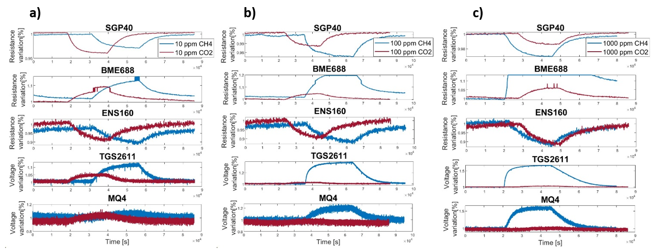

Figure 3. Example of response curves of the 5 MOX sensors to CH4 and CO2 at a) 10, b) 100 and c) 1’000 ppm, respectively

The results show that all sensors tested, except the MQ4, are sensitive to CH4 even at low concentrations i.e., 10 ppm. The TGS2611 is the sensor performing best, showing clear responses at all concentrations tested, with an increasing amplitude as a function of the CH4 concentration analysed, and substantially no response to the CO2. Among the digital MOX sensors, the SGP40 and the BME688 proved to be more sensitive to the CH4 and also less sensitive to the CO2 than the ENS160, making them more suitable for the final application, even though the SGP40 shows some cross-sensitivity to the CO2. Regarding the SGP40, it should be further considered that in these experiments the sensor was set to work with an internal humidity correction fixed at a constant RH of 50%. Future tests should optimise the sensor’s settings to apply the humidity correction at the actual RH value measured by a RH sensor placed inside the sensors’ chamber, which could potentially result in further improvement of the SGP40 sensitivity and selectivity.

* 1. Conclusions

Based on the results of the activities of technology scouting and preliminary lab testing, we were able to identify the subset of sensors to be considered for the development of the portable Sensors Toolbox to be used for CH4 emission monitoring over landfill surfaces, i.e., the TGS2611, the SGP40 and the BME688. Despite not being able to detect CH4 concentrations below 1,000 ppm, we decided to include also the optical sensor MH-441D in the sensor Toolbox, because it is the only sensor selective to CH4, making it useful in order to identify potential “false-positives” due to cross-sensitivities of the non-selective MOX sensors to other VOCs that might be present over the landfill surface. Moreover, because of its selectivity, the MH-441D could potentially be used as a reference for internal calibration and drift correction of the other sensors.

In the next future, as soon as a preliminary version of the sensor Toolbox hardware will be available, systematic laboratory tests will be carried out in order to assess the sensors’ performance in more complex environments, i.e., with varying RH and T conditions, as well as in presence of other interfering compounds, and thus consider the opportunity to develop suitable compensation algorithms.

Acknowledgments

This project has received funding from the Eureka Eurostars Funding Framework under Project ID agreement N.2204

References

Aghdam E.F., Scheutz C., Kjeldsen P., 2019, Impact of meteorological parameters on extracted landfill gas composition and flow, Waste management, 87, 905-914.

Arroyo P., Meléndez F., Suárez J.I., Herrero J.L., Rodríguez S., Lozano J., 2020, Electronic nose with digital gas sensors connected via bluetooth to a smartphone for air quality measurements, Sensors, 20, 3, 786.

Dengel S., Levy P.E., Grace J., Jones S.K., Skiba U.M., 2011, Methane emissions from sheep pasture, measured with an open‐path eddy covariance system. Global Change Biology, 17, 12, 3524-3533.

Duan Z., Scheutz C., Kjeldsen P., 2021, Trace Gas Emissions from Municipal Solid Waste Landfills: A Review, Waste Management, 119, 39–62.

Gonzalez-Valencia R., Magana-Rodriguez F., Maldonado E., Salinas J., Thalasso F., 2015, Detection of hotspots and rapid determination of methane emissions from landfills via a ground-surface method, Environmental monitoring and assessment, 187, 1-8.

IPCC, 2013, Climate Change 2013: The Physical Science Basis. Contribution of Working Group I to the Fifth Assessment Report of the Intergovernmental Panel on Climate Change, T.F. Stocker, D. Qin, G.-K. Plattner, M. Tignor, S.K. Allen, J. Boschung, A. Nauels, Y. Xia, V. Bex, P.M. Midgley (Eds.), Cambridge University Press, Cambridge, United Kingdom and New York, NY, USA.

Kormi T., Mhadhebi S., Ali N.B.H., Abichou T., Green R., 2018, Estimation of fugitive landfill methane emissions using surface emission monitoring and Genetic Algorithms optimization, Waste Management, 72, 313-328.

Lotesoriere, B. J., Invernizzi, M., Panzitta, A., Uvezzi, G., Sozzi, R., Sironi, S., & Capelli, L. (2022). Micrometeorological methods for the indirect estimation of odorous emissions. Critical Reviews in Analytical Chemistry, 53(7), 1531–1560.

Lucernoni F., Tapparo F., Capelli L., Sironi S., 2016, Evaluation of an Odour Emission Factor (OEF) to estimate odour emissions from landfill surfaces, Atmospheric environment, 144, 87-99.

Maasakkers J.D., Jacob D.J., Sulprizio M.P., Scarpelli T.R., Nesser H., Sheng J.X., Zhang Y., Hersher M., Bloom A.A., Bowman K.W., Worden J.R., Janssens-Maenhout G., Parker R.J., 2019, Global distribution of methane emissions, emission trends, and OH concentrations and trends inferred from an inversion of GOSAT satellite data for 2010–2015, Atmospheric Chemistry and Physics, 19, 11, 7859-7881.

Maasakkers J.D., Varon D.J., Elfarsdóttir A., McKeever J., Jervis D., Mahapatra G., Pandey S., Lorente A., Borsdorff T., Foorthuis L.R., Schuit B.J., Tol P., van Kempen T.A., van Hees R., Aben I., 2022, Using satellites to uncover large methane emissions from landfills, Science Advances, 8, 31, eabn9683.

Metz B., Davidson O., Bosch P., Dave R., Meyer L., 2007, Climate Change 2007 Mitigation.

Mønster J., Kjeldsen P., Scheutz C., 2019, Methodologies for Measuring Fugitive Methane Emissions from Landfills – A Review, Waste Management, 87, 835–859.

Mosher B.W., Czepiel P.M., Harriss R.C., Shorter J.H., Kolb C.E., McManus J.B., Allwine E., Lamb B.K., 1999, Methane emissions at nine landfill sites in the northeastern United States, Environmental Science & Technology, 33, 12, 2088-2094.

Polvara E., Ashari B.E., Capelli L., Sironi S., 2021, Evaluation of Occupational Exposure Risk for Employees Working in Dynamic Olfactometry: Focus on Non-Carcinogenic Effects Correlated with Exposure to Landfill Emissions, Atmosphere, 12, 10, 1325.

van den Bossche M., Rose N.T., De Wekker S.F.J., 2017, Potential of a low-cost gas sensor for atmospheric methane monitoring, Sensors and Actuators B: Chemical, 238, 501-509.

You Y., Staebler R.M., Moussa S.G., Beck J., Mittermeier R.L., 2021, Methane emissions from an oil sands tailings pond: a quantitative comparison of fluxes derived by different methods, Atmospheric Measurement Techniques, 14, 3, 1879-1892.

Zhang C., Xu T., Feng H., Chen S., 2019, Greenhouse Gas Emissions from Landfills: A Review and Bibliometric Analysis, Sustainability, 1, 8, 2282.