|  |  |
| --- | --- |
| cetlogo ***CHEMICAL ENGINEERING TRANSACTIONS***  ***VOL. xxx, 2024*** | A publication of  aidiclogo_grande |
| The Italian Association  of Chemical Engineering  Online at www.cetjournal.it |
| Guest Editors: Selena Sironi, Laura Capelli  Copyright © 2022, AIDIC Servizi S.r.l. **ISBN** 978-88-95608-94-5; **ISSN** 2283-9216 | |

Strategies for the reduction of odour impact via dispersion modelling: a case study of a rendering plant

Francesca Tagliaferri\*, Marzio Invernizzi, Selena Sironi

Politecnico di Milano, Department of Chemistry, Materials and Chemical Engineering “Giulio Natta” - Piazza Leonardo da Vinci 32, 20133 Milano, Italy

[francesca.tagliaferri@polimi.it](mailto:marzio.invernizzi@polimi.it)

For several years, the application of versatile Lagrangian puff models like CALPUFF has been widely acknowledged as a standard practice in numerous countries globally for forecasting odour exposure levels in the vicinity of industrial facilities. In this case study, the CALPUFF model was adopted to assess the odour impact related to a rendering plant located in Italy. For the implementation of the emission scenario, data obtained from olfactometric monitoring conducted at the plant were taken into account. The modelling study was divided into two parts. Firstly, the odour impact resulting from the current emission condition of the plant was evaluated, distinguishing between different macro-areas of the plant: production department, cooking vats, and wastewater treatment plant. Secondly, simulations of predictive impact scenarios were conducted, assuming the introduction of odour emission containment systems for the macro-areas identified as the major contributors to impact. In particular, from the simulations, it emerged that the production department contributes negligibly to the odour impacts on the surrounding area. The cooking tanks revealed odour concentrations, at the 98th percentile on an annual basis, near the closest residential areas to the plant, reaching the odour perception threshold (1 ouE/m3). The contribution of the water treatment plant proved to be significant, with concentrations estimated on some sensitive receptors around the odour nuisance threshold (5 ouE/m3). For this reason, it was hypothesized to introduce cooling systems that facilitate the condensation of vapours emitted from the cooking vats before the release into the atmosphere. In this way, based on the simulation results, receptor concentrations lower than 1 ouE/m3 would be achieved. Regarding the wastewater treatment plant, various predictive scenarios were hypothesized, assuming the covering of one or more tanks and the conveyance of air streams to be treated. The results of the different scenarios highlighted that the configuration ensuring the greatest reduction in impacts, among those analyzed, involves covering three tanks. This way, the odour impact could be reduced by approximately 80% compared to the current scenario. However, the solution that appears to be of greater interest seemed to be the closure of only one tank: in this way, by intervening on a single emission source, receptor concentrations could be reduced by an average of 60%.

* 1. Introduction

Rendering, a process that converts animal waste tissue into valuable byproducts like poultry fat and protein meals, is gaining traction due to its applications in animal feed and food industries, alongside growing concerns for environmental sustainability (Jȩdrejek et al., 2016; Müller et al., 2023). Major industry players are making significant investments to meet the rising demand. For instance, Tyson Foods Inc. invested USD 208 million in April 2022 to establish a new rendering facility in Hanceville, Alabama. The global rendered products market, valued at $22.34 billion in 2023, is anticipated to witness substantial growth, reaching $28.64 billion by 2032 (Fortune Business Insight, 2024).

North America, home to around 300 rendering facilities, plays a crucial role in managing animal by-products. The United States alone process roughly 100 million hogs, 35 million cattle, and eight billion chickens annually.

Europe stands out as a significant market driving notable demand for rendering products (Gooding, 2012; Meeker and Hamilton, 2006). The increasing need for high quality animal feed and the growing utilization of animal byproducts in pet foods are poised to elevate the market share of rendered products in Europe in the foreseeable future. As per the Global Feed LCA Institute (GFLI), an estimated 18 million tons of animal materials undergo processing annually in Europe (Fortune Business Insight, 2024).

The rendering industry contributes to environmental sustainability by ensuring safe disposal, processing and subsequent reuse of animal by-products thus reducing the need for landfill space to dispose of animal waste. At the same time, it reduces excess carbon dioxide emissions from such waste, thus mitigating greenhouse gas emissions, although it entails a significant consumption of potable water and generates substantial quantities of wastewater (Racar et al., 2019; Sindt, 2017).

Despite its considerable positive influence on environmental quality, the rendering industry worldwide still faces challenges with nuisance odours that can lead to public complaints regarding health problems, social and individual life disruption (Cheng et al., 2023; Sazakli and Leotsinidis, 2021). The blood storage area is typically the most malodorous section of a rendering plant as well as the cooking vats, the gut department, and the wastewater treatment facility (Shareefdeen et al., 2005).

In this case study, the Lagrangian puff CALPUFF model was adopted to assess the odour impact related to a rendering plant located in Italy. Indeed, for several years, the application of versatile Lagrangian puff models has been widely acknowledged as a standard practice in numerous countries globally for forecasting odour exposure levels in the vicinity of industrial facilities (Invernizzi et al., 2020; Lotesoriere et al., 2022; Tagliaferri et al., 2024, 2023, 2020). Additionally, CALPUFF is also mentioned by the US EPA for near-field simulations (< 50 km) (US-EPA, 2023).

For the implementation of the emission scenarios, data obtained from olfactometric monitoring conducted at the plant, during the summer season, were taken into account. The modelling study was divided into two parts. Firstly, the odour impact resulting from the current emission condition of the plant, distinguishing between different macro-areas of the plant: the production department, cooking vats, and the wastewater treatment plant (WWTP), was evaluated. Secondly, simulations of predictive impact scenarios, assuming the introduction of odour emission containment systems for the macro-areas identified as the major contributors to impact, were conducted. The post-processing of the modelling results was conducted in accordance with the provisions of Italian regulations, which mandates the calculation of the 98th percentile of odour peak concentration (Cod) values on a yearly basis (MASE, 2023).

* 1. Materials and methods
     1. Set-up of the simulations

CALPUFF is a non-steady-state atmospheric dispersion model renowned for its ability to handle complex terrain and non-uniform conditions. It employs a Lagrangian approach, simulating pollutant dispersion by tracking individual puffs or parcels of air through the atmosphere. This allows CALPUFF to capture the intricate interplay of meteorological conditions, such as wind patterns, temperature inversions, and turbulence, with terrain features like hills, valleys, and buildings.

The simulations were conducted over a time period of one year. A square domain of 8x8 km2 was considered, including the nearby residential areas around the production site. The simulation domain, centred on the plant, has a grid resolution of 100 m.

The meteorological data adopted for CALPUFF simulations consist of 3D hourly prognostic data generated by the WRF (Weather Research and Forecasting) model, with a spatial resolution of 1 km.

* + 1. Current emission scenario

Given the presence of numerous odour sources in the rendering plant, in order to better manage computation times and to individually assess the different contributions to odour impact, it was decided to develop distinct emission scenarios. In particular, the different simulated macro-areas of the plant are the production department, the cooking vats and the WWTP.

The Odour Emission Rates (OERs) implemented for the various sources were estimated based on sampling conducted at the plant during the summer season, where all potential odour sources of the facility were monitored. The gaseous samples were subsequently analysed in the laboratory within a 30-hour timeframe by means of dynamic olfactometry (CEN, 2022).

The scenario related to the production department includes four industrial stacks, individually modelled as point sources at a temperature of approximately 40°C, while emissions from the four cooking vats have an emission temperature of about 80°C. The WWTP includes several open tanks for both the water and sludge lines, modelled as area sources.

Table 1 reports, for the different macro areas of the plant and for the current scenario, the OER obtained by summing the contributions of the various emission sources present in each section and the contribution (%), in terms of OER, of each macro area relative to the total emission of the plant.

*Table 1. Odour Emission Rate of the different simulated macro-areas (current scenario).*

|  |  |  |
| --- | --- | --- |
| Macro-area – current | OER [ouE/s] | Contribution [%] to total OER |
| Production department | 9000 | 10% |
| Cooking vats | 20000 | 22% |
| WWTP | 60000 | 67% |

* + 1. Predictive emission scenarios

Based on the results obtained from the simulation of the current emission scenario, the possibility of introducing odour emission containment systems for the cooking vats was evaluated. Specifically, a vapour cooling system was envisaged to promote the condensation of vapours before releasing them into the atmosphere, therefore reducing the emitted airflow. As for the current scenario, the mass flow rate emitted by each cooking vat was estimated by the thermal power of the vat, by implementing an energy balance. The volumetric airflow rate was subsequently calculated based on thermodynamic equations, initially assuming the validity of the ideal gas equation. Unlike the current scenario, however, an emission temperature of 50°C into the atmosphere was hypothesized, instead of 80°C. Considering the direct proportionality between temperature and volumetric flow rate, as expressed by the ideal gas law, a reduced emitted airflow was consequently estimated.

In addition to the cooking vats, different predictive scenarios were developed for the WWTP, assuming the covering of one or more tanks and the conveyance (via a wet scrubber system) of air streams to be treated. Firstly, the tanks on which to potentially intervene were identified. Three different tanks (designated in this study as A, B, and C) were singled out as they represent the major contributors to the overall odour emissions of the investigated scenario, accounting for about 80% of the total OER of the WWTP. In addition to environmental considerations, economic factors were taken into account, including the size of the tanks to be covered. Logistical considerations were also made, evaluating the position of the various tanks and the feasibility of channelling all streams to a single abatement system. Therefore, several emission scenarios were simulated, hypothesising the closure of only one, two, or all three identified tanks. The modelling of the tanks without cover is analogous to that of the current scenario.

To estimate the OER, a series of preliminary considerations were made. Firstly, a reasonable value of the height between the free water surface and the tank cover was hypothesised, i.e. 2 m. Given the tank dimensions, the air volume between the free surface and the tank cover was consequently estimated. A conservative turnover rate of two per hour for this volume was considered. This value, along with the height of 2 meters, was chosen in such a way as to not excessively increase the airflow sent to the scrubber while ensuring a minimum air turnover in the headspace below the cover. Therefore, a first tentative value of the volumetric flow rate was obtained. Finally, assuming an 80% efficiency of the wet scrubber system, which aligns with what is reported in the literature for chemical absorption technologies (Wysocka, 2023), and considering the odour concentration obtained from olfactometric measurements during the monitoring campaign, the OER associated to the scrubber was determined.

Table 2 reports the OER for the different predictive scenarios.

*Table 2. Odour Emission Rate of the different simulated macro-areas (predictive scenarios).*

|  |  |  |
| --- | --- | --- |
| Macro-area – predictive | Description | OER [ouE/s] |
| Cooking vats | Introduction of a cooling coil | 5000 |
| WWTP – scenario 1 | Covering and treatment of air stream from tank A | 50000 |
| WWTP – scenario 2 | Covering and treatment of air stream from tank B | 25000 |
| WWTP – scenario 3 | Covering and treatment of air streams from tank A and B | 20000 |
| WWTP – scenario 4 | Covering and treatment of air streams from tank A and C | 45000 |
| WWTP – scenario 5 | Covering and treatment of air streams from tank B and C | 18000 |
| WWTP – scenario 6 | Covering and treatment of air streams from tank A, B and C | 13000 |

* 1. Results
     1. Current emission scenarios

The model results were evaluated as prescribed by the Italian regulation (MASE, 2023), which mandates the computation of the 98th percentile of odour peak concentration values annually. The Italian regulations require the contour lines corresponding to concentration values of 1 ouE/m3, 2 ouE/m3, 3 ouE/m3, 4 ouE/m3, and 5 ouE/m3 to be reported on the impact maps. These values are identified as concentration limits to be imposed on the receptors, based on the sensitivity class of each receptor. In addition, although there is not a standardized method for the definition of the short-term peak concentration, a constant factor of 2.3, to be applied to the hourly average concentration yielded by the model, is recommended (MASE, 2023) and therefore adopted in the post-processing of the results of this study.

In Figure 1, the impact maps for the current scenario are presented, concerning the yearly 98th percentile, referring to all three different macro areas simulated. Several considerations can be made in this regard. Firstly, the odour impact attributable to the production department appears to be negligible: only the isolines referred to as 1 ouE/m3 and 2 ouE/m3 are visible in the impact map and remain confined within the plant boundary. Secondly, regarding the cooking vats, there is a not entirely negligible impact on nearby areas: the isolines for 2 ouE/m3 and 3 ouE/m3 extend beyond the boundaries of the plant, affecting the neighbouring industrial zone, while the one for 1 ouE/m3 also includes a portion of the nearest dwelled area to the production site. Finally, the major contribution to the odour impact on the area is represented by the WWTP, with odour concentrations clearly significant. This result can be attributed not only to the high OER but also to the limited dispersal capacity of these emissions, which are localized near the ground and devoid of thermal buoyancy that promotes the plume-rise phenomenon. Particularly, the isoline for 1 ouE/m3 extends for over 2 km from the plant boundary.

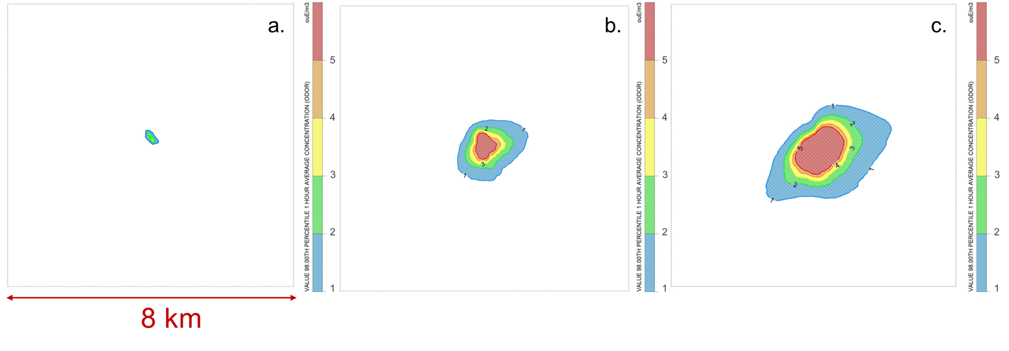

Figure 1. Odour impact maps (98°percentile, on an annual basis) simulated for production department (a.), cooking vats (b.) and WWTP (c.). Rendering plant is located in the centre of the simulation domain.

* + 1. Predictive emission scenarios

Based on the results obtained from the simulation of the current emission scenario, it was hypothesized to introduce odour emission containment systems on the air streams coming from the WWTP and the cooking vats. Regarding the cooking vats, Figure 2a shows the reduction (%) of odour concentration at sensitive receptors after the introduction of the cooling system, compared to the current emission scenario. In particular, discrete receptors (R\_1 – R\_11) were positioned to represent potential areas of interest for estimating the odour impact (e.g., hospitals, schools, city hall, residences). Figure 2b highlights the positions of the 11 sensitive receptors (blue) within the simulation domain and the location of the plant (orange).

From the simulations, a significant reduction in odour concentrations is observed, exceeding 70% for all identified receptors. This way, it would be possible to achieve a negligible impact (<1 ouE/m3) on all dwelled areas.

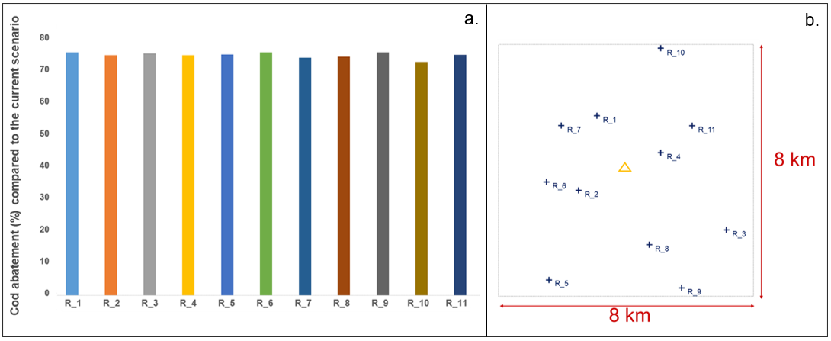

Figure 2. Cod reduction (%) at receptors resulting from the predictive scenario for cooking vats, compared to the corresponding current emission scenario (a.); position of the sensitive receptors R\_1 – R\_11 within the simulation domain (blue) and the rendering plant (orange) (b.).

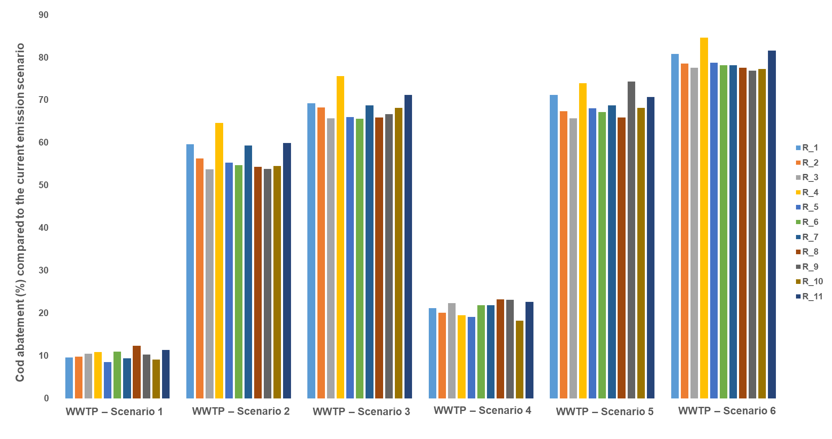

Figure 3. Cod reduction (%) at receptors resulting from the different predictive scenarios for WWTP.

Figure 3 highlights how the solutions hypothesized to reduce odour impact from WWTP in scenarios 1 and 4 appear to be relatively ineffective, as they would result in a reduction of concentrations of around 10% and 20% respectively. Scenario 6, which involves covering all three identified tanks, would ensure the greatest reduction in concentration, averaging around 80%. In this way, only receptors closest to the plant (within a radius of 500 m) would reach a concentration close to 1 ouE/m3, while all more distant receptors would be affected by an impact below the threshold of odour perception. In the remaining scenarios, all of which involve the closure of tank B (scenario 2), possibly along with covering tank A (scenario 3) or tank C (scenario 5), the odor impact appears comparable. In this case, reductions range around 60-70%.

* 1. Conclusions

In this case study, the Lagrangian puff model CALPUFF was adopted to assess the odour impact related to an Italian rendering plant. Initial assessments focused on the current emission scenario, distinguishing between plant macro-areas: production department, cooking vats, and WWTP. Predictive simulations proposed odour containment systems for major contributors.

Concerning the current emission scenario, while the production department provides a negligible contribution, the cooking vats have a not entirely negligible impact, with the isoline referred to as 1 ouE/m3 including a portion of the nearest dwelled area to the production site. The WWTP emerged as the primary contributor to odour impact, with significant concentrations (around 5 ouE/m3) reaching residences.

Proposed containment systems showed promising results. For cooking vats, the introduction of a cooling system allows to achieve over 70% reduction in odour concentrations. This finding appears interesting because, through the introduction of a relatively simple and cost-effective system, a negligible impact (<1 ouE/m3) could be achieved on all inhabited areas. Predictive scenarios for WWTP highlighted the effectiveness of containment strategies, i.e. the covering of one or more tanks and the conveyance (via a wet scrubber system) of air streams to be treated. In particular, it has been highlighted how covering the three identified tanks could ensure an odour concentration reduction of around 80%, with only residences within 500 m from the plant reaching concentrations close to 1 ouE/m3. However, the solution that appears to be of greater interest seems to be the closure of only one tank (scenario 2): in this way, by intervening on a single emission source, hence with a relatively low economic cost, receptor concentrations could be reduced by an average of 60%.

Overall, the odour dispersion modelling has shown to be useful not only by a regulatory point of view, but also for the evaluation of strategies to be implemented for impact reduction.

References

CEN, 2022. Stationary source emissions - Determination of odour concentration by dynamic olfactometry and odour.

Cheng, W.H., Lin, C.H., Yuan, C.S., Chang, K.L., 2023. VOC Emissions from a Rendering Plant and Evaluation for Removal of Pentanal by Oxidization Using Hydrogen Peroxide. Aerosol Air Qual. Res. 23, 1–10. https://doi.org/10.4209/aaqr.220440

Fortune Business Insight, 2024. Rendered Products Market Size, Share & Industry Analysis, By Source (Sheep, Poultry, Cattle, Hogs, and Others), By Type (Tallow, Poultry Fat, Grease, Protein Meal, and Others), By Grade (Food Grade, Feed Grade, and Industrial Grade), and Regional Forecast [WWW Document]. URL https://www.fortunebusinessinsights.com/industry-reports/rendered-products-market-100806

Gooding, C.H., 2012. Data for the Carbon Footprinting of Rendering Operations. J. Ind. Ecol. 16, 223–230. https://doi.org/10.1111/j.1530-9290.2011.00430.x

Invernizzi, M., Brancher, M., Sironi, S., Capelli, L., Piringer, M., Schauberger, G., 2020. Odour impact assessment by considering short-term ambient concentrations: A multi-model and two-site comparison. Environ. Int. 144, 105990. https://doi.org/10.1016/j.envint.2020.105990

Jȩdrejek, D., Levic, J., Wallace, J., Oleszek, W., 2016. Animal by-products for feed: Characteristics, European regulatory framework, and potential impacts on human and animal health and the environment. J. Anim. Feed Sci. 25, 189–202. https://doi.org/10.22358/jafs/65548/2016

Lotesoriere, B.J., Panzitta, A., Capelli, L., 2022. A Method to Evaluate Odour Impacts in the Case of Highly Variable Emission Scenarios: a Case Study in a Foundry. Chem. Eng. Trans. 95, 157–162. https://doi.org/10.3303/CET2295027

Meeker, D.L., Hamilton, C.R., 2006. An overview of the rendering industry. Essent. Render. 1–16.

MASE 2023. Indirizzi per l’applicazione dell’articolo 272-bis del dlgs 152/2006 in materia di emissioni odorigene di impianti e attività. 28/07/2023 https://www.mase.gov.it/pagina/indirizzi-lapplicazione-dellarticolo-272-bis-del-dlgs-1522006-materia-di-emissioni-odorigene

Müller, F.M., de Oliveira, D., Michels, C., 2023. Current status, gaps and challenges of rendering industries wastewater. J. Water Process Eng. 52. https://doi.org/10.1016/j.jwpe.2022.103480

Racar, M., Dolar, D., Farkaš, M., Milčić, N., Špehar, A., Košutić, K., 2019. Rendering plant wastewater reclamation by coagulation, sand filtration, and ultrafiltration. Chemosphere 227, 207–215. https://doi.org/10.1016/j.chemosphere.2019.04.045

Sazakli, E., Leotsinidis, M., 2021. Odor nuisance and health risk assessment of VOC emissions from a rendering plant. Air Qual. Atmos. Heal. 14, 301–312. https://doi.org/10.1007/s11869-020-00935-2

Shareefdeen, Z., Herner, B., Webb, D., Verhaeghe, L., Wilson, S., 2005. An odor predictive model for rendering applications. Chem. Eng. J. 113, 215–220. https://doi.org/10.1016/j.cej.2005.03.006

Sindt, G.L., 2017. Environmental issues in the rendering industry. Essent. Render. 14.

Tagliaferri, F., Facagni, L., Invernizzi, M., Ferrer Hernández, A.L., Hernández-Garces, A., Sironi, S., 2024. Odor Impact Assessment via Dispersion Model: Comparison of Different Input Meteorological Datasets. Appl. Sci. 14, 2457. https://doi.org/10.3390/app14062457

Tagliaferri, F., Facagni, L., Invernizzi, M., Sironi, S., 2023. Variability in odour impact assessment due to different cloud cover estimation approaches: A northern Italy case study. Case Stud. Chem. Environ. Eng. 8, 100492. https://doi.org/10.1016/j.cscee.2023.100492

Tagliaferri, F., Invernizzi, M., Sironi, S., Capelli, L., 2020. Influence of modelling choices on the results of landfill odour dispersion. Detritus 12, 92–99. https://doi.org/10.31025/2611-4135/2020.13998

US-EPA, 2023. Air Quality Dispersion Modeling - Alternative Models [WWW Document]. URL https://www.epa.gov/scram/air-quality-dispersion-modeling-alternative-models

Wysocka, I., 2023. Absorption processes in reducing the odor nuisance of wastewater. MethodsX 10, 101996. https://doi.org/10.1016/j.mex.2023.101996