|  |  |
| --- | --- |
| [[1]](#endnote-1)cetlogo ***CHEMICAL ENGINEERING TRANSACTIONS***  ***VOL. xx, 2024*** | A publication of  aidiclogo_grande |
| The Italian Association  of Chemical Engineering  Online at www.cetjournal.it |
| Guest Editors: Selena Sironi, Laura Capelli  Copyright © 2024, AIDIC Servizi S.r.l. **ISBN** 978-88-95608-94-5; **ISSN** 2283-9216 | |

VOSCs Analysis through TD-GC-MS/FID/PFPD: Tools to Enhance Detectivity and Selectivity in Real Samples

Nicola Massimi, Elisa Polvara\*, Marzio Invernizzi, Selena Sironi

Politecnico di Milano, Department of Chemistry, Materials and Chemical Engineering “Giulio Natta”, Piazza Leonardo da Vinci 32, 20133 Milano, Italy

[elisa.polvara@polimi.it](mailto:elisa.polvara@polimi.it)

The present paper intends to discuss recent developments in detection and quantification of odorous compounds in real industrial gaseous emissions. In this work, the chemical characterization of industrial odours is carried out using an Agilent gas chromatograph (mod. 8890) coupled with three different detectors to obtain a more complete chemical characterization: a Mass Spectrometer (Agilent 5977B MSD), a Flame Ionization detector (FID, Agilent) and a Pulsed Flame Photometric Detector (PFPD, OI Analytical mod. 5833). This system (GC-MS/FID/PFPD) offers different significant advantages if compared with the classical analytical techniques currently adopted in the chemical characterisation of industrial odour mixtures. Applied to industrial case studies, it enables the selective detection and quantification of Volatile Organic Sulphur Compounds (VOSCs), even present in traces (*ppb* level) in complex gaseous mixtures, facilitating the identification of molecules responsible of odour harassment. This instrumentation represents a crucial development in enhancing the understanding of the chemical composition of odorous mixtures, demonstrating cost-effectiveness and time efficiency.

* 1. Introduction

Odour science always requires new tools and strategies to improve the knowledge in odour characterization and treatment. Due to the large number of compounds found in real samples of odorous matrices (Boczkaj et al., 2014; Polvara et al., 2022), a nonspecific characterization of the chemical composition of odour emission is needed. In a complex gas matrix, different compounds could have very different odour contribution: this depends not only on their concentration but also on their chemical characteristics. Volatile Organic Sulphur Compounds (VOSCs) are a class of molecules particularly interesting from an odour point of view because of their well-known unpleasant odour, perceptible to the human nose at extremely low concentrations (*ppb* level) (Armstrong, 2012; Susaya et al., 2011). To selectively detect and quantify these compounds, specific detectors, including a Pulsed Flame Photometric Detector (PFPD), could be used (Cheskis et al., 1993). PFPD detector exploits the photon emission at a specific wavelength to detect, specifically, twenty-eight elements including sulphur: indeed, if excited, different elements have a photon emission at specific wavelength and the excited species have different lifetimes. The knowledge of emission wavelength, lifetimes and kinetics of flame propagation can be used to customize this technique to a specific element detection and quantification.

In this specific context (i.e. the detection of sulphur), combustion in a H2 rich flame breaks down this class of target molecules and releases sulphur atoms that react with each other to form sulphur dimers (S2) in gas phase (Eq. 1) (Tzanani and Amirav, 1995). The flame then excites S2 electrons to a higher energy state, with a following photon emission, proportional to the sulphur concentration, as it returns to its ground states, as shown in Eq. 2.

|  |  |
| --- | --- |
| $$2S\underset{→}{∆}S_{2}$$ | (1) |
| $$S_{2}\underset{→}{∆}S_{2}^{*}→S_{2}+hν$$ | (2) |

The emission wavelength of this photon is about 394 nm. By observing the emission profile, we can detect and measure the presence of sulphur compounds. The rate of reaction for dimer formation is determined by the concentration of S atoms in the reactants, as shown in Eq. 1. Therefore, the concentration of sulphur dimers detected by the sensor is proportional to the square of the sulphur concentration (Eq. 3).

|  |  |
| --- | --- |
| $$\left[S_{2}\right]=\left[S\right]*\left[S\right]={[S]}^{2}$$ | (3) |

This produces the anticipated quadratic responses for sulphur concentrations.

Potential interferences in this measurement may arise from hydrocarbon compounds that coelute with the sulphur compounds. This issue becomes critical when analysing industrial emissions with a high Carbon content. The breakdown product of *C-H* bonds in the flame exhibits a wide emission spectrum that can overlap with sulphur emissions. Consequently, the detector signal being monitored may represent both sulphur and hydrocarbon emissions, resulting in biased and variable outcomes due to the coelution of hydrocarbons and *C-H* bonds in the target molecules. Fortunately, these emissions can be distinguished based on their timing after excitation. Indeed, by pulsing the flame at around 300 milliseconds and monitoring the emission profile after each pulse, sulphur emissions can be differentiated from hydrocarbon emissions based on timing: *C-H emissions* typically occur between 2 and 6 milliseconds after excitation, while *S-S emissions* occur between 5 and 30 milliseconds, as shown in Figure 1. An electronic gate, represented by two green lines in the graphic of Figure 1, is then utilized to filter out the ignition and hydrocarbon signals, focusing specifically on the sulphur emission. This capability stands out as the primary advantage of the PFPD to a selective and sensitive sulphur detention compared, as an example, to a normal FPD that works in continuous flame. Another important advantage of this detector is its ease of use and parameter modification. Indeed, thanks to hardware selection like different glass filters and different photomultiplier tube PMT selection, it can detect different element emissions and in particular Sulphur, Phosphorus, (Jing and Amirav, 1998). Considering these capabilities, PFPD appears as a possible great solution for VOSCs detection in complex matrices.



*Figure 1:* PFPD detector: structure and working flow.

Very often odour contribution is attributable to compounds present in low concentrations (*ppb* level). For this reason, the detection of sulphur compounds, present in low concentrations, in complex real samples and mostly in odorous samples is a challenge. In the scientific literature, different papers and studies using GC-PFPD/FID or GS-MS/PFPD to detect sulphur compounds in a complex matrix are reported (Chambers and Duffy, 2003; Cheng et al., 2021; Del Río et al., 2011; Kim et al., 2005): in these studies, PFPD works simultaneously with FID detector for VOC quantification or MS for species identification. However, to the best of our knowledge, the combination of these three detectors, applied to chemically characterise odorous emissions, is still rarely used. Indeed, the description and evaluation of the applicability of this particular configuration to analyse odorous samples was described only in a previous study by the authors (Polvara et al., 2022). The use of this instrument allowed VOSCs detection, characterised by an extremely low odour threshold (OT). By this, it was possible to achieve a better characterisation of odour mixtures.

Due to the lack of information and the necessity to better understand the chemical composition of odorous mixtures, the aim of the present work is to use this instrumental configuration to analyse real odorous emissions to study its application to different odorous matrices and to prove a more general capability of this analysis workflow.

* 1. Materials and methods
     1. Sample collection

According to EN 13725:2022 guidelines, air samples from an industrial facility (MSW treatment) were collected using 12 L Nalophan™ bags fitted with a Teflon™ inlet tube (materials commonly used in dynamic olfactometry). Air samples were collected using a vacuum pump to sample gas directly into the sampling bag to prevent contaminations and the bags were directly chemically analysed.

* + 1. Chemical analysis: GC-MS/FID/PFPD

The identification and quantification of single species present in the odorous samples was performed utilizing a gas chromatograph (Agilent, model 8890) equipped with a single quadrupole mass selective detector (Agilent 5977B MSD), a Flame Ionization Detector (FID, Agilent), and a Pulsed Flame Photometric Detector (PFPD, OI Analytical, model 5833). As already described in detail in the mentioned previous study (Polvara et al., 2022), this combination was chosen to achieve specific detection and quantification of organic compounds via FID analysis, sulphur compounds through PFPD, and compound identification via MS analysis by comparing generated spectra with MS library references. To summarize, gaseous samples were directly collected from Nalophan™ sampling bags using a calibrated pump (Markes, Air Server-xr) and directed to a thermal desorber (Markes, Unity-xr) to preconcentrate the analytes present on a cold trap (‘TO-15/TO-17 Air toxics’, compatible with the simultaneous analysis of analytes from C2/3 to C30/32, Markes International Ltd) maintained at −27 °C. Subsequently, the cold trap was heated to 300°C. After the preconcentration step, compounds were transferred via a hot transfer line (200°C) into the capillary column (DB-Sulphur SCD, 60 m×0.320 mm×4.20 μm, Agilent J&W, Folsom, CA, USA). After the chromatographic run, the gas flow is divided into equal portions between the three detectors enabling simultaneous acquisition with MS (operated in TIC mode), FID and PFPD detectors. In this way, three different and overlapping chromatograms are registered during a single chromatographic run. Regarding detectors’ setting, mass spectral data were acquired over a mass range of 35–300 u.m.a. and a solvent delay of 3.5 min was set to remove the CO2 signal due to the sample matrix. The FID and PFPD temperatures were set to 150°C and 100°C, respectively. Compound identification was performed by comparing spectra obtained from GC-MS analyses with the NIST20 database (NIST/EPA/NIH Mass Spectral Library, Version 2.4 Mar 25 2020).

1. Results and discussion

Firstly, a summary of peaks detected in both GC-FID chromatogram and GC-PFPD chromatogram (Figure 2), was generated. All these quantifiable peaks were identified by comparing MS spectra (*TIC* mode) obtained in GC-MS chromatogram. As it is evident by comparing the obtained chromatograms (Figure 2), peaks detected in the FID chromatogram do not correspond with ones in PFPD chromatogram: this is due to the presence, in the sample, of VSOCs detected by using PFPD detector. After the detection of chromatographic peaks correlated with VSOCs in PFPD chromatogram, the identification of these compounds is conducted by searching, at the specific retention time RT observed, the signal of sulphur compounds in the GC-MS signal as done for organic compounds in FID chromatogram. Indeed, having determined the presence of sulphur compounds in the sample, the use of PFPD makes it easier to selectively search specific areas of the GC-MS chromatogram for the mass spectrum, useful for the identification of sulphur compounds. This instrumental configuration can be also particularly useful in the case of coelution of two compounds, one of which contains sulphur: indeed, if a coelution with a hydrocarbon compound occurs, it is possible to detect the presence of a second compound below a single GC-MS peak. In this sample (Figure 2), Carbon disulfide and 1-Propanol give a real example of a coelution that can be detected and quantified singularly.

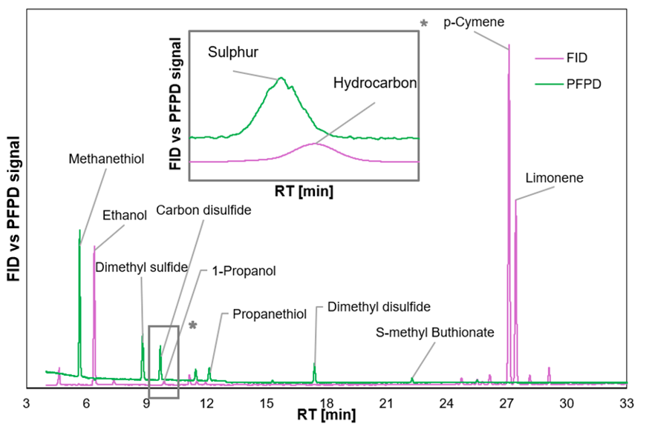

Figure 2. FID vs PFPD chromatogram, with a focus on peaks coelution.

VOCs and VOSCs quantification, with the concentration expressed in terms of mg/m3, was conducted using FID and PFPD, respectively.

To investigate the odour potential of the detected compounds, an evaluation of the Odour Activity Value (OAVi) was conducted. Applying the measured concentration data, Ci, and the Odour Threshold (OT), the OAVi was calculated for each *i* species according to the following formula (Eq. 4):

|  |  |
| --- | --- |
| $${OAV}_{i}=\frac{ C_{i}}{OT_{i}}$$ | (4) |

The OT values are collected from scientific literature using a principal reference (Nagata and Takeuchi, 2003). For compounds without OT in the main reference, the most recent OT values in the scientific literature ​​were used (Van Gemert, 2011).

OAV parameter can offer insights into the primary chemical contributors of an odour mixture (Wu et al., 2017).

OAVs were calculated for all compounds detected in the analysed mixture, however, for the sake of clarity, the odour contribution of species classes is elaborated. Figure 3 shows the mass contribution expressed in concentration (left side) and the odour contribution expressed in OAV (right side) for the chemical classes detected in the sample.

As depicted in Figure 3, terpenes were the chemical class found in the highest concentration (higher contribution in concentration terms), followed by alcohols. However, according to OAVs, these compound classes do not appear to be extremely significant. Conversely, sulphur compounds, followed by esters, emerged as the classes with the highest odour contribution (i.e. higher OAV). These results highlight the importance of a high-sensitive analysis of sulphur compounds for a more accurate odour evaluation. These compounds were non visible in FID chromatogram, due to their low concentration, but in terms of odour contribution the presence of these compounds appears crucial.

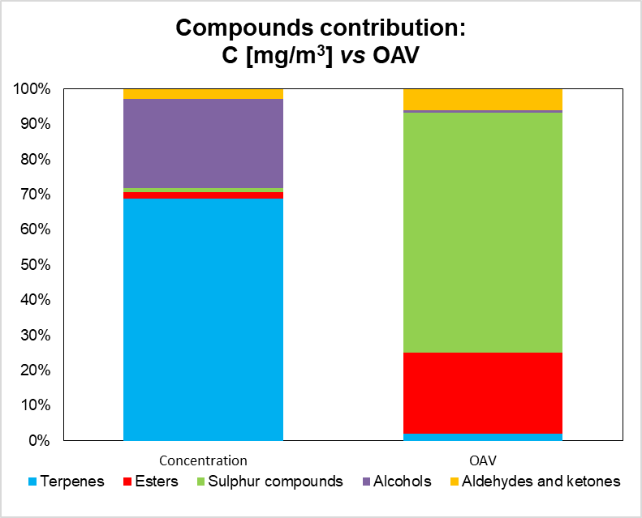

*Figure 3*: Mass contribution expressed in concentration vs OAV contribution of the detected chemical classes.

Focusing on these compounds, Table 1 shows the sulphur compounds identified using PFPD detector and their OAVs calculated by Eq. 4. The table shows how these compounds could contribute to the odour potential of the sample, even if compared to the molecules found in highest concentration like Ethanol (28.39 mg/m3), p-Cymene (45.74 mg/m3) and Limonene (34.19 mg/m3), which exhibit considerably lower calculated OAVs (Table 1) than most of sulphur compounds seen in the sample.

|  |  |  |  |  |
| --- | --- | --- | --- | --- |
| Compound | C  [mg/m3] | OT  [mg/m3] | OAV | Detector |
| Methanethiol | 0.48 | 1.38E-04 | 3460 | PFPD |
| Dimethyl sulfide | 0.40 | 7.62E-03 | 52 |
| Carbon sulfide | 0.11 | 6.54E-01 | 0.2 |
| Propanethiol | 0.10 | 4.05E-05 | 2510 |
| Dimethyl disulfide | 0.15 | 8.48E-03 | 17 |
| Ethanol | 28.39 | 9.99E-01 | 28 | FID |
| p-Cymene | 45.74 | 7.20E+00 | 6.4 |
| Limonene | 34.19 | 2.12E-01 | 161.3 |

*Table 1: VOSCs detected using PFPD detector vs VOCs detected in highest concentration using FID detector and their odour contribution expressed in OAV.*

From Table 1, it is possible to notice that Methanethiol and Propanethiol, two Thiols, were found to possess the highest values of OAV: thus, these two compounds contribute the most, in odorous terms, to the emission. The Identification and quantification of these compounds through PFPD aided in the understanding of odour contributions of the matrix. Consequently, to effectively reduce the odour load of this gaseous flow, it is essential to abate the emission of these compounds, and not strictly focus on the most abundant.

* 1. Conclusions

Accurately analysing odorous gas samples remains a technical challenge due to the complexity of gaseous matrices. Given this complexity, a versatile analytical approach is necessary to efficiently achieve comprehensive chemical characterization. Employing multiple detectors proved to be one of the most valuable strategies for maximizing information extraction within minimal analysis time for samples of different study cases. The application of TD-GC-MS/FID/PFPD system on samples collected from an industrial plant demonstrated its efficacy: it enabled the selective detection of compounds of specific olfactory significance that would have been challenging to identify through generic untargeted MS analysis. This approach notably streamlines chromatographic data processing, simplifies compound identification, within the sulphur compound category, and yields more reliable results. Furthermore, regarding compound quantification, employing detectors such as FID and PFPD reduces calibration costs compared to semi-quantitative MS methods. Thus, the simultaneous use of these three detectors furnishes crucial information for thoroughly characterising complex mixtures like odours, significantly saving time and enhancing analysis efficiency.

References

1. Armstrong, G., 2012. Smelling sulfur. Nature Chem 4, 243–243. https://doi.org/10.1038/nchem.1322

   Boczkaj, G., Przyjazny, A., Kamiński, M., 2014. New Procedures for Control of Industrial Effluents Treatment Processes. Ind. Eng. Chem. Res. 53, 1503–1514. https://doi.org/10.1021/ie402126d

   Chambers, L., Duffy, M.L., 2003. Determination of Total and Speciated Sulfur Content in Petrochemical Samples Using a Pulsed Flame Photometric Detector. Journal of Chromatographic Science 41, 528–534. https://doi.org/10.1093/chromsci/41.10.528

   Cheng, Y., Li, G., Wu, H., Huang, L., Wang, H., 2021. Identification of Light-Induced Key Off-Flavors in Ponkan Mandarin Juice Using MDGC-MS/O and GC–MS/PFPD. J. Agric. Food Chem. 69, 14259–14269. https://doi.org/10.1021/acs.jafc.1c05465

   Cheskis, Sergey., Atar, Eitan., Amirav, Aviv., 1993. Pulsed-flame photometer: a novel gas chromatography detector. Anal. Chem. 65, 539–555. https://doi.org/10.1021/ac00053a010

   Del Río, D., Rey, M., Sedran, U., De La Puente, G., 2011. Combined PFPD–FID assessment of sulfur in liquid fuels. Fuel Processing Technology 92, 2278–2284. https://doi.org/10.1016/j.fuproc.2011.07.017

   Jing, H., Amirav, A., 1998. Pulsed flame photometric detector – a step forward towards universal heteroatom selective detection. Journal of Chromatography A 805, 177–215. https://doi.org/10.1016/S0021-9673(97)01306-X

   Kim, K.-H., Choi, Y., Jeon, E., Sunwoo, Y., 2005. Characterization of malodorous sulfur compounds in landfill gas. Atmospheric Environment 39, 1103–1112. https://doi.org/10.1016/j.atmosenv.2004.09.083

   Nagata, Y., Takeuchi, N., 2003. Measurement of odor threshold by triangle odor bag method. Odor measurement review 118, 118–127.

   Polvara E., Morosini D., Invernizzi M., Sironi S., 2022. Analysis of Odorous Vocs Using Td-gc-ms/fid/pfpd: Development and Applications to Real Samples. Chemical Engineering Transactions 95, 151–156. https://doi.org/10.3303/CET2295026

   Susaya, J., Kim, K.-H., Phan, N.-T., Kim, J.-C., 2011. Assessment of reduced sulfur compounds in ambient air as malodor components in an urban area. Atmospheric Environment 45, 3381–3390. https://doi.org/10.1016/j.atmosenv.2011.03.051

   Tzanani, Nitzan., Amirav, Aviv., 1995. Combined Pulsed Flame Photometric Ionization Detector. Anal. Chem. 67, 167–173. https://doi.org/10.1021/ac00097a026

   Van Gemert, L.J., 2011. Odour thresholds: Compilations of odour threshold values in air, water and other media. Oliemans Punter.

   Wu, C., Liu, J., Zhao, P., Li, W., Yan, L., Piringer, M., Schauberger, G., 2017. Evaluation of the chemical composition and correlation between the calculated and measured odour concentration of odorous gases from a landfill in Beijing, China. Atmospheric Environment 164, 337–347. https://doi.org/10.1016/j.atmosenv.2017.06.010 [↑](#endnote-ref-1)