|  |  |
| --- | --- |
| cetlogo ***CHEMICAL ENGINEERING TRANSACTIONS***  ***VOL. xxx, 2024*** | A publication of  aidiclogo_grande |
| The Italian Association  of Chemical Engineering  Online at www.cetjournal.it |
| Guest Editors: Selena Sironi, Laura Capelli  Copyright © 2024, AIDIC Servizi S.r.l. **ISBN** 979-12-81206-13-7; **ISSN** 2283-9216 | |

Assessing the significance of fugitive emissions from a landfill biogas collecting system using a quantitative optical gas imaging (QOGI) method: a case study

Federico Cangialosia,\*, Luciana Milellaa, Antonio Fornarob

aT&A - Tecnologia e Ambiente Srl, Via Michele Mummolo, 13 - 70017 Putignano (BA), Italy

federico.cangialosi@icloud.com

bLab Service Analytica S.R.L., via Emilia 51/c – 40011 Anzola dell'Emilia (BO), Italy

The biogas collection system in landfills is a crucial environmental safeguard aimed at either recovering gas energy or producing biomethane. However, the unintentional release of biogas during collection and utilization processes poses an environmental risk due to its high greenhouse potential and could significantly contribute to overall odour emissions from landfills. While recent studies have addressed odour emission issues from the landfill surface, there is a notable gap in research focusing on the impact of fugitive biogas emissions on odour impact assessment. The escape of pure biogas from the collection system has an extreme odorous impact compared to biogas emissions from the landfill surface, which are significantly depleted in odour concentration. Moreover, while technical guidelines exist for evaluating biogas dispersion from the landfill surface, comprehensive studies addressing fugitive emissions from landfills are still lacking. This paper proposes an approach for estimating the impact of fugitive biogas emissions on overall odour emissions from a non-hazardous landfill that collects biogas through a network of over 408 vertical wells. Initially, we assessed the mass flow rate of biogas leaks from each fugitive source using Quantitative Optical Gas Imaging (QOGI), a valuable tool in environmental monitoring that provides accurate real-time measurements of gas concentrations and flow rates. QOGI measurements were compared with Flame Ionization Detector (FID) measurements on critical wells to evaluate the technique's reliability. After field validation of biogas fugitive flux measurements, a Langrangian puff model was used to compare overall odour exposure from the landfill, considering scenarios with and without fugitive emissions. The significance of fugitive emissions in terms of odour impact on receptors was assessed at the level of individual biogas wells, driving improvements in landfill biogas collection. This approach enables design engineers and plant managers to reduce fugitive emissions by inspecting and repairing valves and connections within the wellfield system or by expanding the biogas capture network through the addition of new wells.

* 1. Introduction

The release of odour emissions frequently emerges as a primary cause of citizens' complaints regarding local environmental quality. Landfill operations encounter significant challenges related to surface emissions of landfill gas (LFG) and emissions from freshly delivered waste (Capelli et al., 2008). While various techniques (analytical, sensory, and instrumental) prove useful in monitoring and assessing the impact of odour emissions from landfills (Gębicki et al., 2017), primarily associated with surface emissions of landfill biogas (Lucernoni et al., 2017), in recent years, the issue of LFG fugitive emissions has been increasingly acknowledged as a significant source not to be disregarded due to its high greenhouse potential and high odour-producing impact. Fugitive emissions can be defined as emissions that are not intentionally produced by a stack or vent and may include leaks from industrial plants and pipelines. In the case of landfills, fugitive emissions encompass leaks from defective valves or seals, gas migration to the surface near wells, and non-productive discharges such as biogas flaring. Optical gas imaging (OGI) is included among the methods capable of detecting and identifying fugitive emissions of Volatile Organic Compounds in EN 17628:2022, with its methodology being theoretically applicable to methane: the application of OGI technology for identifying methane leaks (Ravikumar et al., 2017) could prove beneficial in reducing such odour emission sources. In this study, we utilized quantitative OGI (QOGI) to evaluate fugitive emissions from a landfill by measuring methane leak rates from the biogas collection system. The objective of the research is twofold: firstly, to assess the capability of QOGI in quantifying methane emission rates from fugitive emissions and verifying whether reasonable assumptions for emission rates are compatible, in terms of order of magnitude, with observed QOGI values. Subsequently, odour dispersion modelling was conducted to evaluate the impact on receptors of estimated fugitive emissions, thus offering a case study in a field where comprehensive and detailed approaches for simulation purposes are still lacking (Barclay et al., 2023).

* 1. Materials and methods

The research was undertaken at a non-hazardous landfill located in Taranto (Puglia, Italy). This landfill is divided into three operational lots: Lot I and Lot II, covering an area of 213,000 m2, and Lot III, spanning 185,000 m2. Lot I and Lot II are authorized to 6.2 Mm3, while Lot III has an authorized capacity of 4.6 Mm3. The investigation focused on Lots I and II for this study, as waste disposal activities have only recently begun in Lot III, making it not yet relevant in terms of LFG emissions. Further detailed site descriptions can be found elsewhere, as extensive investigations, including odour emission modelling (Capelli et al., 2018) and fenceline odour monitoring using IOMS (Cangialosi et al., 2018), have been carried out at this site.

* + 1. **Biogas management system and control**

The biogas management system currently in operation for Lots I and II was implemented in multiple phases over time. In Lot I the final implementation occurred over 10 phases from January 2006 to July 2019. This process involved both the drilling of new wells and the re-drilling of existing ones due to efficiency loss, resulting in a total of 169 operational biogas wells. In Lot II, the development of biogas collection system occurred in 9 phases from December 2013 to November 2021, resulting in the construction and gas collection from 239 wells.

To achieve energy recovery, two engines with capacities of 1.065 MW and 0.995 MW are utilized, resulting in a total recovery rate of 1,000 Nm3/h. Additionally, three blower-flare facilities, with nominal capacities of 2,000, 1,000, and 500 Nm3/h respectively, are employed to manage biogas collection beyond the engine capacity: the static and/or dynamic flares supporting the existing biogas network are activated as needed based on differential pressures measured at each individual capture well. The average composition of recovered biogas is: 55% CH4, 30% CO2, 3% O2, and 11% N2, with other components in traces (<1%). As part of the monitoring and control plan, monthly surveys of surface gas emissions are conducted following the UK EA Guidance (UK EA, 2010) which provides a protocol to evaluate the impact of landfill gas emissions and calculate the diffuse emissions from the landfill surface. The monitoring results, along with information on the volumes of captured biogas, are currently utilized to assess the efficiency of biogas capture from the wells: this efficiency is calculated as the ratio between the mass of collected gas and the sum of the collected and diffuse biogas, with the latter being measured according to the UK EA guidance (2010). Nevertheless, for a more accurate estimation of capture efficiency, it may be important to consider fugitive emissions from the entire landfill gas collection system (wells, wellheads, pipe junctions, etc.), as it is not known to what extent fugitive emissions from the biogas management system are relevant to the overall biogas budget (recovered, diffuse from the surface, fugitive). To address this issue, a Leak Detection and Repair (LDAR) survey has been undertaken on the landfill surface over the past four years to identify and mitigate fugitive emissions of biogas by employing the OGI method. Once the leaks were identified with OGI, their significance was assessed using a portable Flame Ionization Detector (FID) in walkover mode (UK EA, 2010). OGI employs high-resolution and sensitivity infrared image acquisition and processing to detect the predominant presence of methane in biogas through the stretching band C-H bond. An IR EyeCgas® model (Opgal, Israel), certified as IP65 and ATEX, was employed, featuring a cooled optical sensor and a differential thermal sensitivity <12mK at 25°C, with a Minimum Detectable Leak Rate of 0.35 g/h of methane. The technology's capability for gas leak rate quantification, based on proprietary software developments, is described in detail elsewhere (Hashmonay, 2022).

* + 1. **Order-of-magnitude odour emission rate estimation from fugitive sources**

QOGI measurements, including both methane concentration and leak rate, were compared with FID measurements to evaluate the relevant mechanism for LFG fugitive emissions. Once the mechanism of LFG emissions was identified, the assumed volumetric leaking rate of LFG was compared with QOGI measurements to assess their compatibility on an order-of-magnitude basis. Then, using the estimated and assessed volumetric flow rate of fugitive emissions for each well (Q) and assuming the odour concentration of landfill biogas (C), the Odour Emission Rate (OER) of fugitive emissions was calculated according to the following formula:

|  |  |
| --- | --- |
|  | (1) |

* + 1. **Odour exposure by dispersion modeling**

A Lagrangian puff model (CALPUFF) was employed to assess the overall odour emission from the landfill, by comparing two scenarios: one without considering fugitive emissions (Scenario 1) and the other with fugitive emissions (Scenario 2). In both cases, diffuse emissions from the landfill surface were evaluated using a specific odour emission rate (SOER) of 0.07 uoE/m2\*s, which had been previously measured with a flux chamber and validated through field inspections (Capelli et al., 2018).

* 1. Result and discussion
     1. **LDAR survey results and assumptions for odour dispersion modelling**

Monthly data on captured biogas, obtained through monthly analyses of composition and flow rates, are presented in Table 1. The average volumetric flow rate of LFG for each well was calculated based on the yearly-averaged values for Lots I and II, resulting in an average flowrate of 2.8 m3/h.

Table 1: Monthly data of collected biogas in 2023

|  |  |  |  |  |  |  |  |  |  |  |  |  |
| --- | --- | --- | --- | --- | --- | --- | --- | --- | --- | --- | --- | --- |
| Collected biogas (kg/d) | Jan | Feb | Mar | Apr | May | Jun | Jul | Aug | Sep | Oct | Nov | Dec |
| Lot I | 10,516 | 10,614 | 4,191 | 3,908 | 2,076 | 5,479 | 5,159 | 5,606 | 7,641 | 5,840 | 5,308 | 6,003 |
| Lot II | 17,809 | 16,992 | 31,007 | 27,265 | 26,406 | 27,512 | 24,487 | 22,067 | 27,728 | 21,809 | 20,787 | 28,109 |

In 2019, the implementation of the OGI survey, along with FID detection and IOMS fenceline monitoring, significantly enhanced the efficiency of the biogas management system which led to a decrease in both H2S and odour concentrations detected at the landfill fenceline (Cangialosi et al., 2021). Subsequently, LDAR surveys have been carried out monthly at the site for the past few years. The overall collection efficiency is high, with only a small number of areas with poor biogas uptake. Furthermore, occurrences of fugitive emissions from valves or wellhead junctions are exceptionally rare and are promptly addressed within hours of being identified. Despite these improvements, the current LDAR survey reveals numerous LFG wells with high emissivity (CH4 concentration >10,000 ppm), although only a few of them contribute to a significant emission area (Figure 1).

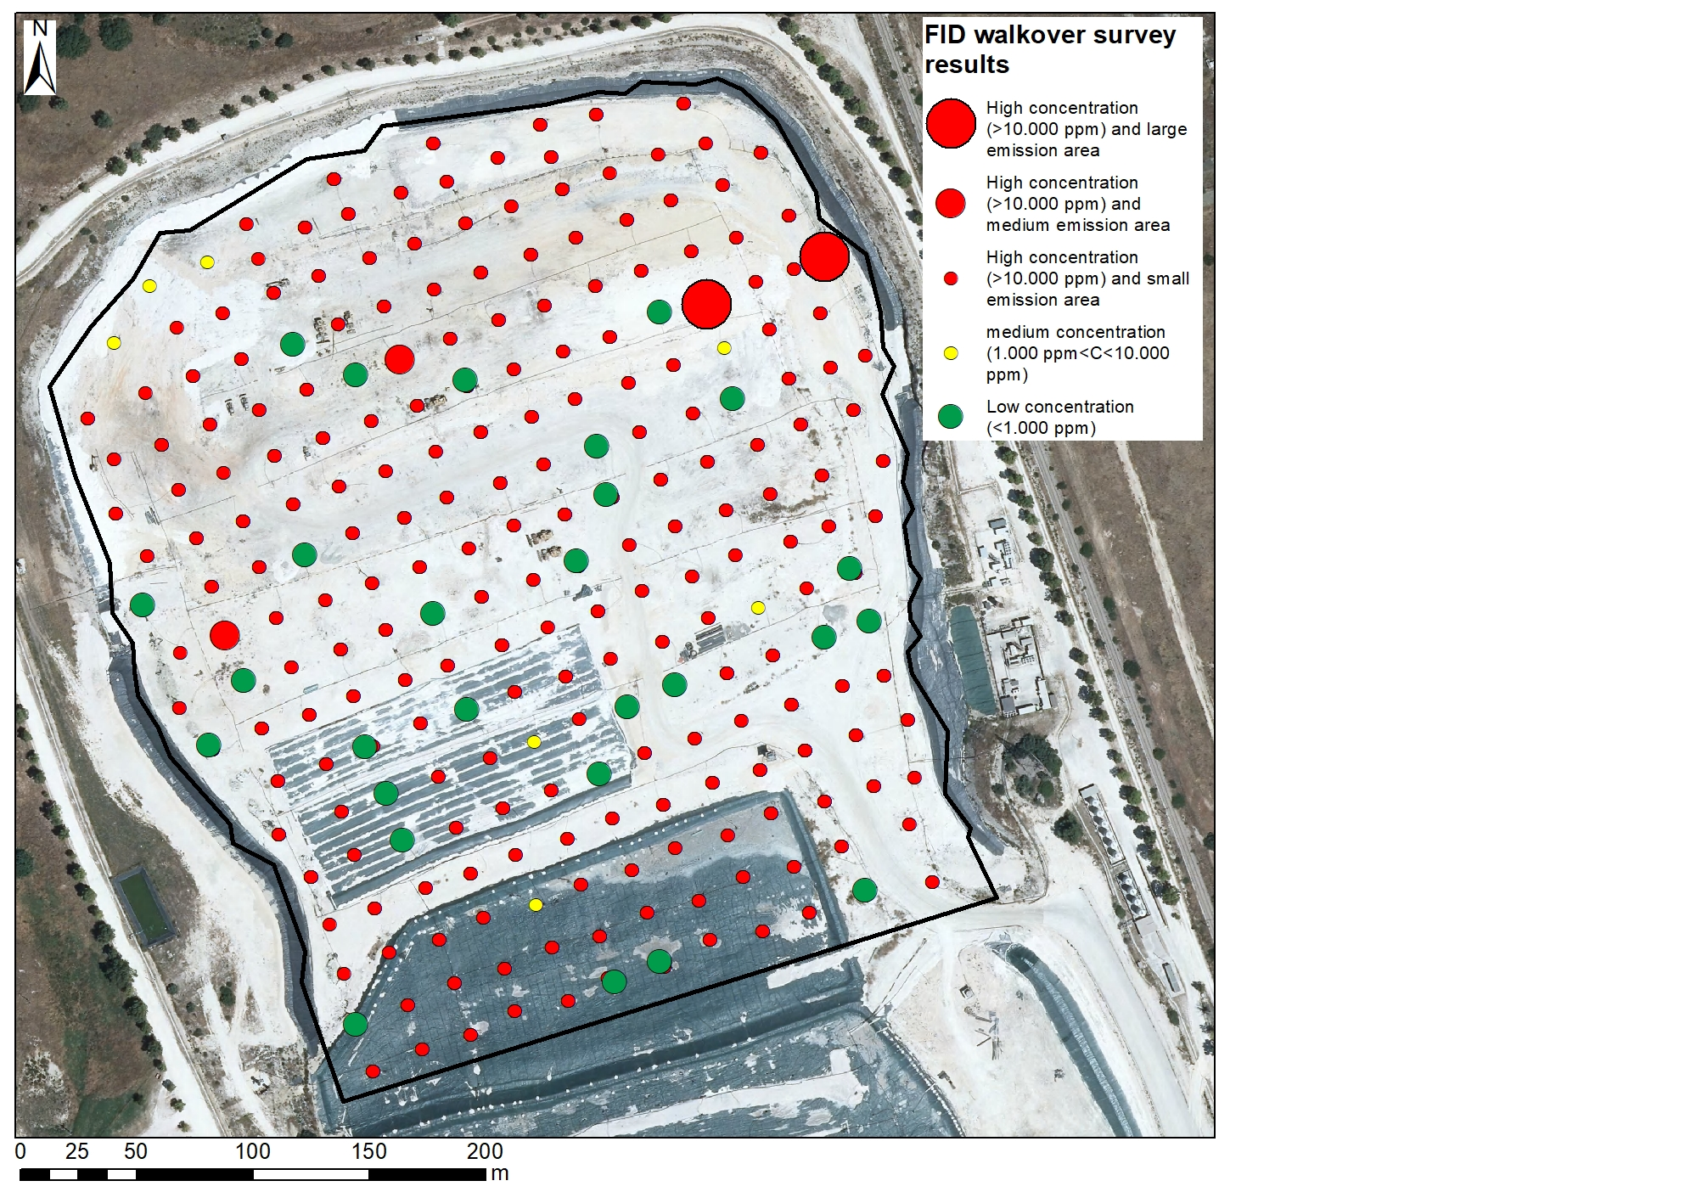

Figure 1: Example of LDAR survey results with FID

The utilization of OGI technology enabled field technicians to recognize that fugitive emissions of LFG are not associated with pipes/valves connections but rather with the migration of biogas to the surface near wells. Most of the wells show limited fugitive emissions, with methane leakage rates found to be below the detection threshold of QOGI (350 g/h). However, a few wells, particularly those with medium to high extension zones, are characterized by methane flux in the order of magnitude of 1,000 g/h (range 500 ÷1,500 g/h), as illustrated in Figure 2.

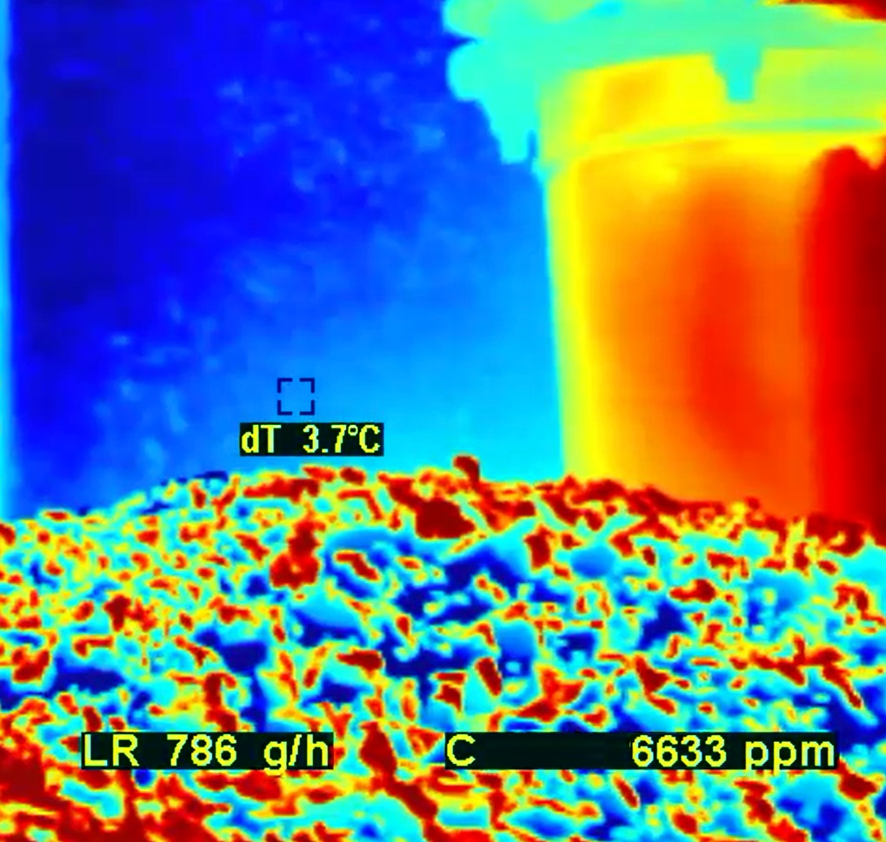

Figure 2: Measurements of methane leak rate using QOGI

These empirical findings suggest that part of the biogas migrating toward the well isn't adequately collected by the well itself. Instead, it vertically migrates along the permeable drain that fills the space between the borehole and the well screen, eventually escaping from the surface due to imperfect sealing of the wellhead to the landfill surface. It is estimated that this fraction accounts for 10% of the biogas collected by those wells exhibiting high methane concentration (around 10,000 ppm) and small emission zones: the calculation yields a fugitive emissions flow rate of 0.28 m3/h of LFG per well, equivalent to 100 g/h of methane. This estimated value can be compared to field measurements obtained using QOGI, although, in the present case, these measurements fell below the detection threshold of QOGI. The information that the values fall below the detection threshold could nonetheless provide valuable insights for a conservative approach to modelling fugitive emissions. Considering that 350 g/h is the upper limit of methane fugitive emission rate detectable by QOGI, it's common practice in statistical data analysis for modelling to employ half the detection limit (175 g/h), assuming a uniform distribution between zero and the detection threshold. Therefore, the hypothesized biogas leaks around the well (100 g/h) can be regarded as a conservative initial estimate of fugitive methane emissions. Therefore, the corresponding LFG emission of 0.28 m3/h can be utilized to assess the impact of fugitive emissions on odour dispersion modelling. The Odour Emission Rate (OER) of fugitive emissions from each well with high emissivity and small extension zones is calculated using Eq(1), assuming an odour concentration of biogas of 300,000 ouE/m3 (Lucernoni et al., 2016), resulting in 23.5 ouE/s. For simulation purposes, the following assumptions were made: (i) wells with low or medium methane concentrations (marked in green and yellow in Figure 1) are not considered relevant in terms of fugitive emissions; (ii) wells with high methane concentrations and small extensions (marked in red in Figure 1) are regarded as sources with an Odour Emission Rate (OER) of 23.5 ouE/s; (iii) wells with high methane concentrations and medium to high extensions (marked in red, covering large areas in Figure 1) are neglected as they represent less than 2% of the total wells. Analysis of the maps derived from LDAR surveys conducted in 2023 enabled the identification of points with methane concentrations exceeding 10,000 ppm, the majority of which have small extensions and are modelled as point emission sources. The percentage of such emission sources among all wells is presented in Table 2 for Lots I and II.

Table 2: Monthly data (2023) of wells fraction (in %) with methane concentration>10,000 ppm

|  |  |  |  |  |  |  |  |  |  |  |  |  |
| --- | --- | --- | --- | --- | --- | --- | --- | --- | --- | --- | --- | --- |
| % of wells with CH4>10.000 ppm | Jan | Feb | Mar | Apr | May | Jun | Jul | Aug | Sep | Oct | Nov | Dec |
| Lot I | 22 | 48 | 31 | 29 | 65 | 68 | 68 | 41 | 52 | 27 | 32 | 42 |
| Lot II | 55 | 56 | 68 | 59 | 73 | 68 | 68 | 67 | 67 | 65 | 62 | 17 |

The yearly average percentage of wells with fugitive emissions from Lot I is 43% (73 out of 169 wells), while for Lot II, the percentage is 59% (141 out of 239 wells). The loss of landfill gas (LFG) due to fugitive emissions can be calculated as the ratio between the yearly average estimate of fugitive emissions (73 + 141) \* 0.28 = 60 m3/h and the yearly average collected LFG (Table 1), which is 5.2%. This percentage is consistent with large-scale estimates of fugitive emissions loss in industrial processes (Laconde T., 2018). In the following section, the impact of this apparently negligible source on odour dispersion modelling will be assessed.

* + 1. **Dispersion modelling results**

Based on the assumptions outlined in the preceding sections, the results of the CALPUFF dispersion model are presented here, with a particular focus on the impact of biogas fugitive emissions on the 98th percentile of the odour concentration field. In the initial scenario (Scenario 1), only diffuse odour emissions from the surfaces of Lots I and II were taken into account (see Figure 3).

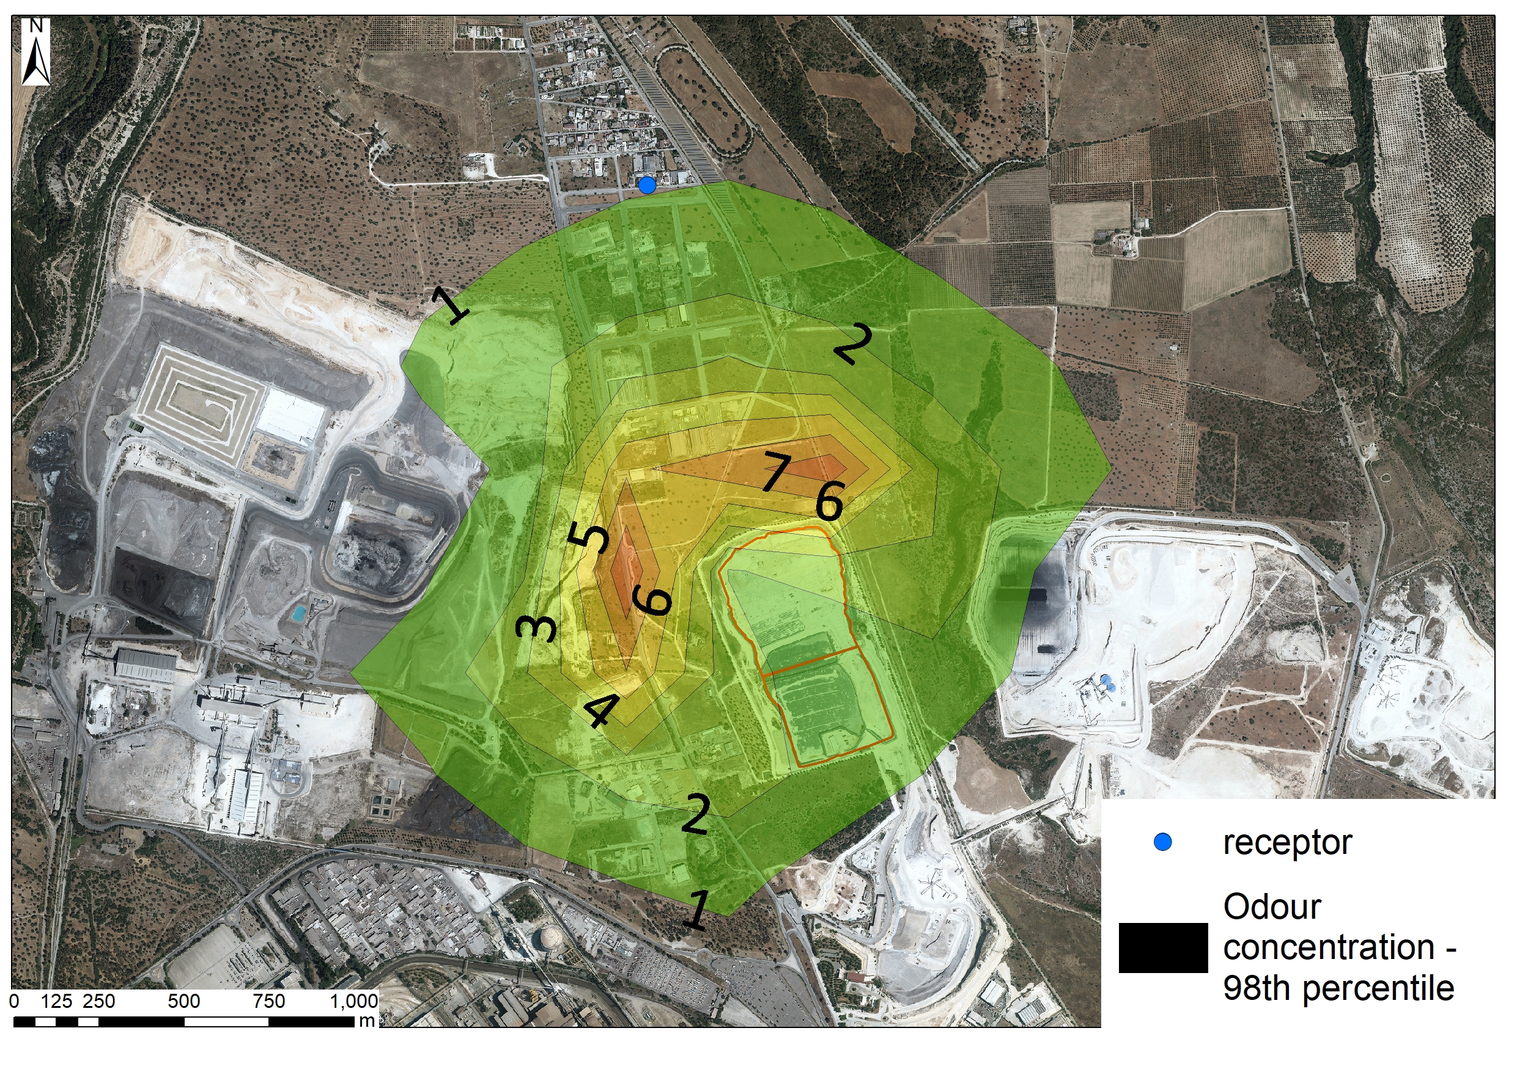

Figure 3: Simulation results: Scenario 1: Emissions of Lots I and II without fugitive emissions

The 98th percentile of odour concentration, considering a peak-to-mean ratio of 2.3 (Barclay et al., 2023) at the nearest receptor, is 0.9 ou/m3. In Scenario 2, diffuse odour emissions from Lots I and II are combined with fugitive emissions. Given the multitude of emitting wells uniformly distributed across the entire landfill surface, as identified through monthly LDAR surveys, there was consideration given to modelling the emissions with equivalent emission sources. This strategy seeks to reduce the number of sources while maintaining the overall Odour Emission Rate (OER). A preliminary trial involved grouping 5 wells into an equivalent emission source with an Odour Emission Rate (OEReq) of 5 times the single-well OER. Subsequently, it was examined whether a less refined approximation (grouping 10 wells into an equivalent emission source with OEReq = 10 \* OER) would yield different results for the odour concentration field. The results, depicted in Figures 4a and 4b, indicate no noticeable difference in the concentration fields. This suggests that grouping the fugitive emission sources with high concentrations by 10 does not affect the simulation results, thereby significantly simplifying the process of simulating fugitive emissions from a large number of LFG wells.

|  |  |
| --- | --- |
|  |  |

Figure 4: Simulation results: Emissions with fugitive emissions: 5-to-1 wells grouping (4a) and 10-to-1 wells grouping (4b)

The 98th percentile of odour concentration at the nearest receptor is 1.2 ou/m3, indicating a potential 33% increase due to biogas fugitive emissions. Consequently, future improvements in the LFG management system should emphasize the development of more effective strategies for sealing the wellhead and minimizing fugitive emissions.

* 1. Conclusions

An investigation was carried out to assess the impact of biogas fugitive emissions on odour dispersion from a non-hazardous landfill. Fugitive emissions surveys were performed using FID walkover and optical gas imaging analysis (OGI). The quantitative OGI (QOGI) technology enabled the determination of the upper limit of landfill gas (LFG) fugitive emissions from the landfill surface surrounding the wells. Based on this evidence, an order-of-magnitude estimation of fugitive emissions by each well, approximately 100 g/h per well, was made, providing a conservative measure for odour dispersion modelling. In this specific case study, the estimated loss of LFG due to fugitive emissions is around 5%, taking into account that 43% and 59% of wells in Lots I and II, respectively, show fugitive losses. Although seemingly negligible, the high concentration of odour in biogas has been demonstrated to have a significant impact on odour dispersion. In fact, when considering fugitive emissions from the wells, grouped into sets of 10 to simplify emission modelling without distorting the results, an increase of up to 33% in the 98th percentile of odour concentration at the receptors is observed compared to when only surface emissions are considered.

Acknowledgments

The technical assistance provided by Italcave SpA (Taranto, Southern Italy) during the investigation is gratefully acknowledged.

References

Barclay J., Nietzsche Diaz C., Shanahan I., Trick L., Bellasio R., Tinarelli G., Brusasca G., Rosales R., Galvin G., Trini Castelli S., Balch A., Romain A, Escoffier E., Öttl D., Duthier E., Berbekar E., Oliva G., Schauberger G., Hauschildt H., Zarra T, 2023, International Handbook on the Assessment of Odour Exposure using Dispersion Modelling. ISBN: 978-84-09-52429-7. https://doi.org/10.5281/zenodo.8367724

Cangialosi F., Intini G., Colucci D., 2018, On line monitoring of odour nuisance at a sanitary landfill for non-hazardous waste, Chemical Engineering Transactions Vol. 68, 127-132.

Cangialosi F., Fornaro A., de Santis G. 2021. Detection of gas leakage from landfills using optical gas imaging coupled with fence monitoring system of odour by IOMS: a case study. 9th IWA Odour & VOC/Air Emission Conference 26-27 October 2021 Bilbao, Spain

Capelli L., Sironi S., Del Rosso R., Centola P., Il Grande M., 2008, A comparative and critical evaluation of odour assessment methods on a landfill site. Atmospheric Environment 42, 7050–7058.

Capelli L., Il Grande M., Intini G., Sironi S., 2018, Comparison of Field Inspections and Dispersion Modelling as a Tool to Estimate Odour Emission Rates from Landfill Surfaces, Chemical Engineering Transactions Vol. 68, 187-192

Gębicki, T. D. and Namieśnik J., 2017, Investigation of Air Quality beside a Municipal Landfill: The Fate of Malodour Compounds as a Model VOC. Environments 2017, 4, 7; doi:10.3390/environments4010007

Hashmonay, 2022). Quantification of VOC Emissions Using Optical Gas Imaging Technology. The air and Waste management Assosiation’s 115th Annual Conference and Exhbition (June 27-30, San Francisco, CA, USA.

Laconde, T. 2018, [Fugitive emissions: a blind spot in the fight against climate change. Fugitives emissions - Sector profile](https://inis.iaea.org/search/searchsinglerecord.aspx?recordsFor=SingleRecord&RN=51070000) <<https://www.climate-chance.org/wp-content/uploads/2019/03/new-fugitive-emissions-a-blind-spot-in-the-fight-against-climate-change.pdf>> accessed 12.03.2024.

Lucernoni, F., Tapparo F., Capelli, L., Sironi, S., 2016. Evaluation of an Odour Emision Factor (OEF) to estimate odour emissions from landfill surfaces. Atmospheric Environment, 144, 87-99.

Lucernoni, F., Capelli, L., Sironi, S., 2017. Comparison of different approaches for the estimation of odour emissions from landfill surfaces. Waste Management, 63, 345-353

Ravikumar AP., Wang J., Brandt AR., 2017, Are Optical Gas Imaging Technologies Effective For Methane Leak Detection? Environmental Science & Technology 2017, 51, 718−724; doi: 10.1021/acs.est.6b03906

UK EPA, 2010, Guidance on monitoring landfill gas surface emissions, <https://assets.publishing.service.gov.uk/media/5a74f8bded915d502d6cc7ad/LFTGN07.pdf> accessed 12.03.2024.